
ISLAMIC UNIVERSITY OF TECHNOLOGY (IUT)
ORGANISATION OF ISLAMIC COOPERATION (OIC)
GAZIPUR, BANGLADESH

Student and Teachers Automation System

Authors:
Abdul Aziz Yousufzai (160040004)
Abdoulbagui Alh Boubakari (160040019)
Hayatou Amadou (160040020)

Supervisor:
Md. Redwan Karim Sony
Lecturer
Department of Computer Science and Engineering (CSE).
A project submitted to the Department of CSE in fulfilment of the requirements
For the Degree of Higher Diploma in CSE.
Academic Year: 2018-2019.

November, 2019

DEDICATION
To our beloved families, teachers and friends whose motivations and prayers, and continuous support to guide us to the completion of this work and enabled our future bright come into reality.

DECLARATION
This is to certify that the work presented in this thesis is authentic and it is the outcome of an investigation carried out by Abdoulbagui Alh boubakari, Abdul Aziz Yousufzai and Hayatou Amadou under the direct scrutiny of Redwan Karim Sony Lecturer, Department of Computer Science and Engineering (CSE), Islamic University of Technology (IUT). We hereby declare that:
- This documentation or part of it has not been submitted elsewhere for the award of any other Degree or Diploma. Rather, it accounts for the completion of our Higher Diploma program with specialization in web technology in Computer Science and Engineering at the Islamic University of Technology.
- All literatures and contributions mentioned here were carefully verified and fully acknowledged by their owners.

Submitted by:

________________________________
Abdoulbagui alh boubakari (160040019)

________________________________________
Abdul aziz yousufzai (160040004)

_________________________________________
Hayatou amadou (160040020)

Student and Teachers Automation System

Approved by:

____________________________________________
Prof. Dr. Muhammad Mahbub Alam
Head, Department of Computer Science and Engineering, IUT

Mr. Redwan Karim Sony
Project Supervisor
Lecturer, Department of Computer Science and Engineering, IUT

ABSTRACT
Students and Teachers Automation System is a Java web application-based software used to automate the management of course registration, attendance, marks and result at the Islamic University of Technology. Currently at the Islamic University of Technology, many of the processing system follows a manual process. Thus, there is a high probability of making errors while entering the marks or taking the attendance and definitely a valuable amount of time is wasted as everything is done using paper work. Students and Teachers Automation comes with the intension to reduce the workload of the users, facilitate their operational duties and finally save their time. It will help to manage both the student and teacher. The user need to register to the system and once he is registered ,he needs to perform the course registration .The teacher will be add by the admin of the system who will assign him the course that he will be teaching. The teacher then logs into the system and perform any operation that he need. He can see the courses that are assign to him, take attendance, enter the marks ,view his timetable and send notification to the students. The student can see his attendance in every course that he is registered to ,view the result ,view his grade and view notification if there is any from the teachers. Students and Teachers Automation also contains an embedded database which stores the records of every student,course,attendance and teacher . The system is a comprehensive automation solution for Islamic University of Technology (IUT) aiming solely to help overcome the challenges in manually setting the paper work.

ACKNOWLEDGEMENT
The success of this project is the fruit of different supports and assistances of many individuals. We would like to extend our sincere gratitude to all of them.
It is a honor to have worked with Redwan Karim Sony, Lecturer, department of Computer Science and Engineering (CSE), who gave us idea on the project title and continuous guidance and support during the implementation of the project we also do appreciate his wonderful advises for the documentation of the project.
We are grateful to Prof. Dr. Muhammad Mahbub Alam, Head of the department, Computer Science and Engineering (CSE) for his enormous support.
We always thank our parents who support us for this long journey with all kinds of challenges.

Table of Contents
LIST OF FIGURES 9
CHAPTER 1: INTRODUCTION 10
1.1 Overview 10
1.2 Main objective 10
1.3 Scope of the Project 11
CHAPTER 2: SYSTEM ANALYSIS 12
2.1 Introduction 12
2.2 Current System 12
2.3 Problem in the Current System 12
2.4 Solution Outline 13
2.5 Goals and Objectives 13
2.6 Evaluation of Objectives 13
2.6.1 General Objectives 13
The general objectives are as follow: 13
2.6.2 Qualitative Objectives 14
2.6.3 Quantitative Objectives 15
2.7 Salient features 15
CHAPTER 3: FEASIBILITY STUDY 16
3.1 Introduction 16
3.2 Feasibility Analysis 16
3.2.1 Technical Feasibility 16
3.2.2 Economic Feasibility 16
3.2.3 Operational Feasibility 16
CHAPTER 4: SYSTEM DESIGN 18
4.1 General Description 18
4.2 User Activities 18
4.3 Elements of the project 18
4.4 UML DIAGRAMS 19
4.4.1 Use case diagram 19
4.4.2 Sequence diagram 21
4.4.3 Activity diagram 22
4.5 E-R diagram 23
4.6 Data Flow Diagram 24
4.6.1 Context diagram 24
4.6.2 Level One Diagram 25
4.6.2.1 Admin Level One Diagram 25
4.6.2.2 Teacher Level One Diagram 26
4.6.2.3 Student Level One Diagram 27
CHAPTER 5: IMPLEMENTATION 28
5.1 Introduction 28
5.2 Operational Requirements 28
5.3 Tutorial 29
5.3.1 Login 29
5.3.2 Course Registration 30
5.3.3 Attendance 31
5.3.4 Marks 32
5.3.5 Notification 33
5.3.6 Result 34
CHAPTER 6: CONCLUSION 35
REFERENCES 35

LIST OF FIGURES
Figure 1: use case diagram 20
Figure 2 :Sequence diagram 21
Figure 3: Activity Diagram 22
Figure 4 :E-R diagram 23
Figure 5: Context Diagram 24
Figure 6: Admin Level One Diagram 25
Figure 7:Teacher Level One Diagram 26
Figure 8: Student Level One Diagram 27
Figure 9 :Login Page 29
Figure 10: Student Home page 30
Figure 11:Course Registration 30
Figure 12:Taking Attendance 31
Figure 13:View Attendance 31
Figure 14:Entering Marks 32
Figure 15:Viewing the Marks 32
Figure 16:Publish Notification 33
Figure 17:Viewing the Notification 34
Figure 18:Result 34

CHAPTER 1: INTRODUCTION

1.1 Overview
University management is becoming a very essential component in education in this modern-day age. With the help of University Automation System, we can gather all the useful information needed to the management in few clicks.
University Automation System consists of different modules such as student, faculty, admin etc. Our main purpose is to create a software which will manage the working of these different modules. The interconnectivity among modules reduces the time to perform different operational task.
University automation system is the software which gathers the basic information of student automatically. This software manages the information about various users including faculties, information about subjects offered in various semesters, attendance for every course, marks obtained by Students in different semesters and then generate a final report of each and every student.

1.2 Main objective
The main objective of our system is to reduce the paper work and to eliminate manual processes and to save significant staff time. Another objective is to have an organized, less complex and feasible automation system which can easily be modified to respond to different user requirements. The system is required to be user-friendly in order to ease its interaction with the user. The system should also be flexible enough to accept changes depending on the user’s needs.

1.3 Scope of the Project
The scope of this project is to implement an interactive system to manage the course registration, attendance, marks and result at the Islamic University of Technology (IUT). Due to some factors such as time constraints, the scope of Schedule Generator covers the following functionalities:
- Manage teachers’ information (adding, editing and deleting)
- Manage students’ information (adding, editing and deleting)
- Manage courses’ information (adding, editing and deleting)
- Manage attendance’ information (adding, editing and deleting)
- Manage marks’ information (adding, editing and deleting)
- Manage result’ information (adding, editing and deleting)
- Manage timetable’ information (adding, editing and deleting)
- Manage notification’ information (adding, editing and deleting)
- Assign course to a teacher
- Open registration
- Register courses by students
- Allow students viewing their attendance, marks and result
- Allow teachers viewing their timetable and publish notification

CHAPTER 2: SYSTEM ANALYSIS

2.1 Introduction
Sometimes referred to as requirement analysis, system analysis is the process of collecting relevant information regarding any working system with the intention of identifying its strengths, problems and then analyze them in order to produce a new system having better functionalities and less limitations than the evaluated system. In this chapter, we are going to study the actual process of managing the manual system. Then identify the problems existing in it. Finally, we will propose some solutions to these problems.

2.2 Current System
In Existing System for managing various modules such as Student module, Administrative module and Teachers etc. takes lot of paper work as well as time. To take the attendance ,the teachers need to do it manually using pen and paper which is prone to error. The students cannot view their percentage of attendance in any course to know their position, neither theirs marks . And the communication between the teacher and the students is not efficient. The current system requires the participation of many users and it is taking a huge amount of time and resources to work.

2.3 Problem in the Current System
Since there is no proper software designed to deal with the present needs of users to manage various modules, the existing system will cause the following issues:
- Difficulty to search for a record
- Attendance paper lost
- Costly utilization of time
- Errors
- Data Duplications
- Data Conflicts

2.4 Solution Outline
In Our System we are providing role based accessed rights to different users, many logins are created for the user based on their access rights. By this proposed system all the Notices, Course registered, Class test marks, Attendance list etc. can be viewed from single system at any time. Thus, it will reduce the time and preserves the workload and each student can able to see their report by just login profile. All the details regarding exam cell marks of each student are kept in single System with additional security so that the only authorized person can access that system and notice related to exams for students are directly put to the student portal.

2.5 Goals and Objectives
- To enable automation system
- Dynamic system coping with future modifications or changes
- Ensure consistency of information
- Allow course registration for students

2.6 Evaluation of Objectives
This project intends to develop a system to manage automation of modules with the following objectives:
- General Objective
- Qualitative Objective
- Quantitative Objective

2.6.1 General Objectives

The general objectives are as follow:
- Teacher Login
- Student registration
- Course registration
- Add teacher
- Open registration
- Assign course
- Delete student
- Take attendance
- Enter marks
- View timetable
- Publish notification
- View attendance
- View marks
- View result
- View notification

2.6.2 Qualitative Objectives
The qualitative objectives of student and teacher automation are as follow:
- Keep up with technical change
- Save time
- Permanent storage of data
- System protected application requiring valid credentials to operate with it
- Student and teacher automation of Islamic University of Technology (IUT)

2.6.3 Quantitative Objectives
The qualitative objectives of Student and teacher automation are listed below:
- The system should store the attendance information for every student and course available in Islamic University of Technology (IUT)
- The system should store the marks for every student available in Islamic University of Technology (IUT)
- The system should organize the notification in an efficient manner

2.7 Salient features
The salient features of Student and teacher automation are listed below:
- The administrator will be able to add teachers, assign courses and delete students
- Taking attendance in an efficient way
- Entering marks in efficient manner
- Viewing the attendance, the marks and result

CHAPTER 3: FEASIBILITY STUDY

3.1 Introduction
In this chapter, we will discuss about the feasibility study of our project. We will detail some technical, economic and operational feasibility.

3.2 Feasibility Analysis

3.2.1 Technical Feasibility
The technical feasibility of our project is determining that whether the technology is available or not, our current technical resources are enough to develop the project or not. Our system will need only available hardware and software. MySQL database does not require any complex configurations or compatibilities issues. NetBeans IDE is free for form designing.

3.2.2 Economic Feasibility
We have done cost analysis for our system to determine whether the current financial conditions are suitable to implement our system. This investigation led to the following conclusion:
- All dependent facilities are satisfied from open source materials.
- No extra facilities or resources needed to implement our system.

3.2.3 Operational Feasibility
The following elements are the outcomes of our operational feasibility investigation.
- There is a system administrator who is able to use our application
- The system has a nice GUI with notifications enabled to guide the user
- The system is user-friendly and there is no extra training needed for using it

CHAPTER 4: SYSTEM DESIGN

4.1 General Description
Following the initial requirements analysis, the design phase defines the elements of a system with its components, security model, modules, architecture and the different interfaces and type of data that goes flows in the system.

4.2 User Activities
The following list of elements define the different activities that a user can perform in the system.
- Login: In this section, the student and the teacher provide their valid username and password.
- Course registration: here the student register to the courses that he is going to attend for a particular semester.
- Managing attendance: This functionality enables the teacher to take the attendance and the student to view their attendance.
- Managing marks: This functionality enables the teacher to enter the marks and the student to view their marks.
- Managing notification: This functionality enables the teacher to publish notification and the student to view the notification.
- Viewing the result.

4.3 Elements of the project
Student and teacher automation contain three main elements. They are:
- Input/Output: The inputs are those elements that are sent to the system by the user through the GUI. In RMS, the inputs are the data entered when filling in the forms.
- Process: It is the operation of the system that deals with the steps needed to interpret a given input and provide an output responding to the service requested by the user.
- Control: This is what guides the system by deciding how it can work well. It is the decision-making subsystem that manage the different activities of input process and output.

4.4 UML DIAGRAMS

4.4.1 Use case diagram
In the Unified Modeling Language (UML), a use case diagram can summarize the details of your system's users (also known as actors) and their interactions with the system. To build one, you'll use a set of specialized symbols and connectors.
In figure below the Admin, Teacher and students are the actors, Where the Admin can login to the system add teachers, assign course, open registration and delete student Teacher can login to the system, take attendance, Enter marks. Student can also log into the system and see the their attendance, marks and result.
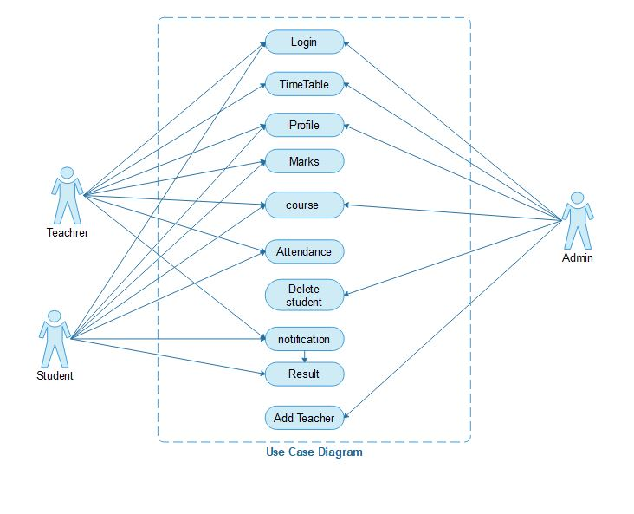
Figure 1: use case diagram

4.4.2 Sequence diagram
A sequence diagram simply depicts interaction between objects in a sequential order i.e. the order in which these interactions take place. We can also use the terms event diagrams or event scenarios to refer to a sequence diagram. Sequence diagrams describe how and in what order the objects in a system function.

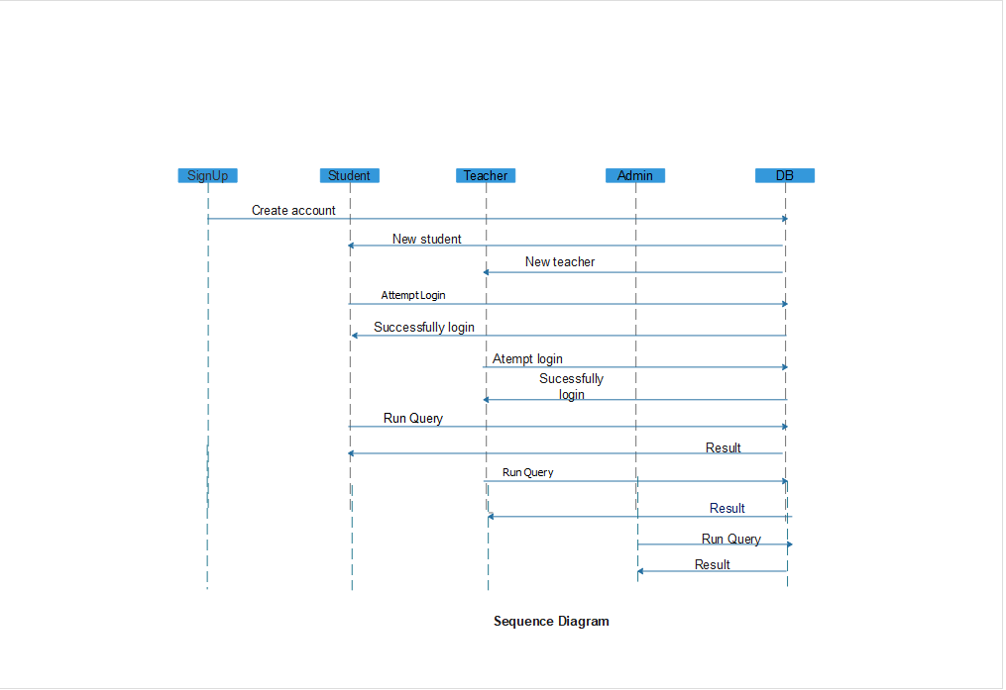
Figure 2 :Sequence diagram

4.4.3 Activity diagram
We use Activity Diagrams to illustrate the flow of control in a system and refer to the steps involved in the execution of a use case. We model sequential and concurrent activities using activity diagrams. So, we basically depict workflows visually using an activity diagram. An activity diagram focuses on condition of flow and the sequence in which it happens. We describe or depict what causes a particular event using an activity diagram.

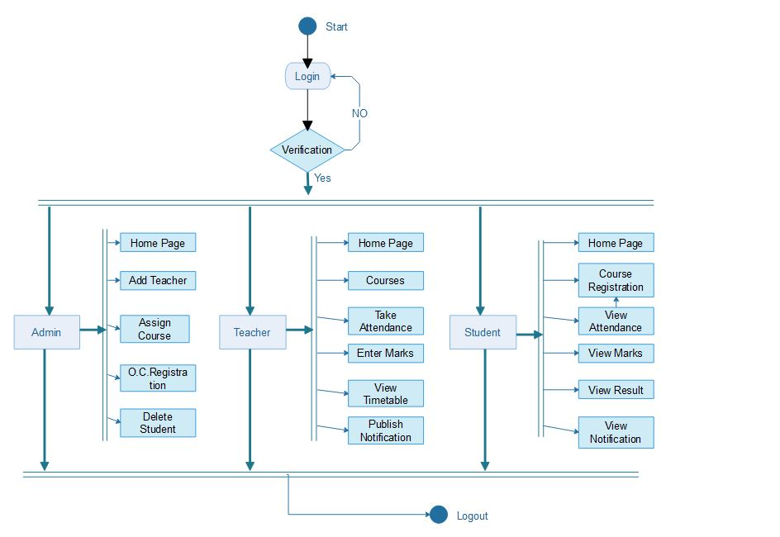
Figure 3: Activity Diagram

4.5 E-R diagram
An entity relationship diagram (ERD), also known as an entity relationship model, is a graphical representation of an information system that depicts the relationships among people, objects, places, concepts or events within that system. An ERD is a data modeling technique that can help define business processes and be used as the foundation for a relational database. The ERD diagram of our project is shown below as:

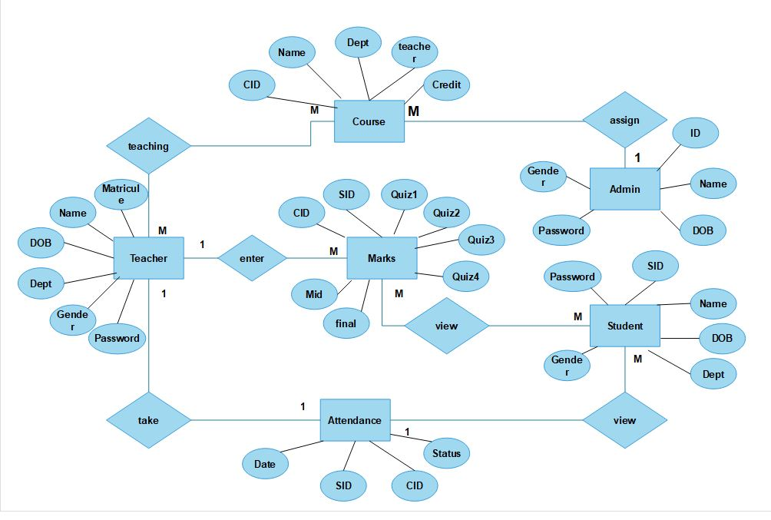
Figure 4 :E-R diagram

4.6 Data Flow Diagram
A data-flow diagram (DFD) is a way of representing a flow of a data of a process or a system (usually an information system). The DFD also provides information about the outputs and inputs of each entity and the process itself. A data-flow diagram has no control flow, there are no decision rules and no loops

4.6.1 Context diagram
A context diagram, sometimes called a level 0 data-flow diagram, is drawn in order to define and clarify the boundaries of the software system. It identifies the flows of information between the system and external entities. The entire software system is shown as a single process.

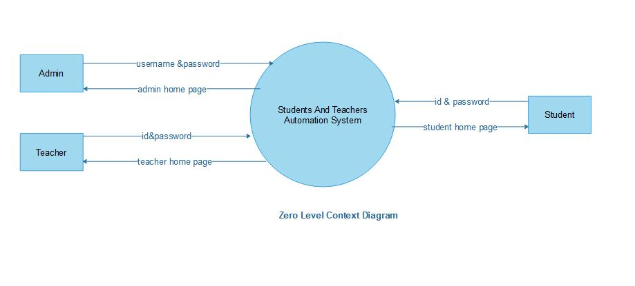
Figure 5: Context Diagram

4.6.2 Level One Diagram
A level 1 data flow diagram (DFD) is more detailed than a level 0 DFD but not as detailed as a level 2 DFD. It breaks down the main processes into subprocesses that can then be analyzed and improved on a more intimate level. Below we present the level 1 diagram for the admin, teacher and student.

4.6.2.1 Admin Level One Diagram

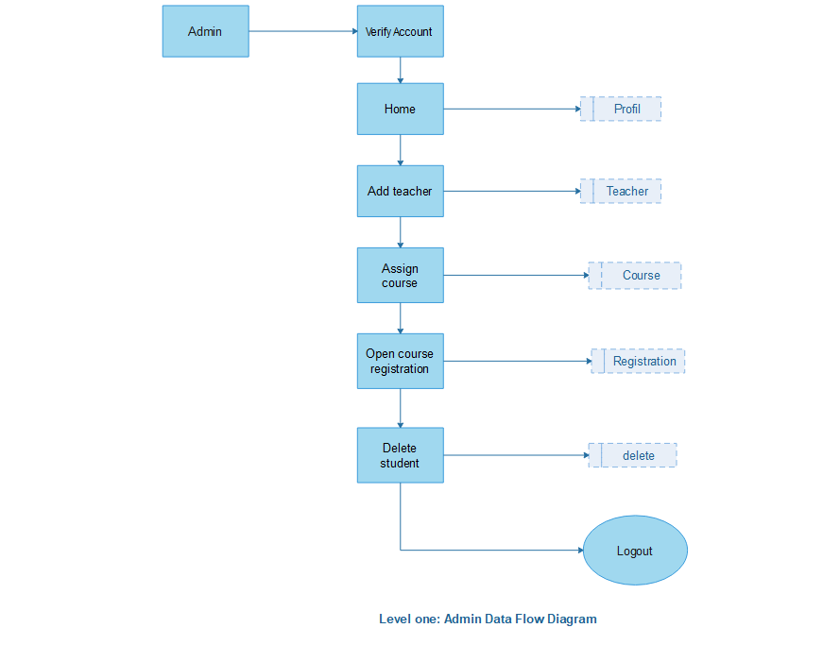
Figure 6: Admin Level One Diagram

4.6.2.2 Teacher Level One Diagram

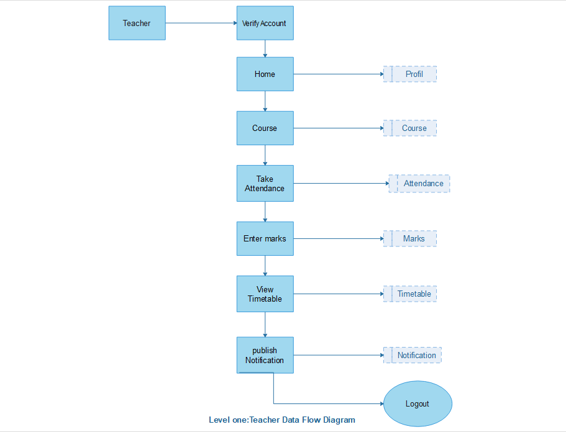
Figure 7:Teacher Level One Diagram

4.6.2.3 Student Level One Diagram

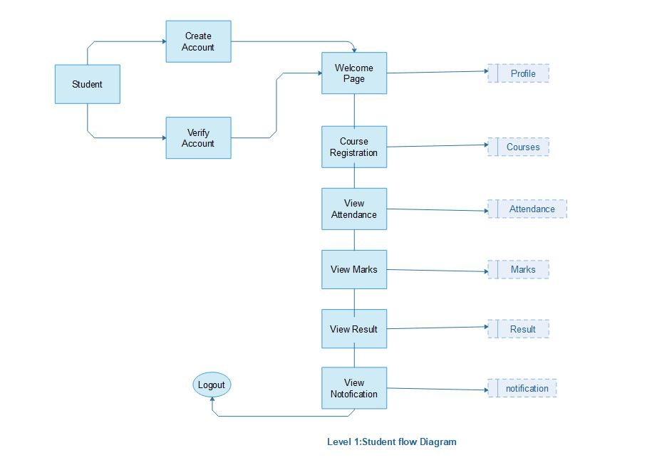
Figure 8: Student Level One Diagram

CHAPTER 5: IMPLEMENTATION

5.1 Introduction
This chapter will present our Student and teacher automation highlighting its operational requirements along with a tutorial showing how to operate with it.

5.2 Operational Requirements
❖ Development tools:
- Oracle Java Runtime Environnent.
- Tomcat Server
- MySQL database
- MySQL connector
- NetBeans IDE for coding in JAVA
❖ Documentation tools:
- MS power point
- MS Visio 2016
- MS Word
❖ Graphical Design tools:
- CSS
- JSP
- NetBeans IDE for facilitating the design through drag and drop
❖ Hardware requirements:
- At least 2GB of RAM
- Hard Disk space with a minimum 320GB
- CPU – Intel Core 2 Duo

5.3 Tutorial
This section will act as a user manual. There will be instructions on how to operate with the system depending on the desired action.

5.3.1 Login

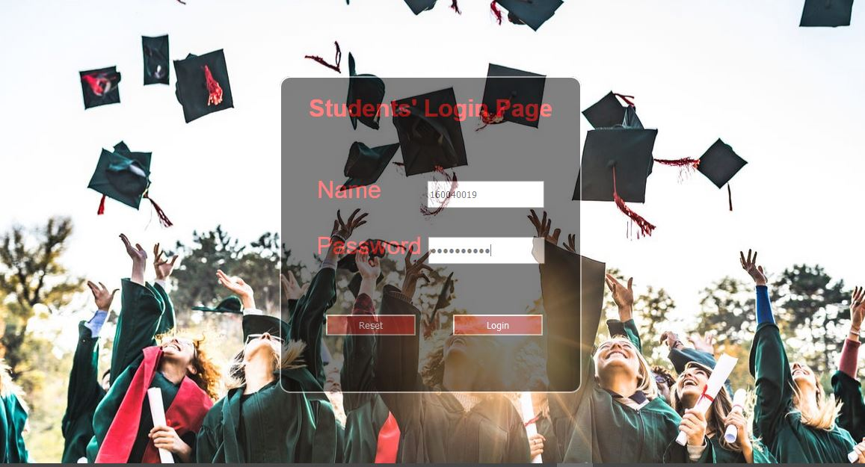
Figure 9 :Login Page

In this form, the user is required to provide valid login credentials in order to be redirected to the homepage illustrated below:

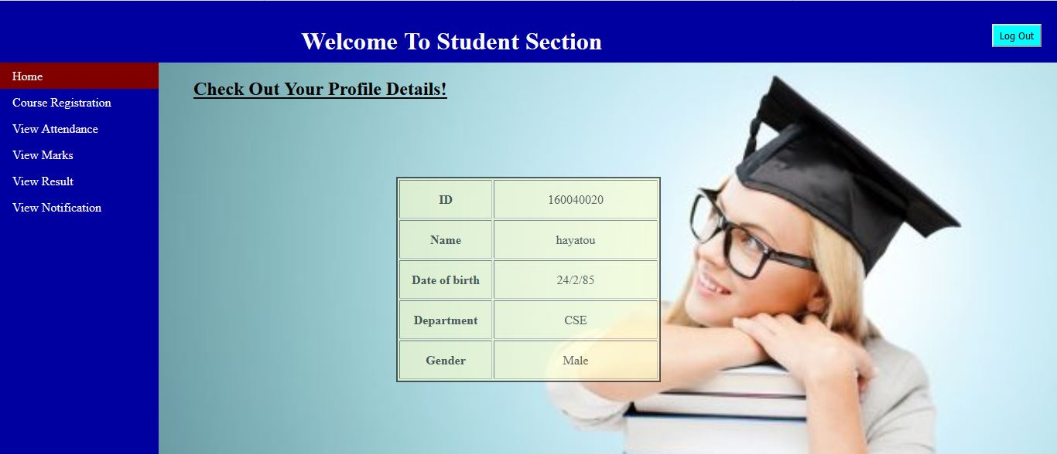
Figure 10: Student Home page

5.3.2 Course Registration
In this form, the user is required to select all the courses that he is going to attend for the semester.

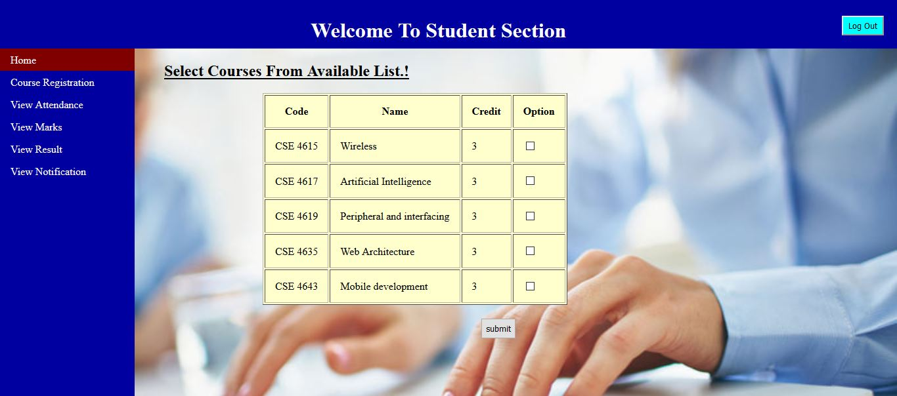
Figure 11:Course Registration

5.3.3 Attendance
In this section, the teacher will take the attendance for the students who have registered to the course.

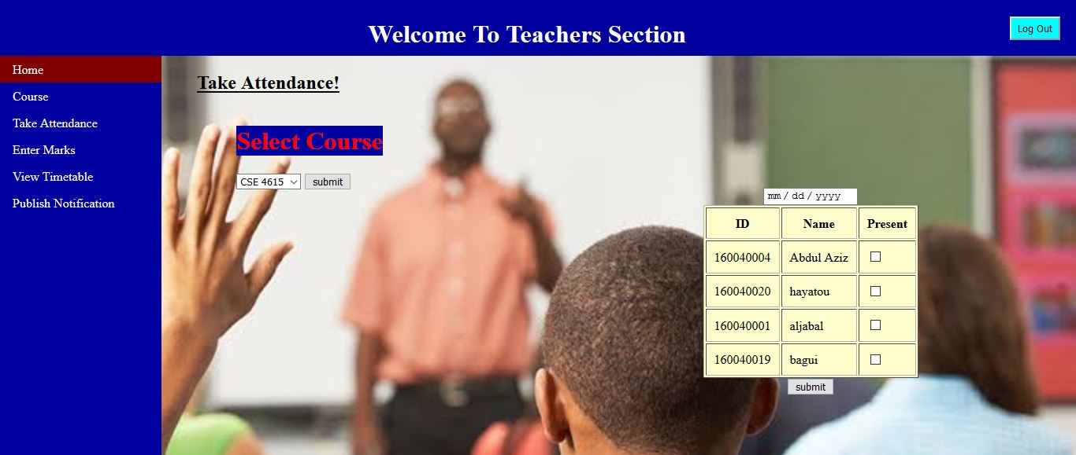
Figure 12:Taking Attendance
And the Students can view their attendance from their account. This is illustrated by the figure shown below:

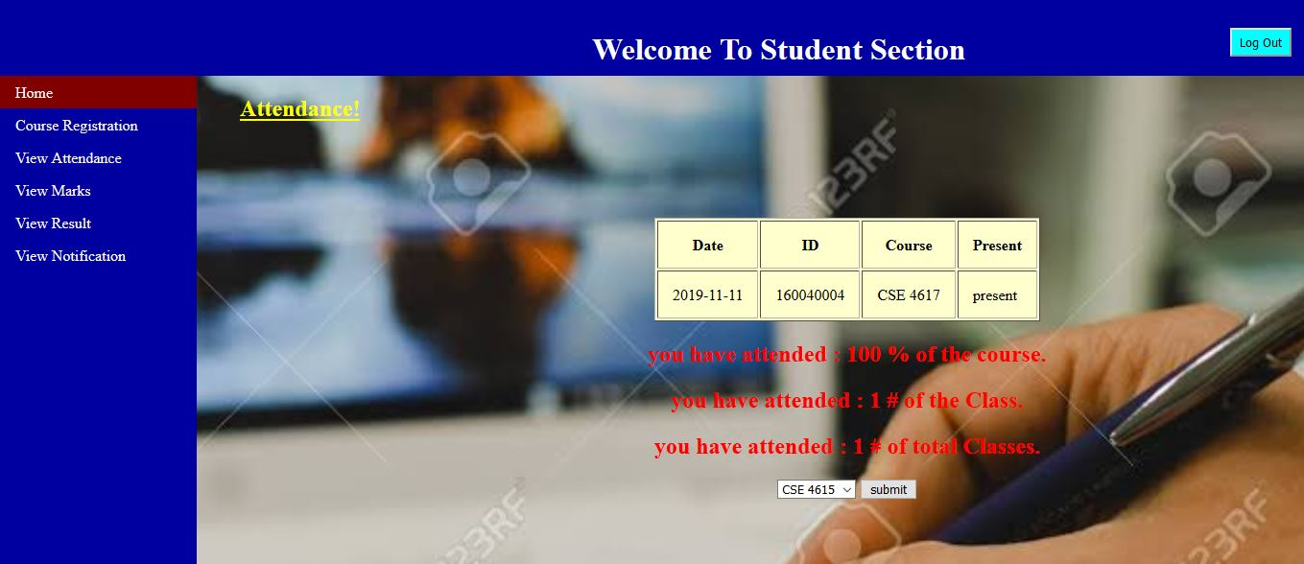
Figure 13:View Attendance

5.3.4 Marks
In this section, the teacher will enter the Marks for the students who have registered to the course.
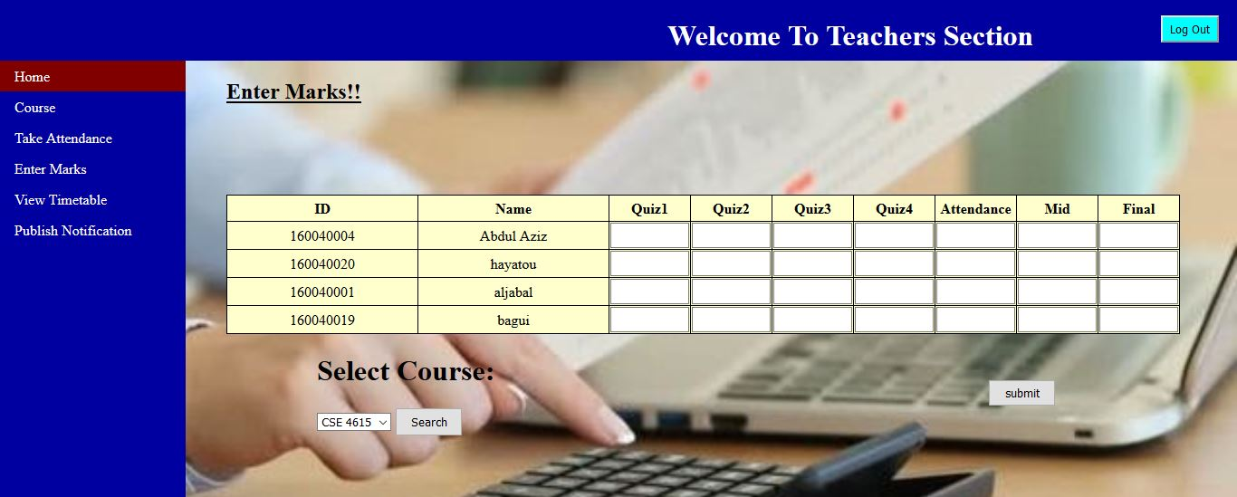
Figure 14:Entering Marks
And the Students can view their Marks from their account. This is illustrated by the figure shown below:

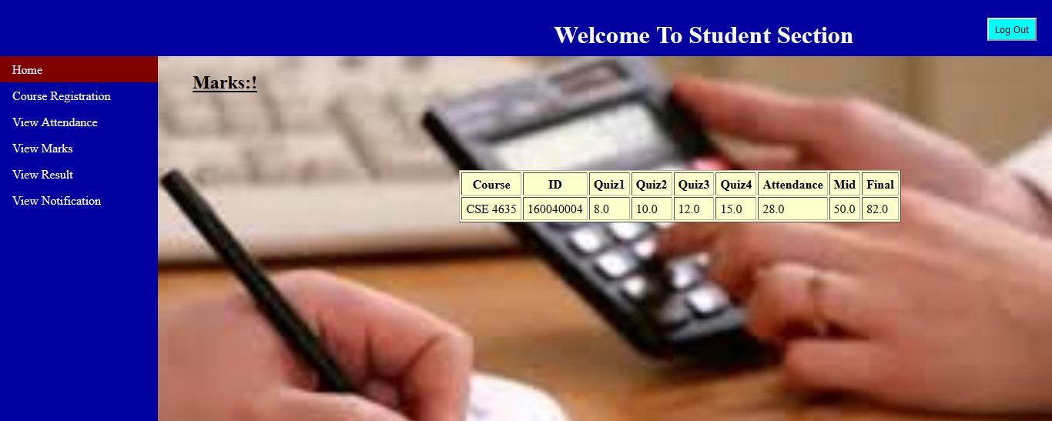
Figure 15:Viewing the Marks

5.3.5 Notification
In this section, the teacher will publish any notification to the students who have registered to the course.
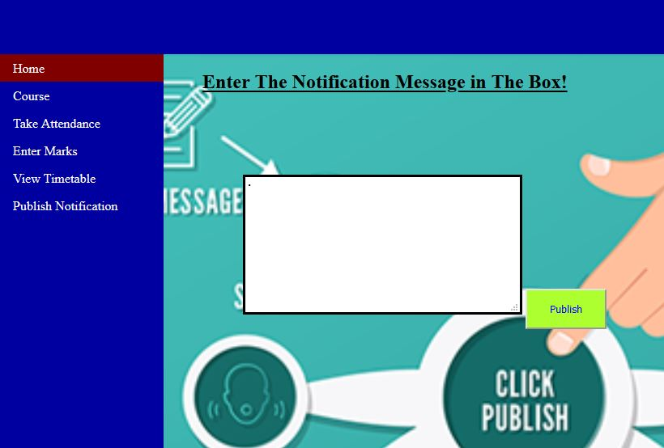
Figure 16:Publish Notification

And the Students can view all the notifications from their account. This is illustrated by the figure shown below:
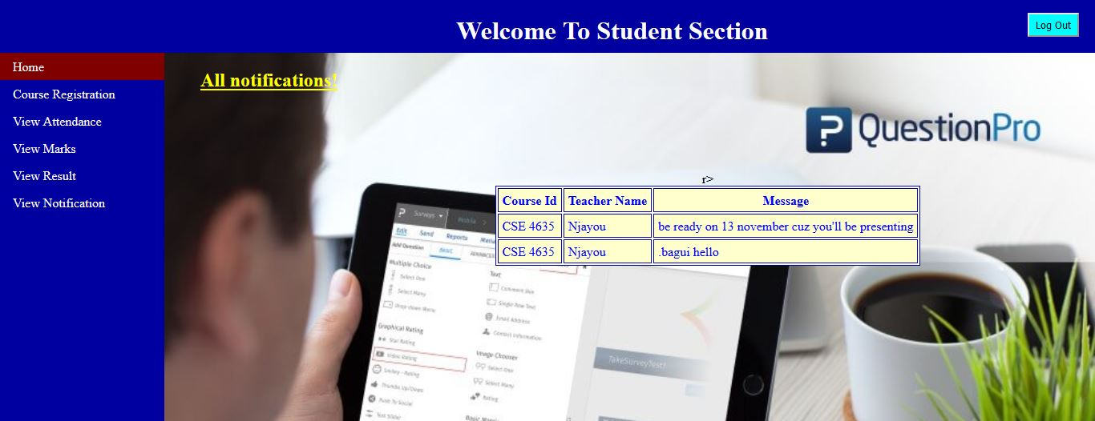
Figure 17:Viewing the Notification

5.3.6 Result
In this section, the students will view their grade for different courses. This is illustrated by the figure shown below:
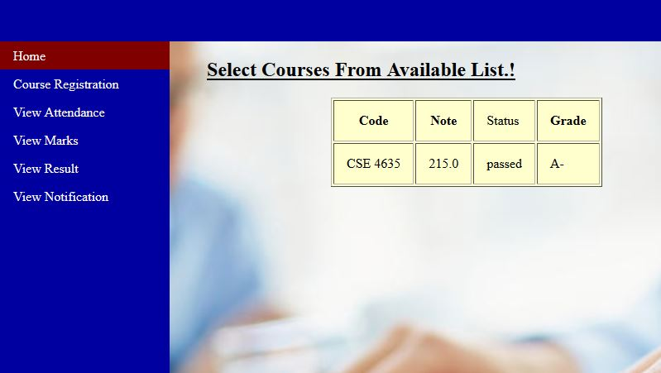
Figure 18:Result

CHAPTER 6: CONCLUSION
By using Existing System accessing information from files is a difficult task and there is no quick and easy way to keep the records of students and staff. Lack of automation is also there in the Existing System.
The aim of Our System is to reduce the workload and to save significant staff time. This System assists in automating the existing manual system no manual processing is required. This is a paperless work. It can be monitored and controlled remotely. It reduces the man power required. It provides accurate information always. All years together gathered information can be saved and can be accessed at any time. The data which is stored in the repository helps in taking intelligent decisions by the management providing the accurate results. The storage facility will ease the job of the operator. However, due to some restrictions, we could not make it a whole system. Therefore, in the future, we plan to add the following functionalities:
- Make the system handle automation for all available department of Islamic University of Technology (IUT)
- Make a platform where students and teachers can come together and share the ideas and communicate.

REFERENCES

- www.visual-paradigm.com
- www.lucidchart.com
- https://www.academia.edu/24351218/College_Automation_System

