
ISLAMIC UNIVERSITY OF TECHNOLOGY
UNDER GRADUATE THESIS
Analysis of Wave Impact on Offshore Structure & Modeling a Physical Wave Creating Device
Submitted By :
Fahad Mannan. I.D: 111420
Md. Imtiaz-Ur-Rahman. I.D: 111443
Md. Alamin Hossain. I.D: 111447
Supervisor :
Md. Hamidur Rahman
Assistant Professor
Department Of Chemical and Mechanical Engineering
Islamic University of Technology

A thesis submitted to the Department of MCE in fulfilment of the requirements for the degree of B.Sc Engineering.
NOVEMBER,2015
Declaration of Authorship
This is to certify that the work presented in the thesis is the outcome of analysis and investigation carried out by Fahad Mannan, Md. Imtiazur Rahman and Md. Alamin Hossain under the supervision of Md. Hamidur Rahman, Assistant professor, MCE Department, IUT, Dhaka, Bangladesh.It is also declared that neither of this thesis nor any part of this thesis has been submitted anywhere else for any degree or qualification.

Authors:
Fahad Mannan
I.D: 111420.
Md. Imtiaz-Ur Rahman
I.D: 111443.
Md. Alamin Hossain
I.D: 111447

Supervisor :
Md. Hamidur Rahman
Assistant Professor
MCE Department,IUT.

Acknowledgements

In full gratitude,we would like to acknowledge the following individuaals who encouraged, inspired, supported and asssisted to help our pursuit of the successful thesis work.
From our academy, we would like to thank our supervisor Md. Hamidur Rahman,Assistant Professor,MCE department, IUT for the continuous support of our thesis work and related research,for his patience,motivation and immense knowledge.His guidance helped us in all the time of research and writing of this thesis paper.
Special thanks to our fellow classmates, senior brothers and juniors who helped us in achieving success in our research work.

Abstract
Structures in offshore seabed area is quite common affair.Offshore monopile foundation is one of the most commonly used foundation structures.The Sangu Gas field in Sangu river is an example in our country.These offshore structures are subjected to continuous cyclic load impact caused by sea waves which may cause structural failure and collapse.
In this work, a developed numerical method for water-wave body interaction is used to study the water wave’s effects on the structural behavior of the monopiles. A validation procedure will be conducted by comparing the numerical results with analytical wave mathematical model results. The numerical model is based on Reynolds Averaged Navier Stokes equations (RANS) considering the effects of energy dissipation.
ANSYS CFX is used to solve (RANS) using finite volume method. The free surface displacements are tracked by the volume of fluid method. The numerical model is used to simulate periodic first order waves and their interaction with a vertical slender monopile. The physical analysis is to be performed in a wave tank model where artificial waves is created using slider crank mechanism operated by an A.C motor.The offshore obstacles considered in the analysis were two types:- cylindrical monopile and square shape monopile.

List Of Contents:-
Chapter 1(page 8-11):-Introduction, Problem Statement, Objectives Of Research, Brief Research Methodology, Research Importance.

Chapter 2(page 12-18):-Background Review(Wave Modeling), Classification of Seawater Waves, Numerical Models for Water Waves, Fully three-dimensional wave models with turbulence: Navier-Stokes equation models, Fully three-dimensional wave models without turbulence: potential flow Models.

Chapter 3(page 19-29):-CFD Theory(Conservation of mass, momentum and energy), Morison Equation, Turbulence models, Eddy viscosity models, Free Surface Boundary Conditions, Boundary Conditions, Potential Wave Theory, Proposed Wave-maker Model.

Chapter 4(page 30-43):-Numerical model setup, Numerical set-up & Inputs, Obstacle Dimensions,Simulations & Outputs, Conclusion,References.

List Of Abbreviations:-

CFD Computational Fluid Dynamics

FSI Fluid Structure Interaction

NWT Numerical Wave Tank

NSE Navier Stokes Equations

SWL Sea Water Level

VOF Volume of Fluid

WMT Wave Maker Theory

List Of Figures:-
Figure1.1: Sangu Gas Field In Sangu River
Figure1.2: Offshore windmill in Germany
Figure 2.1: Littoral zone classification
Figure 3.1: Velocity fluctuating with time in a turbulent flow
Figure 3.2:Boundary layer showing the sub layer, logarithmic layer and the
buffer layer
Figure 3.3: Water fraction
Figure 3.4: An exaggerated view of three inflation layers on each side of the uppermost subdomain boundary surface
Figure 3.5: Bottom-hinged flap wavemaker
Figure 3.6: Piston wavemaker
Figure 3.7: Proposed piston type wavemaker
Figure 4.1: Geometry 1(Cylindrical Obstacle)
Figure 4.2: Mesh For Geometry 1
Figure 4.3: Force Distribution For Geometry 1
Figure 4.4: Velocity Streamline For Geometry 1
Figure 4.5: Geometry 2 (Square obstacle)
Figure 4.6:Mesh For Geometry 2
Figure 4.7: Force Distribution For Geometry 2
Figure 4.8: Velocity Streamline For Geometry 2

CHAPTER 1

Introduction:-

Numerical simulation using computers or computational simulation has increasingly become a very important approach for solving complex practical problems in engineering and science. Numerical simulation translates important aspects of a physical problem into a discrete form of mathematical description, recreates and solves the problem on a computer, and reveals phenomena virtually according to the requirements of the analysts. Rather than adopting the traditional theoretical practice of constructing layers of assumptions and approximations, this modern numerical approach attacks the original problems in all its detail without making too many assumptions, utilizing the increasing computer power.
In general, computation of wave loads on structures is complicated by the complex nature of wave-structure interaction. Because structure in water interrupts the propagation of waves, the flow field associated with waves depends on both wave conditions and thestructure geometry.

Problem Statement:-
Offshore monopiles, as an important foundation concept, have been increasinglyreceiving attention of scientists and engineers. Generally, embedded in shallow waterswith a depth of no more than 50 m, offshore monopiles have a much larger diameter thanthose of other pile foundations.

Ocean waves impose cyclic and detrimental loads on monopiles during their entire
operational lifetime, and therefore, are considered as predominant factors when analyzing monopile behavior.

Unfortunately, there is no established technical guideline for offshore monopile designand construction that can be universally applied due to its environmental-dependent
nature.

Objectives Of Research:-

- To model a physical wave creating device to create wave in a water tank.

- To model a numerical wave tank which can replicate the behavior of wave in the experimental tank using ANSYS CFX .

- To produce regular waves (linear waves) within the proposed NWT.

- To determine forces and wave actions in the numerical wave tank using ANSYS CFX simulation and compare results with practical model.

- Validating forces and moments obtained from ANSYS CFX against Morison’s equation.

Brief Research Methodology:-

In this study, a numerical model will be developed to explore the monopile response to sea waves and the interaction between them. The model is set for the benefit of subsequent investigation on the effect of monopile cross section shape and length on its behavior when it is exposed to seawater loads.

A typical monopile is associated with three physical aspects according to the spatial division by the medium surrounding it, i.e., aerodynamically with the wind,
hydrodynamically with the seawater, and geotechnically with the seabed. There are also static loads transferred and act on the monopile. These aspects are not considered due to the intensive objective of this study, which mainly focuses on the wave loads and the resulting structural response of the monopile.

A model for predicting the interaction of fluid with structures will be introduced in this work, which is a complex problem due to the interaction of the nonlinear fluid behavior with the structural behavior.

A set of simulations will be performed to demonstrate the structural response due to water impact; hence, a parametric study has been carried out using key parameters such as monopiles section shape and monopile height, which are of great significance to the monopile behavior.

Research Importance:-

Now-a-days structures in offshore seabed area is quite common affair.Offshore monopile foundation is one of the most commonly used foundation structures.The Sangu Gas field in Sangu river is an example in our country.These offshore structures are subjected to continuous cyclic load impact caused by sea waves which may cause structural failure and collapse.
Fig: Offshore Windmill,Germany.

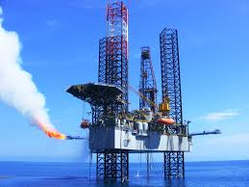
Figure1.1: Sangu Gas Field In Sangu river,Bangladesh.

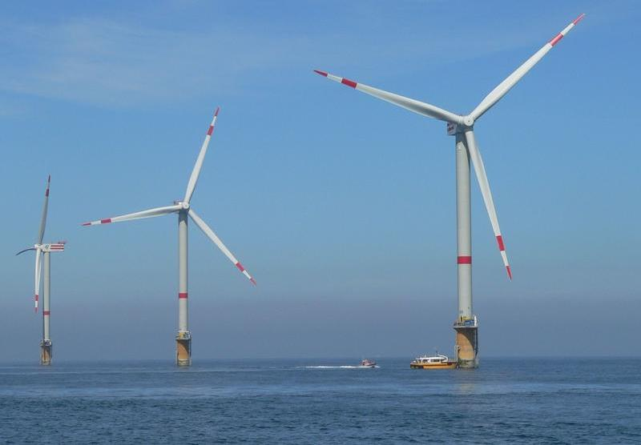
Figure1.2: Offshore windmill in Germany.

CHAPTER 2

Background Review:-
Wave Modeling

There are various types of techniques for modeling a prototype wave system, i.e., analytical wave modeling, empirical wave modeling, physical wave modeling, and numerical wave modeling. With their inherent advantages and limitations, these techniques shall be applied for different purposes.

Analytical wave modeling

A physical wave system in nature can be very complicated. A way to represent the wave system by analyzing the system with a simplified theoretical model that should be able to capture the most important characteristics of the wave system. The model is usually expressed by mathematical equations, which are in the form of partial differential equations (PDEs) or ordinary differential equations (ODEs) governing the space-time relationship of the important variables for the waves.

A good theoretical model is always constructed on rigorous mathematical derivations, each step of which has clear physical and mathematical assumptions and implications. When the equations are solved analytically for a specific condition, the closed-form solution can be obtained and used to predict wave system behavior accurately. This procedure of solution seeking is called analytical wave modeling, which is a powerful tool for us to understand the physical phenomenon of a particular wave system.

One typical example of this kind of modeling is the wave-scattering pattern around a large vertical circular cylinder with the use of diffraction theory. Unfortunately, although most of the wave systems can be formulated theoretically, only very few of them can be solved
analytically. This greatly limits the application of this approach to general wave problems.

Empirical wave modeling

An empirical formula is usually a simple mathematical expression summarized from available field data of a prototype system. It can describe the system behavior in terms of simple algebraic equations with important parameters. Since the empirical approach is simple and easy to implement, it is widely adopted in engineering design. In empirical wave modeling, empirical formulas can be used to estimate the maximum wave load on a structure (i.e., the Morison equation), the reflection coefficient from a certain type of structure, the maximum wave run-up on a beach, and the maximum wave overtopping rate over a dike. However, since empirical formulas are established on the known problems and database, when a new prototype system is considered, the existing empirical formulas may not be suitable.

Physical wave modeling (Prototype)

To understand a prototype wave system in nature, alternatively a small-scale physical model can be built in the laboratory as a prototype. The wave characteristics (and wave loads on the model structure if wave-structure interaction is investigated) can be obtained by laboratory measurements. The information can then be extrapolated based on certain scaling laws to estimate what will really happen to the prototype system. This approach is called physical wave modeling. It is straightforward and allows us to visualize and understand the important physical processes from the small-scale model study. Typical examples of physical wave modeling include the studies of wave loads on an offshore structure, wave transmission and reflection from a breakwater, etc. However, when a physical system becomes very complicated, a physical model that satisfies all the important scaling laws, on which the physical model is designed and constructed, may not exist. Under such circumstances or when a physical model study is too expensive and time-consuming other approaches may have to be sought. Readers are referred to Hughes (1993)for a more detailed description of the physical models in coastal engineering and to Chakrabarti (1994) for offshore structure modeling.

Numerical wave modeling

A numerical wave model is the combination of the mathematical representation of a physical wave problem and the numerical approximation of the mathematical equations.Compared to analytical modeling, the difference is only in the means of finding the solution of the governing equations for the wave problems. To model ocean waves numerically, it must be started from some existing “wave equations” obtained from theoretical studies. In most cases, more than one wave equation is there to describe the same wave phenomenon, depending on different levels of approximation made in the theoretical derivations. Similarly, the same wave model can also be applied to manydifferent wave problems, as long as the basic assumptions in the model are valid.

Classification of Seawater Waves:-

The seawater waves are classified according to the water depth to three main zones, as shown in Figure 2.1:-

- The onshore zone: the depth of water varies from 0m to 10m.

- The nearshore zone: the depth of water varies from 10m to 50m.

- The offshore zone: the depth of water is over 50m.

Figure 2.1: Littoral zone classification.

Numerical Models for Water Waves:-

In the following subsections, classification for wave models based on their modeling capability is presented.

Wave spectral models

The most commonly employed wave model in modeling large-scale wave motion is the wave energy spectral model or wave action spectral model. This type of model is constructed on the assumption that a random sea state is composed of an infinite number of linear waves whose wave height is a function of wave frequency and the direction of wave propagation. The representative wave energy spectral models are WAM (Wave Prediction Model) Hasselmann, et al. (1988) and Wavewatch III Tolman (1999), which can be used to model large-scale variations of wave heights in deep oceans. Being connected with an atmosphere model, a wave energy spectral model is able to predict global ocean wave climate. When the current effect is considered, the wave action spectral model can be formulated and used instead to simulate combined wave-current interaction in a largescale nearshore region.

With the wave phase information being filtered out in the formulation, the wave spectral model can use computational meshes much larger than a wavelength and thus can be applied in a very large area. Without wave phase information, however, the model is unable to represent wave diffraction that is phase-related. For this reason, this kind of model is usually used to provide far-field wave information only. The detailed wave pattern around coastal structures where diffraction is important is left to other types of wave models.

Mild-slope equation wave models

The mild-slope equation (MSE) was originally derived based on the assumptions of linear waves and slowly varying bottoms. The equation can be used to describe combined wave refraction and diffraction in both deep and shallow waters. In most events, the MSE model is employed to study monochromatic waves, though it can be applied to irregular waves by summing up different wave harmonics. The extension of the MSE to abruptly varying topography and larger amplitude waves was also attempted in the last two decades. So far, most of the applications of the MSE models are limited to the region from an offshore location to a nearshore location some distance away from the shoreline before wave nonlinearity becomes strong.One exception is its application in harbor resonance modeling because water depth in a harbor is usually deep even along the boundaries. The MSE has three different formulations, namely the hyperbolic MSE for a time-dependent wave field, the elliptic MSE for a steady-state wave field, and the parabolic MSE for a simplified steady-state wave field that has a primary wave propagation direction.

Boussinesq equation wave models

To model nearshore waves with strong wave nonlinearity, a Boussinesq equation wave model (or simply the Boussinesq model in water wave modeling) is often a good choice.The Boussinesq equations are depth-averaged equations with the dispersion terms partially representing the effect of vertical fluid acceleration. Rigorously speaking, Boussinesq equations are valid only from intermediate water depth to shallow water before the waves break. However, in engineering applications, the equations are often extended beyond the breaking point, up to wave run-up in the swash zone. This is possible by adding an artificial energy dissipation term for wave breaking.Besides, efforts are also made to extend the model to deeper water. Unlike the wave spectral model and the MSE model, the Boussinesq model does not have the presumption that the flow is periodic. Therefore, it can be applied to waves induced by impulsive motions, i.e., solitary waves, landslide-induced waves, tsunami, and unsteady undulation in open channels.

Shallow-water equation wave models

To model tsunami or other long waves (e.g., tides), a shallow-water equation (SWE) model is more likely to be adopted. Compared with the Boussinesq model, the SWE model is simpler because the flow is assumed to be uniform across the water depth and the wave-dispersive effect is neglected. The SWE model has a wide application range in modeling tsunami, tides, storm surges, and river flows. The main limitation of the SWE model is that it is suitable only for flows whose horizontal scale is much larger thanvertical scale.

Quasi-three-dimensional hydrostatic pressure wave models

All the earlier discussed wave models can be operated on a horizontally two-dimensional(2D) plane due to vertical integration. When a shallow-water flow is modeled, the depthvarying information may still be needed on some occasions. A typical example is ocean circulation where the horizontal length scale is much larger than the vertical scale, but the vertical circulation, though relatively weak, is still of interest in many events. Thus, in this case, a three-dimensional (3D) model would be necessary. This type of model often solves the 3D Navier-Stokes equations (NSEs) directly under the hydrostatic pressure assumption. Under such an assumption, the solution procedure to the 3D NSEs is greatly simplified and the model is referred to as the quasi-3D model, against the fully 3D model to be discussed later. The model of this type is often solved in the σ-coordinate that maps the irregular physical domain to the regular computational domain for the ease of application of the boundary condition. The representative model of this kind is the Princeton Ocean model (POM) .

Fully three-dimensional wave models with turbulence: Navier-Stokesequation models:-
To model fully 3D wave problems, a turn to the general governing equations, NSEs is necessary, without a hydrostatic pressure assumption. The NSEs are derived from the general principle of mass and momentum conservation that is able to describe any type of fluid flow including water waves. With the inclusion of a proper turbulence model, it is possible for an NSE model to simulate difficult wave problems, e.g., nonbreaking or breaking waves, wave-current interactions, and wave-structure interactions. When breaking waves are simulated, there is the potential to include air entrainment on the surface of the water; when the wave-body interaction is computed, it can treat both the rigid body and the flexible body. With almost no theoretical limitation, this type of model seems to be the best choice of all. However, the main barrier that prevents the wide application of such a model is the expensive computational effort. To solve the fully 3D NSEs, the computation can be much more expensive than all the previously introduced wave models. So far, the application of such models in engineering computation is still restricted to the simulation of local wave phenomena near the location of interest, e.g., the surf zone when the breaking wave and/or sediment transport is considered and the flows around coastal and offshore structure when the wave-structure interaction is
considered.

Fully three-dimensional wave models without turbulence: potential flowModels:-

When turbulence is negligible and the bottom boundary layer thickness is thin (e.g.
nonbreaking waves), the NSEs can be reduced to the Laplace equation based on potential flow theory. The theory is applicable to most of the linear and nonlinear nonbreaking waves and their interaction with large bodies. The Laplace equation can be solved numerically by many different methods. One of the most commonly used methods is the boundary element method (BEM), which converts domain integration into surface integration with the use of Green’s theorem. This type of model is capable of simulating highly nonlinear waves in both deep and shallow waters. It is effective in the study of nonlinear wave transformation over changing topography, linear wave diffraction over a large body, and wave force on a large structure. The major limitation of such a model lies on the potential flow assumption that requires the flow to be irrotational. For this reason, the model is unable to simulate breaking waves as well as wave interaction with small bodies, during which the flow becomes rotational. Furthermore, the computational cost for modeling 3D fully nonlinear waves using BEM is rather high .

CHAPTER 3

CFD Theory:-

The fundamental equations used are the Navier-Stokes equations for an incompressible, constant viscosity fluid based on the three laws of conservation, which are:
1. Conservation of Mass based on continuity.
2. Conservation of Momentum based on Newton’s second law.
3. Conservation of Energy based on the first law of thermodynamics.

Conservation of mass
The continuity equation (3.1) states that the mass is constant in a given system. Meaning that the amount of mass into the system is equal to the mass out of the system.
In (3.1) 𝕍represents the volume, 𝜌 the density, 𝑚 the mass, and 𝑡 the time. By rewriting the total derivative, given in equation (3.2), and relate the rate of volume change to the normalstrain rate and further to the fluid velocity we get the more known continuity equation given in equation (3.3). In a numerical wave tank, the fluid can be assumed incompressible, with constant density, and the continuity equation reduces to equation

$\frac{Dm}{Dt}$ = $\frac{D(ρV)}{Dt}$ = 0 3.1
$\frac{∂ρ}{∂t}$ + $Δ\left(ρV\right)=0$ 3.2
$Δ\left(V\right)=$ 0 3.3

Where the Del operator is defined in Cartesian coordinates by

$Δ= \frac{∂}{∂x} i$+$\frac{∂}{∂x}j+\frac{∂}{∂x}$ k 3.4

In addition, the fluid velocity vector is

V = u $i$+ v $j$+ w k

Where u, v and w are the velocity components and i, j and k are the unit vector in the direction of the Cartesian coordinates x, y and z respectively.

Conservation of momentum:-

The conservation of momentum are often referred to as the Navier Stokes equation
In fluid mechanics. From Newton’s second law, the total force is given as the rate of change of momentum. Momentum is often noted as mass times velocity, as shown in equation (3.5) with constant mass m outside of the total derivative. In a given system the conservation of momentum means that the momentum into the system equals the momentum out of the system. In practice, this illustrates Newton’s third law between fluid particles were an equal and opposite force will act on each particle in order to conserve the momentum. By dividing the mass of the fluid particle with its volume, the mass can be represented only with density,. Further, the sum of forces per volume can be divided into a body force and surface forces from external stresses as given in the stress-strain formulation of Navier Stokes in equation (3.6)

∑F = m a = m $\frac{Dv}{Dt}$ = $ρ$ V $\frac{Dv}{Dt}$ 3.5

$ρ\frac{Dv}{Dt}$ = f+ $Δ.σ$ 3.6

The body force, given in equation represents the forces which is applied to the total mass of the fluid element, usually given as the gravity force per unit volume ρg. In a numerical wave tank, the buoyancy force must also be taken into consideration together with the gravity force. A buoyancy force is in general a force due to difference in density . We have assumed constant density but due to the two-phase flow between water and air in a wave tank, we have to take the difference between the fluids into account.

Conservation of energy:-

The conservation of energy, given in equation, states that heat added and work done on the system will increase the total energy of the system. The temperature is of minor importance in a numerical wave tank with isothermal conditions.

$ρ\frac{Dh}{Dt}$ = $\frac{Dρ}{Dt} Δ(kΔT)$ + $ϕ$
Where h is the enthalpy, k is the thermal conductivity and Φ is the dissipation function.
From the three equations, continuity, momentum and energy conservation, the three unknowns; pressure, velocity and temperature can be found. These parameters are the main output parameters in a CFD analysis and are the basis for all the other results.

Morison Equation:-

Morison proposed the following formula for determining the total wave
force, which is just the sum of the two forces, drag and inertia. Equation
shows the force per unit length.

F(t) = $\frac{1}{2}ρC_{D}$ A|u|u + $ρC_{M}\frac{πD^{2}}{4}\dot{u}$

Where $C_{M}$ is the inertial coefficient and $C_{D}$ is the drag coefficient and A is the projected area perpendicular to the flow.

Turbulence models:-

In a wave tank with only non-breaking regular waves the flow will follow the orbital motion and can be assumed laminar, in similar manner as if a uniform current flow will be laminar. If no structure is disturbing the fluid flow, no separation and turbulent mixing will occur. In a real water of fluid, the flow around structures will in most cases beturbulent and a turbulence model must be set up. From Reynolds decomposition, the velocity can be written as a mean velocity and a fluctuation velocity as in equation and Figure.

u
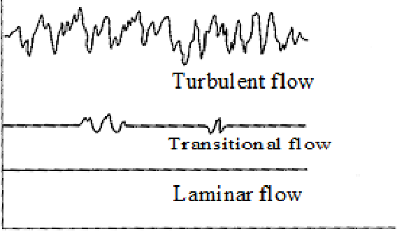t
Fig 3.1: Velocity fluctuating with time in a turbulent flow.

Eddy viscosity models:-

The Boussinesq hypothesis, links turbulent, or Reynolds stresses to the mean rate of deformation as shown in equation . This onlymoves the turbulent unknown from the apparent stresses to a turbulent viscosity, μT. The model is a two-equation model, which relates the unknown turbulent viscosity, μT to the turbulent kinetic energy, K, and the turbulent dissipation 𝜖. The relation is given in equation.

$ρ\overline{\acute{u_{i}}{\acute{u}}_{j}}$=$μ_{T}$($\frac{∂u_{i}}{∂x_{j}}$ + $\frac{∂u_{j}}{∂x_{i}}$)

$μ_{T}$ = $ρC_{μ}\frac{K^{2}}{ϵ}$

Here Cμ = 0.09 for the model. Near walls, the model use a wall function. A scalable wall function uses the logarithmic velocity profile approximated from the velocity close to the wall. The boundary layer can be divided into a sub layer with almost linear velocity profile, a logarithmic layer following the logarithmic profile and a buffer layer where the laminar and turbulence effects are of equal importance. A boundary layer is shown in Figure 3.4.

Figure 3.2:Boundary layer showing the sub layer, logarithmic layer and the
buffer layer.

Free Surface Boundary Conditions:-

There exists two conditions defining the free surface:

1. Kinematic boundary condition
2. Dynamic boundary condition

The kinematic boundary condition requires that the water particles at the free surface stay at the free surface. This indicates no net fluid flow through the free surface. The normal water velocity component located at the free surface has to be equal to the normal velocity component of the free surface boundary, equation –

[(𝑣 − 𝑣𝑏 )𝒏]𝑓𝑠 = 0 𝑚̇𝑓𝑠 = 0

Here v is the water velocity, vb the boundary velocity, 𝑚̇𝑓𝑠 the mass flux and fs indicates the free surface. The dynamic boundary condition requires force equilibrium at the free surface. Normal forces on the surface has to be equal and opposite in direction and tangential forces equal and in the same direction. In gravity driven free surface flows, the surface tension force and the viscous shear stress force at the surface can be neglected, and we are left only with the pressure force. This gives water pressure equal to the air pressure at the free surface, equation-

[𝑝𝑤𝑎𝑡𝑒𝑟 − 𝑝𝑎𝑖𝑟 ]𝑓𝑠 = 0

Since the location of the free surface is unknown and becomes a part of the solution, one can only use one of the boundary conditions at the surface. The other boundary condition is needed to locate the surface position iteratively. There are several methods to define the surface position, and they can be classified into two main groups:

1. Interface Tracking method
2. Interface Capturing method

In the interface tracking method, the free surface is defined as a sharp interface. The mesh is shaped according to the surface boundary, which will follow the wave elevation. This requires a moving mesh, which must be regenerated for each time step. The other method, interface capturing method, is used with a fixed mesh extended into the air. The volume cells will all be specified with a volume fraction of air and water. The free surface willthen be located along the volume cells with a volume fraction of 0.5, which indicatesequally filled with water and air. This method is also referred to as a Volume trackingmethod since it tracks cells with equally water and air fraction. The first capturing method was the Marker and Cell method, (MAC). Later on this method developed to the Volume of Fluid method, (VOF) which is used by many CFD solvers.

Due to the fact that all cells would have a water and air fraction this method was time consuming earlier and the interface tracking method was preferred since it was faster. With increasing computer power, the interface capturing method has become more popular. Also for reasons that the interface capturing method is more robust and can handle effects as flow spray and breaking waves. For the interface tracking method only simple wave profiles can be studied, were the mesh cells can follow the surface boundary. This limits the method from effects as breaking waves. In Figure 3.5 volume cells with given water fraction is shown.

Figure 3.3: Water fraction

ANSYS CFX use the interface capturing method to define the free surface. To get the free surface as thin as possible the mesh must be very fine with high density in the region covering the free surface. In the practical computation, the free surface will be smoothed over some grid cells. Adaptive mesh refinement is often used for unstructured meshes in steady state analysis were cells with water fraction of 0.5 will be refined, the solver then refines the area close to the free surface automatically Figure 3.4.

Figure 3.4: An exaggerated view of three inflation layers on each side of the uppermost subdomain boundary surface.
In a numerical wave tank, a transient simulation is necessary. The mesh around the freesurface are therefore refined uniformly around the initial location of the free surface.

Boundary Conditions:-
Overview of domain boundary conditions:-
In a CFD analysis, the problem to solve is bounded and modeled by a domain. The domain boundaries has to be specified in order to have a solution. The most used boundary conditions in a numerical wave tank are shortly listed in the following. Refer to the specific section for more information regarding the actual boundary conditions used in each analysis. Further details can also be found in the user manual of ANSYS (2013).

Inlet boundary condition:-
At an inlet boundary condition all fluid quantities has to be specified. At the boundary the velocity components can be specified in all three directions, the mass flow rate can be specified or the pressure can be specified. From the specified values, the convective fluxes can be directly calculated. The gradient driven diffusive fluxes can be found from an approximation of the gradients. If the fluid conditions at the inlet not is known, the inlet should be placed far from the studied part of the domain. In addition to the fluid specifications, the turbulence settings must be specified at the inlet.

Outlet boundary condition:-

Similar to the inlet condition, the outlet should be placed far away from the studied part of the domain since normally little information is known at the outlet. Most used outlet condition is to specify the pressure since the velocity profile usually not is known. In a numerical wave tank a static pressure can be used which will give a constant mean free surface level at the outlet. The static pressure condition is crucial to the dynamic wave elevation; it will force the elevation to the mean surface level at the outlet. If the wave elevation could be prescribed at the outlet, a dynamic pressure condition could be used.

Opening

An opening boundary condition allows the fluid to flow both ways through the boundary. Here pressure with direction, velocity or entrainment can be specified. The entrainment option can be useful in situations where the flow direction is unknown. The turbulence settings also need to be specified. In flows where the flow oscillates or the fluid is free to move in or out, an opening boundary is often used.

No slip and free slip wall

An impermeable wall is a physical boundary, which limits the fluid to flow through. The physical condition states that Ui = Ui,wall, indicating similar tangential fluid velocity on the wall as the wall velocity. The normal velocity on the wall is set to zero. With no fluid flow through the wall, the convective fluxes can be set to zero. If the wall is fixed, also the tangential velocity on the wall is zero, indicating the no slip condition. A moving wall can also have a no slip condition if the fluid has the same tangential velocity as the wall. In a piston or flap type wave maker an impermeable moving wall will force the fluid into motion. For a free slip wall the tangential fluid velocity are not affected by the wall and only the normal velocity on the wall is set to zero, Un,wall = 0. On a free slip wall also the wall shear stress is set to zero, τw = 0. In connection with turbulence, the roughness can be specified. A wall can also be used as a thermal boundary with heat convection.

Potential Wave Theory:-

The wave theory used in the present work is based on the potential theory. In the potential theory three well known assumptions can be summarized as follows:

1. Incompressible: $\frac{∂ρ}{∂x}$= 0

2. Inviscid: 𝜈 = 0

3. Irrotational: ∇ × 𝑣⃗ = 0

Where ρ is the density, 𝜈 is the kinematic viscosity, ∇ is the Del operator, and 𝑣⃗ is velocity vector.

The incompressible assumption states that the density, ρ is constant. In an inviscid fluid the viscosity is equal zero. Irrotational flow means that the curl of the velocity is zero, or in other words, the local angular velocity in a given point is zero. By these assumptions together with the given boundary conditions, a velocity potential for regular waves canbe expressed.

Proposed Wave-maker Model:-

Producing waves at the inlet

A wavemaker can be made by several methods. In a physical wave basin, a double flap or a multi flap wavemaker is often used in order to produce both regular and irregular sea.In a numerical sense similar wavemaker as in a physical wave basin can be modeled. In, Figure 3.5 and Figure 3.6, two simple wavemakers has been compared. A piston type wavemaker, a bottom hinged flap wavemaker and a general hinged flap wavemaker. Domain size, numerical settings and mesh settings as guided by Finnegan and Goggins (2012) [1]has been used. The only difference was the dynamic motion of the wavemaker. The domain and mesh of the model is dicussed in the following sections.

Figure 3.5: Bottom-hinged flap wavemaker

Figure 3.6: Piston wavemaker
In our experimental setup we proposed to use piston type wavemaker as it is easy and simple to build and operate.Our proposed model :-

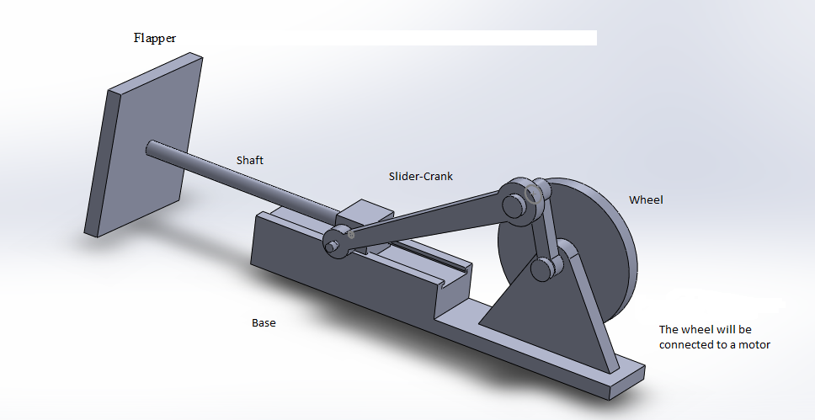

Figure 3.7: Proposed piston type wavemaker

CHAPTER 4

NUMERICAL MODEL SETUP

Numerical Wave Tank:-
In CFD, a domain of interest is modeled by discretized elements. In each element, a set of fundamental conservation equations is solved for each time step. The results in each element are then used as input for the next time step. From this method, a time dependent dynamic analysis can be simulated. There are today many different numerical schemes and numerical methods for fluid dynamics, both commercial software, open source codes and in house codes in the industry and at universities. For the commercial software, it is often combined with a nice interface, which makes it easier to perform analysis. For the open source and in house codes there might be more opportunities and easier to direct affect the solver equations but often not as easy to perform analysis due to limited interface. Therefore, most commercial software has been used for engineers in a time limited and profit based industry.

In connection with increased computer power and fast development in numerical fluid dynamic solvers, CFD analysis has been used in many new areas in the last years. A numerical wave tank (NWT) has been one of the new areas with increasing activity, especially for marine engineers. With a numerical wave tank, one can do almost similar analysis as many of the more expensive experiments performed in physical water basins. For many companies this will reduce both experimental costs and time performing analysis. Due to many numerical parameters involved in a numerical setup, CFD analysis usually has to be validated with experimental data. In the present time, CFD is not capable of taking over performing physical experiments. CFD analysis can instead reduce experimental test conditions and perform parameter studies. In this way physical experiments and CFD, analysis together can be a very effective tool and give faster andmore accurate results.

There are several different commercial CFD softwares, which are capable of wavemodeling. In the present work ANSYS Workbenchversion 13.0 has been used to modela three dimensional numerical wave tank with ANSYS DesignModeler for geometry,ANSYS Meshing for meshing and ANSYS CFX for numerical setup and solver. The method used to model the above cases is thepiston wavemaker method. The inletwall is given a specified oscillation motion similar to a wavemaker in a physical wave tank.

Numerical set-up & Input :-

Density and viscosity of water and air :-
Fluid | Density ρ  [kg/m^3] | Dynamic viscosity µ  [kg/ms]
Water | 1025 | 8.899 × ${10}^{-4}$
Air | 1.185 | 1.831× ${10}^{-5}$

Domain and mesh properties :-

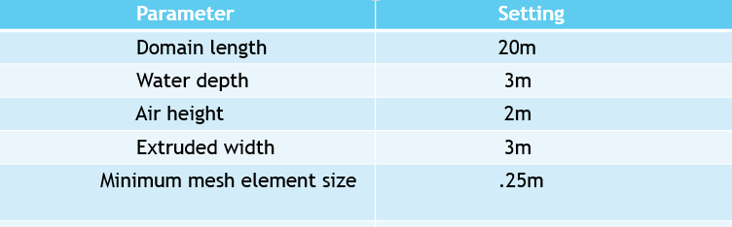

CFX SOLVER Inputs:-

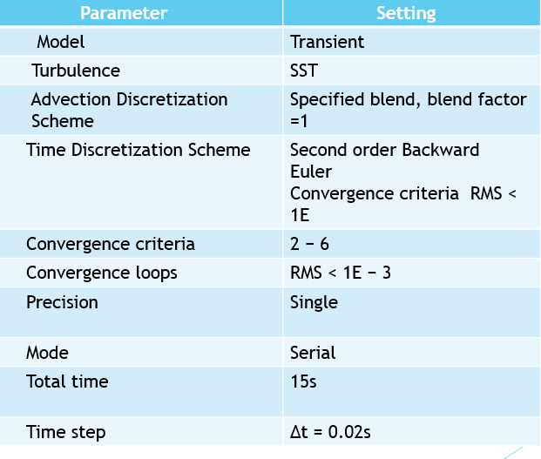

Wave input parameters :-

Where L is the wave length, h is the water depth, H is the wave amplitude, k is the wave number =$\frac{2π}{L}$ , and 𝜔 = $\frac{2π}{T}$ is the frequency.

Obstacle Dimensions:-

Circular Obstacle :-

- Centre Co-ordinates = (2,3,1.5)
- Radius = .5 m

Square Obstacle :-

Top Co-ordinates = (2,3,1), (3,3,1),(2,3,2),(3,3,2).
Edge dimension = 1 m

Simulations & Output:-

Geometry 1(Cylindrical Obstacle):-

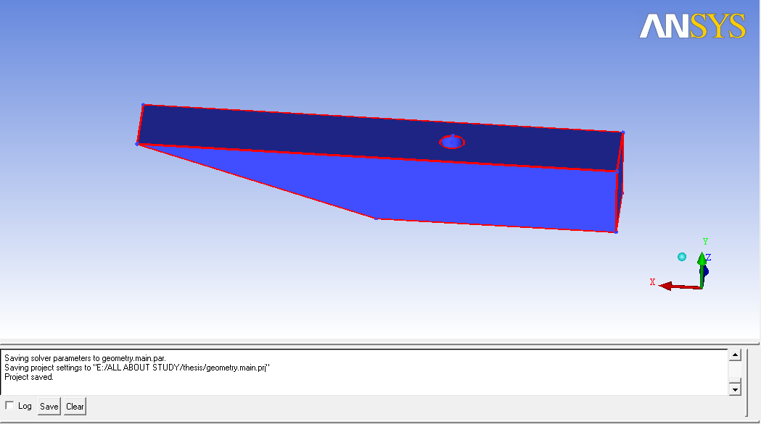
Figure:4.1

Mesh For Geometry 1 :-

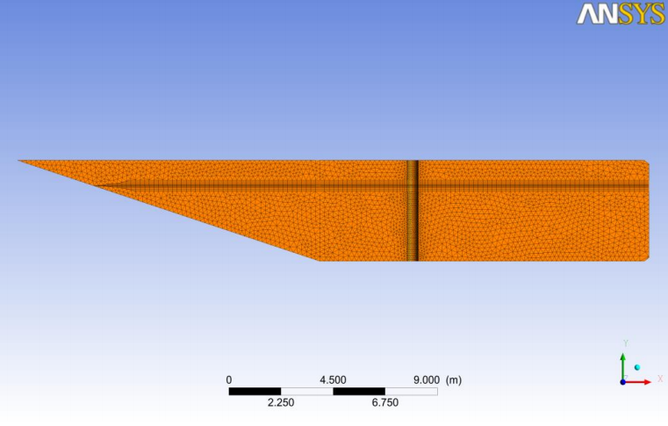
Figure:4.2

Force Distribution For Geometry 1 :-

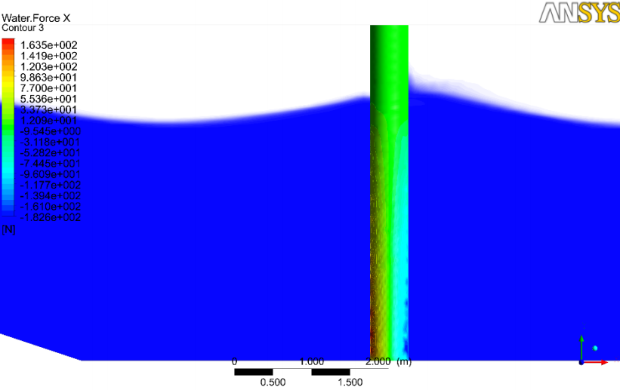
Figure:4.3

Velocity Streamline For Geometry 1 :-

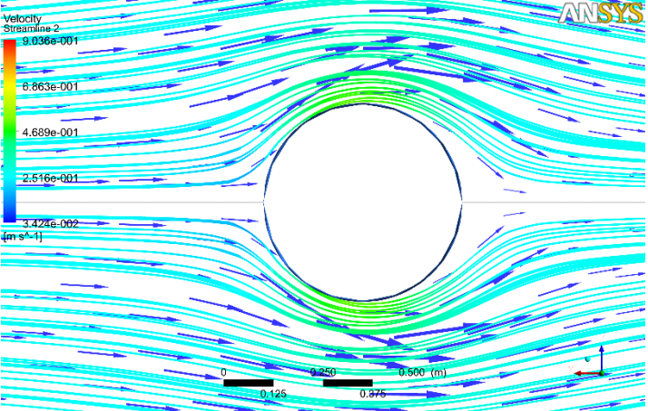
Figure:4.4

Geometry 2 (Square obstacle) :-

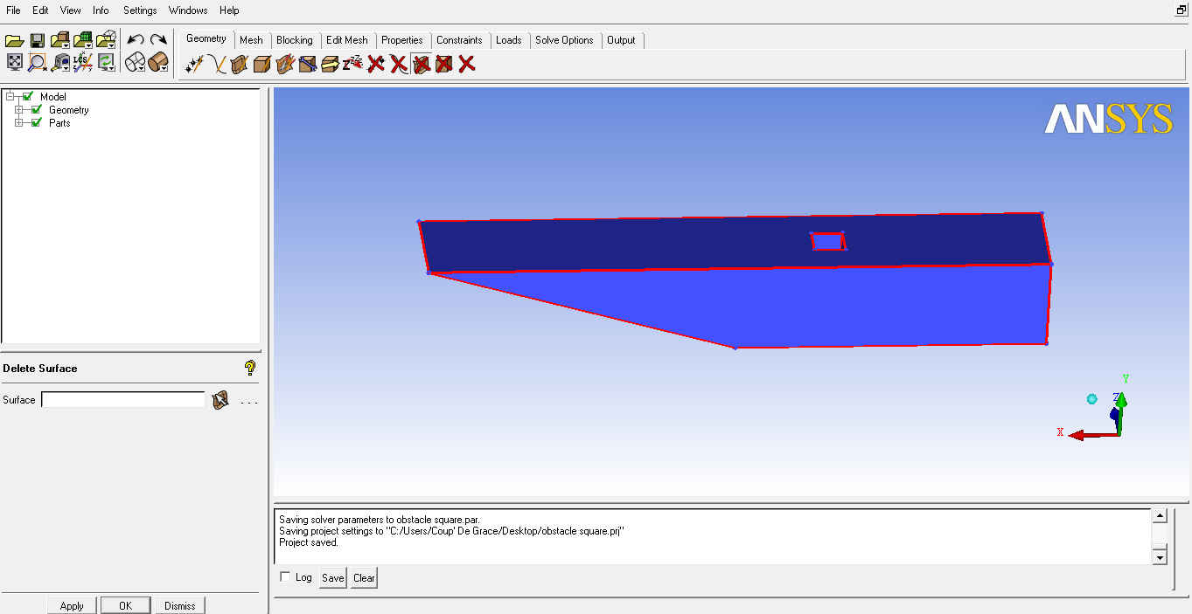
Figure:4.5

Mesh for Case 2 :-

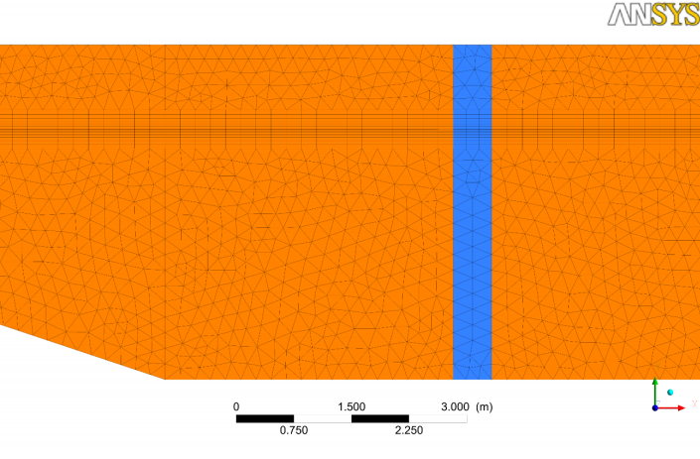
Figure:4.6

Force Distribution (Case 2):-

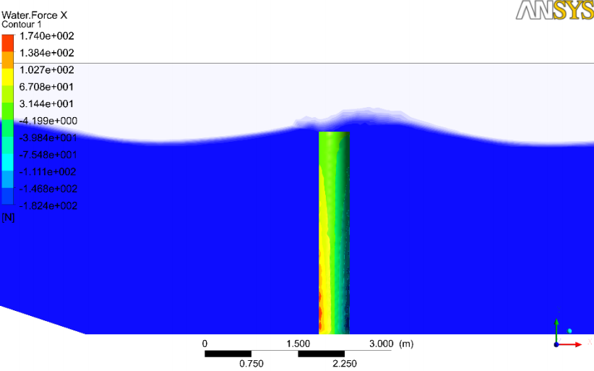
Figure:4.7

Velocity Streamline For Case 2 :-

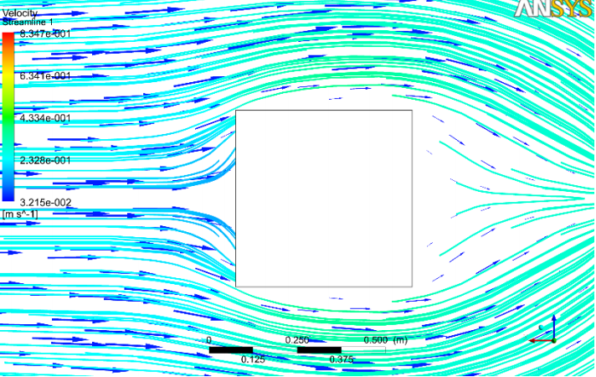
Figure:4.8

Conclusion :-
In this project we simulated wave impact on a cylindrical and a square shaped obstacles in CFX 14.0.We also worked on building a physical model and finding out practical results. All the drawings and meshing was done in ICEM-CFD. Due to lack of time we could not finish the practical setup. The version of ANSYS used is 13.We considered the flow is turbulent.
The modeled numerical wave tank from chapter 4 has been used to study wave forces on the two cases- a round shaped cylindrical monopole and a square shaped monopole.We observed difference of force distribution and velocity distribution on each obstacle.

It is clearly seen that, more yellow area is found in square shape obstacle than cylindrical obstacle which indicates high force distribution on those areas.The red areas indicates critical zone.

References :-
1. Finnegan, W. and J. Goggins, Numerical simulation of linear water waves and
wave–structure interaction. Ocean Engineering, 2012. 43(1): p. 23-31.
2. Silva, M.C., et al. Numerical Simulation of monochromatic wave generated in
laboratory: Validation of a CFD code. 2010. Rio de Janeiro: 23 Congresso
Nacional de Transporte Aquaviário, Construção Naval e Offshore.
3. Pengzhi, L., Numerical Modeling of Water Waves. 2008, New York: aylor &
Francis Routledge.
4. Chakrabarti, S.K., Handbook of Offshore Engineering. 2005, Plainfield, Illinois,
USA: Elsevier.
5. Mo, W., et al., A 3D Numerical Model for Computing Non-breaking Wave Forces
on Slender Piles. Journal of Engineering Mathematics 2005: p. 1-14.
6. Hughes, S.A., Physical Models and Laboratory Techniques in Coastal
Engineering. World Scientific, 1993. 7(1): p. 1-17.
7. Chakrabarti, S., Offshore Structures Modeling. World Scientific, 1994. 1(1): p.
50-62.
8. Coastal Landscapes: Forms and Processes. 2014 [cited 2014; Available from:
http://clasfaculty.ucdenver.edu/callen/1202/Landscapes/KarCoast/Coastal/Coast
alLandscapes.htm.
9. Hasselmann, S., et al., The WAM model—a third generation ocean wave
prediction model. J. Phys. Oceanogr, 1988. 1(18): p. 1775–1810.
10. Tolman, H.L., User manual and system documentation of WAVEWATCH-III
version 1.18. 1999, Environmental Modeling Center: Washington D C. p. 1-22.
11. Ris, R.C., N. Booij, and L.H. Holthuijsen, A third-generation wave model for
coastal regions, Part II, Verification. J. Geophys. Res., 1999. 104: p. 7649–7666.
12. Eckart, C. The propagation of gravity waves from deep to shallow water. 1952.
USA: Proceedings of the NBS Semicentennial Symposium on Gravity Waves.
13. Dingemans, M., Water Wave Propagation Over Uneven Bottoms. Vol. 13. 1997,
Delft: World Scientific.
14. Randall, D., The Shallow Water Equations. 2006, Colorado State University: Fort
Collins.
15. Tu, J., G. Heng Yeoh, and C. Liu, Computational Fluid Dynamics: A Practical
Approach. 2008, Burlington: Elsevier.
16.ANSYS CFX Release 13. 2011, -: ANSYS-Inc.

