
HOPE ONLINE PHARMACY SYSTEM
SUMMITTED:
MOHAMED KAFI AHAMADA ALI 160040015
ASHRAF GAMAL HASAN HATEM 160040001
SANI USMAN AMINU 154305

SUPERVISED BY:
NJAYOU YOUSSOUF
Lecturer, Department of Computer Science and Engineering (CSE)

ISLAMIC UNIVERSITY OF TECHNOLOGY (IUT) ORGANISATION OF THE ISLAMIC COOPERATION (OIC) 1704,BOARD BAZAR, GAZIPUR, DHAKA BANGLADESH
NOVEMBER, 2019

CERTIFICATION

This is to clarify that this report ebodies the original work done ( HOPE ONLINE PHARMACY SYSTEM ) by Mohamed Kafi Ahamada Ali, Ashraf Gamal Hasan Hatem and Sani Usman Aminu respectively. We have successifully completed our Final year project in computer Science and engineering Department oF Islamic university of Technology Dhaka, Bangladesh. Project submitted by us is here by approved.

SUPERVISOR: STUDENT SIGNATURE:
Name: NJAYOU YOUSSOUF MOHAMED KAFI AMADA ALI
Signature: ASHRAF GAMAL HASAN HATEM
Date: SANI USMAN AMINU

ACKNOWLEGMENT

We are grateful to Almighty ALLAH (S.W.A) for the good health wellbeing and sparing our lives that is necessary in taking our endeavor to a successful culmination
We wish to express our sincere thanks to the department for providing us with all the necessary facilities for research
We also place on record our sincere thank you to the Head of department for the continuos encouragement and support thank you sir!
We are also grateful to Njayou Youssouf lecturer in the Department of computer science and engineering. We are extremly thankful and indebted to him for sharing expertise, sincere valuable guidance and encouragement extended to us we really appreatiate it thank you The satisfaction that accompanies the successful completion of any task would have been incomplete without the mention of people whose ceaseless cooperation made it possible,whos constant guidance and encouragement made it possible. We have to thank our parent for their endless love,support,prayers and guidance throughout our life. a big Thank you both for giving us the strength to reach the stars and chase our dreams.

ABSTRACT

This project is a online pharmacy system for an existing pharmacies.The project objective Is to deliver the online shopping application into online pharmacy.

This project is an attempt to provide the advantage of online shopping to customers of real shop. It helps buying the medicine online in the pharmacy anywhere through the use of internet and a web browser.

Thus the customer will get the service of online shopping and home delivery from his favorite pharmacy. This system can be implemented to any pharmacy in the locality or to multinational branded pharmacy.

If pharmacies are providing an online portal where their customers can enjoy easy shopping from anywhere, the pharmacy won’t be losing any more customers to the trending online pharmacy such as flipcart or ebay Since the application is in web platform and can easily be accessible and
always available.

Over all this project of ours is being developed to help pharmacies to easily sell available medicines from anywhere in the best possible way and reduce the human efforts.

Table of contents
Chapter 1
- Introduction
- application
- Modules
- Administrator
- User
Chapter 2
- System analysis
- Existing system
- Proposed system
- System requirements
- General description
- System objectives
- function requirements
- Non functional requirements
- Feasibility study
- Technical feasibility
Chapter 3
- Data Base
- System Tools
- Front End
- Back End
- E-R Diagram
- Data Flow Diagrams(DFD)
- Screen Shoots
- Sample Code
- Project Analysis
- Conclution

Chapter 1

1. INTRODUCTION
The main aim of the project is the management of the database of the pharmaceutical shop. This is done by creating a database of the available medicines in the shop. The database is then connected to the main program by using interconnection of the Visual Basic program and the database already created.

2. APPLICATION

This program can be used in any pharmaceutical shops having a database to maintain. The software used can generate reports, as per the user’s requirements. The software can print invoices, bills, receipts etc. It can also maintain the record of supplies sent in by the supplier.

3. MODULES:
The system after careful analysis has been identified to be presented with the following modules and roles.

The modules involved are:

1. Administrator
2. Users

4. The administrator is the super user of this application. Only admin can have access into the admin page. Admin may be the owner of the shop.The administrator has all the information about all the users and about all products.
1. Manage Products
2. Manage Orders

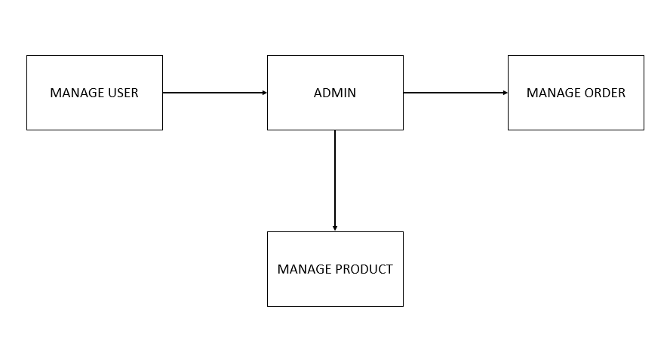
FIG 1.1 ADMIN MODULE

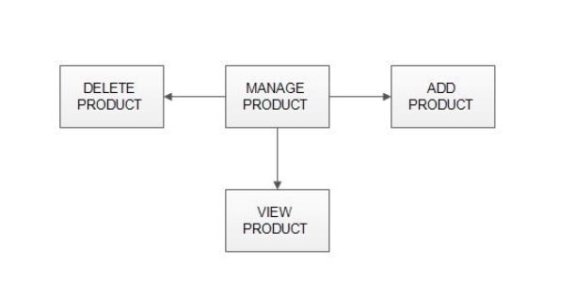
FIG 1.2 MANAGE PRODUCT

Add Products:
The shopping cart project contains different kind of products.The products can be classified into different categories by name
Admin can add new products into the existing system with all its details including an image

Delete Products:
Administrator can delete the products based on the stock of that particular product.

View products:
Admin will have a list view of all the existing products. He can also search for a particular product by name

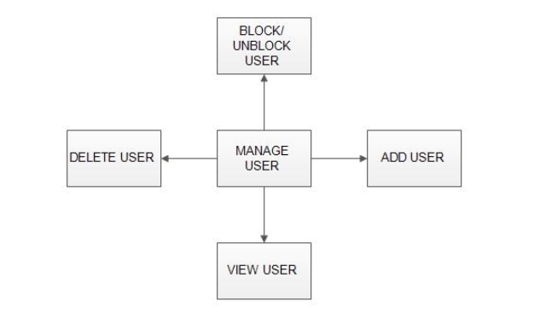

FIG 1.3 MANAGE USER
VIEW USER:
Admin will have a list view of all the users registered in the system.admin can view all the details of each user in the list except password.
ADD USER:
Admin has privileges to add a user directly by providing the details.
DELETE USER:
Administrator has a right to delete user.
BLOCK/UNBLOCK USER:
Administrator have the right to block and ublock user.

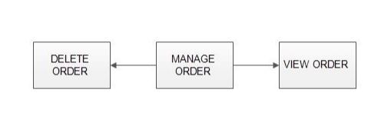

FIG 1.4 MANAGE ORDERS

View Order:
Administrator can view the Orders which is generated by the users. He can verify the details of the purchase.
Delete order:
Admin can delete order from the orders list when the product is taken for delivery.

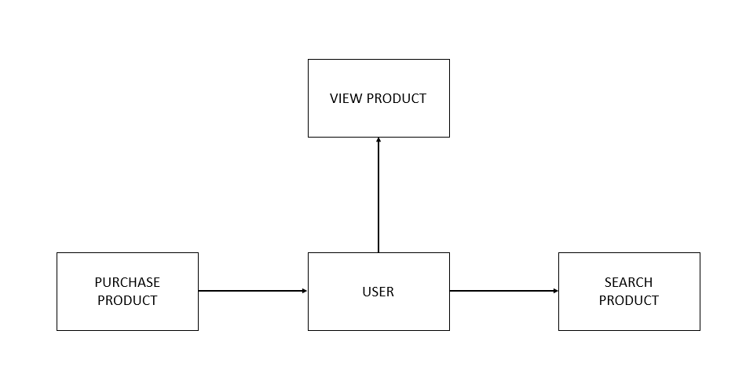

FIG 1.5 USER MODULE

5. User
A new user will have to register in the system by providing essential details in order to view the products in the system
Login
A user must login with his user name and password to the system after registration.
View Products
User can view the list of products based on their names after successful login. A detailed description of a particular product with product name, products details, product image, price can be viewed by users.
Search Product
Users can search for a particular product in the list by name.
Add to cart:
The user can add the desired product into his cart by clicking add to cart option on the product. He can view his cart by clicking on the cart button. All products added by cart can be viewed in the cart. User can remove an item from the cart by clicking remove

Submit Cart: After confirming the items in the cart the user can submit the cart by providing a delivery address.On successful submitting the cart will become empty.

Chapter 2

1. SYSTEM ANALYSIS

It is the most creative and challenging phase of the system life cycle. The analysis phase is used to design the logical model of the system whereas the design phase is used to design the physical model.
Many things are to be done in this phase .we began the designing process by identifying forms, reports and the other outputs the system will produce. Then the specify data on each were pinpointed. we sketched the forms or say, the displays, as expected to appear, on paper, so it serves as model for the project to began finally we design the form on computer display, using one of the automated system design tool.
After the forms were designed, the next step was to specify the data to be inputted, calculated and stored individual data items and calculation procedure were written in detail. File structure such as paper files were selected the procedures were written so as how to process the data and procedures the output during the programming phase. The documents were design ion the form of charts.
Output design means what should be the format for presenting the results. It should be in most convenient and attractive format for the user. The input design deals with what should be the input to the system and thus prepare the input format. File design deals with how the data has to be stored on physical devices. Process design includes the description of the procedure for carrying out operations on the given data.

2. EXISTING SYSTEM
The current system for shopping is to visit the pharmacy manually and from the available medicine choose the item patient want and buying the item by payment of the price of the item.
1- It require more Paper work
2- Less secure
3- User take more efforts so process is time consuming

3. PROPOSE SYSTEM

1. Less time consuming
2. Secure process
3. Less paper work
4. Manual efforts are overcome

4. System Requirements

The system services and goals are established by consultation with system user. They are then defined in details and serve as a system specification. System requirement are those on which the system runs.
Hardware Requirements:
1. Computer with either Intel Pentium processor or AMD processor.
2. 128MB DDR RAM
3. 40GB hard disk drive

Software Requirements:
1. Text editor – Sublime Text 3
2. PHP
3. Mysql
4. Javascript
5. Jquery
6. Bootstrap
7. HTML
8. Style Sheets (CSS)

6. FUNCTIONAL REQUIREMENTS
USER
1-USER LOGIN:
Description of feature This feature used by the user to login into system. A user must login with his user name and password to the system after registration. If they are invalid, the user not allowed to enter the system.
Functional requirement - Username and password will be provided after user registration is confirmed. - Password should be hidden from others while typing it in the field
2-REGISTER NEW USER
Description of feature A new user will have to register in the system by providing essential details in order to view the products in the system.
Functional requirement - System must be able to verify and validate information. - The system must encrypt the password of the customer to provide security
3-PURCHASING AN ITEM
Description of feature The user can add the desired product into his cart by clicking add to cart option on the product. He can view his cart by clicking on the cart button. All products added by cart can be viewed in the cart. User can remove an item from the cart by clicking remove. After confirming the items in the cart the user can submit the cart by providing a delivery address. On successful submitting the cart will become empty.
Functional requirement - System must ensure that, only a registered customer can purchase items.
ADMIN
MANAGE USER
Description of feature
The administrator can add user, delete user, view user and block user.
.
MANAGE PRODUCTS
Description of feature
The administrator can add product, delete product and view product.
MANAGE ORDERS
Description of feature The administrator can view orders and delete orders.
Functional requirements The system must identify the login of the admin. -Admin account should be secured so that only owner of the shop can access that account
7. NON FUNCTIONAL REQUIREMENTS
i. EFFICIENCY REQUIREMENT
When an online shopping cart android application implemented customer can purchase product in an efficient manner.
ii. RELIABILITY REQUIREMENT
The system should provide a reliable environment to both customers and owner. All orders should be reaching at the admin without any errors.
iii. USABILITY REQUIREMENT
The android application is designed for user friendly environment and ease of use.
iv. IMPLEMENTATION REQUIREMENT
Implementation of the system using css and html in front end with jsp as back end and it will be used for database connectivity. And the database part is developed by mysql. Responsive web designing is used for making the website compatible for any type of screen.
v. DELIVERY REQUIREMENT
The whole system is expected to be delivered in 10 months of time with

8. Feasibility Study
A feasibility analysis involves a detailed assessment of the need, value and practicality of a proposed enterprise, such as systems development. The process of designing and implementing record keeping systems has significant accountability and resource implications for an organization. Feasibility analysis will help you make informed and transparent decisions at crucial points during the developmental process to determine whether it is operationally, economically and technically realistic to proceed with a particular course of action.

Most feasibility studies are distinguished for both users and analysts. First, the study often presupposes that when the feasibility document is being prepared, the analyst is in a position to evaluate solutions. Second, most studies tend to overlook the confusion inherent in system development – the constraints and the assumed attitudes.

9. Operational feasibility
People are inherently resistant to change, and computers have been known to facilitate change. An estimate should be made of how strong a reaction the user staff is likely to have toward the development of a computerized system. It is common knowledge that computer installations have something to do with turnover, transfers, retraining, and changes in employee job status. Therefore, it is understood that the introduction of a candidate system requires special effort to educate, sell and train the staff on new ways of conducting business.
10. Technical feasibility

Technical feasibility centers around the existing computer system (hardware, software, etc.) and to what extend it can support the proposed addition. For example, if the current computer is operating at 80 percent capacity – an arbitrary ceiling – then running another application could overload the system or require additional hardware. This involves financial considerations to accommodate technical enhancements. If the budget is a serious constraint, then the project is judged not feasible.

Chapter 3
1. DATABASE DESIGN:
Databases are the storehouses of data used in the software systems. The data is stored in tables inside the database. Several tables are created for the manipulation of the data for the system. Two essential settings for a database are
Primary key- the field that is unique for all the record occurrences.
Foreign key -the field used to set relation between tables.
Normalization is a technique to avoid redundancy in the tables.
2. SYSTEM TOOLS:
The various system tools that have been used in developing both the front end and the back end of the project are being discussed in this chapter.
3. FRONT END:
1-JSP,
2-HTML,
3-CSS,
4-JAVA SCRIPT &
5-BOOSTRAP.
are utilized to implement the frontend

Java Server Pages (JSP)
Different pages in the applications are designed using jsp. A Java Server Pages component is a type of Java servlet that is designed to fulfil the role of a user interface for a Java web application. Web developers write JSPs as text files that combine HTML or XHTML code, XML elements, and embedded JSP actions and commands. Using JSP, one can collect input from users through web page.
HTML (Hyper Text Markup Language)
HTML is a syntax used to format a text document on the web.
CSS (Cascading Style Sheets)
CSS is a style sheet language used for describing the look and formatting of a document written in a markup language.
Java Script
JS is a dynamic computer programming language. It is most commonly used as part of web browsers, whose implementations allow client-side scripts to interact with the user, control the browser, communicate asynchronously, and alter the document content that is displayed.
Java Script is used to create pop up windows displaying different alerts in the system like “User registered successfully”, ”Product added to cart” etc
4. BACK END:
The back end is implemented using MySQL which is used to design the databases.
MySQL
MySQL is the world's second most widely used open-source relational database management system (RDBMS).The SQL phrase stands for Structured Query Language.
An application software called xampp was used to design the tables in MySQL.

5. E-R DIAGRAMS

LOGIN

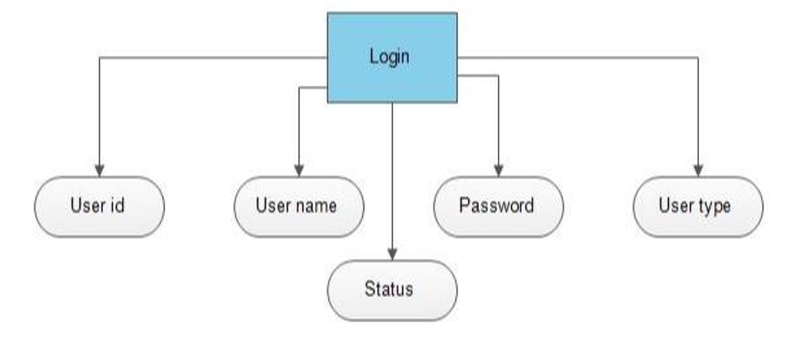

FIG 3.1: LOGIN
USER DETAILS

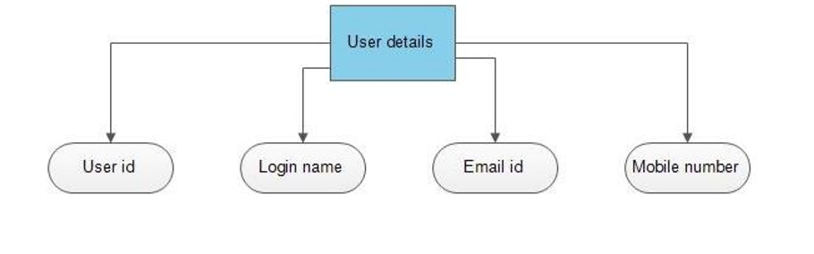

FIG 3.2: USER DETAILS

PRODUCTS DETAILS

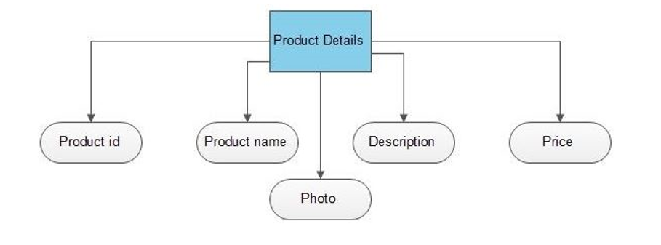

FIG 3.3: PRODUCT DETAILS

PRODUCT ORDERS

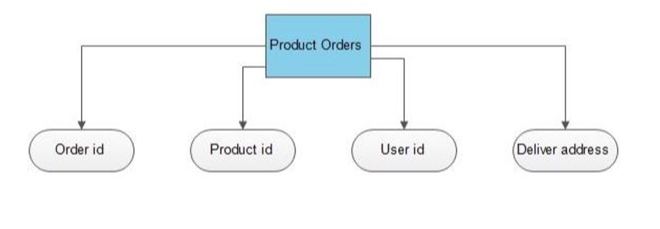
FIG.3.4: PRODUCT ORDERS

E-R DIAGRAM

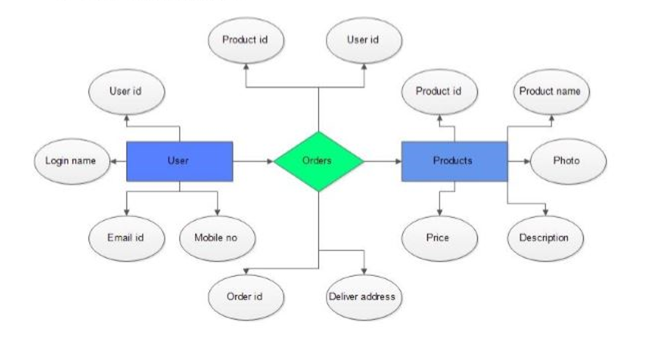

FIG.3.5: E-R DIAGRAM

6. DATA FLOW DIAGRAM
A Data Flow Diagram (DFD) is a structured analysis and design tool that can be used for flowcharting. A DFD is a network that describes the flow of data and the processes that change or transform the data throughout a system. This network is constructed by using a set of symbols that do not imply any physical implementation.It has the purpose of clarifying system. requirements and identifying major transformations. So it is the starting point of the design phase that functionally decomposes the requirements specifications down to the lowest level of detail. DFD can be considered to an abstraction of the logic of an information-oriented or a process-oriented system flow-chart. For these reasons DFD’s are often referred to as logical data flow diagrams
EXTERNAL ENTITY
An external entity is a source or destination of a data flow. Only those entities which originate or receive data are represented on a data flow diagram. The symbol used is a rectangular box.
PROCESS
A process shows a transformation or manipulation of data flow within the system. The symbol used is an oval shape.
DATAFLOW
The data flow shows the flow of information from a source to its destination. Data flow is represented by a line, with arrowheads showing the direction of flow. Information always flows to or from a process and may be written, verbal or electronic. Each data flow may be referenced by the processes or data stores at its head and tail, or by a description of its contents.
DATA STORE
A data store is a holding place for information within the system: It is represented by an open ended narrow rectangle. Data stores may be long-term files such as sales ledgers, or may be short-term accumulations: for example batches of documents that are waiting to be processed. Each data store should be given a reference followed by an arbitrary number.

LOGIN DFD

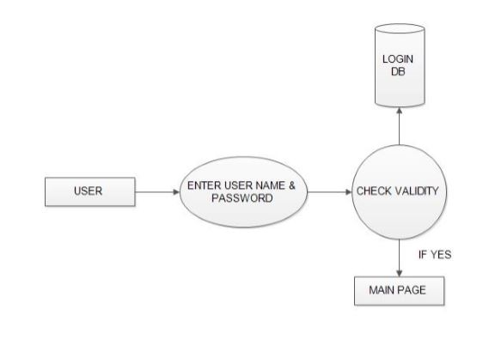

FIG 3.6: LOGIN DFD

REGISTRATION DFD

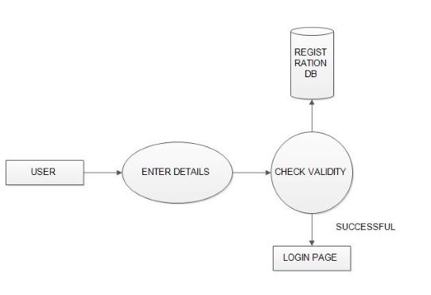

FIG 3.7 REGISTRATION DFD

ADMIN DFD

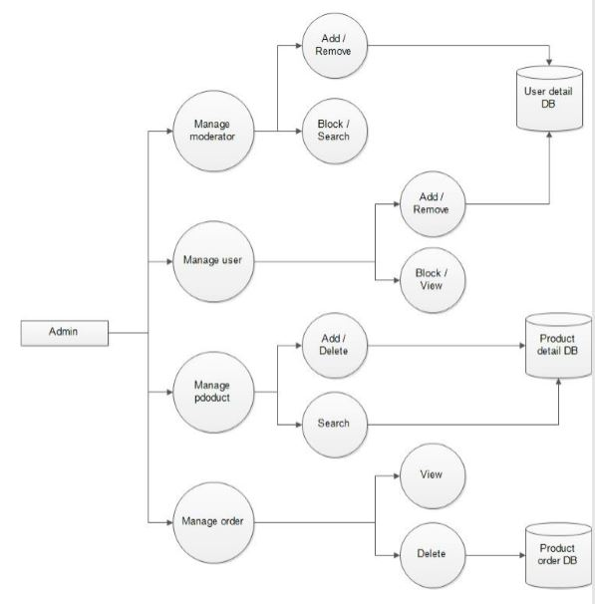
FIG 3.8: ADMIN DFD

7. Screenshoot:
DATA BASE
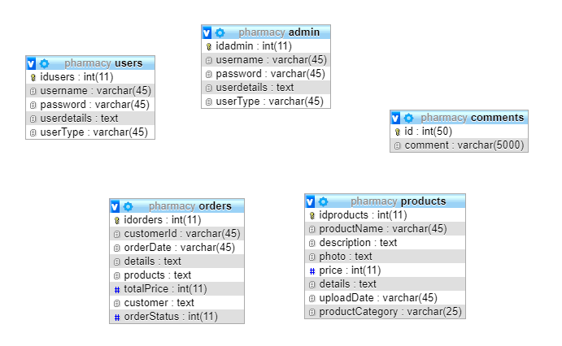

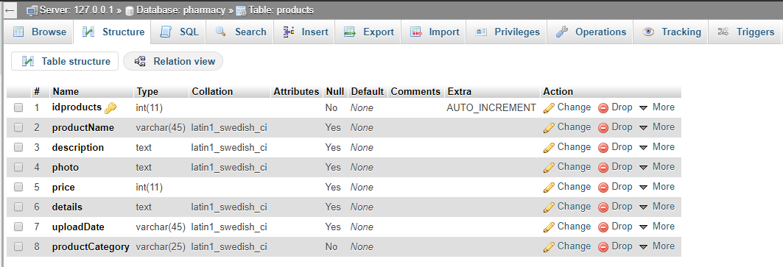

USERS LOGIN AND REGISTER

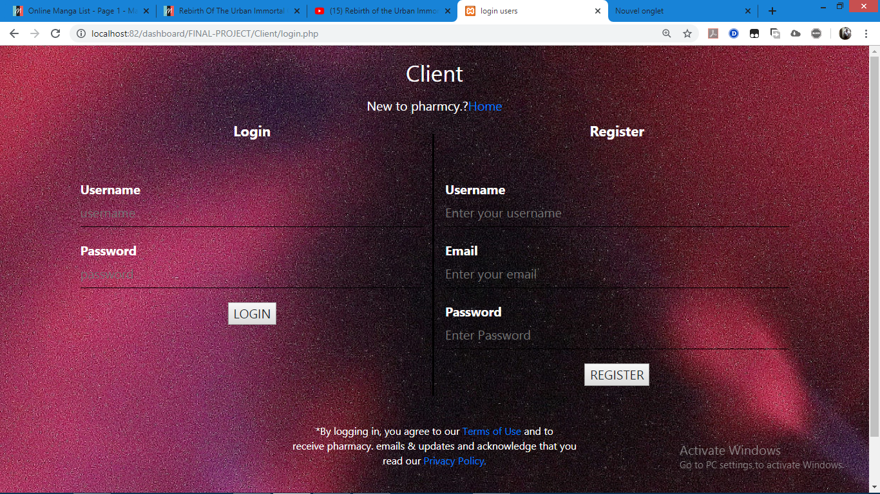

.

8.SAMPLE CODE:

INDEX

<?php

include('functions.php');

?>

<!DOCTYPE html>

<html>

<head>

<meta charset="UTF-8">

<meta name="viewport" content="width=device-width,innitial-scale=1.0">

<meta http-equiv="X-UA-compatible" content="ie-edge">

<link rel="stylesheet" href="css1/main.css">

<link rel="stylesheet" href="css1/style.css">

<link rel="stylesheet" href="css1/bootstrap.css">

<link rel="stylesheet" href="dropdownmyStyl.css">

<title>Index</title>

</head>

<body>

<div class="wrap">

<div class="slide">

<p><?php include('slideshow.php');?></p>

</div>

</div>

</div>

</body>

</html>

MEDICINE

<?php

//boots=medicine

$boots = getCategoryProducts("boots");

if(!empty( $boots)) {

?>

<div class="container mt-5" style="clear: both;">

<div class="main_body">

<h1 class="label_coming">PRODUCT</h1>

</div>

<div class="clr"></div> <div class="row" >

<?php foreach ($boots as $product) { ?>

<div class="col-lg-3 ">

<div class="trending-img">

<img src="img/uploads/<?php echo($product['photo']); ?>" alt="Card image cap">

<button type="button" class="btn-buy"><a href="product.php?id=<?php echo($product['idproducts']); ?>" title="">Buy Now</button>

<div class="overlay"></div>

<div class="card-body" id="c-body">

<h4 class="card-title">

<a href="product.php?id=<?php echo($product['idproducts']); ?>" title="">

<?php echo($product['productName']); ?>

</a>

</h4>

<p class="card-text"><a href="#" ><?php echo($product['price']); ?> tk</a></p>

</div>

</div>

</div>

<?php } ?>

</div>

<?php } ?>

FUNCTION

<?php

session_start();

$servername = "localhost";

$username = "root";

$password = "";

$db = "pharmacy";

$conn = new mysqli($servername, $username, $password, $db);

if ($conn->connect_error) {

die("Connection failed: " . $conn->connect_error);

}

function message($message, $type) {

$_SESSION['msg']['body'] = $message;

$_SESSION['msg']['type'] = $type;

}

function getCategoryProducts($cartegory, $limit = 100) {

$cats = array();

$sql = "SELECT * FROM products WHERE productCategory= '{$cartegory}' limit {$limit}";

$results = $GLOBALS['conn']->query($sql);

while ($pro = $results->fetch_assoc()) {

array_push($cats, $pro);

}

;

return $cats;

}

function fetchUser($userId) {

$sql = "SELECT * FROM users WHERE idusers ='{$userId}' LIMIT 1";

$res = $GLOBALS['conn']->query($sql);

$user = $res->fetch_assoc();

return $user;

}

?>

ADD CART

<?php

include("../functions.php");

$sql = "SELECT * FROM products WHERE idproducts = '{$_GET['id']}'";

$res = $conn->query($sql);

$pro = $res->fetch_assoc();

$_SESSION['cart'][$pro['idproducts']] = $pro;

message("Product was added to cart successfully","success");

header("Location: ../medicine.php"); //shop.php

?>

DELETE PRODUCT

<?php

include "../functions.php";

$id = $_GET['id'];

$sql = "SELECT * FROM products WHERE idproducts = '{$id}'";

$re = $conn->query($sql);

$data = $re->fetch_assoc();

$photo = "img/uploads/" . $data['photo'];

if (file_exists($photo)) {

unlink($photo);

}

$sql = "DELETE FROM products WHERE idproducts = '{$id}'";

if ($conn->query($sql)) {

message("Product was deleted successfully.", "success");

} else {

message("Something went wrong while deleting the product. Please try again.", "danger");

}

header("Location: staff.php");

?>

PLACE THE ORDER

<?php

include("../ functions.php");

$order['customerId'] = $_SESSION['user']['idusers'];

$order['customer'] = $_SESSION['user'];

$order['products'] = $_SESSION['cart'];

$customers = json_encode($_SESSION['user']);

$products = json_encode($order['products']);

$products= $conn->real_escape_string($products);

$order['orderDate'] = time();

$details = $conn->real_escape_string(json_encode($order));

$tot = 0;

foreach($_SESSION['cart'] as $item) { $tot += $item['price']; }

$order['totalPrice'] = $tot;

$sql = "INSERT INTO orders (

customerId,

details,

orderDate,

products,

customer,

totalPrice

) VALUES (

'{$order['customerId']}',

'{$details}',

'{$order['orderDate']}',

'{$products}',

'{$customers}',

'{$order['totalPrice']}'

)";

if($conn->query($sql)){

unset($_SESSION['cart']);

message("Your order was placed successfully","success");

header("Location: profile.php");

die();

}else{

die($sql);

message("Something went wrong while placing your order. Please try again.","danger");

header("Location: medicin_page_1.php");

}

/*

customerId

details

idorders

orderDate

products

*/

?>

HOME PAGE DISCRIPTION

<script>

var images = ["images/s1.jpg", "images/s2.jpg", "images/s3.jpg","images/s4.jpg"];

var i = 1;

var max = images.length;

function changeImage(){

document.getElementById("slider").src = images[i++];

if(i==max){

i=0;

}

}

setInterval(function(){changeImage()}, 3000);

</script>

<p align="center"><img src="images/s1.jpg" class="slide" width="100%" id="slider" align="center"></p>

<span style="">

<a href="#" title=" " class="" id="Home"><img src="images/logo.png" class="bg-blue" id="img" height="200" alt=""></a>

<p>Our aim has always been <br>

to bring world–class medical(medicine)<br>

care within the reach of common man.</p>

<br> <br>

<?php

include('dropdown.php');

?>

</span>

9. Project analysis
In this stage we gather the information from the different sources for project development. The methods of collecting information are:
- Observations
- Viewing of documents and manuals from different online pharmacy

10. Conclusion and Future Scope

- Detailed information gathering has to be done. Without that the purpose for using the software wont be satisfied properly.
- However it can give good profits in the long run.
- Implementing the software requires change in the business practices.
- Efficient organization of all knowledge is the analysis company and easy analysis access and retrieval of information is possible.
- In this project we can also include BAR CODE facility using the bar code reader, which will detect the expiry date and the other information about the related medicines.
- Company using this software will always be able to plan in future and always be aware of their financial position in the market.
- It leads to streamling of business processes.
- The implementation and maintence costs run very high (about 2 to 3 % of the company’s revenue.)
- This software aims at reducing paper work & provide multiple facilities to user with less efforts and Accessing the Portal according to choice & availability

