A LAWN MOWER MACHIN
OR
Grass Cutting Machine

SUBMITTED BY MOUNJOUONPOU YAYA ID 160010007
MAHOUD A. M. NASSAR ID 141305
ABDALLAH N.M ABUKASHER ID 16001003

UNDER THE SUPERVISION OF
Md. Abdul Karim Miah
LECTURERDEPARMENT OF MECHANICAL ENGINEERING
ISLAMIC UNIVERSITY OF TECHNOLOGY (IUT)
November - ©2019

Islamic University of Technology (IUT)
Organization of Islamic cooperation (OIC)

Contents
Table of Figures 1
ACHNOWLEGMENT 2
ABTRACT 3
Chapter 1: Introduction 4
IMPORTANCE OF THE STUDY 4
RESEARCH PROBLEM STATEMENT 4
OBJECTIVES OF THE STUDY 5
Project Motivation 5
Project Goals and Objectives 5
Scope and limitation of the study 6
System Requirements 6
Specifications 7
Vehicle Requirements 7
Limitations 8
METHODOLOGY 8
Chapter 2: LITERATURE REVIEW 10
INTRODUCTION: 10
TYPES OF LOWN MOWERS 16
BY ROTATION 16
CYLINDER OR REEL MOWERS 16
Rotary mowers 18
BY ENERGY SOURCE 18
OTHER NOTABLE TYPES 20
Feature Selection 22
Related Works 23
Chapter 3: RESEACH DESIGN 24
INTRODUCTION 24
FRAME WORK OF RESEARCH 24
Mechanical Overview 26
Framework for dada collection 27
DESIGN TEAM 27
COMPLETE SYSTEM OPERATION 27
System requirement 30
Chapter 4: Data collection and analysis 48
PERFORMANCE FACTORS 51
Chapter 5: CONCLUSION NAD FUTURE WORK 52
APPLICATION 52
ADVANTAGES 52
LIMITATION 52
FUTURE WORK 53
CONCLUSION 53
References 54

Table of Figures
Figure 1 Project circuit diagram 9
Figure 2: first types of lawn mower 11
Figure 3: Henderson new horse lawn mower 13
Figure 4: The first gasoline power lawn mower 14
Figure 5: The first drive lawn mower 15
Figure 6: Cylinder lawn mower 17
Figure 7: Rotary lawn mower 19
Figure 8: Riding lawn mower 21
Figure 9: Frame of the project 26
Figure 10: Machine overview 26
Figure 11: NRF24L01 Transceiver module 34
Figure 12: Arduino Uno 34
Figure 13: Arduino Nano 35
Figure 14:H-Brige l298 36
Figure 15: DC Gear motor 36
Figure 16:DC motor 37
Figure 17:Joystick 38
Figure 18:Switch 38
Figure 19:UPS Battery 39
Figure 20: Electrical Circuit 40
Figure 21: Electrical Design 42
Figure 22:Aduino program 45
Figure 23:Arduino programming 46
Figure 24:Arduino programming 46
Figure 25:Arduino programming 47

ACHNOWLEGMENT
First and foremost, I would like to thank Allah the almighty who makes all things possible and givingus the patience in completing this research project.
I would like to express my sincere gratitude to my supervisorMd. Abdul Karim Miah for all his endless efforts supporting, patience, understanding and believe in me. Indeed, his advice and guidance has made this thesis a success
I would to thank our teacher in the department of mechanical and chemical engineering for their support and guidance given for the completion of this project.In addition, we wish to thank our dearest family members, friends, lecturers and the department of Computer Science and Engineering of Islamic University of Technology (IUT) for their support and understanding in difficult times.
We would like to convey our deep gratitude and appreciation to the Bachelor of Science students of Islamic University of Technology (IUT) for their guidance and valuable suggestion regarding this study.
Finally, our special thanks to everyone who contributed in one way or the other towards the successful completion of our thesis.

ABTRACT
A remote controlled solar lawn mower is a device which reduces the work load on humans for trimming lawn. Rapid growth of various high-tech tools and equipment makes our work comfortable, accurate and time efficient. This project considers the implementation of a device which can be operated wirelessly with the help of a remote. In this report, I discuss the feasibility and design of a remote-controlled platform to be used in conjunction with a push lawnmower. It works on the principle of DC motor. When current from battery given to motor, motor shaft will start rotating. To the shaft two tyre is connected which also rotates. Another motor is connected to center of the base located at lower side of the lawn mower base. From this cutting blade is connected which cut the grass with respect to cutting speed of motor.
The movement of the mower and speed of the mower may be controlled by remote. By handling this task autonomously, the user is free to relax and be worry free about their lawn. This project improves upon existing designs using advanced technologies to efficiently perform is dedicated task. To accomplish its task, this project has a specific set of goals which are to be easy to use, accurate, and efficient. This paper summarizes and reviews different technological developments for making efficient and cost effective lawn mowers In-depth design and construction will begin once school re-convenes and engineering.

Chapter 1: Introduction

IMPORTANCE OF THE STUDY
A lawn mower is a machine that uses cutting blades or strings to trim lawn at an even height. The working principle of a lawn mower is: High speed of rotation of cutting blades provide the force required for effective and accurate trimming of lawn. Lawn mowers have become very essential in our daily life. More and more lawn mowers have been manufactured and used in the last few years. When we put all this together, a lot of power is being consumed by lawn mowers. Also, we can observe that lawn mowers have been the cause for a lot of air and noise pollution around the globe. This has led to consumers seeking for ways to reduce and solve their own carbon footprints. Also, there are government regulations limiting the pollution level of the device to a certain maximum level, which is decreasing over the years.
Our four-member project team have observed this, and decided to design and fabricate a remote-controlled lawn mower, which not only reduces air and noise pollution and dependence on non-renewable energy sources, but also reduces the work load on laborers and speeds up the work. This lawn mower integrates a conventional lawn mower, remote controlled operation and a storage unit for collecting trimmed lawn. We have incorporated all these features in our lawn mower at the lowest price possible, without compromising much on quality of the product. We hope to see this device as the future of lawn mowers around the globe in the years to come.

RESEARCH PROBLEM STATEMENT
Grass cutter machines have become very essential to our daily living in maintaining the yards. Furthermore, environmental awareness on usage of grass cutting machines has caught a great interest among consumers. As a result, consumers are searching for ways to reduce and solve their own carbon footprints. Moreover, environmental pollution keeps increasing and it can be experienced in our daily life, particularly in our homes. Based on a study, it is reported that 70% of Malaysian home citizens are utilizing fuel powered lawn mowers for their daily grass cutting routine
Thus, high maintenance is needed in order to maintain a lawn mower. For instance, one should change the fuelor oil regularly so that the lawn mower works efficiently during the process of grass cutting. Furthermore, this will in cur extra variable cost since the fuel price has been increased lately
In order to overcome these issues, an eco-friendly lawn mower needs to be designed and fabricated in order to support the green technology initiatives. In this study, a newly designed lawn mower was fabricated which powered through a rechargeable battery. Besides that, the grass cutting machine was fabricated at low cost by taking consideration on important aspects such as lightweight, durable, and environmentally friendly

OBJECTIVES OF THE STUDY
The following are the specification of this project
- To design and fabricate the lawn mower which is feasible in size.
- To design and fabricate the lawn mower which is cost effective.
- To design and fabricate the lawn mower which operates around acute areas.

Project Motivation
The primary motivation for this project is to remove the chore of mowing your lawn. By creating a lawn mower that handles this task autonomously, the user is freed from this physically demanding and time consuming task. The projected design helps those with physical limitations who could not otherwise mow their own lawn. Even without a physical limitation, the autonomous lawn mower provides the user with more free time. This freedom is provided in a worry-free platform in which little user interaction is required. Another customer basethatisinneedofthisproductisbusiness ownerswhohaverathersmallareasofgrassthatneed weeklymowing. Theycurrentlypayalargesumofmoneytohaveasmallareaofgrassmowed.The RoMow wouldallowthemtomowthatgrassquicklyandwithoutmucheffort.Thisproductcanalsobe marketedtowardspeoplewhoaretech-savvyandwouldprefertocontrola mowerremotely

Project Goals and Objectives
In keeping with the motivation behind the project, the goal of this project is to reduce end-user work through the utilization of an easy-to-use device. The autonomous design eliminates the need to go outside and mow your lawn every week. Aplatform systemcapableofremote-controlmowingwouldaddressbothoftheneedsdescribedabove. Theplatformcanbeattachedandremoved fromapushmower.Whenattached, themowercanbedriven remotely withahand-heldcontroller.Themower canalsoberolledofftheplatformandusedinatypical mannerwith nochanges,besideschangingthewheelheightandremovingtheemergencystop plug. With someaddedwork,automationisalsoattainablebutiscurrentlyoutsidethescopeoftheproject. The design of the RoMow should represent a functional product but should also express the following qualities, which are characteristic of a responsible design.

Transparency
One of the goals for this project is for it to be usable on any mower of similar make and model. For this to occur, the design must be done in such a way that makes the product easy for the general public tounderstand and use. The product should be flexible to various applications for which a customer mightuse a lawnmower. The customer should know what the RoMow is capable of and how to use it in a safeand effective way. The mechanical design should be sturdy and have the necessary safety factors built inso that the system does not fail prematurely under operating conditions.

Caring
The RoMow is designed for those who cannot easily mow their lawn, so caring is a critical aspect to thedesign. The design must be sensitive to the customers who will be using it. It should make mowing thelawn a simple task requiring little to no physical work to accomplish. Along with being easy to use, itshould also be safe. The platform should make the task of mowing the lawn no more dangerous than itwas before, and if possible make it safer.

Integrity
The design process of the RoMow shall be guided by the principle of integrity. This means that the designwill be a delightful combination of both form and function. Included in this idea is that the design of theRoMow will make operation by the user intuitive. There shouldn’t be any and will not be any differencebetween expectations and reality.

Scope and limitation of the study

System Requirements
The system described in this report has to take into account different aspects such as motion, speed, direction of travel, maintain motion in a straight line, re-alignment in case of going off track, determination of when and where to turn, amongst others.
The robot is expected to maintain constant speed around the garden area; this speed should not be very fast as it should be able to accomplish its main purpose, which is of cutting grass. During motion it is important that the device is kept in a straight line (in the forward path) and able to turn at a 180 degrees angle at the extremity of the garden in order to continue with the same motion in the opposite direction and adjacent to the previous path taken. Figure 23 illustrates the path that the robot is to follow and the limit where it is required to turn. The robot should be able to re-align itself and continue through the path in the case of it going off track.
A simple approach taken in tackling the problem is to have poles positioned in the garden area as the limits. It was chosen that the poles could be a stick independent of any electronics which could either be purchased or found in the garden area, the dimensions on the other hand is to be determined. The robot once switched on would start off looking for the poles. Once the distance from the poles is determined, the robot would then be required to establish its current location in the garden area, where it has to go in order to initiate its motion in the desired path (as shown in Figure 23) whilst mowing.
During motion of the robot, it is important that some feedback is given to the system in order to ensure that the correct path is being followed and that there are no errors in accomplishing the task, for this reason a sensor would be required. It is necessary to account for possible errors or inaccuracies that the sensor may provide under different conditions. More attention during selection process of the relevant sensor(s) is paid to its performance under different weather conditions, due to the fact that the robot is required to operate outdoors, where many disturbances are present.
The disturbances in this case can originate either from varying temperatures to the amount of sunlight present, both aspects which may impact the overall system performance and ability to fulfil its requirements.
Other aspects considered include the external design of the robot, shape and size, grass cutting blades specifications, number of motors required and application of good motor control. All of these components would enable the robot to accomplish the task of cutting grass and its mobility around the garden.

Specifications
A motor mechanism that would provide different viewing angles to the robot is required and this method was chosen as an economic alternative to having an array of sensors for the same task. The cost of having one sensor and a motion mechanism for it, to that of an array of sensors is more than halved therefore contributing to a lower cost end product.
Selection of two motors (where the wheels are attached) that would enable the vehicle motion to be controlled was made due to the fact that each wheel can be controlled independently; consequently a close to perfect 180 degree rotation can be made possible at the end of a forward motion track. This can be achieved by controlling one motor to stop, whilst the other makes a 180 degree rotation, meaning that the vehicle will be able to turn suitably adjacent to its previous motion path.

Vehicle Requirements
Selection of a two-wheeled vehicle was made due to the fact that it enables for the robot to be more flexible. The flexibility relates to the motion around the track such as the 180 degree rotation required for the vehicle to position itself directly adjacent to its previous track. For example if the vehicle comes to the end of a forward path and it is to change to an adjacent path. The other consideration made for the vehicle is positioning of the blades that will cut the grass, these will need to be positioned such that it can efficiently cover the garden area through one motion cycle; that is without the vehicle having to go through a motion path moree than once. Considerations are also made to the dimensions of the moving wheels of the vehicle, as the surface are covered by the wheels play an important role in ensuring that the vehicle is able to run in a straight line with being easily drifted. Wheels that cover a smaller surface area, especially with grass and sand, would normally drift to one side, whilst those with greater cover can overcome this issue and help in reducing the amount of drift

Limitations
One of the limitations of the design method is the distance determination, which includes precision and maximum distance that can be determined by the sensor. As the system relies on the information captured by the sensor, its malfunction or failure may render the entire system useless. The garden shape and dimensions also constitute a limiting factor for the system described on the present report; the reasoning behind this resides on the motion pattern chosen. For instance if the

METHODOLOGY

The steps followed for the design of lawn mower is represented in the form of a flowchart as depicted in the figure below.
- The system would be required to be made such that it follows a certain path and more efficient cutting pattern.
- A garden area limiting method that can be of long term, resistant life cycle and more cost effective; that is a better solution than that of the guide wire.
- Good cutting methodology
- More cost effective sensor array arrangement that would enable for obstacle and garden limit determination.
- Use of a four wheeled vehicle opposed to any other number would enable to the robot to easily navigate around the track.
- Opposed of the robot relying on additional electronics set in the garden area; it should be chosen that all electronics are onboard and that the device is able to determine all relevant.
The methodology for this project is similar to the prototype analysis process. In this project we used remote control lawn mower.
The methodologies of these attachments are explained in few sub- headings.
- Components of attachment
- Working of remote control grass cutter
  - Component of Attachment
The main components of the solar powered grass cutter are,
- Batteries
- Circuitry
- Mechanism used
- Blades
- Tyres
- PVC pipes
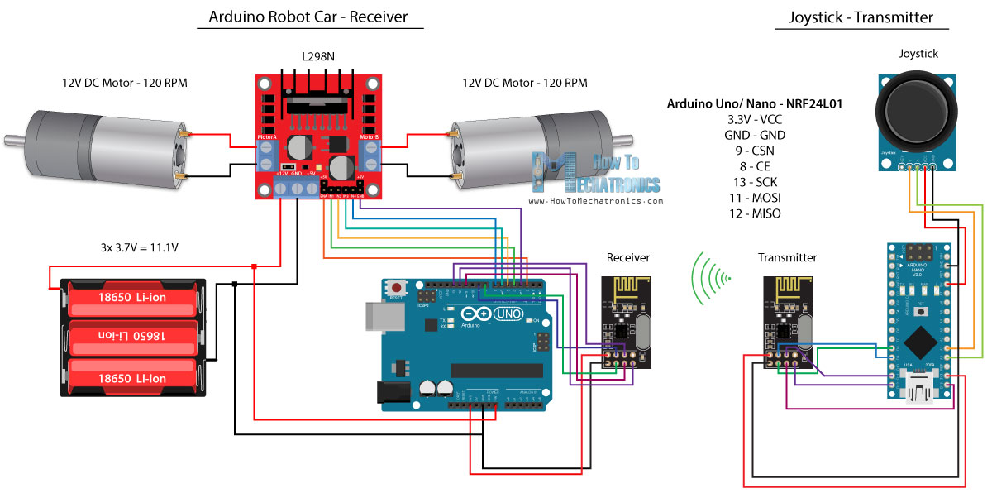
Figure 1 Project circuit diagram

Chapter 2: LITERATURE REVIEW

INTRODUCTION:
A lawn mower (mower, etc.) is a machine utilizing one or more revolving blades to
cut a grass surface to an even height. The height of the cut grass may be fixed by
The design of the mower, but generally is adjustable by the operator, typically by a
single master lever, or by a lever or nut and bolt on each of the machine's wheels.
The blades may be powered by muscle, with wheels mechanically connected to the
cutting blades so that when the mower is pushed forward, the blades spin, or the
machine may have a battery-powered or plug-in electric motor. The most common
power source for lawn mowers is a small (typically one cylinder) internal
combustion engine, particularly for larger, self-propelled mowers. Smaller mowers
often lack any form of propulsion, requiring human power to move over a surface;
"walk-behind" mowers are self-propelled, requiring a human only to walk behind
and guide them. Larger lawn mowers are usually either self-propelled "walkbehind"
types, or more often, are "ride-on" mowers, equipped so the operator can
ride on the mower and control it. A robotic lawn mower ("lawn-mowing bot",
"mowbot", etc.) is designed to operate either entirely on its own, or less commonly
by an operator by remote control.
Many lawn mowers include other functions such as mulching the cut grass or collecting their grass clippings in a removable bag or bin.
Two main styles of blades are used in lawn mowers. Lawn mowers employing a single blade that rotates about a single vertical axis are known as rotary mowers, while those employing a cutting bar and multiple blade assembly that rotates about a single horizontal axis are known as cylinder or reel mowers (although in some versions, the cutting bar is the only blade, and the rotating assembly consists of flat metal pieces which force the blades of grass against the sharp cutting bar).
There are several types of mowers, each suited to a particular scale and purpose. The smallest types, unpowered push mowers, are suitable for small residential lawns and gardens. Electrical or piston engine-powered push-mowers are used for larger residential lawns (although there is some overlap). Riding mowers, which sometimes resemble small tractors, are larger than push mowers and are suitable for large lawns, although commercial riding lawn mowers (such as zero-turn mowers) can be "stand-on" types, and often bear little resemblance to residential lawn tractors, being designed to mow large areas at high speed in the shortest time
possible. The largest multi-gang (multi-blade) mowers are mounted on tractors and are designed for large expanses of grass such as golf courses and municipal parks, although they are ill suited for complex terrain requiring maneuverability A transition from traditional hand-guided or ride-on mowers to automatic electric mowers is beginning to take place in some regions, with the growth in robotic lawn mower sales of 2012 being 15 times the growth in sales of the traditional styles. At current rates of growth automated lawn mowers may soon outsell traditional mowers in those regions. Invention The first lawn mower was invented by Edwin Budding in 1830 in Thrupp, just outside Stroud, in Gloucestershire, England. Budding's mower was designed primarily to cut the grass on sports grounds and extensive gardens, as a superior alternative to the scythe, and was granted a British patent on August 31, 1830.Budding's first machine was 19 inches (480 mm) wide with a frame made of wrought iron.
The mower was pushed from behind. Cast iron gear wheels transmitted power from the rear roller to the cutting cylinder, allowing the rear roller to drive the knives on the cutting cylinder; the ratio was 16:1. Another roller placed between the cutting cylinder and the main or land roller could be raised or lowered to alter the height of cut. The grass clippings were hurled forward into a tray-like box. It was soon realized, however, that an extra handle was needed in front to help pull the machine along. Overall, these machines were remarkably similar to modern mowers. Two of the earliest Budding machines sold went to Regent's Park Zoological Gardens in London and the Oxford Colleges. In an agreement between John Ferrabee and Edwin Budding dated May 18, 1830, Ferrabee paid the costs of enlarging the small blades, obtained letters of patent and acquired rights to manufacture, sell and license other manufacturers in the production of lawn mowers. Without patent, Budding and Ferrabee were shrewd enough to allow other companies to build copies of their mower under license, the most successful of these being Ransomes of Ipswich, which began making mowers as early as 1832. His machine was the catalyst for the preparation of modern-style sporting ovals, playing fields (pitches), grass courts, etc. This led to the codification of modern rules for many sports, including for football, lawn bowls, lawn tennis andothers

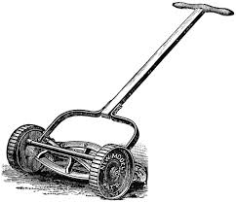

Figure 2: first types of lawn mower

It took ten more years and further innovations to create a machine that could be drawn by animals, and sixty years before a steam-powered lawn mower was built. In the 1850s, Thomas Green & Son of Leeds introduced a mower called the Silens Messor (meaning silent cutter), which used a chain drive to transmit power from the rear roller to the cutting cylinder. These machines were lighter and quieter than the gear driven machines that preceded them, although they were slightly more expensive. The rise in popularity of lawn sports helped prompt the spread of the invention. Lawn mowers became a more efficient alternative to the scythe and domesticated grazing animals. Manufacture of lawn mowers took off in the 1860s. By 1862, Ferrabee's company was making eight models in various roller sizes. He manufactured over 5000 machines until production ceased in 1863. The first grass boxes were flat trays but took their present shape in the 1860s. James Sumner of Lancashire patented the first steam-powered lawn mower in 1893. His machine burned petrol and/or paraffin as fuel. These were heavy machines that took several hours to warm up to operating pressure. After numerous advances, these machines were sold by the Stott Fertilizer and Insecticide Company of Manchester and Sumner. The company they both controlled was called the Leyland Steam Motor Company. Around 1900, one of the best known English machines was the Ransomes' Automaton, available in chain- or gear-driven models. Numerous manufacturers entered the field with petrol (gasoline) engine-powered mowers after the start of the 20th century. The first was produced by Ransomes in 1902. JP Engineering of Leicester, founded after World War I, produced a range of very popular chain driven mowers. About this time, an operator could ride behind animals that pulled the large machines. These were the first riding mowers.

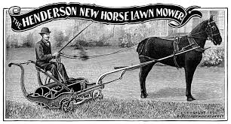
Figure 3: Henderson new horse lawn mower

The first gasoline-powered lawn mower, 1902.
It took ten more years and further innovations to create a machine that could be drawn by animals, and sixty years before a steam-powered lawn mower was built. In the 1850s, Thomas Green & Son of Leeds introduced a mower called the Silens Messor (meaning silent cutter), which used a chain drive to transmit power from the rear roller to the cutting cylinder. These machines were lighter and quieter than the gear driven machines that preceded them, although they were slightly more expensive. The rise in popularity of lawn sports helped prompt the spread of the invention. Lawn mowers became a more efficient alternative to the scythe and domesticated grazing animals. Manufacture of lawn mowers took off in the 1860s. By 1862, Ferrabee's company was making eight models in various roller sizes. He manufactured over 5000 machines until production ceased in 1863. The first grass boxes were flat trays but took their present shape in the 1860s. James Sumner of Lancashire patented the first steam-powered lawn mower in 1893. His machine burned petrol and/or paraffin as fuel. These were heavy machines that took several hours to warm up to
operating pressure. After numerous advances, these machines were sold by the Stott Fertilizer and Insecticide Company of Manchester and Sumner. The company they both controlled was called the Leyland Steam Motor Company. Around 1900, one of the best known English machines was the Ransomes' Automaton, available in chain- or gear-driven models. Numerous manufacturers entered the field with petrol (gasoline) engine-powered mowers after the start of the 20th century. The first was produced by Ransomes in 1902. JP Engineering of Leicester, founded after World War I, produced a range of very popular chain driven mowers. About this time, an operator could ride behind animals that pulled the large machines. These were the first riding mowers.

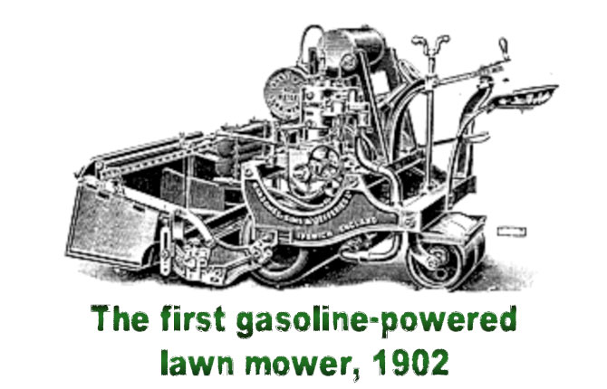

Figure 4: The first gasoline power lawn mower

The first United States patent for a reel lawn mower was granted to Amariah Hills on January 12, 1868. In 1870, Elwood McGuire of Richmond, Indiana designed a human-pushed lawn mower, which was very lightweight and a commercial success. John Burr patented an improved rotary-blade lawn mower in 1899, with the wheel placement altered for better performance. Amariah Hills went on to found the Archimedean Lawn Mower Co. in 1871. In the United States, gasoline powered lawn mowers were first manufactured in 1914 by Ideal Power Mower Co. of Lansing, Michigan, based on a patent by Ransom E. Olds. Ideal Power Mower also introduced the world's first self propelled, riding lawn tractor in 1922, known as the "Triplex." The roller-drive lawn mower has changed very little since around 1930.Gang mowers, those with multiple sets of blades to cut a wider swath, were built in the United States in 1919 by the Worthington Mower Company.

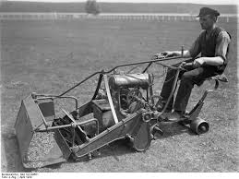

Figure 5: The first drive lawn mower

Atco Ltd and the first motor mower
In the 1920s one of the most successful companies to emerge during this period was Atco, at that time a brand name of Charles H Pugh Ltd. The Atco motor mower, launched in 1921 was an immediate success. Just 900 of the 22-inch-cut machines were made in 1921, each costing £75. Within five years, annual production had accelerated to tens of thousands. Prices were reduced and a range of sizes was available, making the Standard the first truly mass-produced enginepoweredmower.
Rotary mowers were not developed until engines were small enough and powerful enough to run the blades at sufficient speed. Many people experimented with rotary blade mowers in the late 1920s and early 1930s, and Power Specialties Ltd. introduced a gasoline-powered rotary mower. Kut Kwick replaced the saw blade of the "Pulp Saw" with a double-edged blade and a cutter deck, converting the "Pulp Saw" into the first ever out-front rotary mower. One company that produced rotary mowers commercially was the Australian Victa company, starting in 1952. Its mowers were lighter and easier to use than similar ones that had come before. The first Victa mowers were made at Mortlake, an inner suburb of Sydney, by local resident Mervyn Victor Richardson. He made his first model out of scrap in his garage and then moved to a shed behind St Mary's Church of England, where the first Victa mowers were manufactured, going on sale on 20 September 1952. The new company, Victa Mowers Pty Ltd, was incorporated on 13 February 1953.
The venture was so successful that by 1958 the company moved to much larger premises in Parramatta Road, Concord, and then to Milperra, by which time the mower incorporated an engine, designed and manufactured by Victa, which was specially designed for mowing, rather than employing a general-purpose engine bought from outside suppliers. Two Victa mowers, from 1958 and 1968 respectively, are held in the collection of the National Museum of Australia. The Victa mower is regarded as something of an Australian icon, appearing en masse, in simulated form, at the opening of the Sydney Olympic Games in 2000.

TYPES OF LOWN MOWERS

BY ROTATION

CYLINDER OR REEL MOWERS
A cylinder mower or reel mower carries a fixed, horizontal cutting blade at the desired height of cut. Over this is a fast-spinning reel of blades which force the grass past the cutting bar. Each blade in the blade cylinder forms a helix around the reel axis, and the set of spinning blades describes a cylinder. Of all the mowers, a properly adjusted cylinder mower makes the cleanest cut of the grass and this allows the grass to heal more quickly. The cut of a welladjusted cylinder mower is straight and definite, as if cut with a pair of scissors. This clean cut promotes healthier, thicker and more resilient lawn growth that is more resistant to disease, weeds and parasites. Lawn cut with a cylinder mower is less likely to result in yellow, white or brown discolouration as a result of leaf shredding. While the cutting action is often likened to that of scissors, it is not necessary for the blades of the spinning cylinder to contact the horizontal cutting bar. If the gap between the blades is less than the thickness of the grass, a clean cut can still be made. If more however, the grass will slip through. Reel mowers
also have more difficulty mowing over uneven terrain.
There are many variants of the cylinder mower. Push mowers have no engine and are usually used on smaller lawn areas where access is a problem, where noise pollution is undesirable and where air pollution is unwanted. As the mower is pushed along, the wheels drive gears which rapidly spin the reel. Typical cutting widths are 10 to 16 inches (410 mm). Advances in materials and engineering have resulted in these mowers being very light and easy to operate and manoeuvre compared with their predecessors while still giving all the cutting advantages of large professional cylinder mowers. Their distinct environmental benefits, both in noise and air pollution, are also a strong selling points, something not lost on many international zoos, animal sanctuaries and exclusive hotel groups.

The basic push mower mechanism is also used in gangs towed behind a tractor. The individual mowers are arranged in a "v" behind the tractor with each mower's track slightly overlapping that of the mower in front of it. Gang mowers are used over large areas of turf such as sports fields or parks.

A gasoline engine or electric motor can be added to a cylinder mower to power the cylinder, the wheels, the roller, or any combination of these. A typical arrangement on electric powered machines for residential lawns is for the motor to power the cylinder while the operator pushes the mower along. The electric models can be corded or cordless. On petrol machines the engine drives both the cylinder and the rear roller. Some variants have only three blades in a reel spinning at great speed, and these models are able to cut grass which has grown too long for ordinary push mowers. One type of reel mower, now largely obsolete, was a powered version of the traditional side-wheel push mower, which was used on residential lawns. An internal combustion engine sat atop the reel housing and drove the wheels, usually through a belt. The wheels in turn drove the reel, as in the push mower.

Greens mowers are used for the precision cutting of golf greens and have a
cylinder made up of at least eight, but normally ten, blades. The machine has a roller before and after the cutting cylinder which smooths the freshly cut lawn and minimizes wheel marks. Due to the weight, the engine also propels the mower. Much smaller and lighter variants of the roller mower are sometimes used for small patches of ornamental lawns around flower beds, and these have no engine. Riding reel mowers are also produced. Typically, the cutting reels are ahead of the vehicle's main wheels, so that the grass can be cut before the wheels push the grass over onto the ground. The reels are often hydraulically powered. The main parts of a cylinder or reel mower are:

• Blade reel/cylinder — consist of numerous (3 to 7) spiral blades that are attached to a rotating shaft. The blades rotate, creating a scissor-like cutting motion.
• Bed knife — is the stationary cutting mechanism of a cylinder/reel mower. This is a fixed horizontal blade that is mounted to the frame of the mower.
• Body frame — the main structural frame of the mower onto which the other parts of the mower are mounted.
• Wheels — these help propel the mower in action. Generally, reel mowers have two wheels.
• Push handle — the "power source" of a manually operated reel mower. This is a sturdy T-shape handle that is connected to the frame, wheels and blade chamber.
• Motor — the power source of a reel mower that is powered by gasoline or electric.

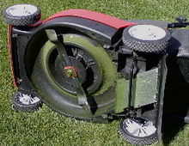

Figure 6: Cylinder lawn mower

A rotary mower (viewed from underneath), with a mulching blade that rotates
around the center.

Rotary mowers
A rotary mower rotates about a vertical axis with the blade spinning at high speed relying on impact to cut the grass. This tends to result in a rougher cut and bruises and shreds the grass leaf resulting in discoloration of the leaf ends as the shredded portion dies. This is particularly prevalent if the blades become clogged or blunt. Most rotary mowers need to be set a little higher than cylinder equivalents to avoid scalping and gouging of slightly uneven lawns, although some modern rotaries are fitted with a rear roller to provide a more formal striped cut. These machines will also tend to cut lower (13 mm) than a standard four-wheeled rotary.

The main parts of a rotary mower are:
• Cutter deck housing — this houses the blade and the drive system of the mower. It is shaped to effectively eject the grass clippings from the mower.
• Blade mounting and drive system — the blade of a rotary mower is usually mounted directly to the crankshaft of its engine, but it can be propelled by a hydraulic motor or a belt pulley system.
• Mower blade — a rotary mower generally has one blade that rotates horizontally. The blade features edges that slightly curved up to generate a continuous air flow as the blade rotates, thus creating a sucking and tearing action.
• Engine — may be powered by gasoline or electricity.
• Wheels — rotary mowers generally feature a set of four wheels; two front wheels and two rear wheels.

BY ENERGY SOURCE

Gasoline (petrol)
Most rotary push mowers are powered by internal combustion engines. Such engines are usually four-stroke engines, used for their greater torque (although a number of older models used two-stroke engines), running on gasoline (petrol) or other liquid fuels. Internal combustion engines used with lawn mowers normally have only one cylinder. Power generally ranges from two to seven horsepower (1.5 to 6.75 kW). The engines usually have a carburetor and require a manual pull crank to start them, although an electric starter is offered on some models, particularly large riding and commercial mowers. Some mowers have a throttle control on the handlebar with which the operator can adjust the engine speed.
Other mowers have a fixed, pre-set engine speed. Gasoline mowers have the advantages over electric mowers of greater power and distance range. They do create a small amount of pollution due to the combustion in the engine and their engines require periodic maintenance such as cleaning or replacement of the spark plug and air filter, and changing the engine oil.
Electricity
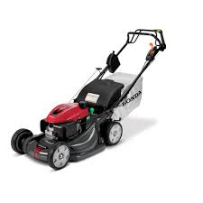
Figure 7: Rotary lawn mower

Electric mowers
Electric mowers are further subdivided into corded and cordless electric models. Both are relatively quiet, typically producing less than 75 decibels, while a gasoline lawn mower can be 95 decibels or more.[18]
Corded electric mowers are limited in range by their trailing power cord, which may limit their use with lawns extending outward more than 100–150 feet (30– 45 m) from the nearest available power outlet. There is the additional hazard with these machines of accidentally mowing over the power cable, which stops the mower and may put users at risk of receiving a dangerous electric shock. Installing a residual-current device (GFCI) on the outlet may reduce the shock risk. Cordless electric mowers are powered by a variable number (typically 1-4) of 12- volt rechargeable batteries. Typically, more batteries mean more run time and/or power (and more weight). Batteries can be in the interior of the lawn mower or on the outside. If on the outside, the depleted batteries can be quickly swapped with recharged batteries. Cordless mowers have the maneuverability of a gasoline powered mower and the environmental friendliness of a corded electric mower, but are more expensive and come in fewer models (particularly self-propelling) thaneither. The eventual disposal of worn-out batteries is problematic, and the motors in cordless mowers tend to be less powerful than gasoline motors of the same total weight (including batteries). By hand While considered antiquated in modern times, the original type of push-powered reel mowers are still available. The reel is attached to the mower's wheels by gears, so that when the mower is pushed forward, the reel spins several times faster than the rubber-tired wheels turn. These types of reel mowers offer the benefit of zero pollution being produced. Since all of the energy necessary comes from the user however, this method of mowing is the most strenuous and is not recommended for large lawns. Depending on the placement of the reel, these mowers often cannot cut grass very close to lawn obstacles, like trees, driveways, edging, etc, and also require a very smooth lawn surface to operate properly without bottoming out the cutter bar.

OTHER NOTABLE TYPES

Hover mowers are powered rotary push lawn mowers that use an impeller above the spinning blades to drive air downward, thereby creating an air cushion that lifts the mower above the ground. The operator can then easily move the mower as it floats over the grass. Hover mowers are necessarily light in order to achieve the air cushion and typically have plastic bodies with an electric motor. The most significant disadvantage, however, is the cumbersome usability in rough terrain or on the edges of lawns, as the lifting air-cushion is destroyed by wide gaps between the chassis and the ground. Hover mowers are built to operate on steep slopes, waterfronts, and high-weeded areas, so they are often used by golf course greens keepers and commercial landscapers. Grass collection is often available, but can be poor in some models. The quality of cut can be inferior if the grass is pushed away from the blade by the cushion of air.

A robotic mower is contained by a border wire around the lawn that defines the area to be mowed. The robot uses this wire to locate the boundary of the area to be trimmed and in some cases to locate a recharging dock. Robotic mowers are capable of maintaining up to 5 acres (20,000 m2) of grass. Robotic lawn mowers are increasingly sophisticated, are usually self-docking and contain rain sensors, nearly eliminating human interaction for mowing grass. Multiple robotic mowers can be used to mow an even larger area. Tractor pulled mowers are usually in the form of an attachment to a tractor. The attachments can simply function by the movement of the tractor similar to manual push cylinder mowers, but also sometimes may have a powered moving blades. They are commonly mounted on either the side or the back of the tractor.

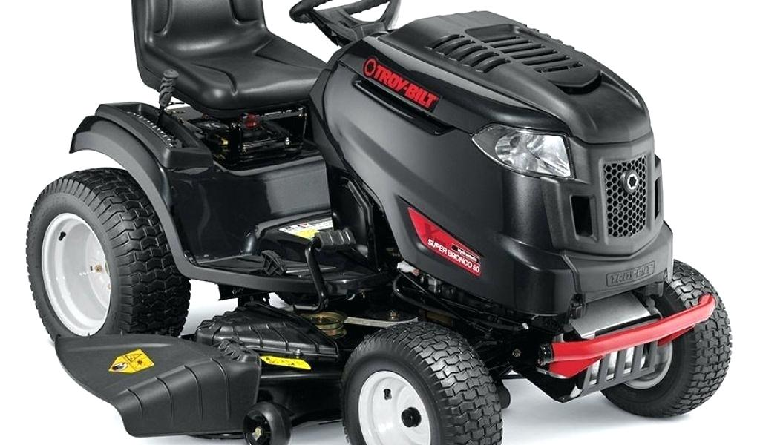

Figure 8: Riding lawn mower

Riding mowers (U.S. and Canada) or ride-on mowers (U.K. and Canada) are a popular alternative for large lawns. The operator is provided with a seat and controls on the mower and literally rides on the machine. Most use the horizontal rotating blade system, though usually with multiple blades. A common form of ride-on mower is the lawn tractor. These are usually designed to resemble a small agricultural tractor, with the cutting deck mounted amidships between the front and rear axles.
The drives for these mowers are in several categories. The most common transmission for tractors is a manual transmission. The second most common transmission type is a form of continuously variable transmission, called the hydrostatic transmission. These transmissions take several forms, from pumps driving separate motors, which may incorporate a gear reduction, to fully integrated units containing a pump, motor and gear reduction. Hydrostatic transmissions are more expensive than mechanical transmissions, but they are easier to use and can transmit greater torque to the wheels compared to a typical mechanical transmission. The least common drive type, and the most expensive, is electric.

There have been a number of attempts to replace hydrostatic transmissions with lower cost alternatives, but these attempts, which include variable belt types, e.g., MTD's "Auto Drive", and toroidal, have various performance or perception problems that has caused their market life to be short or their market penetration to be limited. Riding lawn mowers can often mount other devices, such as rototillers/rotators, snow plows, snow blowers, yard vacuums, occasionally even front buckets or forklift tines (these are more properly known as "lawn tractors" in this case, being designed for a number of tasks). The deck of a rotary mower is typically made of steel. Lighter steel is used on less expensive models, and heavier steel on more expensive models for durability. Other deck materials include aluminum, which does not rust and is a staple of higher priced mowers, and hard composite plastic, which does not rust and is lighter and less expensive than aluminum. Electric mowers typically have a plastic deck.

Riding mowers typically have an opening in the side or rear of the housing where the cut grass is expelled, as do most rotary lawn mowers. Some have a grass catcher attachment at the opening to bag the grass clippings. Mulching mowers Special mulching blades are available for rotary mowers. The blade is designed to keep the clippings circulating underneath the mower until the clippings are chopped quite small. Other designs have twin blades to mulch the clippings to small pieces. This function has the advantages of forgoing the additional work collecting and disposing grass clippings while reducing lawn waste in such a way that also creates convenient compost for the lawn, forgoing the expense and adverse environmental effect of fertilizer.

Feature Selection

Feature selection, also known as variable selection, feature reduction, attribute selection or variable subset selection, is the technique of selecting a subset of relevant features for building robust learning models.
We have preprocessed the SEER data of 2004-2013 which contain 262,423 records, which have all the available72 fields for breast cancer to remove redundancies and missing information.
The resulting data set had 106,237 records, which then pre-classified into two groups of “survived” and “not survived”.
• Supervised learning generates a function that maps inputs to desired outputs.
• Unsupervised learning models a set of inputs.
• Semi-supervised learning combines both labeled and unlabeled examples to generate an appropriate function or classifier.
• Reinforcement learning learns how to act given an observation of the world. Every action has some impact in the environment, and the environment provides feedback in the form of rewards that guides the learning algorithm.
• Transduction tries to predict new outputs based on training inputs, training outputs, and test inputs.
• Learning to learn learns its own inductive bias based on previous experience

Feature Selection Techniques

From a theoretical perspective, it can be shown that optimal feature selection for supervised learning problems requires an exhaustive search of all possible subsets of features of the
Chosen cardinality. If large numbers of features are available, this is impractical. For practical supervised learning algorithms, the search is for a satisfactory set of features instead of an optimal set. Feature selection algorithms can be classified into two broad categories: Feature ranking (FR) also called feature weighting, assesses individual features and assigns them weights according to their degrees of relevance. Many researches have been done with feature ranking as the base meth.

Related Works
Bellachia et al [2] uses the SEER data to compare three prediction models for detecting breast cancer. They have reported that C4.5 algorithm gave the best performance of 86.7% accuracy.
Delen et al [6] in their work preprocessed the SEER data for to remove redundancies and missing information. They have compared the predictive accuracy of the SEER data on three prediction models indicated that the decision tree (C5) is the best predictor with 93.6% accuracy on the holdout sample.
Endo et al [3] implemented common machine learning algorithms to predict survival rate of breast cancer patient. This study is based upon data of the SEER program with high rate of positive examples (18.5 %). Logistic regression had the highest accuracy, artificial neural network showed the highest specificity and J48 decision trees model had the best sensitivity
Kotsiantis et.al. [13] did a work on Bagging, Boosting and Combination of Bagging and Boosting as a single ensemble using different base learners such as C4.5, Naïve Bayes, OneR and Decision Stump. These were experimented on several benchmark datasets of UCI Machine Learning Repository

Chapter 3: RESEACH DESIGN

INTRODUCTION

Moving the grass cutters with a standard motor is inconvenient, and no one takes pleasure in it. Classical grass cutters with heavy engines create pollution due to the combustion in the engine. Motor powered engines require periodic maintenance such as changing the engine oils etc. If electric grass cutter is corded, moving could prove to be problematic and dangerous. Along with motor powered lawn mowers, electric lawn mowers are also hazardous and cannot be easily used by all. Also, if the electric lawn mower is corded, mowing could prove to be problematic and dangerous. The self-propelling electric remote control lawn mower is a lawn mower that has remote control capability. The main objective of our project is to develop a lawn mower which reduces human effort so that elderly users can fulfill their tasks by themselves. The working range is also increased due to absence of main supply wires.

FRAME WORK OF RESEARCH

The identification of a problem or need in the market is one of the first things we needs to do before they begin the process of designing a product. 8 new product will not besuccessful if there is no need for it in the market. 6o before the project is started, I identified couple of market and customer needs that it can address with the design of the Ro-Mow.people who are incapable of or find difficulty in using a standard push lawnmower would benefit from a product that allows their property to be taken care of without help from a third party. Another customer base that is in need of this product is business owners who have rather small areas of grass that need weekly mowing. They currently pay a large sum of money to havea small area of grass mowed. The RoMow would allow them to mow that grass quickly andwithout much effort. This product can also be marketed towards people who are tech-savvy andwould prefer to control a mower remotely.

1. Wireless electric lawn mower releases zero emissions in our lawn.
2. Rechargeable 12V battery and highly efficient motor allow the user to mow up to 100 sq. ft. of a lawn in 10 min.
3. With a highly efficient blade, users can achieve manicured lawn without the hassles of a gas-powered mower.
4. Removable battery allows users to swap in additional batteries for larger lawns.
5. it goes without frustrating starting issues with direct remote control access.
6. Adjustable height of blade with rack and pinion mechanism.
7. This mower is environmentally friendly; it runs on a 12v cordless system, which is powerful and emission-free. It is equipped with rack and pinion mechanism which can adjust the cutting height up to 2” inches. It is also light weight, making it lighter than most other battery/cordless mowers.
8. Height of cut = 0.5”

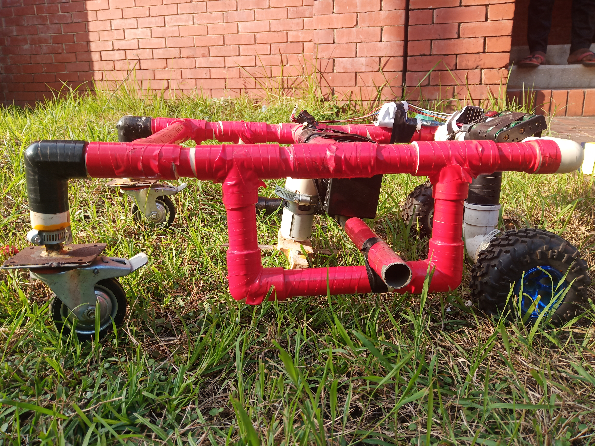
Figure 9: Frame of the project

Mechanical Overview
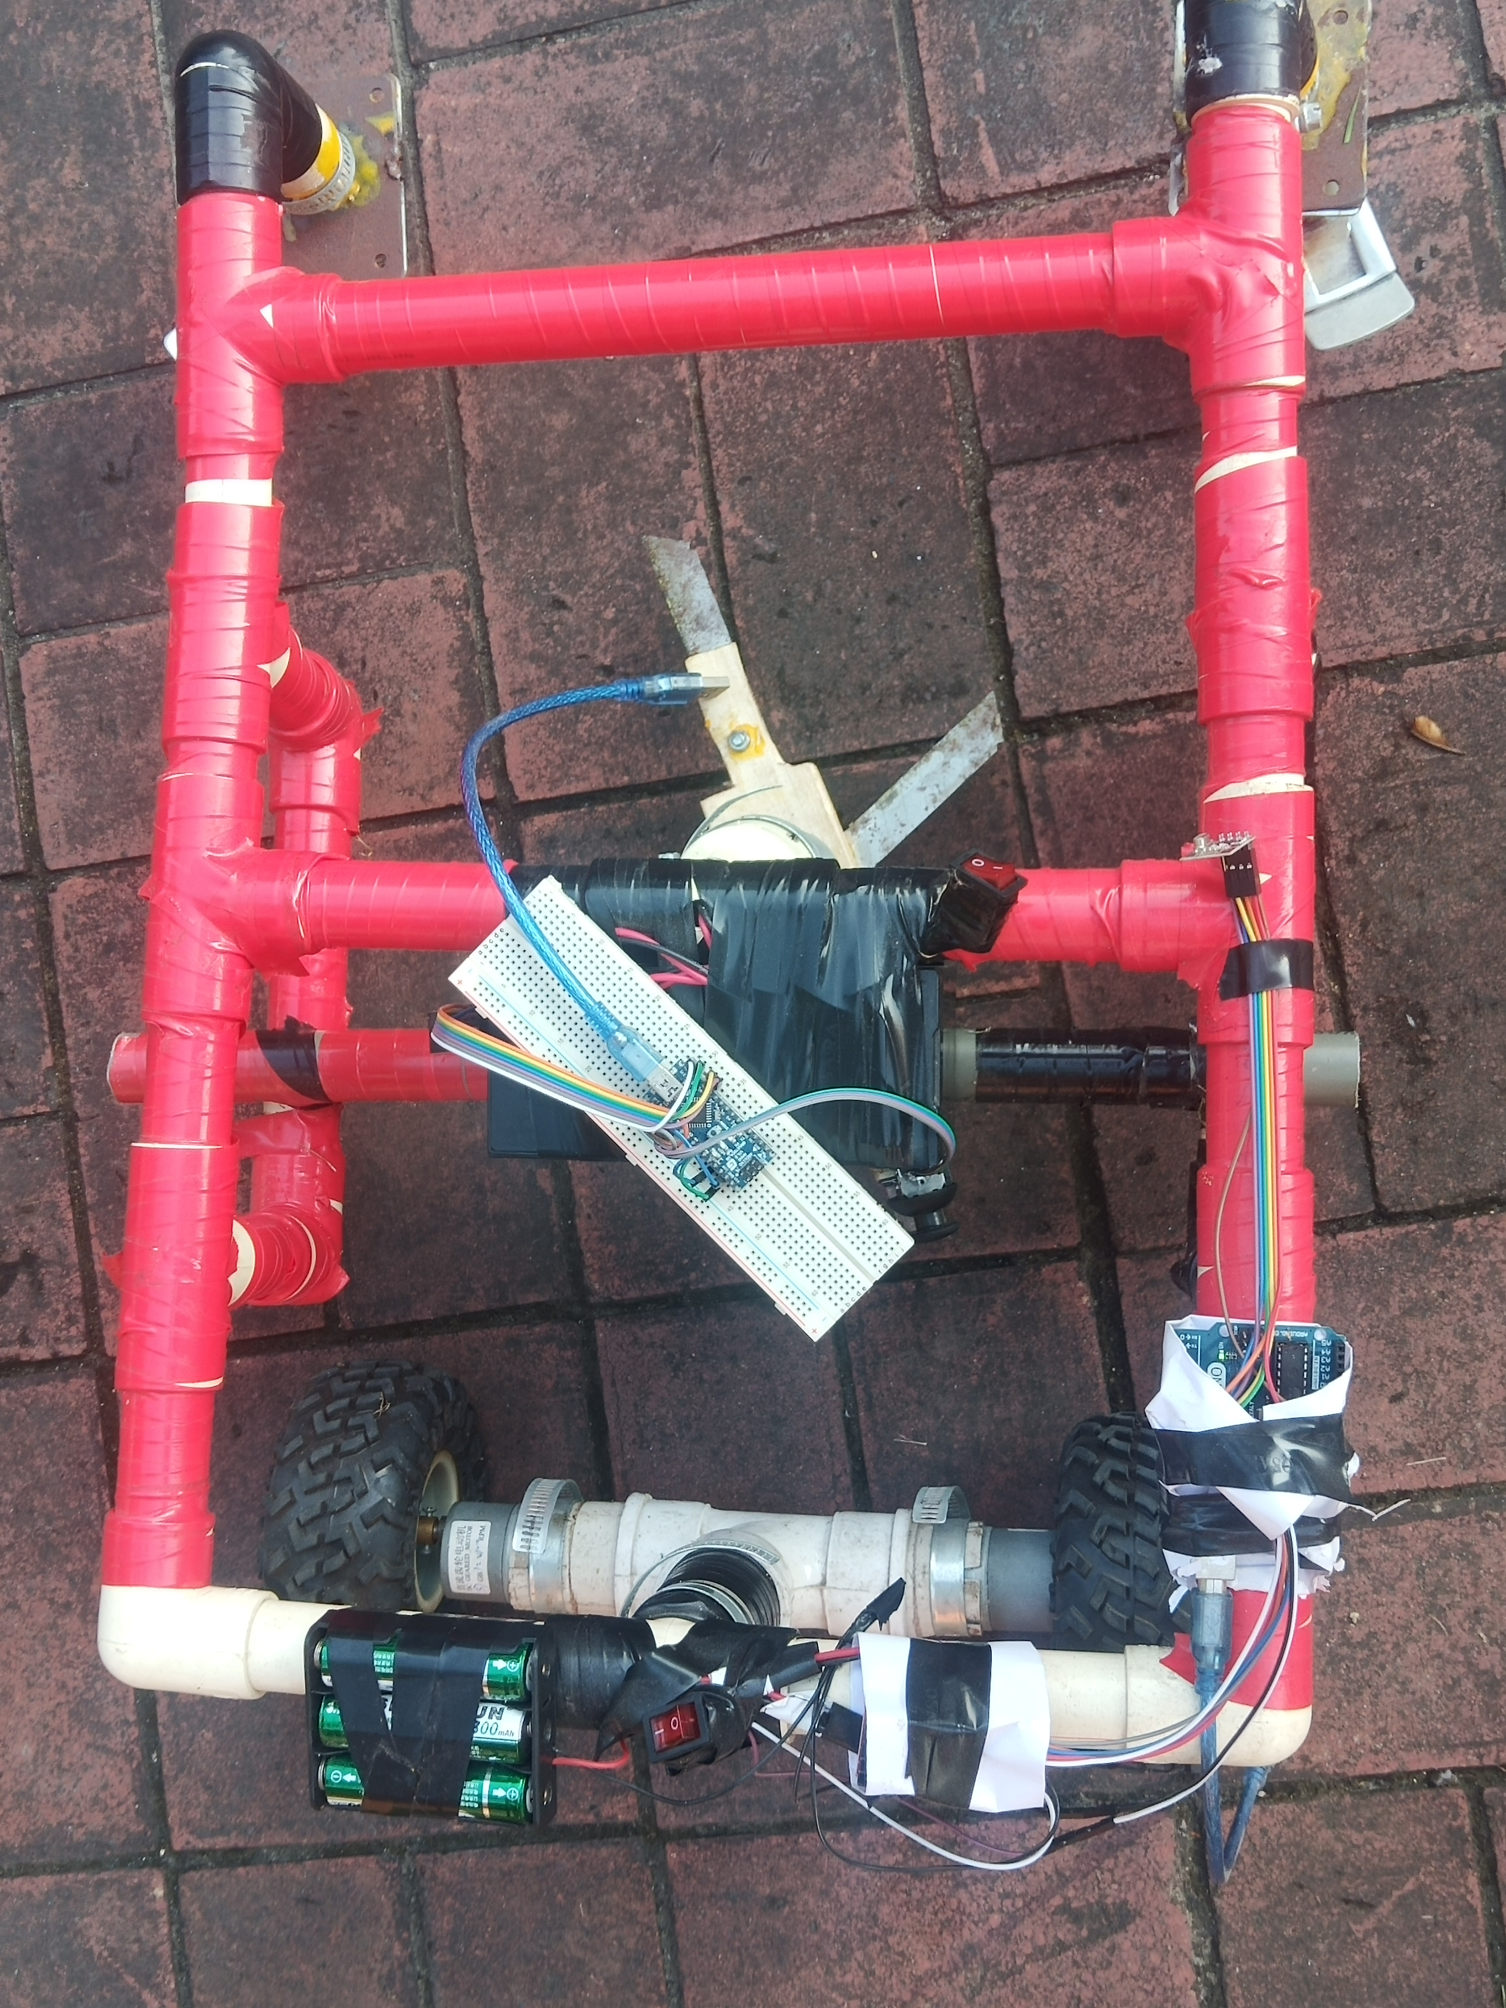
Figure 10: Machine overview

Framework for dada collection

DESIGN TEAM

The process of creating an intelligent lawnmower requires the design of several component subsystems that must be fully integrated into the completed machine. The design team consists of three mechanical engineers . The project is set up into two different categories, electrical and mechanical. The electrical engineers are responsible for providing the electrical components; the batteries, the motor, the computer and programming the control systems. The mechanical engineers are responsible for the mechanical components, the deck, the chassis, wheels, mounting brackets, and the wheel adaptors. A majority of the electrical components have been sponsored by Invacare Products, while the mechanical items have been sponsored and manufactured by MTD Products Incorporated. Throughout the design process projects are assigned according to the engineering discipline required. It is important to take a system approach to this project to ensure all subsystems are accurately integrated into a complete unit.

COMPLETE SYSTEM OPERATION
We have used five methods in our experiments which are Naïve bays, Artificial Neural Network ,logistic regression, support vector machine and Decision tree J48 we have compared the results between them among these logistic regression has better performance.
Building accurate and efficient classifiers for large databases is one of the essential tasks of data mining and machine learning research. Building effective classification systems is one of the central tasks of data mining.

Naïve Bayes

The Naive Bayes is a quick method for creation of statistical predictive models [16]. NB is based on the Bayesian theorem. This classification technique analyses the relationship between each attribute and the class for each instance to derive a conditional probability for the relationships between the attribute values and the class. During training, the probability of each class is computed by counting how many times it occurs in the training dataset. This is called the “prior probability” P(C=c). In addition to the prior probability, the algorithm also computes the probability for the instance x given c with the assumption that the attributes are independent. This probability becomes the product of the probabilities of each single attribute. The probabilities can then be estimated from the frequencies of the instances in the training set.

Decision Tree J48

Decision tree is a classifier in the form of a tree structure where each node is either a leaf node, indicating the value of the target attribute or class of the examples, or a decision node, specifying some test to be carried out on a single attribute-value, with one branch and sub-tree for each possible outcome of the test. A decision tree can be used to classify an example by starting at the root of the tree and moving through it until a leaf node is reached, which provides the classification of the instance.

Artificial Neural Network
Neural networks are capable of modeling extremely complex, typically non-linear functions [10]. It is made up of structure or a network of numerous interconnected units (artificial neurons).
Each of these units consists of input/output characteristics that implement a local computation or function. The function could be a computation of weighted sums of inputs which produces an output if it exceeds a given threshold. The output (whatever the result), could serve as an input to other neurons in the network. This process iterates until a final output is produced.

Logistic Regression

Logistic regression is considered as the standard statistical approach to modeling binary data [16]. It is a better alternative for a linear regression which assigns a linear model to each of the class and predicts unseen instances basing on majority vote of the models. During prediction, 8

instead of predicting the point estimate of the event itself, it builds a model to predict the odds of its occurrence. In two class problem for example, when the odds are greater than 50%, then the case is assigned to the class designated as “1” for YES and “0” for “YES” and “NO” instead. The given equations, equ1 and equ2, are the linear regression and logistic regression respectively.

SUPPORT VECTOR MACHINE (SVM)
Support Vector Machine are a set of related supervised learning methods that analyze data and recognize patterns, used for classification and regression analysis. Support Vector Machine is an algorithm that attempts to find a linear separator (hyper-plane) between the data points of two classes in multidimensional space. Support Vector Machine represents a learning technique which follows principles of statistical learning theory [14]. Generally, the main idea of Support Vector Machine comes from binary classification, namely to find a hyper plane as a segmentation of the two classes to minimize the classification error. The Support Vector Machine finds the hyper plane using support vectors (training tuples) and margins (support vectors). The Sequential Minimal Optimization (SMO) algorithm is a simple and fast method for training a Support Vector Machine.

System requirement

The system described in this report has to take into account different aspects such as motion, speed, direction of travel, maintain motion in a straight line, re-alignment in case of going off track, determination of when and where to turn, amongst others. The robot is expected to maintain constant speed around the garden area; this speed should not be very fast as it should be able to accomplish its main purpose, which is of cutting grass. During motion it is important that the device is kept in a straight line (in the forward path) and able to turn at a 180 degrees angle at the extremity of the garden in order to continue with the same motion in the opposite direction and adjacent to the previous path taken. Figure 23 illustrates the path that the robot is to follow and the limit where it is required to turn. The robot should be able to re-align itself and continue through the path in the case of it going off track.
A simple approach taken in tackling the problem is to have poles positioned in the garden area as the limits. It was chosen that the poles could be a stick independent of any electronics which could either be purchased or found in the garden area, the dimensions on the other hand is to be determined. The robot once switched on would start off looking for the poles. Once the distance from the poles is determined, the robot would then be required to establish its current location in the garden area, where it has to go in order to initiate its motion in the desired path whilst mowing. During motion of the robot, it is important that some feedback is given to the system in order to ensure that the correct path is being followed and that there are no errors in accomplishing the task, for this reason a sensor would be required. It is necessary to account for possible errors or inaccuracies that the sensor may provide under different conditions. More attention during selection process of the relevant sensor(s) is paid to its performance under different weather conditions, due to the fact that the robot is required to operate outdoors, where many disturbances are present.

Proposed Design
Overall Design of the Lawn Mower Body Structure
Before the actual fabrication process was carried out, the lawn mower was designed and simulated usingAutodesk Inventor Professional 2016 software. The body structure of the lawn mower hadthree main components which were the bicycle handle, the wheels and the base. The handle and the wheels will be usedas the navigation panel to control the lawn mower while the base acts as the support where the motor and the battery willbe attached to it.
Mowing the lawn with a standard motor powered lawn mower is an inconvenience, and no one takes pleasure in it. Cutting grasscannot be easily accomplished by elderly, younger, or disabled people. Taking into account this context we first considered a remotecontrolled robotic lawn mower. Expected outcome for this project is the creation of a lawn mower that will cut via remote control,and then adapt that design to create a mower to operate autonomously The primary goal was to create a reliable and efficient roboticlawn mower that is not expensive to build and performs well. The purpose of this project is to alter the already built lawn mower insuch a way that minimal effort will be required to perform the task of mowing grass. This incorporates designing all of the featuresnecessary to perform all the tasks posed for this lawn mower to accomplish. Once a final design has been created to the standardsagreed on by the group, parts for the mower will then have to be obtained. The final design will incorporate communication betweenboth hardware and software components. The two main aspects of the project needed to be accomplished was the overall safety ofthe machine itself and the effectiveness to efficiently cut grass. The next objective was to automate the mower so that the user istaken out of the picture, and the user’s only task is setting up the device initially. Another area which was considered was an ideawhich could be innovative and resource saving. Lawnmower. For these reasons the team’s design will utilize a platform design.

Motor Controller
For our project, the motor controller will control the back wheels of the lawnmower, propelling it forward, backward, or in any direction by varying the speed at each wheel e.g. full power at the left wheel and no power at the right wheel will turn the robot immediately left. To accomplish this task, we need a rather robust controller, as our motors require relatively high continuous amperage (~5A each). Moreover, we need a responsive controller – a ‘laggy’ response is unacceptable when zero-radius turning is required and when the accuracy of our cutting pattern is imperative. Lastly, as we would like our design to be applicable to varying environments and terrains e.g. thicker grass, wet grass, etc., a motor controller that will provide constant, reliable current to our drive motors is essential.Thus, the motor controller we chose for our design is the Saber tooth Dual 25A
Regenerative Motor Driver. This motor controller has many key features thatmake it suitable for our needs, the most important of which is its power delivery.The Saber tooth can control two motors simultaneously, delivering 25A ofcontinuous current to each (with a peak current of 50A). While this is certainlymore current than we need, it provides the stability and robustness that werequire while simultaneously ensuring that our motors will never burn out due tovoltage drops (assuming an adequate battery). Moreover, the Saber tooth hasadded features that make it ideal for our project. For example, this motorcontroller has regenerative braking/reverse, a feature that recharges the onboardbattery whenever the motors are reversed or slowed. As a result, we have the ability to constantly recharge our battery by running our design backwards, allowing us to provide the same cutting pattern (in reverse) while reducing the need for the operator to manually recharge the battery i.e. plug it into an AC outlet for several hours. Another key feature of this motor controller is its ability to be controlled via multiple modes: R/C, analog, and serial. This flexibility allows our control method to change without having to significantly change the on-board hardware; for the purposes of future expandability, this is a desirable function to have. However, for our purposes, we will be using pulse-width modulation (PWM) via our microcontroller, which can be used in either the analog or serial modes. We will ultimately use the analog mode with the output of the microcontroller running through an RC filter (as per the Saber tooth’s specifications). And, as an added feature for these modes, the Sabertooth provides a set of DIP switches to manually change the settings of each mode (response, signal mixing, etc.), making it even simpler to tune our design as this does not have to be via software.
Finally, the Sabertooth has some general characteristics that make it ideal for our design: it operates at a supersonic frequency (32 kHz), eliminating the ‘whine’ of the motor while it’s operating; it has onboard heat sinks and heat dissipation, additional elements that we will not have to design or purchase separately (leaving us with more time and more money to complete our design); it has a variable input voltage operating range (6-30V), giving us flexibility in choosing our power source; it does not require the motors to come to a complete stop before reversing, resulting in much smoother operation; and, it is available at many online retailers, resulting in a short lead time and little chance of unavailability. The only real consequence of choosing the Sabertooth 2x25 is its price: $125. However, given the total cost of the other components of our design relative to our funding, the Sabertooth has little overall budgetary impact, and its many positive features make it the ideal motor controller for our project

NRF24L01 TRANSCEIVAR MODULE

Let’s take a closer look at the NRF24L01 transceiver module. It uses the 2.4 GHz band and it can operate with baud rates from 250 kbps up to 2 Mbps. If used in open space and with lower baud rate its range can reach up to 100 meters.The module can use 125 different channels which gives a possibility to have a network of 125 independently working modems in one place. Each channel can have up to 6 addresses, or each unit can communicate with up to 6 other units at the same time.Three of these pins are for the SPI communication and they need to be connected to the SPI pins of the Arduino, but note that each Arduino board have different SPI pins. The pins CSN and CE can be connected to any digital pin of the Arduino board and they are used for setting the module in standby or active mode, as well as for switching between transmit or command mode. The last pin is an interrupt pin which doesn’t have to be used.
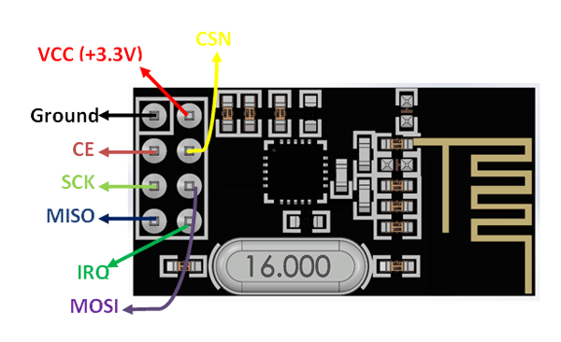
Figure 11: NRF24L01 Transceiver module

Arduino UNO:

Why choose Arduino?
Uses atmega328 microcontroller with a 32kb memory. Feasible software programmability due to its open source and compact style. Enhanced feasibility due to the use of USB cable. Has 14 digital input/output pins, 6 analog inputs, 16 Mhz ceramic resonator, USB connection and a power jack.
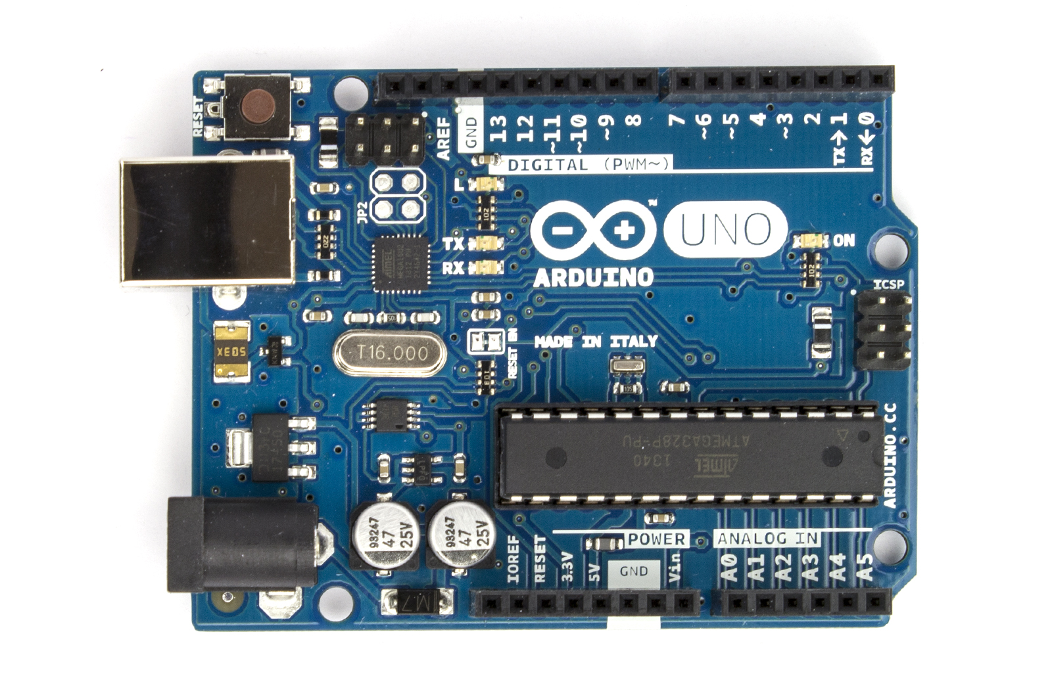
Figure 12: Arduino Uno

Arduino Nano

The Arduino board is designed in such a way that it is very easy for beginners to get started with microcontrollers. This board especially is breadboard friendly is very easy to handle the connections. Let’s start with powering the Board.
USB Jack: Connect the mini USB jack to a phone charger or computer through a cable and it will draw power required for the board to function
Vin Pin: The Vin pin can be supplied with a unregulated 6-12V to power the board. The on-board voltage regulator regulates it to +5V
+5V Pin: If you have a regulated +5V supply then you can directly provide this o the +5V pin of the Arduino.
Input/output:
There are totally 14 digital Pins and 8 Analog pins on your Nano board. The digital pins can be used to interface sensors by using them as input pins or drive loads by using them as output pins. A simple function like pinMode() and digitalWrite() can be used to control their operation. The operating voltage is 0V and 5V for digital pins. The analog pins can measure analog voltage from 0V to 5V using any of the 8 Analog pins using a simple function liken analogRead()

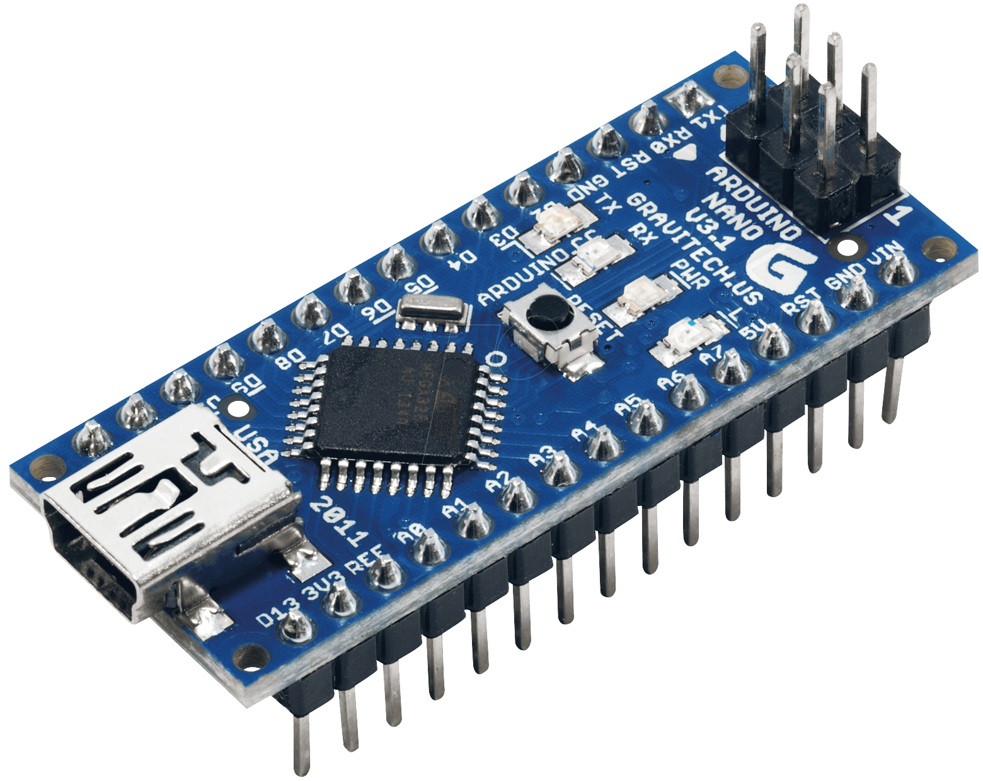
Figure 13: Arduino Nano

H-Bridge L298
• The agility of the S.A.G.E BOT is derived from the 200 rpm geared motors.
• The above mentioned geared DC motors are current hungry and the L298 will help quench the current thirst.
• Key features
– Operating Supply Voltage up to 46 volts.
– Total DC Current up to 4A.
– Over Temperature Protection.
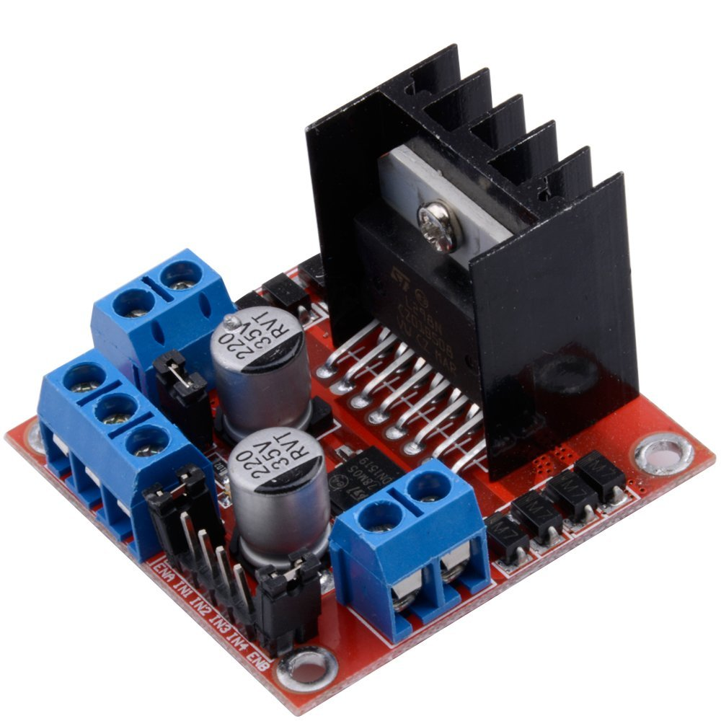
Figure 14:H-Brige l298

DC gear motor:

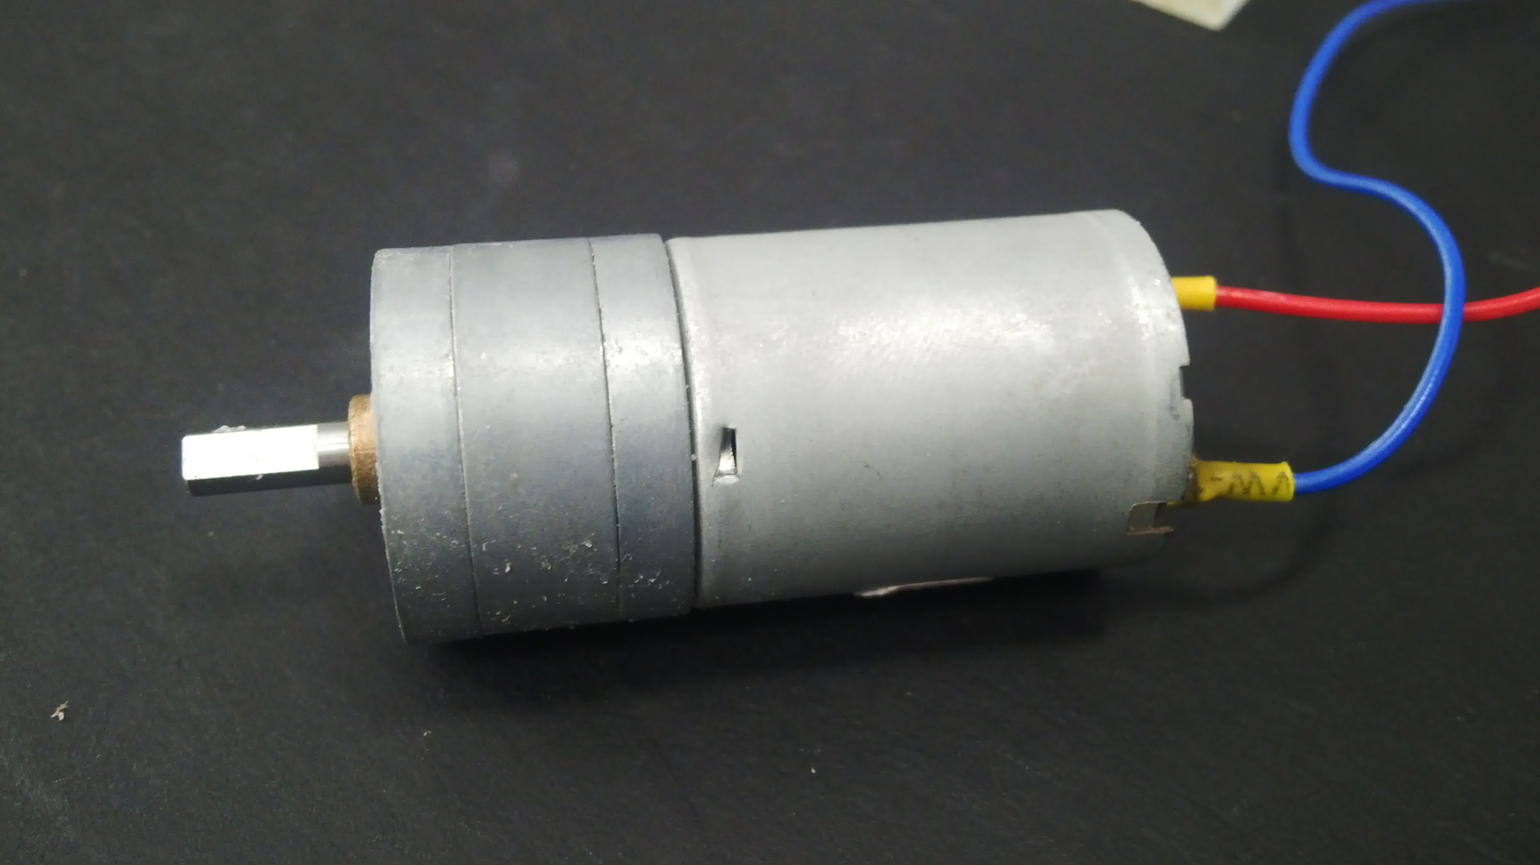
Figure 15: DC Gear motor

This two DC gear motor is used for the movement operations of the robot’s wheel. These two are driven by the motor driver L298 D. It is a high speed, high torque, low power consumption, low noise and simple machine. It features arena structure, easy maintenance, long service life.
Specifications
_ Model: DC motor RS-555
_ Rated voltage: DC 12V
_ No-load speed: 3000-3500 rpm/min
_ Load speed: 40rpm/min
_ Weight: 502g
_ Size: Diameter 37mm, Length 65mm

DC Motor
Blade motor used for cutting the grass and speed of these motor is 3550 rpm/min. Thus it is more speed than the other motor. The cutting operation stops while the ultrasonic sensor senses the object. If not, the vehicle cuts the grass.

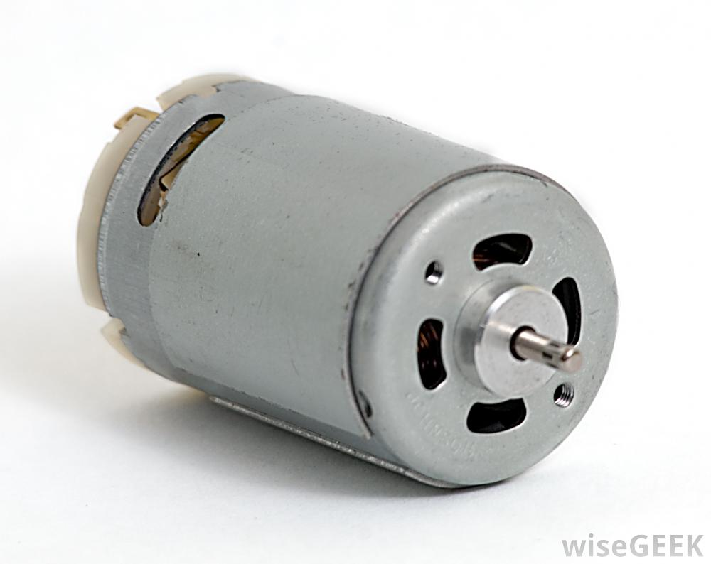
Figure 16:DC motor

Joystick

A joystick is an input device that allows the user to control a character or machine in a computer program, such as a plane in a flight simulator. They look similar to the control device you would find on an arcade game, but nearly always include extra buttons for additional functionality. The picture shows the Logitech Freedom 2.4, an example of a joystick.
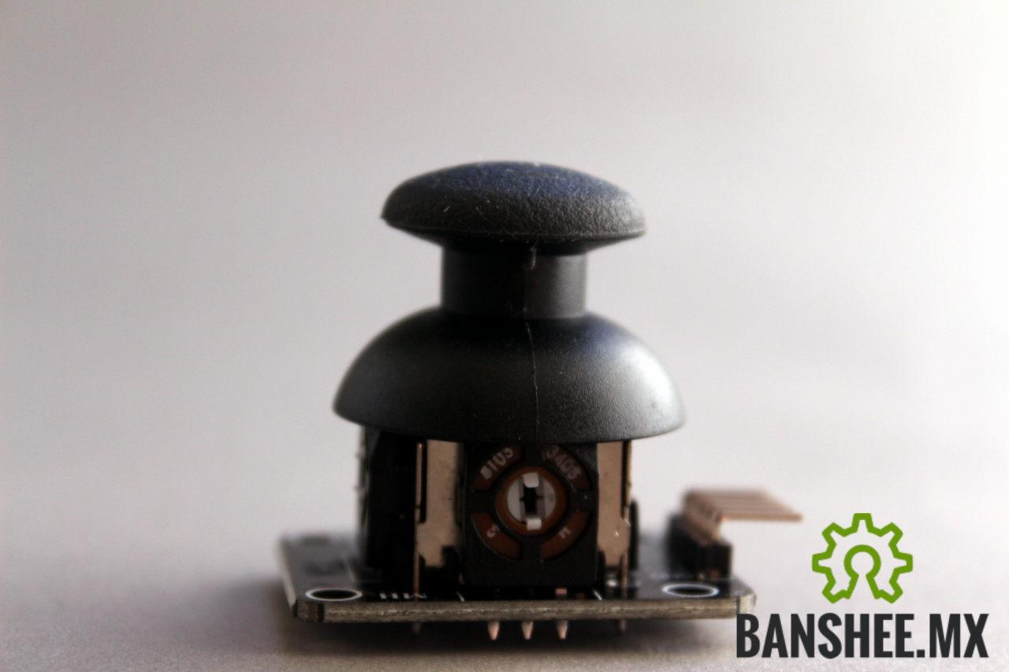
Figure 17:Joystick

Switch
A switch is an electrical component that can break an electrical circuit, interrupting the current or diverting it from one conductor to another.
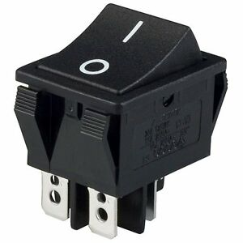
Figure 18:Switch

Battery

Battery will provide the energy required for working of the device. The battery connected to any component should provide enough power to drive the component under load. We have used three batteries of 12V 15Ah each: Two to drive the wheels, and another to drive the cutter thread and rotating brush.

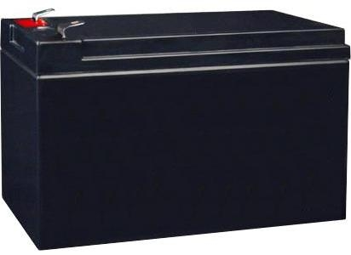

Figure 19:UPS Battery

Electrical system
Figure 20: Electrical Circuit
To help develop the electrical system, we created a block diagram of the system to guide us in the design and help illustrate how each component would physically connect in the overall electrical module; moreover, we use this diagram to determine necessary wire sizes and overall circuit routing. The final system is shown above:
The system operates as follows:
• The Main Battery (1) is a 12 V, 75 Amp-hour (Ahr), rechargeable, lead-acid battery. This provides all power for the electrical system, and feeds directly into the Remote On/Off unit (3) and the Motor Controller (5), as the motors require significant amperage and will be the largest drain on the battery. Moreover, the battery feeds directly into the Internal Mower Circuitry (7), as this is the default lawnmower configuration.
• The Microcontroller controls the compass and proximity sensors (2); additionally, the microcontroller controls the pulse-width modulation (PWM) signal needed to drive the Motor Controller (5).
• The Remote On/Off unit (3) turns the mower blade on and off via the Internal Mower Circuitry (7); it also turns the Microcontroller (2) on and off, allowing the wheel motors to be controlled independently from the blade motor.
• The Proximity Sensors and Compass transmits this signal to the Microcontroller to be stored for future waypoint following.
• The Motor Controller (5) receives its modulated signal from the Microcontroller (2), determining which way to turn, how fast to move, and whether to drive forward or in reverse. The motor controller’s power is derived directly from the Main Battery (1), and it feeds both Wheel Motors (9, 10).
• The Internal Mower Circuitry (7) is the existing on-board circuitry that came with the lawnmower itself. This controls the recharge feature of the battery, as well the blade motor control and the existing on/off switch on the lawnmower handle (not shown).
• The Blade Motor (8) is an existing motor that spins the lawnmower’s blade.
• The Left and Right Wheel Motors (9 and 10, respectively) control the left and right wheels, respectively.
Figure 21: Electrical Design

Cost Analysis
The budget for the project is established at 1570TK. The following table depicts the total cost of the system with minimal redundancies:

Risk Analysis
This risk analysis shows the current possible events leading into the spring semester. The left column showing the likelihood that the event will happen, the right showing the severity of the event happening. For example power is labeled as five and has a moderate 10 to 50 percent chance of occurring. If the event is to occur it would have a major consequence to the project.
Table I Risk Analysis
1. Precision
2. Cost
3. Complexity
4. Size
5. Power
6. Damage to Lawn
7. Obtainability

Precision
In the event that our GPS system is not as accurate as needed we have two different options. We will alter our programming method to account for the error involved with the control system. If does not fix the problem we will then visit different ways of directing our mower. The team was unable to obtain a GPS system as planned in the Critical Design Review. We then faced a lack of precision in the control system. In order to mediate the precision risk, we used two proximity sensors with the addition of a compass to provide a multi-level way for the control system to determine the mowing route.

Cost
In the event that a component we need is out of budget we will contact the vendor to see what discounts are offered for example if there is a chance of using our project to promote their product for a discount. If there is no discount we will then search for other vendors for the same product as well as look for possible used items. If there are no other vendors offering the item we will then research similar products that will fit our needs. This event is highly unlikely of happening as our design is well under the allotted $3500 budget.

Complexity
In the event that our design becomes to complicating in the fabrication or electrical process we will then assess our design. We will then either seek out advisement on how to complete the design and see if there is a better way. If the design is still too complex we will then reevaluate our design and possibly redesign our system and fabrication methods. This event has a moderate possibility as our electrical system is complex as it communicates with our sensor system and directs the mower to the correct path. This event has moderate consequences as we have many options on how to redesign our system.

Size
In the event our mower is too large and does not meet our requirements we will reevaluate our design. Starting with the mechanical components and seeing where size can be cut down. We do not however believe that this will be a high risk as we are keeping the width dimensions the same as the purchased mower.

Power
In the event that our system does not have enough power to power both the mower itself as well as our drive mowers we will then reevaluate our power needs. We will then discuss the replacement of our main battery or by adding an additional battery to power our drive system. This event has a moderate possibility and has a major consequence. We will then have to redesign our electrical system by adding additional batteries to our system.

Damage to Lawn
In the event of our system causing damage to the lawns surface we reevaluate our mechanical design. Starting with the rear drive system we will be looking for traction issues and wheel spin. We do not believe our drive system will cause wheel spin, but in the case of wheel spin we will increase the diameter of the rear wheels or turn down the speed of our drive motors. The caster front wheels we however to do not believe lawn damage will occur as there is no drive motors powering them. This event is very unlikely of happening and a minor consequence to our project.

Obtainability
In the event that some of our parts are not obtainable or cannot not be acquired in time for the build time we will then look to other vendors. If other vendors cannot provide us with the required parts as well we will research for similar products that fulfill the requirements of the original part needed. This event is likely to happen in the time span that we will need parts, but with only minor consequence. Unfortunately the GPS system with the desired level of precision was not available from the vendor Swift Navigation. Swift Navigation advertises the only commercially available GPS with the high precision. The team dealt with this challenge by using other commercial off the shelf parts to construct another control system using different sensors.

ARDINO PROGRAMING
Figure 22:Aduino program

Figure 23:Arduino programming

Figure 24:Arduino programming
Figure 25:Arduino programming

Chapter 4: Data collection and analysis

DESIGN CALULATIONS
Speed of lawn mower
Circumference of wheel
C = 3.142 x d=3.142x18 = 56.54 cm
Speed of movement of the device
= (N1/60) x C
= (60/60) x 56.54x10-2 = 0.57 m/s
= 0.57 x 18/5= 2.052 km/hr
Power required to drive the lawn mower
Force F = m x g = 30 x 9.81 = 294.3 N
Power, P = F x V = 294.3 x 0.57 = 167.751W
Power produced by wheel motor
Effective mass on each motor, m’ = m/2 = 30/2 = 15 kg
Force F = m’ x g = 15 x 9.81 = 148N
Radius of the wheel, r = d/2 = 0.18/2 = 0.09 m
Torque produced T= F x r1
= 148 x 0.09= 13.32 Nm
Power = (2 x π x N1 x T)/60
= (2 x 3.142 x 60 x 13.32)/60 = 83.7 W
Total power produced by both wheels
P = 83.7 x 2 = 167.4W
Volume of the storage unit
Volume V = l x b x h = 34 x 14 x 12= 5712 cm3
Angular velocity of the blade
ω= 2πN3/60= 2 x π x (150)/60 = 15.70 rad/sec
Torque produced by the blade
Area of cross section of the cutter thread
A = πd2
2/4 = π x (0.3)2/4 = 0.07cm2
Volume of the cutter thread V = A x l2
V = 0.07 x 40 = 2.8 cm3
Weight of the cutter W2 = m2g=
0.5 x 9.81 = 4.9N
Torque T = W2 x l2/2 = 4.9 x 0.4/2 = 0.98Nm
Force produced by the blade
Fc = m2 (l2/2) ω2 = 0.5 x (0.3/2) x (15.7)2 =18.5N
Battery charging time
Current produced by solar panel I = P’/V’ = 5/12 = 0.416 A
Charging time = Battery capacity/current
= 7.5/ 0.416 = 18 hrs
A] SELECTION OF ELECTRIC CUTTING MOTOR
DC motor
Speed = 2000 rpm
Voltage = 12 volt
Power = 180 w
T = (P x 60)/ 2 Π N
= (180 x 60)/2 Π 2000
Hence Torque produced by cutting motor is 0.862 Nm.
B] SELECTION OF LIFTING MOTOR
FORCE = (Wt. Of motor + rack Wt. + misc.) x 9.81
= 0.85 kg x 9.81
= 8.338 N
T = force x radius of lifting pinion
= 8.338N x 0.02m
= 0.1667 Nm
P = (2ΠNT) / 60 = (2 x Π x 2000 x 0.1667) / 60
= 34.91 ≈ 35 watt
Hence power and torque of the lifting motor is 35 watt and 0.1667Nm.

OBSERVATIONS OF THE LAWN MOWER

1) Wheel diameter, d = 18 cm
2) Rotation speed of wheels, N1 = 60 rpm
3) Rotation speed of brush, N2 = 80 rpm
4) Rotation speed of cutter thread, N3 = 150 rpm
5) Mass of the lawn mower, m = 30 Kg
6) Length of storage unit, l = 34 cm
7) Breadth of storage unit, b = 14 cm
8) Height of storage unit, h = 12cm
9) Diameter of blade, d2 = 3 mm
10) Mass of the cutter, m2 = 0.5 Kg
11) Length of blade, l2 = 40 cm
12) Power capacity of solar panel, P’ = 5 W
13) Voltage rating of battery, V’ = 12 V
14) Storage capacity of battery = 7.5 Ah

PERFORMANCE FACTORS

PERFORMANCE FACTORS
The device has to be evaluated on some factors to find out its working efficiency, and if it is convenient practically or not. Some of the factors are:
1) Cutting Time: It is one of the basic factors, which effects the performance of the device to a great extent. It is defined as the time required by the lawn mower to trim lawn in a unit area. As time is the most valuable resource in the present days, this factor becomes most important in determining the usability of the device.
2) Trimmed lawn condition: Whether the cut made to the lawn is clean or not, and if the height of the trimmed lawn is uniform or not are two very important factors in determining the performance of the device. The desired outcomes are uniform and clean trimming of lawn.
3) Movement Pattern: Movement pattern is an important factor. If the lawn mower moves over a previously trimmed area, it leads to wastage of energy and time. Hence, the movement pattern must be decided before-hand to avoid this un-necessary wastage of resources.
4) Power requirements: Power requirement decides the efficiency of the device. The power requirement of the device decides the energy consumed for trimming a unit area of lawn. More the power requirement, more is the energy required to trim unit area of lawn.

Chapter 5: CONCLUSION NAD FUTURE WORK

APPLICATION

The lawnmower can be used in various are:
In Grassland at university and departments of the office.
In the backyard or garden at home.
In Public Parks to remove the unwanted grass/weeds.
Playground like, cricket ground, football ground, etc.

ADVANTAGES

1) The device reduces work load on humans.
2) It has simpler design than most commercial mowers.
3) This lawn mower is cheaper than most commercial lawn mowers.
4) It can be operated wirelessly from a distance.
5) It aids elderly users or those with disabilities.
6) The collected lawn can be used as fertilizers for a variety of vegetation

LIMITATION

1. Large time required to remove the grass
2. Manually operated
3. Difficult to operate in rainy seasons
4. In some cases, an autonomous grass cutter, is not safety enough

FUTURE WORK

 this is the key system that will enable the mower to recognize objects, avoid them, and can mow also in a pattern.
 much experience has already been gained with the other sensors (infrared, solar, etc) working on the first two generations of autonomous lawn mowers.

CONCLUSION

Robotics is very vast field which comes with different combinations of technology this will helps to reduce the human effort and gives maximum efficient output for the work, Nowadays lot of energy is wasted for mowing lawn in different areas of the world and also takes lots of human effort for the work. The main aim of this project is to make a automated robotic lawn mower system which will helps to mows the lawn in different design with lesser human effort. Advantages of this system are used components are of low cost so and in bulk production.
The auto controlled lawn mower provides the user with many benefits, and therefore could someday become a very profitable and marketable technology. However, most consumers are not aware of this advancement of the lawn mower. Each benefit of the previously designed lawn mowers and incorporating them into a new design of the mower that integrates a software and hardware for the use of a remote control. The safety features, reliability and cost efficiency, and the user friendliness of the mower designed will succeed the benefits of some other mowers that are present today

References

[1] "Mower History." The Old Lawnmower Club Collection, Preservation and Display of Old Lawn Mowers. N.p., n.d. Web., 29 Feb 2012.
[2] Diggs, Steven. "Corded Vs. Cordless Electric Lawn Mowers." ehow. N.p., n.d. Web. ,29 Feb 2012.
[3] A.Dipin and T.K .Chandrashekhar , ―Solar powered vision based robotic lawn mower, International Journal of Engineering Research and Reviews ,vol. 2, pp: 53-56, April 2014 - June 2014.
[4] O. A Tanimola, P. D Diabana, and Y. O. Bankole ,―Design and development of a solar powered lawn mower, International Journal of Scientific & Engineering Research, vol. 5,June-2014.
[5] D.Satwik, N.Ramalingeswara Rao, SreeramReddy, ―Design and fabrication of lever operated solar lawn mower.
[6] "Mower History." The Old Lawnmower Club Collection, Preservation and Display of Old Lawn Mowers. N.p., n.d. Web., 29 Feb 2012.
[7] Diggs, Steven. "Corded Vs. Cordless Electric Lawn Mowers." ehow. N.p., n.d. Web. ,29 Feb 2012.
[8] A.Dipin and T.K .Chandrashekhar , ―Solar powered vision based robotic lawn mower, International Journal of Engineering Research and Reviews ,vol. 2, pp: 53-56, April 2014 - June 2014.
[9] O. A Tanimola, P. D Diabana, and Y. O. Bankole ,―Design and development of a solar powered lawn mower, International Journal of Scientific & Engineering Research, vol. 5,June-2014.
[10] A.Dipin and T.K .Chandrashekhar , “Solar powered vision based robotic lawn mower,” International Journal of Engineering Research and Reviews,vol. 2, pp:
53-56, April 2014 -June 2014.
[11] O. A Tanimola, P. D Diabana, and Y. O. Bankole ,“Design and development of a solar powered lawn mower,” International Journal of Scientific &
Engineering Research, vol. 5,June-2014.
[12] D.Satwik, N.Ramalingeswara Rao, SreeramReddy, “Design and fabrication of lever operated solar lawn mower and contact stress analysis of spur gears,”
International Journal of Science, Engineering and Technology Research, vol. 4, August-2015.
[13] G. Newstadt , K. Green, D. Anderson, M. Lang, Y. Morton, and J. McCollum , “Miami Redblade III: A GPS-aided Autonomous Lawnmower”.
[14] P. Patil, A. Bhosale, S. Jagtap, “ Design and implementation of automatic lawn cutter,”
[15] Ray Jarvis , “A tele-autonomous heavy-duty robotic lawn mower,” proc.2001 Australian conference on Robotics and Automation Sydney,Nov 14-15,2001.
[16] H. Singh, J. Singh Mehta, “Design and analysis of wireless remote controlled lawn mower,” SSRG International Journal of Mechanical Engineering, April
2015.
[17] S. Sujendran, P. Vanitha , “Smart Lawn Mower for Grass Trimming,” IJSR ,vol 3, Issue 3, March 2014

