Connecting The Unconnected
A Combination of DTN, CDN & TCP/IP Approach

by:
Md. Tahmidul Bari (112433)
Mir Shahrukh Islam (112434)
Nafiz Imtiaz (112435)
Md. Ehsanul Islam (112436)

BACHELOR OF SCIENCE
IN
ELECTRICAL AND ELECTRICAL ENGINEERING

ISLAMIC UNIVERSITY OF TECHNOLOGY (IUT)
A Subsidiary Organ of Organization of Islamic Cooperation (OIC)
Dhaka, Bangladesh.
November, 2015

Page intentionally left blank

Declaration of Authorship

We, Md. Tahmidul Bari (112433), Mir Shahrukh Islam (112434), Nafiz Imtiaz (112435), Md. Ehsanul Islam (112436) declare that this thesis titled,’Connecting The Unconnected A Combination of DTN, CDN & TCP/IP Approach’ and the works presented in it are our own. We confirm that:

- This work has been done for the partial fulfillment of the Bachelor of Science in Electrical and Electronic Engineering degree at this university.

- Any part of this thesis has not been submitted anywhere else for obtaining any degree.

- Where we have consulted the published work of others, we have always clearly attributed the sources.

Connecting The Unconnected
A Combination of DTN, CDN & TCP/IP Approach

Approved By:

Prof. Dr. Md. Shahid Ullah
Head of the Dept. (EEE)
Islamic University of Technology.

Dr. Khondokar Habibul Kabir
Assistant Professor
Department of Electrical and Electronic Engineering
Islamic University of Technology.

Contents

Abstract 6

Abbreviations 7

1 Introduction and Background 8

1.1 Overview of DTN . . . . . . . . . . . . . . . . . . . . . . . . . . . . . . . . . . . . . . . . . . . . . . . . . . 9
1.2 Thesis Introduction . . . . . . . . . . . . . . . . . . . . . . . . . . . . . . . . . . . . . . . . . . . . . . . . . 10
1.3 Thesis Proposal . . . . . . . . . . . . . . . . . . . . . . . . . . . . . . . . . . . . . . . . . . . . . . . . . . . . 11

2 Operations and Setup 17

2.1 Data Transfer Procedure . . . . . . . . . . . . . . . . . . . . . . . . . . . . . . . . . . . . . . . . . . . .18
2.2 Registration Procedure . . . . . . . . . . . . . . . . . . . . . . . . . . . . . . . . . . . . . . . . . . . . . . .19
2.3 Registration Module . . . . . . . . . . . . . . . . . . . . . . . . . . . . . . . . . . . . . . . . . . . . . . . . 19
2.4 Server Module . . . . . . . . . . . . . . . . . . . . . . . . . . . . . . . . . . . . . . . . . . . . . . . . . . . . . 20
2.5 Companion Android Application . . . . . . . . . . . . . . . . . . . . . . . . . . . . . . . . . . . . . . .21
2.6 Request Sub-Module . . . . . . . . . . . . . . . . . . . . . . . . . . . . . . . . . . . . . . . . . . . . . . . . 22

3 Applications and Implementation Requirements 23

3.1 Education and Youth Development . . . . . . . . . . . . . . . . . . . . . . . . . . . . . . . . . . . . . 24
3.2 Interconnection within the village . . . . . . . . . . . . . . . . . . . . . . . . . . . . . . . . . . . . . . 24
3.3 Implementation Requirements . . . . . . . . . . . . . . . . . . . . . . . . . . . . . . . . . . . . . . . . . 30
3.2 Impact On Implementation of Proposal On Socio-Economic Situation . . . . . . . . . .31

4 Financial Aspects of DTN using TCP/IP Approach 33

4.1 Project Costs . . . . . . . . . . . . . . . . . . . . . . . . . . . . . . . . . . . . . . . . . . . . . . . . . . . . . . 34
4.2 Financial Aspects. . . . . . . . . . . . . . . . . . . . . . . . . . . . . . . . . . . . . . . . . . . . . . . . . . . 37

References 42

Abstract

The Delay Tolerant Network (DTN) at supporting
communication in a rather unorthodox way for the intermittent
networks where direct link at all times may not be available. This
proposal paper describes a proposal on the practical implementation
of DTN architecture using android devices in the third world
countries where sometimes technological amenities are scarce.
Here in this paper proposes a network scheme for rural areas
of Bangladesh, implementing which a slow but efficient and cost
effective network can be established.

Abbreviations

DTN – Delay Tolerant Network
CDN – Content Delivery Network
TCP – Transmission Control Protocol
IP – Internet Protocol
MAC – Media Access Control
GSM – Global System for Mobile
EDGE – Enhanced Data rates for GSM Evolution

Chapter 1

Introduction and Background

1.1 Overview of DTN

Delay-tolerant networking (DTN) is an approach to computer network architecture that seeks to address the technical issues in heterogeneous network that may lack continuous network connectivity. Examples of such networks are those operating in mobile or extreme terrestrial environments, or planned networks in space.

Recently, the term disruption-tolerant networking has gained currency in the United States due to support from DARPA, which has funded many DTN projects. Disruption may occur because of the limits of wireless radio range, scarcity of mobile nodes, energy resources, attack, and noise. The ability to transport, or route, data from a source to a destination is a fundamental ability all communication networks must have.

Delay and disruption-tolerant networks (DTNs) are characterized by their lack of connectivity, resulting in a lack of instantaneous end-to-end paths. In these challenging environments, popular ad hoc routing protocols such as AODV and DSR fail to establish routes. This is due to these protocols trying to first establish a complete route and then, after the route has been established, forward the actual data. However, when instantaneous end-to-end paths are difficult or impossible to establish, routing protocols must take to a "store and forward" approach, where data is incrementally moved and stored throughout the network in hopes that it will eventually reach its destination. A common technique used to maximize the probability of a message being successfully transferred is to replicate many copies of the message in the hope that one will succeed in reaching its destination. This is feasible only on networks with large amounts of local storage and inter-node bandwidth relative to the expected traffic. In many common problem spaces, this inefficiency is outweighed by the increased efficiency and shortened delivery times made possible by taking maximum advantage of available unscheduled forwarding opportunities. In others, where available storage and inter-node throughput opportunities are more tightly constrained, a more discriminate algorithm is required.

1.2 Thesis Introduction

At this age of technology, most of the places of the world are interconnected via Internet or other means of electronic communications. The people of the developed countries have flawless, fast and reliable connectivity. But unfortunate as it may be, the scenario is not quite the same in most of the developing countries or the third world countries, especially in their rural or remote areas. The people living there do not even get their fundamental amenities, let alone information and technologies. So they are somewhat detached from modern technologies. As for example, In Bangladesh, 65% of rural areas are out Internet facilities to get suitable information. Moreover, it is not always possible for the network vendors to establish networks in rough and harsh terrains in infrastructure-less remote rural areas. Again, the cost of establishing optical fiber links or broadband or other traditional networks is high. Therefore, in such scenarios, a new, cost effective and efficient network architecture is essentially required. The Internet has been a great success at interconnecting communication devices across the globe. However, for the following cases it fails to transfer data: no end-to-end connectivity, intermittent connectivity, long or variable delay, asymmetric data rates, high error rates. A delay-tolerant network (DTN) is a unique technique that enables communication and data transfer in the situations where traditional networks are obsolete, i.e., where, physical end-to-end connectivity is not present. In such scenarios, DTN uses store-carry-forward message delivering system. By using DTN technique, we propose to practically establish connectivity within a village and/or among villages in rural Bangladesh using Wireless equipped devices, where devices connect each other using Ad-Hoc networking. There are two kinds of devices: Clients and Servers or data carriers. Clients are carried by user within the village, whereas, sever or data carry is carried by message ferries, i.e., by vehicles or by volunteers throughout the village. The message ferry carries the messages from sources and delivers them to the intended destinations within or among villages using the store-carry forward mechanism.

1.3 Thesis Proposal

In our proposal, we demonstrate the technique for interconnecting a village and make it autonomous in terms of data transfer and non-real time Internet access. The rural areas of the third world countries are deprived of the modern communication facilities. Due to lack of infrastructure or rough terrain, setting up conventional connections in these areas is very difficult. Therefore, DTN comes as a savior in this case, that enables data transfer and communication even in intermittent networks. In our scenario, we use WiFi equipped device, i.e., smartphone, tablet, netbook, notebook, laptop, etc, as the client or
server (data carrier). Due to the cheap price, openness for upgrade, easy user interface, attractive features, the smartphone and tablet with Android operating system (OS) becomes the best choice. Their prices are becoming cheaper and more affordable to general people day by day. The main goal of this proposed scheme is to find a way to interconnect a rural villages within themselves, which are detached from modern technologies and give autonomous solutions to them so that village people does not require any costly Internet connection or infrastructure to connect themselves.

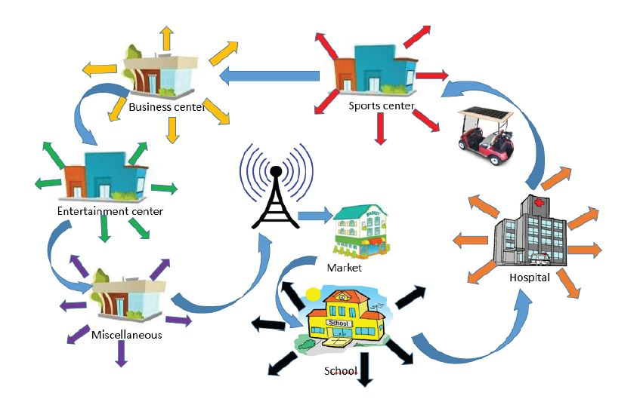

Fig. 1: DTN using TCP/IP approach via vehicle/message ferry

Main Aspects

A. The Vehicle
We are using a multipurpose vehicle for carrying the android device through a predefined path along the village. This multipurpose vehicle does different works, like-roaming medical checkup. An android phone or Tab will be placed in the vehicle. This mule will be fitted with a solar panel on its top, so that the android phone and other necessary electronic devices can be charged during the usage. In this way no separate power source will be needed. So, in case of power failure or any disaster where power lines are out and electricity is not available, data will still be possible to transfer.

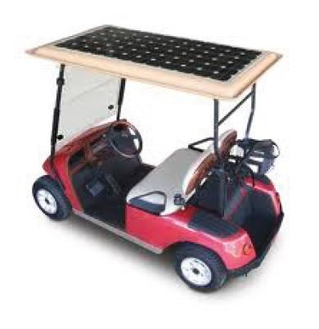
Fig. 2: Vehicle / Message Ferry

B. A Gateway:

In the village there may be an antenna through which internet connection is possible in a certain place. This antenna doesn’t need to cover a wide area or the whole village for internet coverage. Just a connection is enough to provide a gateway for the android carriers to upload and download data. This antenna may be placed in the most crowded place where more data is likely to be transmitted. Like a village market. From there the vehicle can carry the data throughout the village. If there is no such connection the vehicle will move back and forth from the village to neighboring town where internet connection is available.

C. Data Centers:

In such similar projects, the vehicle roams around the village and distributes data or uploads the data to a kiosk or a local server. But this is not as efficient as data of all categories are mixed together. So bring up the concept of data centers. The vehicle will move to all the centers and upload data related to the demand. This way the villagers will not need to gather to a common place for different purposes. Instead of centralizing, we are decentralizing the data. Suppose a person requires so medical information. In the existing examples or projects done so far, he would have to upload his query to a common server. Then when it arrives he would have to collect the data from the village center or kiosk along with others whose interests are in other topics. As the density of people is high there will be problems with data transfer speed, Precedence of data etc. So this is a slower process.

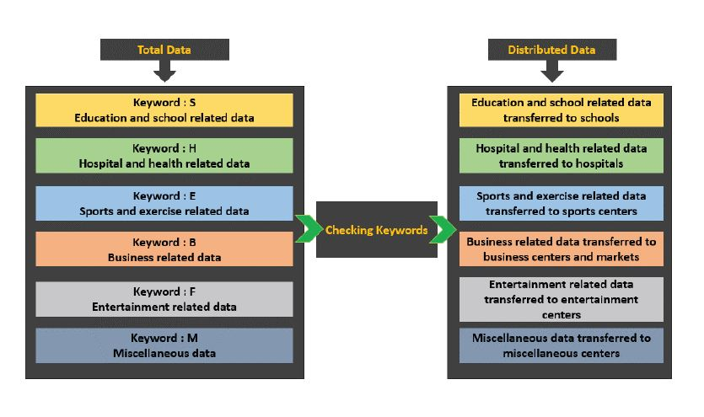
Fig. 3: Data Distribution Technique

Instead we propose, there should be different centers throughout the village for different types of queries. The mule will travel to all the centers and upload and download data according to the query topic. We can use identification keywords to distinguish between the query types. When a keyword match is found, the data will be transferred to the centers. People can collect their data from there. In this way the density of people will be lessened and data transfer will take place with more speed and reliability.

D. Storage Device:

There are some storage devices in the vehicles and the centers to store data. As there is no direct connection, data will not pass immediately. In DTN we use store and forward method. So external hard drives can be used for storage of data. More over when queries are asked there should be an option to choose whether the data is personal or public. If personal then the data will be erased from memory for good so no unauthorized person can access any personal data. But if the query is of public type, then the data may be saved for a long period so that any future queries about this topic will no longer need any internet connection or the vehicle. The different stations then will work as local offline servers. The person with a query will get his data instantly.

Chapter 2

Operation and Setup

2.1 Data Transfer Procedure

- Devices will be connected via WiFi Ad-Hoc network
- Two kinds of devices: Clients and Data Carriers
- Clients are carried by users within the destination area
- Sever or data carry is carried by message ferries ( i.e by vehicles or by volunteers throughout the destination )
- Message ferry carries the messages from sources
( Resource / Files provided by the admin )
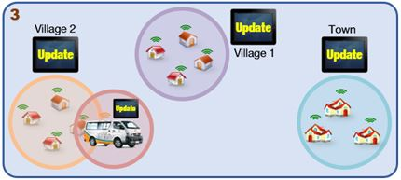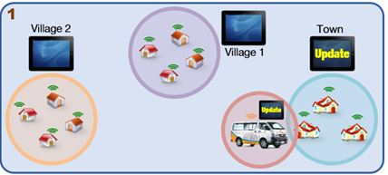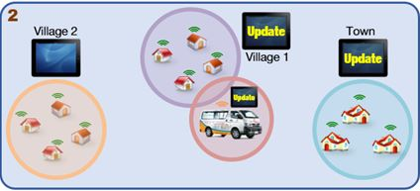
Fig. 4: Data Transfer Procedure
2.2 Registration Procedure
- Media Access Control (MAC) address is a unique identifier for each mobile device
- We are using MAC address to register mobile devices which helps to search registered users before any physical communication takes place.
- New users have to provide their device MAC address to the admin before using the system
- Admin will include the MAC in the registered users database.

2.3 Registration Module

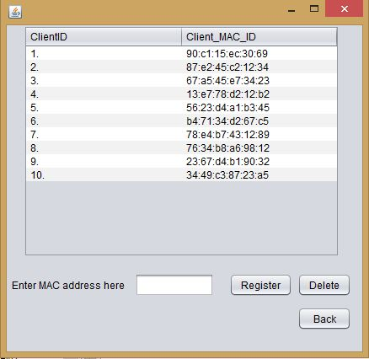
Fig. 5: Registration Module
- Only Accessible By The Admin Panel
- Admin sets the authorized/subscribed MAC addresses in this panel
- Devices will be ready for data transfer only if they are permitted in registration module.

2.4 Server Module

- Accessible Only By The Admin Panel
- Admin Panel Assigns MAC Address Before Transferring Any File Or Data
- Server Module will Be Installed in any vehicle or carrier which regularly circulates within the route
- It Automatically Takes Updates/Requests each time it enters within the WiFi network.
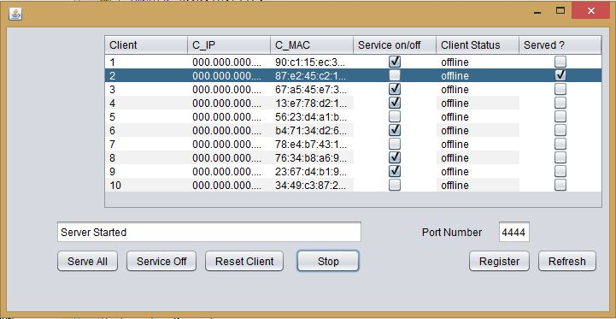Fig. 6: Server Module
  - Companion Android Application
- A companion Android application has been developed to properly distribute the server information to target client.
- The application has been developed with Java and compatible with Android OS 2.3 and later versions.
- This application automatically synchronizes the files between the device SDcard and the server pc hard drive when the vehicle reaches the destination Ad-Hoc network range.
- Till now (November 2015) three modules have been included in the application for (farmer, student and business module).

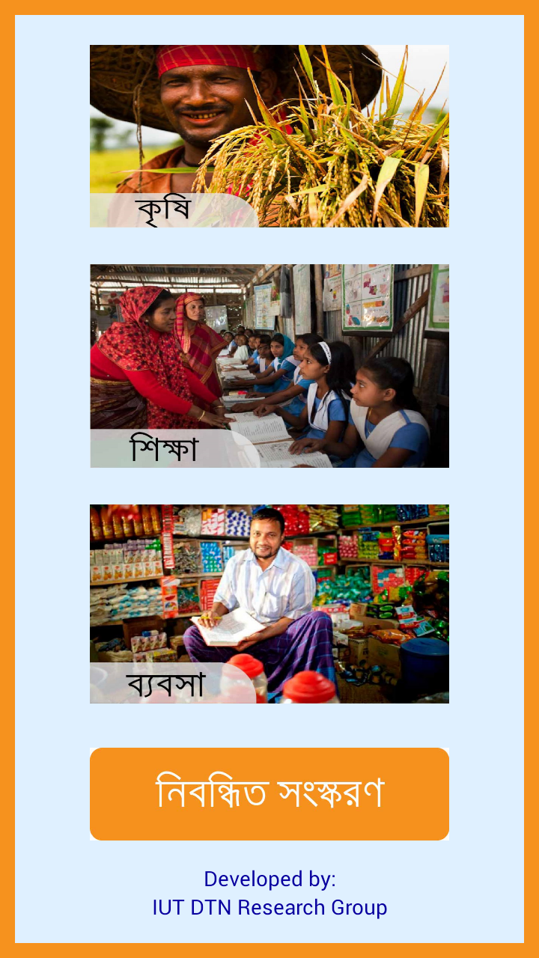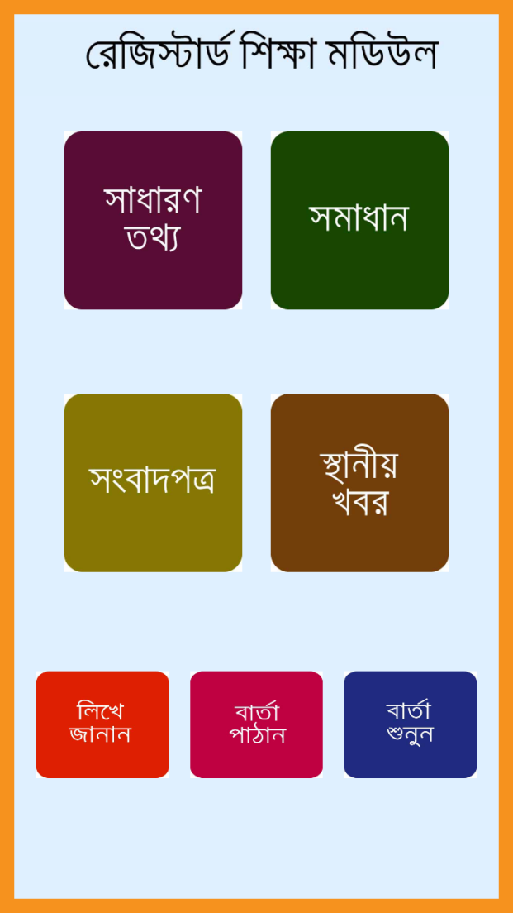
Fig. 7: Basic modules of companion Android application
  - Request Sub-Module
Request sub-modules has a simple interface to make it convenient for the technically backward people. It incorporates a text message and voice message option. After taking the text input from this panel the message is saved in plain text (.txt) format and for voice message, the file is saved in (.wav) format. Both file types are saved in the device sdcard. After synchronization these files are transferred to the admin via vehicle and admin responses accordingly by putting the requested files on the server to serve the target clients.

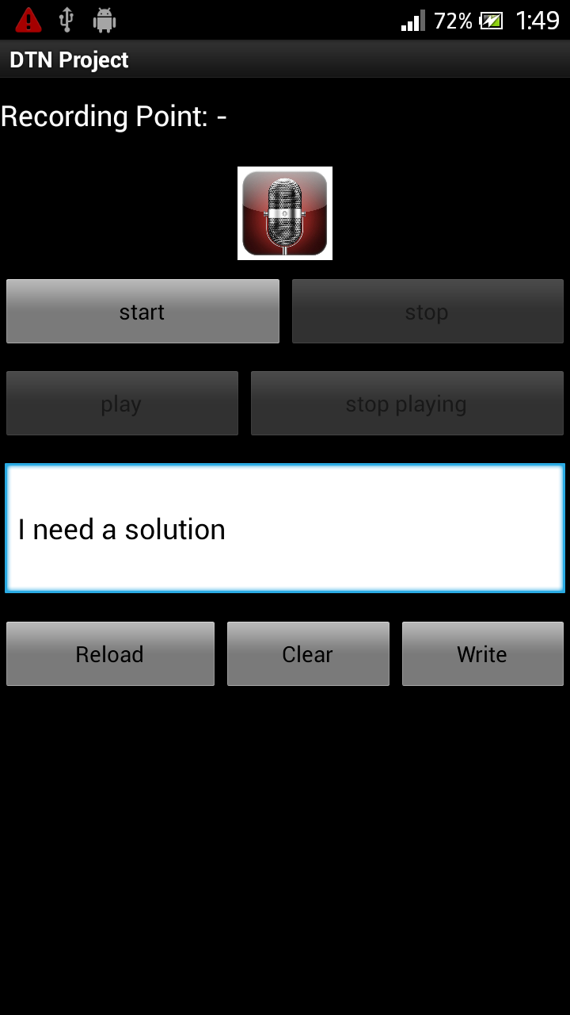
Fig. 8: Request Sub-Module (text and voice)

Chapter 3

Applications and Implementation Requirements

3.1 Education and Youth Development

For Education:

1) Using this network to access information:
2) For more convenience, weekly video lectures or tutorials may be downloaded and taught.

For the Rural Youth:

Youths are the main driving force for development. So, if they are deprived of modern education no development will be possible. So, information and technology has to be made available for the mass people. The people living in difficult terrains should not be left either. They also have to be connected. So, in these cases unconventional communication techniques like DTN has to be deployed. If proper information and training materials are supplied there, they won’t lag behind anymore. Trainings may be provided via videos on electronics,
solar home systems, mobile phone repair, fisheries, looms, carpentry, breeding cows and goats, milk production, growing seedlings, setting up nursery, small businesses, tailoring, potteries, pickles, chalk, pure drinking water etc.

3.2 Interconnection Within The Village

1) If someone wants to send a message or e-mail he/she can send it to the local server. The mule will carry the message to the destination. So internet or traditional connectivity is needed.
2) Recorded voice messages may also be sent. So no charge is needed. It’s free of cost.

A. For business purposes

- Business men can get the various information such as the
- price of commodities of other neighboring village markets.

B. Agricultural Aspects

1. They can get information about the weather, and also can send and analyze the data from the fields related to crops for better cultivation.
2. We can implement DTN based sensor data gathering from agricultural fields for research.

Fig. 9: Smart farming using DTN

C. Navigational Purposes
There may be small storage devices at the entrance or at the gateway of the village to other villages or towns. These storage devices will carry the local map and local information. So, when an outsider comes to the village he will get the basic information about the area and landscape to navigate through.

D. Offline Position Tracker
The global positioning system (GPS) uses satellite connections for tracking a position. In our case, for getting positions and directions in a local area we can deploy sensors at strategic pints. To certainly locate a position we need at least three references. So if we deploy the sensors, when a person comes close to them the mobile device will automatically triangulate its position with reference to the sensors. This way, we can
navigate, get directions and see where we stand in an unknown area. No internet or Satellite connection is needed here. We would propose to call this Offline position tracking system (OPTS).

D. Health Care
1) Patients can send information about their health condition. The doctors can then later check out the symptoms and prescribe accordingly.
2) The symptoms of the common diseases and their cures may be given on a local server. The patients may watch and learn about those.

E. Livestock Management
1) Important tips about the management about the livestock may be saved on a local server for reference.
2) Always the veterinary physician is not available in rural areas. But in case of disease situations, the information about the disease can be sent to the doctor residing in other areas. The doctor after seeing the symptoms can suggest some remedies.

E. Transportation
1) Inter village or inter district buses have schedules for departure. For convenience, the timetable may be automatically transferred to the traveler or it may be sent at a distant place for later reference.
2) In today’s world internet is taking over all the sectors. The transportation sector is also influenced by internet. The bus scheduling, ticketing is done online now. But for the communities without internet facilities, DTN may serve as an alternative. Tickets may be bought offline from the house. Of course as this process is not real time so the chances of delayed request is highly possible. So advanced tickets may be bought before a certain time.

F. Price Comparison
Normally in Bangladesh all the foods and fresh goods come from different regions, from different villages. These supplies are transported to the district cities for selling purpose. Normally the producers or the farmers have not much of a saying in case of price as they don’t know about the prices on the districts. The average prices of the goods of a week within the district and in other districts can be transferred to the remote server within the grasp of the producers. With this reference
they can compare the real price and what they are currently getting so that they can get the exact amount of money they deserve. The prices may be sent to the remote location instantly using internet. But as we are considering the challenged network conditions where the conventional networking fails, we are using DTN concept here. That’s why instead of using the daily price as a reference we are using the average price of a week so that a constant value may be considered. Otherwise if we consider the prices of each day individually the price may fluctuate rapidly.

G. Business Purpose Transportation
1) Normally foods and other supplies are sent to business centers in the towns and cities. Not all of them offer the same money. Some more, some less. Naturally everyone goes for the big amount. But there may be several areas located at different distances which may offer the same amount of money. So in that case the minimal path area is the wise and most likely option. So for this purpose a navigation system may be
established which will show all the possible destinations and the current product prices. The vendors may select from that where to send their products.

2) At the end of the day data concerning the sells transaction may be recorded and sent all over to be stored. This will give a clear idea about what sort of products are more demanding in which areas. So that the producers may send their respective items to the right place.

G. Offline Marketing
1) Not all the regions of the country are experts in all sorts of things. Different regions have their own heritage and areas of expertise. So a nationwide database of products, their quality and relative prices may be created. So when a buyer want to buy a product he may look up in the list and select as per his criteria and demand. This whole process may be done offline using DTN.

2) Nowadays not only buying and selling is done on the markets but also reselling and exchanges are also done. So these information may be categorized under the reselling or exchange category and those who are looking for these sort of transaction may proceed onwards using this info. Again these sort of information and transaction need not to be real time. So, a constant continuous connection is not needed. That’s why instead of using the internet we can use DTN concept.

H. Offline Community Network
1) In today’s virtual world, we socialize with other people via different social networks like- facebook, tweeter, linkedin etc. All of them use the internet. But for the regions with challenged networks, this facility is hard to get. So for this purpose or if we don’t wish to use the internet, we can use the DTN to carry the data all throughout the region or even
nationwide. Comments, pictures even videos may be shared. Not instantly, but with a delay. We are considering a challenged network situation or alternative to internet system. So in this case real time communication is a tradeoff.

2) Similarly e-mails, newspaper headlines etc. may also be shared.

I. Offline Library
All text books and books of different writers on different topics may be stored on a central server for future use. These may be downloaded on demand. Again on arrival to the local server these may be stored there so that if anyone else wants that particular item, he/she will get it instantly. It won’t be necessary anymore to look up for the item in the central server because it is already present in the local server.

J. Weather Forecast
Weather forecast is a crucial event. Especially for the crop farmers, fishermen at sea and the coastal area populations. So this thing has to be delivered in real time. But for the intermittent network we have no other choice. Delay is not a matter, the information counts here. So for the regions where conventional network is not present like islands, hilly areas, DTN concept may be used as an alternative.

3.3 Implementation Requirements

To execute the desired objective and to implement the proposal successfully in intermittent communication scenarios, some special and some general facilities have to be ensured. Some of these facilities are:

1) Training the volunteers: A group of enthusiastic and energetic young boys and girls have to be selected first from among the local community, who would be given proper training by the skilled trainers so that they attain computer literacy and become ready to train others. Later, this group would take up the responsibility of training and coaching the various local groups of people to continue or sustain the process.

2) Proper equipments: Vehicles, Mobile devices, Technical support, power supply etc.

3) Funding and space allocation: Proper funding for the project, adequate space for setting up different data centers.

4) Security facilities: Proper hardware and skilled manpower for preventing cyber crime, Blocking harmful and inappropriate contents while requesting for a search.

3.4 Impact On Implementation Of Proposal On Socio-Economic Situation

1) Education sector: There is no boundaries of education nowadays. So reading only text books isn’t enough. To keep pace with the ever changing world, Internet is a must. So, this proposal if implemented successfully will help in educational aspects.

2) Economic sector: A virtual market is expected to be established by implementation of this proposal. People can sell exchange and buy goods easily. Local products will get advertisement quickly and be well judged according to their values.

3) Social sector: The use of DTN technology will also help in improving the social scenario. People can learn many things and watch their favorite shows. Many important and ethical tutorials and programs can help in shaping the peaceful and well organized social structure.

4) Health-care sector: People of the village and rural areas are mostly illiterate and know a little about health and sanitation. As a result they are easy prey to different malicious and seasonal diseases. But a little concern can prevent these things. To raise the concern level of the general people, documentaries and tutorials regarding health issues can be a life saving thing. Awareness about sanitation and proper diet can play a major role in the health of the rural people.

5) Agricultural sector: Being an agrarian country, Bangladesh mostly relies on her agricultural sector. This is the main driving force of the country. But they are victims of nature and no more less, lack of proper knowledge. Though the agriculture department is working relentlessly to provide them with the proper help, but still farmers are sometimes victims of drought, heavy rain, hail storms etc. Most of the times the lack the knowledge of modern farming and they do it the traditional way. So the output is less. For this, the instructions and videos of modern farming can be a savior. They can learn how to protect the crops from different threats like pests. They can also learn how things are done in the technologically advanced world.

Chapter 4

Financial Aspects of DTN using TCP/IP Approach

4.1 Project Costs

A. Power
Maximum load of the project will be 150 W. The power will be available from local PDB source. Annual cost for electricity consumption stand at Tk. 374.76 [{(150 x 12 X 300)/1000} x 6.95] only.

B. Repair and Maintenance
For equipments this cost has been consider at 1%, 1.5%, 2% for 1st, 2nd , 3rd year & onward respectively.

C. Manpower
The requirement of technical & managerial personnel with their salaries & wages is given below:

i. Admin

Category | No. | Monthly salary | Annual salary
General manager | 1 | 25,000/- | 300000/-
Accountant & commercial | 1 | 18,000/- | 216000/-
Peon/Guard | 3 | 5000/- | 180000/-
Total | 5 |  | 696000/-

ii. Technical

Category | No. | Monthly salary | Annual salary
Engineer/ operator | 2 | 15,000/- | 360000/-

Above personnel will be allowed increment at 10% on the basic pay and 2 months basic pay as bonus. High incentive may be allowed for skilled workers.
D. Furniture / Fixture
The project will require office furniture & fixture, ceiling fan, telephone, printer, carpet etc. for which an amount of Tk. 300,000/- has been estimated.

E. Pre-Operation Expense
To test the trial run of the equipment & operation a cost of Tk. 50,000/- has been estimated.

F. Preliminary Expense
An amount of Tk. 200,000/- has been estimated for company formation. Registration, appraisal, design, consultancy, traveling expense, documentation etc.

G. Transportation
The project will require 1 vehicle for carrying data. We may arrange a vehicle which will frequently visit our project area. Monthly rent for carrying data is estimated Tk. 1000/- and will increase at 10% per year.

Implementation Schedule

Months | 1 | 2 | 3 | 4 | 5 | 6
Design & Software development
Rent space for data/support booth
Equipment delivery
Installation
Trial run

4.2 Financial Aspects

2.1. Fixed cost of the project:
Items | Total
Application (5 module) | 100,000/-
Equipments
2 Desktop | 100,000/-
Solar IPS | 170,000/-
Tablet PC | 20,000/-
Sub-total | 290,000/-
Furniture & fixture | 300,000/-
Preliminary expense | 200,000/-
Pre-operating expense | 50,000/-
Total | 940,000/-

2.2 Revenue forecast:
Here, our 1st project will be executed in Matlab Upazilla, Chittagong Division. Total population in households is 210,038 & total household is 45,569. It is estimated that 30%, 35%, 45% of total household will use our service in 1st year, 2nd year & 3rd year respectively. i.e.

Year | Household | Increase
1st year | 13671 | -
2nd year | 15950 | 2279
3rd year | 20507 | 4557

We will offer 5 modules in 1st phase & estimating that 20% of household will use 3 modules, 30% will use 2 modules & 50% will use 1 module. i.e.
Year | Household using 3 module (A) | Household using 2 module (B) | Household using 1 module (C)
1st year | 2734 | 4101 | 6836
2nd year | 3190 | 4785 | 7975
3rd year | 4101 | 6152 | 10254

Here, installation cost of 1 module is Tk. 49/- per year. So, income from module sale is given below:
Year | Sales from customer (A) | Sales from customer (B) | Sales from customer (C) | Total
1st year | 401898 | 401898 | 334964 | 1138760
2nd year | 468930 | 468930 | 390775 | 1328635
3rd year | 602847 | 602896 | 502446 | 1708189
Total | 1473675 | 1473724 | 1228185 | 4175584

To receive/ send any data by customer, he/she has to pay Tk. 0.50/ instance. Considering each household will spend Tk. 5/-, Tk. 8/-, Tk. 10/- per month in 1st year, 2nd year, 3rd year respectively. Service charge will be as follows:
Year | Households | Service charge/ year | Total
1st year | 13671 | 60/- | 8,20260/-
2nd year | 15950 | 96/- | 15,31200/-
3rd year | 20507 | 120/- | 24,60840/-
Total |  |  | 48,12300/-

Total revenue for 3 years:
Year | Service charge | Application charge | Total
1st year | 8,20,260/- | 11,38,760/- | 19,59,020/-
2nd year | 15,31,200/- | 13,28,635/- | 28,59,835/-
3rd year | 24,60,840/- | 17,08,189/- | 41,69,029/-
Total | 48,12,300/- | 41,75,584/- | 89,87,884/-

2.3 Expenditure forecast:
Particulars | 1st year | 2nd year | 3rd year
Wages & salaries | 1056000 | 1161600 | 1277760
Utilities | 375 | 375 | 375
Repair & maintenance | 2900 | 4350 | 5800
Rent & insurance | 21000 | 23100 | 25410
Depreciation & written off | 10000 | 10000 | 10000
Other exp. | 50000 | 50000 | 50000
Total | 1140275 | 1249425 | 1369345

2.4 Earning forecast:
Particulars | 1st year | 2nd year | 3rd year
Sales revenue | 19,59,020/- | 28,59,835/- | 41,69,029/-
Expenditure | 11,40,275/- | 12,49,425/- | 13,69,345/-
Profit before tax | 8,18,745/- | 16,10,410/- | 27,99,684/-

References

[1] A. Doria, M. Uden, and D. Pandey, “Providing connectivity to the saami nomadic community,” generations, vol. 1, no. 2, p. 3, 2002.

[2] T. Liu, C. M. Sadler, P. Zhang, and M. Martonosi, “Implementing software on resource-constrained mobile sensors: Experiences with impala and zebranet,” in Proceedings of the 2nd international conference on Mobile systems, applications, and services. ACM, 2004, pp. 256-269.

[3] M. Motani, V. Srinivasan, and P. S. Nuggehalli, “Peoplenet: engineering a wireless virtual social network,” in Proceedings of the 11th annual international conference on Mobile computing and networking. ACM, 2005, pp. 243–257.

[4] H. Ntareme and S. Domancich, “Security and performance aspects of
bytewalla: A delay tolerant network on smartphones,” in Wireless and
Mobile Computing, Networking and Communications (WiMob), 2011
IEEE 7th International Conference on. IEEE, 2011, pp. 449–454.

[5] H. Ochiai, H. Ishizuka, Y. Kawakami, and H. Esaki, “A field experience on dtn-based sensor data gathering in agricultural scenarios,” in Sensors, 2010 IEEE. IEEE, 2010, pp. 955–958.

[6] M. Papadopouli and H. Schulzrinne, “Performance of data dissemination among mobile devices,” En cours de soumission, 2001.

[7] T. Small and Z. J. Haas, “The shared wireless info station model: a new ad hoc networking paradigm (or where there is a whale, there is a way),” in Proceedings of the 4th ACM international symposium on Mobile ad-hoc networking & computing. ACM, 2003, pp. 233–244.

[8] R. Yanggratoke, A. Azfar, M. J. P. Marval, and S. Ahmed, “Delay tolerant network on android phones: Implementation issues and performance measurements,” Journal of Communications, vol. 6, no. 6, pp. 477–484, 2011.

