

ISLAMIC UNIVERSITY OF TECHNOLOGY (IUT)
A brief review of phase change materials and CFD study of thermal management technique for electronic cooling using phase change material (PCM)

B.Sc. Engineering (Mechanical)

THESIS
BY
Basit Khan (160011090)
Muhammad Wasim khan (151455)
Momen Almojamer (151457)
Muhammad Asif Nawaz Khan (141459)

Department of Mechanical and Production Engineering
Islamic University of Technology (IUT), Gazipur-1704, Bangladesh.

SUPERVISED BY
PROF. DR. Md. Nurul Absar Chowdhury
DATE: 6 March 2021

Declaration
I hereby declare that the work presented in this thesis has not been submitted for any other degree or professional qualification and that it is the result of our independent work.
Signature of the candidates

___________________________
Session 2019-2020
Department of Mechanical and Production Engineering (MPE)
Islamic University of Technology (IUT), OIC
Board Bazar, Gazipur
Dhaka, Bangladesh.
Signature of the Supervisor
______________________
DR. Md. Nurul Absar Chowdhury
Professor
Department of Mechanical & Production Engineering (MPE)
Islamic University of Technology (IUT), OIC
Board Bazar, Gazipur
Dhaka, Bangladesh.

Acknowledgments
At first, I would like to begin by saying Alhamdulillah and grateful to Almighty Allah who made it possible for us to finish this project successfully on time.
I would like to express my sincere thanks and deepest gratitude to my supervisor Prof Md. Md. Nurul Absar Chowdhury for his impeccable support, astounding expertise, and limitless help throughout the whole time. It wouldn’t have been possible without his technical, logistic and moral support.
I would like to thank all my colleagues for their kind helpfulness.
I am thankful to my family and friends for their constant encouragement and support.

Abstract
In this project two different studies were performed, coupled with the review study a numerical study of (2D/3D) transient numerical simulation of a phase change material (PCM) based finned heat sink were performed to investigate the heat transfer performance for passive cooling of electronic devices. A 2D/3D computational domain of finned heat sinks of 2 mm and 3 mm fin thickness are employed with a constant fin volume fraction of 9%, acting as thermal conductivity enhancer (TCE). The n-eicosane is employed as a PCM inside the heat sink to store the heat generated from the electronic device applied at the heat sink base. Transient numerical simulations are performed using finite-volume-method and conjugate heat transfer and melting/solidification phenomenon are investigated by applying various power levels to both computational domain, while the main focused was given to 3D computational domain. The numerical results show that the employed PCM with low temperature keeps the heat sink base temperature in lower limits and uniform melting is observed inside the finned heat sink. With the increase of heating power level, the PCM melting time is decreased for fin thickness heat sinks. Hence, thermal performance of heat sink was significantly improved owing to the inclusion of rectangular fins and PCM.

Contents
Declaration 2
Acknowledgments 3
Abstract 4
Chapter 1: Introduction and Literature Review 9
1.1. Phase Change Materials 10
1.2. Important PCM Material Properties 14
1.3 Types of PCMs and Their Selection 16
1.3.1. Organic PCM 16
1.3.2. Inorganic PCMs 19
1.3.3. Metal and Metal Alloy PCMs 21
1.4. Advantages of PCMs 24
1.5. Application of PCM (phase change material): 25
1.5.1. Energy Storage Applications 25
1.5.2. Thermal Management of Electronics 26
1.5.3. Energy Storage in Building Materials 28
1.5.4. Domestic Solar Applications 29
1.5.5. Packed Bed Designs 31
1.5.6. Heat Exchanger Designs 32
Chapter 2: Numerical Study 33
2.1. Part1: 33
2.1.1. 2D-Computational Domain 33
2.1.2. Grid independence test: 35
2.2. Contours: 35
2.2.1. Mass Fraction: 35
2.2.2. Temperature: 37
2.3 Part 2 38
2.3.1 3D- Computational Domain: 38
2.3.2 Grid independence test: 39
2.3.3Validation study 40
2.4. Contours 40
2.4.1. Temperature: 40
2.4.2. Mass fraction: 43
Chapter 3: Conclusions: 45
Chapter 4: Recommendation for researchers: 46
Chapter 5: References 47

Table of Figures:
Figure 1. The melting/solidification process 9
Figure 2. Standard heating curve 9
Figure 3. Thermal energy storage for solar power plants 11
Figure 4. Paraffin wax (left) and stearic (fatty) acid (right) 16
Figure 5. Example DSC curve for paraffin 16
Figure 6. Delay to steady-state of PCM in electronics thermal management 26
Figure 7. Electronics casing temperature during peaking operation with and without PCM 26
Figure 8. Domestic solar hot water heating system with PCM thermal storage 29
Figure 9. Packed bed design with PCM spherical capsules 31
Figure 10. PCM on the shell side of a shell and tube heat exchanger 32
Figure 11. Computational domain for 2D geometry 33
Figure 12. Applied boundary conditions 34
Figure 13. Structured grid shown for 2D computational domain 34
Figure 14. Mass fraction contours a) Time=5Min b) TIME=15min 35
Figure 15. Mass fraction contours a) Time=25Min b) 35Min 35
Figure 16. Temperature Contours a) 25 min b) 35 min 36
Figure 17a Dimensions of computational domain 37
Figure 18b 3D-Computational domain shown in ANSYS WORKBENCH 37
Figure 19c PCM (on the left) and Solid (on the right) 38
Figure 20. Mesh shown for 3D-Computational domain 38
Figure 21. Temperature variation in the solid and fins regions at 5min 40
Figure 22. Temperature variation in the solid and fins regions at 10min. 40
Figure 23. Temperature variation in the solid and fins regions at 15min. 41
Figure 24. Mass fraction in 3D-computational domain at different time intervals 42

Tables:
Table 1. Thermal properties of some common organic PCMs 16
Table 2. Thermal properties of common inorganic PCMs 19
Table 3. Thermal properties of common metallic PCMs 21

Introduction and Literature Review
The advancement and multi-functionality of electronic devices have undergone a great revolution in current era. The features result in the overheating of electronic components and lead to the unreliable and dramatic increase in operating temperature [1]. Thermal control of modern electronics circuitry has become increasingly complex and it is very essential to ensure its reliability, durability and user comfort. Researchers are always in search of finding new effective solutions for thermal management of electronic devices. The choice of cooling techniques depends on number of factors. Active cooling and all other techniques have proven to be incapable of fulfilling the demands of modern electronic industries as it consumes power itself. So, passive cooling techniques employing PCM based heat sinks are used widely in these portable devices like computers, mobile phones, personal digital assistants, laptops and so on. Effective thermal management by incorporating PCM based heat sinks in these devices have led to increase in its functionalities, reliability, less probability to internal damages and failure, ultimately to stretch their useful life. Around 55% of failures in operating electronic devices are due to the increase in device temperature [2]. Therefore, to overcome the overheating phenomenon and efficient temperature distribution, a novel and efficient cooling technology is needed to avoid any type of failures. Many researchers are working on the electronic cooling system by using piezoelectric energy harvesting mechanism specifically in the field of mechanical and aerospace engineering [3–5]. In recent years, the invention of passive thermal management (TM) of electronics devices using phase change materials (PCMs) and various thermal conductivity enhancers (TCEs) have introduced a new direction in cooling technologies. PCMs are the best competitors for cooling of electronics devices because of high heat storage density and isothermal process during phase transition [6].Several studies have been reported which introduced the finned heat sinks as a TCE, filled with PCMs which have high specific and latent heat of fusion with small change in volume. Phase change materials (PCMs), have the characteristics to absorb high amount of thermal energy during changing the solid-liquid interface [5]. PCMs have a large amount of latent heat of fusion, high specific heat, chemical stability under repeated melting and cooling modes, high volumetric density, little sub-cooling, small volume change, low vapor pressure and are non-toxic, non-explosive and non-flammable.

Phase Change Materials
Phase change materials (PCMs) are materials that undergo the solid-liquid phase transformation, more commonly known as the melting-solidification cycle, at a temperature within the operating range of a selected thermal application. As a material changes phase from a solid to a liquid, it absorbs energy from its surroundings while remaining at a constant or nearly constant temperature. The energy that is absorbed by the material acts to increase the energy of the constituent atoms or molecules, increasing their vibrational state. At the melt temperature the atomic bonds loosen and the materials transitions from a solid to a liquid. Solidification is the reverse of this process, during which the material transfers energy to its surroundings and the molecules lose energy and order themselves into their solid phase. This can be seen in Fig. 1.1
The energy that is either absorbed or released during the melting-solidification cycle is known as the latent heat of fusion. Latent heat is unique in that it is heat that is absorbed into a material without the material itself increasing in temperature. It is easy to picture this process by considering the melting of an ice cube. We can heat the ice cube by exposing it to ambient room temperature conditions, by heating it with a hair dryer, or by blasting it with a blow torch, but no matter how much heat flux is supplied to it, that ice cube will not increase in temperature until the melting process is complete. The latent heat absorbed during the melting process is referred to as the latent heat of fusion, in order to distinguish it from the other form of latent heat, the latent heat of vaporization, which characterizes the change in phase from a liquid to a gas.
In contrast to latent heat, which does not increase the temperature of a material, sensible heat is that heat which does result in a change in temperature within the material. A standard continuous heating process may begin with a sub cooled solid, which is heated to the melting point through sensible heating. As the heating process continues the solid transitions to a liquid through the latent of heat fusion, and sensible heat then increases its temperature to the boiling point. Once the boiling point is reached, the liquid transitions to a vapor through the latent heat of vaporization until the phase change process is complete. Any additional heating is now in the form of sensible heat which acts to superheat the vapor. This process can be seen in Fig. 1.2.
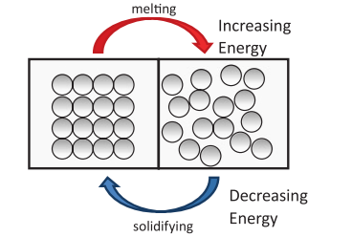

Figure 1. The melting/solidification process

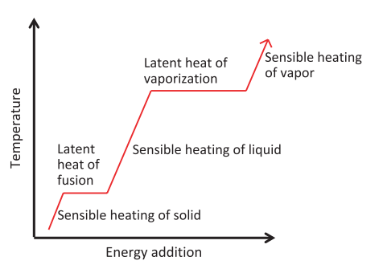

Figure 2. Standard heating curve
It can be seen in Fig. 1.2 that the latent heat of vaporization is a higher energy process than the latent heat of fusion. Therefore, you might wonder why PCMS are utilized for their latent heat of fusion rather than their latent heat of vaporization. It is true that in general that the boiling/condensation process absorbs/and releases more energy, but the density change from a liquid to a vapor is large, and working with boilers and condensers often requires a significant amount of support equipment which is not always convenient. There are of course many applications for boiling heat transfer, but here we will concentrate on the applications for which a solid-liquid phase change process is most advantageous.
The amount of energy absorption or release during the melting-solidification cycle is governed by the value of that material’s latent heat of fusion. The latent heat of fusion is commonly expressed in units of J/g or kJ/kg. Thus the process is a mass-based process. The amount of energy absorbed by the material during melting depends solely on the mass of material present in the design. The rate at which the material melts is governed by the operating conditions. For instance, water (ice) has a latent heat of fusion of 333 kJ/kg, so 1 kg of ice will require a heat input of 333 kJ to melt. The rate at which the ice melts depends on the heat transfer process. How quickly can the heat be transferred into the ice? The applied heat flux and the temperature difference from the heat source to the melt point will govern this process. Thus it becomes clear that 1 kg of ice will not increase in temperature if it is melted using a blow torch, rather than being left out on the kitchen counter, and it will not take more energy to melt, but the ice melted with the blow torch will certainly melt faster due to the increased heat flux and increased temperature differential

Energy storage through solid-liquid phase change is inherently a transient process. The material is either absorbing or releasing energy as its melts or solidifies. Thus this type of system is not particularly well suited for applications that operate primarily in steady-state conditions. Instead it is best suited for systems that experience repeated transients, such as on-off cycles, periodic peaking cycles or which require thermal energy storage for later use.
Systems that operate in off/off or peaking load cycles will use PCMs for what is referred to as thermal management. In these applications, the energy that is being released is absorbed into the PCM in order to prevent overheat elsewhere in the system. When the duty cycle has finished, the stored energy is released to the ambient and the PCM solidifies in preparation for the next peak energy event. A common example of this type of system is the on/off or high use/low use cycle of many portable electronics. As the system transition into high use mode, additional energy is dissipated when compared to the baseline case. This energy can be absorbed in a PCM at constant temperature. As long as the PCM melt cycle is longer than the duty cycle of the electronics, the system should not increase in temperature. Once the duty cycle ends, the hot PCM dissipates its heat into the environment as it solidifies. This type of application requires PCMs which respond well to rapid transients. The heat must penetrate quickly and effectively into the PCM mass, leading to congruent melting throughout the system. The system should also be designed for maximum melting times of the PCM in order to extend the operational range of the duty cycle as long as possible. This type of application can also include solid state electronics, battery pack thermal management and human comfort systems such as military uniforms or sports equipment.
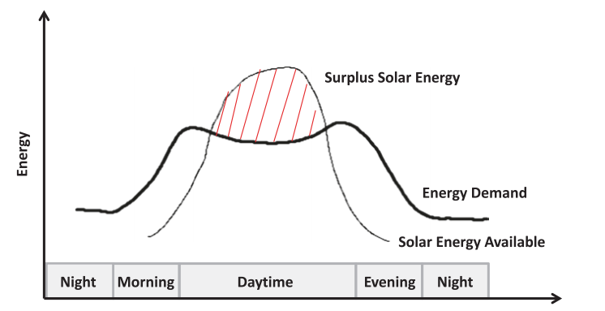
Systems that require storage of thermal energy for later system usage will use PCMs for what is referred to as thermal energy storage or TES. In these applications, during times of excess energy production, some of that thermal energy can be diverted into a storage system where it is kept for utilization at a later time period. The storage system features a solid PCM which slowly transitions to a liquid at constant temp as the thermal energy flows into the material. The energy is thus stored in within the material itself, and can easily be extracted by solidifying the material.
Figure 3. Thermal energy storage for solar power plants
This application is quite different from thermal management applications because here the thermal energy is the desired product. A common example of this type of system is a solar energy power plant. Many large scale solar energy plants provide a surplus of energy at certain times of day. If the plants can be designed to store the surplus energy for use during times of decreased supply, the plant will operate more economically and efficiently as seen in Fig. 1.3. Despite the difference in the operational characteristics when compared to thermal management applications, TES applications have many of the same PCM requirements. TES applications do not require the extended melt times of the thermal management cases, but do require high latent heat materials in order to store as much energy as possible. As before, it is best if the PCM responds respond well to rapid transients for better operation during the system switch to stored energy and the heat must penetrate quickly and effectively into the PCM mass. This type of application can also include high efficiency heating and air conditioning systems, domestic hot water systems, and advanced building materials.

Important PCM Material Properties
There are many different types of PCMs available, but the vast majority fall into three main classifications: organics, inorganics, and liquid metals. This chapter is devoted to looking at each of these main types in depth. However, there are several material selection considerations that are common to all PCM applications, regardless of primary material types, so we will explore those first.
First and foremost, the melting point is the property of primary consideration when choosing a material. An obvious consideration is that the melting point of the PCM must be both below the temperature of the heat source and above the ambient conditions to which the device will be exposed. Certainly, it does not make sense to choose a material which will already be in liquid phase before absorbing heat from the intended source. When choosing the operating point, one must also be certain to consider all the extremes in temperature to which your device will be subjected. For instance, in designing PCMs for portable electronics—what are the highest possible ambient temperatures to which your device may be exposed? Will the PCM be as effective if we have a global market?
For systems that are designed preferentially for thermal management (maintenance of a specific operating point), the general guide is to pick a PCM with the highest possible melt point that is still below the desired thermal control point. For instance, if the desired operating point of a portable electronic system is 80 °C, then it will be advantageous to select a PCM with a melt temperature range around 70–75 °C. The advantage to using a high melting point material in these situations is that it leads to a longer melting time, and thus a longer effective thermal management duty cycle before the PCM is completely melted. Systems with a higher melting point will dissipate more heat to the ambient while simultaneously melting, due to the higher differential from the system to the ambient, thus extending the melt time. A study by illustrates the effect of PCM melt temperature by comparing the transient absorption time for two PCMs with similar latent heats, but different melt temperatures. Changing the selected PCM from one with a melt temperature of 36 °C to one with a melt temperature of 44 °C, with all other system variables held constant, extended the transient melting time, and thus the effective operation of the system, by 50 %.
Once you have narrowed in on a desirable melt range for the PCM, the second most important criterion is generally the latent heat of fusion of the material. The latent heat is the measure of how much energy can be stored in a specified mass of material (kJ/kg) during melting and released during solidification. The higher the latent heat of fusion, the more energy efficient the system is, and the less mass can be used, minimizing the size of the system. You want to select the material with the highest latent heat of fusion with a melt temperature in the range previously
determined.
Materials with high latent heats of fusion also tend to have relatively high specific heats. Specific heat refers to the amount of energy it takes to raise one kg of mass of the material one degree kelvin and is reported in units of J/kg K. For energy storage applications, having a high specific heat is as advantageous, as having a high latent heat of fusion. This is because a significant amount of energy can then be stored during both the sensible heating stage (as the PCM approaches the melt point) and during the latent heating phase (through the melt transition).
There are several other criteria that should be considered when selecting a PCM material. The material should exhibit stability, both chemically and physically over repeated thermal cycling with repeatable and consistent melting/freezing cycles. Certain PCMs may break down
over extended cycling, so one must be aware of this possibility. The compatibility of the selected material with the casing and other materials should also be considered as certain PCMs tend to be corrosive and/or chemically incompatible. It is also preferred that the PCM be environmentally safe, nonflammable and nontoxic.
Many PCMs exhibit a density different between the solid and liquid phase, which in most cases leads to contraction upon solidification. This density difference must be considered in the design of any containment structure.
Finally, it is desirable for the PCM to have a high thermal conductivity to prevent thermal bottlenecking at the source, although it is challenging to find materials that have both high latent and specific heats as well as high thermal conductivities. In most cases, the desire to store more energy (high latent heat) will win out over the need for high thermal conductivity simply due to the nature of the applications. From the above discussion it can be seen that the
thermal properties of greatest interest in PCMs are the melt temperature, the latent
heat, specific heat, and thermal conductivity.

1.3 Types of PCMs and Their Selection

1.3.1. Organic PCM
Organics are arguably the most popular type of PCM. Organics can include a wide range of PCMs such as those in the alkane (paraffin) family (CnH2n+2), and the fatty acids family (CH3 (CH2)2nCOOH). The organic PCMs tend to be abundantly available, relatively inexpensive and easy to work with. As seen in Fig. 2.1, the alkanes and the fatty acids have similar physical characteristics, exhibiting a white surface which is soft and waxy in appearance.
The organics, specifically paraffin, are the most commonly studied PCMs for electronics thermal management. The melt range of materials in the paraffin family tend to be from 35 °C to about 70 °C, depending on the specific hydrocarbon structure, making them an excellent match with electronics which have a maximum junction temperature of around 85 °C. Many researchers, are using paraffin based PCMs for thermal management of electronics and there is a significant amount of ongoing work to fully classify and characterize the thermal properties of different paraffin’s in both the solid and liquid phases to enable their effective use in systems .Despite their popularity, it remains challenging to find accurate thermal property data for the different organics, particularly when the materials are in the liquid phase.

Fatty acids have lower melting points than paraffin’s, making them better suited for applications related to human comfort. For example, mixtures of fatty acids such as stearic acid, lauric acid and capric acid have been embedded in mats of polyacrylonitrile fibers and in diatomite, perlite and vermiculite .In these cases the fatty acid PCM composite materials were intended for use as energy storage building materials with the aim to reduce HVAC costs.
For organic PCMs, it is typically more accurate to speak of a melt range, rather than a melt temperature. A specific melt temperature implies a sharp gradient in behavior, whereas for most organic PCMs, the melt occurs more slowly over a range of temperatures. This can be seen most clearly considering a transient heating curve. Figure 2.2 shows a heating curve resulting from the use of the differential scanning calorimetry (DSC) technique to measure an organic PCM’s specific heat, latent heat and melt range. Differential scanning calorimetry measures the changes in the heat capacity of a material as temperature increases. This allows one to determine both the specific heat of the material by tracking changes in capacity when the material is purely solid or purely liquid, and also the latent heat of the material as it transitions from solid to liquid over the melt range. The melt range is commonly known as the “mushy zone” during which the PCM first softens and then melts. The melt range can be seen in Fig. 2.2. The mushy zone begins as the heating curve begins to dip around 319 K and peaks at the peak melt point of 331 K. The mushy zone for paraffin’s is wider than for fatty acids, and can be several degrees. Blended paraffin’s, like those commonly available from commercial suppliers, can have mushy zones which extend 10–20 °C as seen here. Paraffin’s also commonly exhibit a solid-solid phase transition prior to melting, which can also be seen in Fig.2.2.
There are many advantages to using the organic PCMs. Chief among these are melt temperatures that match well with the electronics thermal management and building systems management applications. Organics also have high latent heats of allowing them to store a high amount of energy in a smaller mass. Common paraffin’s exhibit latent heats in the range of 200–300 kJ/kg and fatty acids in the range of 100–200 kJ kg.
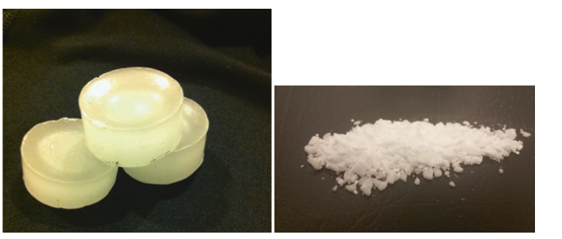
Figure 4. Paraffin wax (left) and stearic (fatty) acid (right)
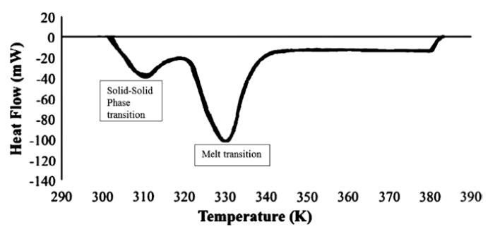
Figure 5. Example DSC curve for paraffin

Table 1. Thermal properties of some common organic PCMs
Name | Type | Tm(°C) | Latent heat(kJ/kg) | ρ (kg/m3) | Cp (kJ/kg) | K(W/mK) | References
Octadecane | Paraffin | 29 | 244 | 814 (sol)  724 (liq) | 2150 (sol)  2180 (liq) | 0.358 (sol)  0.152 (liq) | [1]
Heneicosane | Paraffin | 41 | 294.9 | 773 (liq) | 2386 (liq) | 0.145 (liq) | [2, 3]
Tricosane | Paraffin | 48.4 | 302.5 | 777.6(liq) | 2181 (liq) | 0.124 (liq) | [2, 3]
Tetracosane | Paraffin | 51.5 | 207.7 | 773.6 (liq) | 2924 (liq) | 0.137 (liq) | [2, 3]
IGI 1230A | Blended  paraffin | 54.2 | 278.2 | 880 (sol)  770 (liq) | 2800 (liq) | 0.25 (sol)  0.135 (liq) | [4, 5]
Oleic acid | Fatty acid | 13 | 75.5 | 871 (liq) | 1744 (liq) | 0.103 (liq) | [2, 6]
Capric acid | Fatty acid | 32 | 153 | 1004(sol)  878 (liq) | 1950 (sol)  1720 (liq) | 0.153 (liq) | [7]
Lauric acid | Fatty acid | 44 | 178 | 1007 (sol)  965 (liq) | 1760 (sol)  2270 (liq | 0.147 (liq) | [7]
Palmitic acid | Fatty acid | 64 | 185 | 989 (sol)  850 (liq) | 2200 (sol)  2480 (liq) | 0.162 (liq) | [7]
Stearic acid | Fatty acid | 69 | 202 | 65 (sol)  848 (liq) | 2830 (sol)  2380 (liq) | 0.172 (liq) | [7]

The properties of several common organic PCMs can be found in Table 3.1. There are several comprehensive reviews available that list the available properties of many more possible organic PCMs and combinations of organics PCMs. In some cases, using blended organic PCMs allows customized melt temperature ranges and specific thermal properties which can be tailored to the specific application. Thermal engineers are urged to treat these reported values as guidelines as it becomes clear from a review of the literature that in many cases there are conflicting values of organic PCM thermal properties reported and the discrepancies as be as high as 10–50 % from source to source.

1.3.2. Inorganic PCMs
The family of inorganic PCMs includes the salts and salt hydrates. Salt hydrates are combinations of members of the inorganic salt family (oxides, carbonates, sulfates, nitrates and halides) with water molecules in a specific ratio. Salt hydrates are named using the name of the salt compound *n H2O. Common salts and salt hydrates used as PCMs include MgCl2 · 6H2O, CaCl2 · 6H2O, Na2SO4 · 10H2O (Glauber’s Salts), NaNO3, KNO3, KOH, MgCl2, and NaCl. Salts and salt hydrates have similar characteristics. The salt hydrates exhibit a three dimensional structure which is open enough to allow water molecules to fit inside the crystal lattice. Figure 3.3a shows the crystal structure of Calcium Chloride which easily absorbs H2O to become Calcium chloride hexahydrate. The crystal structure is seen to be quite open in comparison to the tightly packed crystal structure of NaCl shown in Fig. 3.3b which is not easily hydrated. All of the salts and salt hydrates exhibit a well-defined crystalline structure. Physical samples of salts and salt hydrates are seen in Fig. 3.4.
Salts and salt hydrates can be found with melting points over a very wide range of operating point from 10 to 900 °C. In the lower melt temperature ranges, where the melting points overlap with those of the paraffin’s and fatty acids, salts and salt hydrates are not commonly used. However, in the higher melt temperature ranges the inorganics become the primary choice for PCMs. Inorganics are widely used in solar energy applications where the melt temperatures are extremely high, such as in concentrating solar plants. Currently the operating concentrating solar plants are using inorganic salts entirely in the molten phase to store energy using sensible heat. This is possible due to the high specific heat that these salts and salt hydrates possess. However, much research is ongoing in the solar field in order to take advantage of the latent heat as well as the sensible heat capability of these materials in order to store even higher amounts of energy for use during times in which incident sunlight is not available [8, 9].
Few of the organics are suitable for use in applications above 100 °C, so the extended range of the inorganics (up to 900 °C) is noteworthy. The inorganics have sharp transitions at the melt point, rather than exhibiting an extended mushy region, have latent heats that are comparable to the organics, and have higher thermal conductivities than the organics, although in many cases their thermal conductivity still needs to be further enhanced. The inorganics also exhibit smaller density changes as they transition from liquid to solid, reducing containment issues. The inorganics have higher densities than the organics, which can be either a positive or negative depending on the application. The higher density results in a higher mass for a given volume, which can lead to greater energy density since energy is stored on per unit mass basis. This is beneficial in most cases. However, it can also lead to greater weights, which can be detrimental in some applications.
However, despite these advantages, in all applications except the high temperature ranges where few options exist, the negative attributes of salts and salt hydrates limit their implementation. The most significant issue with salt hydrates is that they exhibit significant instabilities. The hydrates tend to dehydrate as the water is driven off during the heating cycles, leading to breakdown of the material itself, and all of the salts exhibit a tendency to break down and separate into constituent parts over repeated cycling Several studies have examined the instability of these materials and note their limited application at this point [10, 11].
The inorganics tend to aggressively attack many common casing materials making their design implementation challenging. Thermal engineers are cautioned to check all compatibilities careful before working with the salts and salt hydrates. Despite their corrosiveness however, most of the inorganic salts are not highly flammable or combustible.
Finally, the inorganics tend to exhibit a high propensity towards supercoiling, meaning that they do not begin to freeze at their solidification point, but instead can require substantial sub cooling before solidification nucleation begins. This is a form of undesirable instability that makes it difficult to solidify the melted PCM for the next thermal cycle. This can be solved to a degree by using nucleating agents with a selected PCM. The nucleation agents provide a surface from which the crystal formation can more readily occur, greatly reducing the rate of supercoiling. For example NaCl at low seed rates (<1 %) can provide nucleation initiation sites for CaCl2 · 6H2O. In one study, 1 wt% NaCl in calcium chloride hexahydrate eliminated phase separation and improved supercoiling over 1000 thermal cycles [12].
The properties of several common inorganic PCMs can be found in Table 3.2. As with the organic PCMs there are comprehensive reviews available that list the available properties of many more possible organic PCMs and combinations of organics PCMs and thermal engineers are urged to treat these reported values as guidelines as in many cases there are wide ranges of inorganic PCM thermal properties reported.
Table 2. Thermal properties of common inorganic PCMs
Chemical  formula | Name | Peak melt  point (°C) | Latent  heat  (kJ/kg) | Density  (kg/m³) | Thermal  conductivity  (W/m K) | Ref
MgCl₂ ·6H₂O | Magnesium  chloride  hexahydrate | 117 | 168.6 | 1450 (liq)  1569 (solid) | 0.579 (liq)  0.694 (solid) | [7]
CaCl₂ · 6H₂O | Calcium  chloride  hexahydrate | 29 | 170-192 | 1562 (liq)  1802 (solid) | 0.561 (liq)  1.008 (solid) | [6]
NaSO₄ · 10H₂O | Glauber’s  salts | 32 | 251 | 1485 (solid) | 0.544 | [6]
NaNO₃ | Sodium  nitrate | 307 | 172 | 2260 (solid) | 0.5 | [7]
KNO₃ | Potassium  nitrate | 333 | 266 | 2110 (solid) | 0.5 | [7]
MgCl₂ | Magnesium  chloride | 714 | 452 | 2140 (solid) | NA | [7]
NaCl | Table salt  (sodium  chloride) | 802 | 492 | 2160 (solid) | 5.0 | [7]
KF | Potassium  fluoride | 857 | 452 | 2370 (solid) | NA | [6, 7]

1.3.3. Metal and Metal Alloy PCMs
The family of metal and metal alloys is perhaps the most underused of all the common PCM families, perhaps due to the low latent heat that most of these materials exhibit. However, despite this the metals do show promise in certain applications. The metal and metal alloys PCMs include a number of materials with melting points in the range of desired PCM applications. Many of these metals are easy to work with and have been used for years in other applications requiring molten metals, for example, the hobby of casting tin soldiers. Of course the practice of using lead for many of these low melt point metal applications, such as casting bullets, is now obsolete due to the proven adverse health effects of working with lead. There do remain however, many other promising and easy to work with soft metals which transition in the temperature ranges of interest here.
The metals that exhibit the most promise in low temperature applications are Cesium, Gallium, Indium, Tin and Bismuth, while the metals for high temperature applications include zinc, magnesium, aluminum and their alloys. While metals are not actively used in many applications, they are starting to attract some interest due to their high thermal conductivities and their physical and chemical stability at high temperatures.
The metals and metal alloys cover a wide range of melt temperatures, and exhibit a much sharper melt transition than the organics. Metals such as Cesium and Gallium can melt at ambient conditions on a warm day (28.65 and 29.8 °C respectively), while Magnesium melts at 648 °C and Aluminum melts at 661 °C. Custom alloys can be designed to create tailored melt points for specific applications. The metals exhibit excellent chemical and physical stability and are compatible with a wide range of casing materials, eliminating many of the negative characteristics of the salts.
The metals are the only PCMs that do not suffer from low thermal conductivities, with values that are several orders of magnitude larger than those of the organics and the inorganics. Aluminum of course is well-known for its excellent thermal conductivity (237 W/m K), and while the low melt point metals don’t approach this value, they still exhibit thermal conductivities in the range of 8–40 W/m K, a significant improvement over the 0.2 W/m K of the paraffin family. This characteristic eliminates any concerns about the thermal resistance of the PCM itself and significantly reduces any issues with thermal isolation at the heat source.
The main detriments to the metallic PCMs are their high densities and low latent heats of fusion. The high densities do offset some of the low latent heat concern, as high densities lead to greater energy densities. Larger masses in the same volume will store more energy/volume than low masses. However, the latent heats exhibited by the metals are low enough that the higher energy density can’t entirely offset the low energy storage values, and typically greater masses and volumes are required for metals, leading to weight concerns with the high densities.
The latent heats for the metals and metal alloys can be an order of magnitude lower than organics in the same melt temperature range. For instance, Cesium and Gallium have latent heats of 16.4 and 80.1 kJ/kg respectively while Octadecane has a latent heat of 244 kJ/kg at the same melting temperature. The higher melt temperature metals are more competitive with the inorganic salts, exhibiting latent heats of 300–500 kJ/kg, which is the same range exhibited by the high temperature.
The properties of several common metallic PCMs can be found in Table 1.3. Due to the limited application of metallic PCMs at this point, there are not as many comprehensive reviews of these materials, but [21] may be useful.
Table 3. Thermal properties of common metallic PCMs
Name | Tm (°C) | Latent heat  (kJ/kg) | ρ (kg/m³) | C_{p} (kJ/kg) | k (W/m K) | References
Cesium | 28.65 | 16.4 | 1796 | 0.236 | 17.4 | [13]
Gallium | 29.8 | 80.1 | 5907 | 0.237 | 29.4 | [13]
Indium | 156.8 | 28.59 | 7030 | 0.23 | 36.4 | [13]
Tin | 232 | 60.5 | 730 | 0.221 | 15.08 | [13]
Bismuth | 271.4 | 53.3 | 979 | 0.122 | 8.1 | [13]
Zinc | 419 | 112 | 7140 | 0.39 (sol)  0.48 (liq) | 116 | [14]
Al59-35Mg-6Zn | 443 | 310 | 2380 | 1.63 (sol)  1.46 (liq) | NA | [15]
Al54-22Cu-  18Mg-6Zn | 520 | 305 | 3140 | 1.51 (sol)  1.13 (liq) | NA | [15]
Al65-30Cu-5Si | 571 | 422 | 2730 | 1.3 (sol)  1.2 (liq) | NA | [15]
Al88-Si12 | 576 | 560 | 2700 | 1.038 (sol)  1.741 (liq) | 160 | [15]
Mg | 648 | 365 | 1740 | 1.27 (sol)  1.37 (liq) | 156 | [14]
Al | 661 | 388 | 2700 | 0.9 (sol)  0.9 (liq) | 237 | [14]

1.3.4. Eutectics PCMs
The eutectics are a combination of chemical compounds or elements that has a single chemical composition and solidifies at a lower temperature than any other composition obtained from the same components. The combinations can be organic–organic, inorganic–inorganic, or inorganic–organic. There are numerous eutectic mixtures suitable to be used as PCM, and they are preferred in cooling applications.

1.4. Advantages of PCMs
When compared to the other options available for thermal management and thermal energy storage applications, PCMs are found to have significant benefits. The main options available for thermal management of transient systems are actively cooled air and liquid methods such as fans, cold plates, heat spreaders and heat sinks. The use of PCMs for transient thermal management has the advantage of maintaining a constant system temperature throughout the melt process regardless of applied heat flux. PCMs are lightweight, portable and highly reliable depending only on the characteristics of the material itself, and do not depend on an external flow source such as a fan or pump.
The main options available for thermal energy storage include sensible heat storage and thermochemical storage. Latent heat storage has a much higher energy density than sensible heat storage, resulting in less required material mass and/or smaller storage tank volumes. Latent heat storage systems are also easier to work with than thermochemical storage. The solid-liquid transition results in only a small density change, resulting in smaller system size and less support equipment than when attempting to store thermal energy for long term use through the liquid vapor phase change process.
PCMs, however, are far from perfect solutions. The detriment most commonly cited to their greater utilization is that many PCMs do not have high thermal conductivities or diffusivities, preventing rapid system transients.
The main advantage of PCM is the ability to store large amounts of energy, nevertheless, their thermal conductivity can be more than one order of magnitude higher than typical insulator materials. Thus, the use of PCM or thermal insulator materials or both should take in to account not only the thermal conductivity but the combination of thermal conductivity, heat capacity and density, i.e. thermal diffusivity (in cases of insulator materials) and the combination of thermal diffusivity and the Stefan number in cases of PCM. In the heat equation, PCM will mainly play role in the dynamic term (the heat storage term or left side term) whereas the insulation will influence the steady state term (conductivity term or right side term). In a simple term, PCM will store heat while insulation will actually reduce the heat transfer when temperature difference is present.

1.5. Application of PCM (phase change material):
Applications of phase change materials include, but are not limited to:
Applications of PCM

Industrial
Thermal energy storage

Cooling of heat and electrical engines
Solar cooking

Solar power plants
Computer cooling

Spacecraft thermal systems
Computer cooling

Conditioning of buildings, such as 'ice-storage'

Thermal comfort in vehicles

Thermal protection of electronic devices

Textiles used in clothing

1.5.1. Energy Storage Applications
Energy storage through solid-liquid phase change I inherently a transient process and is best suited for systems that experience repeated transients, such as on-off or periodic peaking cycles, or for those systems which require thermal energy storage for later use. PCMs are commonly used in applications for both thermal management and for thermal energy storage.
Interest in PCMs for thermal management of systems can be traced back at least through the 1970s. NASA in particular was interested in the use of PCMs as what were then referred to as “thermal capacitors” and PCMs were implemented in several moon vehicles and in Skylab. The 1977 NASA tech brief “A Design Handbook for Phase Change Thermal Control and Energy Storage Devices” was one of the first comprehensive PCM references, and is still widely cited and used today.
The concept of embedding PCMs in various types of building materials, such as wallboard and floorboards, in order to create houses and offices with lower heating and cooling loads for greater energy efficiency, also began in the 1970s/80s. Simultaneously, a significant amount of fundamental research was being completed on PCMs, considering in-depth the melting and solidification processes, and the roles of conduction and natural convection on the phase change processes.

1.5.2. Thermal Management of Electronics
The design of electronics over the past five decades has closely followed “Moore’s law” in which processing power doubles approximately every 2 years. This exponential increase in processing power has been a great boon to the field of electronics, but a great challenge for thermal engineers. Particularly when combined with a significant decrease in packaging size, the heat transfer aspects of electronic packaging grow more challenging every year. For reliability reasons, most chip packages are constrained to operate below 85 °C and all the generated heat must be dissipated into the environment during both steady-state and transient operating conditions.
For standard computing systems such as laptops and desktops, the heat loads can usually be dissipated using a heat sink coupled with a fan, assuming enough space exists in the casing for the heat sink geometry. High performance computing systems with higher heat flux loads are increasingly turning to liquid based cooling systems such as cold plates, which then necessitates the use of auxiliary support equipment such as pumps, piping and external heat exchangers. But for portable electronics, one of the largest segments of the consumer electronics market, and which includes tablets and smart phones, possible thermal management solutions are severely constrained by their form factor. The demand for ultra-thin systems precludes the use of large air-cooled heat sinks or pumped liquid loops.
Fortuitously, most portable electronics are used in on/off or peaking duty cycles, which makes the use of PCMs for thermal management feasible. Many tablets and smart phones are in low-power standby mode for most of the day, with random bursts of activity that cause processing power to peak. For these applications, PCMs can be used to absorb these bursts of energy and then to dissipate the stored heat when the peaking cycle has ended. The idea is to have the heat effectively penetrate the PCM when the peaking cycle begins, melting the PCM and maintaining a constant operating temperature. The length of the PCM melt cycle should be matched to common usage time intervals (perhaps 10–30 min). Once melted, the PCM must shed its heat to the environment as it solidifies and “recharges” for the next cycle. The use of PCMs in this application is to delay the onset of steady-state conditions for as long as possible. Once the PCM is fully melted, if the electronics still remain on, the temperature will rise through sensible heating to a steady-state operating condition (See Fig. 2.3).
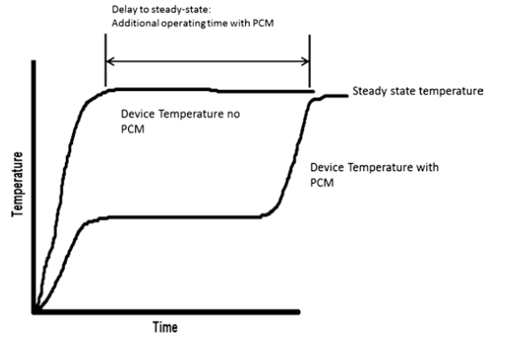

Figure 6. Delay to steady-state of PCM in electronics thermal management
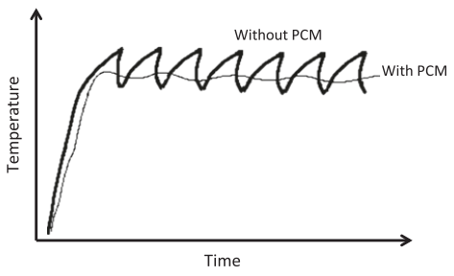

Figure 7. Electronics casing temperature during peaking operation with and without PCM
The use of PCM in this way maintains a more constant temperature of the electronics in peaking operation (see Fig. 2.4), and is a passive thermal solution with no mechanical working parts like fans or pumps, thus increasing reliability. In this case the PCM is used in a thermal management application, not an energy storage solution, since the stored heat is not used productively elsewhere in the system. The PCMs used in these applications typically have melt temperatures between 36 and 56 °C in order to keep the junction temperature well below the 85 °C allowable for integrated circuits. For portable electronics, it is important not only to keep the junction temperature low, but also the casing temperature low in order to protect the user from burns. In general, casing temperature must be maintained below 40–45 °C for safe usage. PCMs based on paraffin are most commonly used in these systems although liquid metal blends are sometimes implemented.

1.5.3. Energy Storage in Building Materials
Energy storage has long been a part of the selection of building materials. From the earliest days, man has wanted to design comfortable dwellings that absorb heat during the day, preventing overheating, and which retain as much heat as possible at night, maintaining a comfortable temperature within. The use of material such as adobe is a prime example. These materials store significant amounts of sensible heat during the day, and release it slowly during the cooler night hours creating a comfortable abode in desert environments.
The use of thermal storage technology in a building can reduce temperature fluctuations and therefore energy use. Thermal energy storage in buildings can be implemented by sensible heat management (increasing and decreasing the temperature of the building envelopes, for example), by latent heat (with the inclusion of phase change materials to increase thermal inertia), or by thermochemical storage (with chemical reactions or sorption systems)
When a material stores heat at phase transition, the heat is stored as latent heat. This material is then known as a phase change material (PCM). A solid-liquid phase change process by melting and solidification can store large amounts of heat if a suitable material is selected. Upon melting, while heat is transferred to the storage material, the material still keeps its temperature constant at the melting temperature, also called the phase change temperature.

PCMs have been studied for thermal storage in buildings since the 1980s.These systems provide a higher thermal inertia to the building which, when combined with thermal insulation, can reduce the energy consumption of the building by absorbing the heat gains and reducing the heat flow. During daytime, the PCM can absorb part of the heat through the melting process, and during the night, the heat is released by solidification of the PCM, resulting in a lower heat flow from outdoors to indoors. This can be implemented in a building as a passive or active system.
It can be seen from this brief overview that PCMs have been shown to be an effective way to reduce energy costs when embedded in building materials. The PCMs can be embedded by direct immersion, microencapsulation or microencapsulation, depending on the host material and application. The primary advantages to using PCM in building materials is their ability to store energy without temperature increase, thus mitigating temperature rise and thus HVAC loading within the building. Several commercial products are now available, and the only barrier to their greater implementation is currently cost and wide scale availability. These materials can be further refined any optimized by addressing issue of melt temperature range to avoid situations where the PCM remains either fully liquid of fully frozen for days at a time, as well as issues of weight and for concrete, structural integrity.

1.5.4. Domestic Solar Applications
While the large CSP plants certainly have significant technical and economic incentives to implement PCM thermal energy storage systems, smaller scale solar systems can also reap some benefits from TES. For example, solar thermal systems can be used by small businesses and homes for hot water production and for heating systems. A small scale solar hot water system with energy storage can be seen in Fig. 2.5. These systems feature a flat plate solar collector, typically mounted on the roof, which features a heat transfer fluid passing through the receiver tubes. The receiver tubes are isolated within an enclosure with a glass cover plate. The enclosure may be evacuated to prevent convective losses. In many ways this is similar to the CSP solar field, but without the concentrators. The lack of concentrators means that the HTF will not reach the high temperatures characteristic of CSP. As such the fluid can’t be used to create vapor and drive a power system, but is hot enough to provide the heat source for a domestic hot water tank. As with CSP, the effectiveness of the system is limited to daylight hours, but the solar thermal system can be designed to store extra heat using PCM in the storage tanks for the overnight hours, greatly reducing dependence on supplemental natural gas or electrical heating.

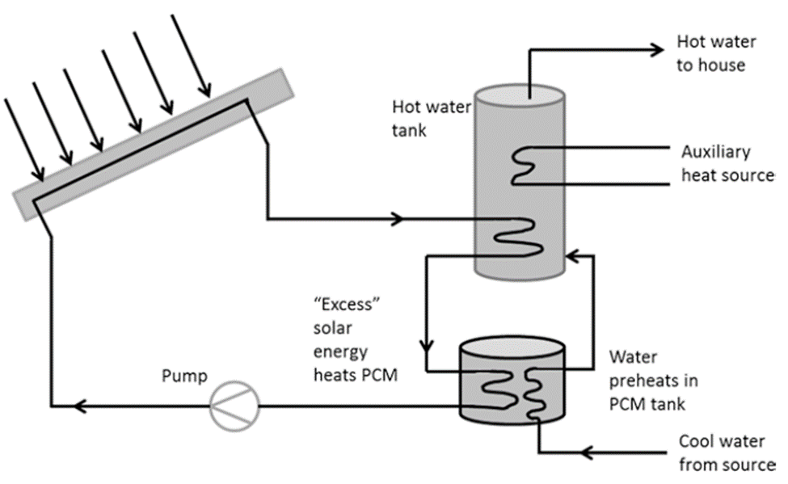

Figure 8. Domestic solar hot water heating system with PCM thermal storage
Thermal energy storage can also be used with solar thermal systems intended to heat air (instead of water) in order to eliminate or reduce the size of HVAC systems. This is particularly useful for solar heating in greenhouse systems. For example, a 180 m2 greenhouse facility with 27 m2 of flat plate solar air collectors used 6000 kg of paraffin wax with a melt range of 48–60 °C as the medium for solar energy storage. A steel tank 1.7 m in diameter and 5.2 m long served as the latent heat storage unit (LHS). While the system was shown to be effective and energy efficient, an exergy analysis found a low net exergetic efficiency, highlighting an issue with the quality and usefulness of the stored heat in this case.
PCM thermal energy storage can also be implemented as part of a solar-aided heat pump system to allow operation during the night and on cloudy days. During times in which solar insolation occurs, the thermal energy is transferred to and stored in the PCM tank and when space heating demands occur they are met using the tank’s stored energy. In this application, a parametric analysis was completed to determine the effect of PCM choice on the solar energy storage time. The PCMs considered were calcium chloride hexahydrate (CaCl2 · 6H2O) with a melt temperature of 29 °C, paraffin with a melt temperature of 47 °C and sodium sulphate decahydrate (Na2SO4 · 10H2O) with a melt point of 39 °C. The lower melt point materials melted more quickly, resulting in a faster charge of the system, but that was offset by a lower quality of the stored heat at the lower temperature. A similar system was experimentally tested for a flat plate solar collector powered heat pump system which was used to heat a 75 m2 laboratory building. CaCl2 · 6H2O served as the energy storage medium.
Of course, if PCM thermal energy storage units are useful for solar assisted heat pump heating systems, then they are also going to be effective with ground source heat pump heating systems. This was shown in practice using a ground source heat pump with thermal storage in CaCl2 · 6H2O to provide heating for a 30 m2 glass greenhouse. Testing over a period from October to May, it was found that the heat pump produced a temperature increase of 5–10 °C, and the Latent heat storage provided an additional 1–3 °C of auxiliary heating.

1.5.5. Packed Bed Designs
Both large scale and domestic scale solar systems are typically arranged such that the energy storage is implemented using PCMs contained within industrial tanks of various sizes. Although the use of heat pipes to transfer and extract stored energy from the tanks these tanks are arranged in packed bed designs. Packed bed designs typically feature large spherical capsules containing PCM closely packed within the tank. The heat transfer fluid flows in, around and over the spheres as it passes through the tank, as seen in Fig. 2.6. In charging flow, a hot fluid will pass through the tank, exchanging heat with each sphere, which contains PCM in the solid phase. The energy exchange through the capsule shell leads to melting within and energy storage within the capsule. For energy discharge flow, the direction of flow is reversed within the tank. Cold fluid now flows through the tank, which warms as it passes over the hot capsules which contain liquid phase PCM. Heat is exchanged from the hot capsule to the colder fluid and the PCM transitions to solid phase
It exchanges energy. Advantages to packed bed systems include the high heat exchange contact area, and the ability to exchange energy in both charging and discharge flow in one single tank, significantly reducing costs over the two tank design. The containment of the PCM within the spherical capsules also leads to simple and reliable implementation of the system.
Packed beds designs have been around for decades, but in most cases the paced bed material does not change phase, featuring only sensible heat storage. The solid material in these designs is a material with a high specific heat, which can store a significant amount of energy through increases in temperature. Common sensible heat packed bed storage materials include concrete, rocks and masonry. If PCMs are used instead of sensible heat storage material, smaller volumes are required to store the same amount of energy through latent heat, thus reducing capital equipment costs.
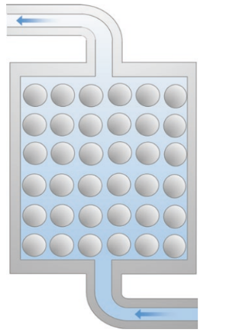

Figure 9. Packed bed design with PCM spherical capsules
The packed bed was modeled in discharge flow during which the PCM slowly solidified as dissipated heat into the fluid flowing through the bed. The high conductivity particles were not found to exert much influence on the initial stage of discharge during which the superheated liquid PCM approached the solidification point. Once solidification began however, and the energy transfer became conduction dominated, the particles exerted a strong influence on energy discharge. The addition of the particles to PCM resulted in quicker energy discharge, leading to a faster warming of the heat transfer fluid and a faster solidification rate of the PCM. This increased energy transfer rate continued throughout the solidification process and also through the supercoiling of the solid PCM. As the supercoiling process is completely conduction based, increases in thermal conductivity are particularly significant.

1.5.6. Heat Exchanger Designs
The PCM is implemented in a heat exchanger type design where the heat from the solar field is used to charge the storage tank. In fact, PCM energy storage heat exchangers can be useful in any system in which an excess heat capacity can be stored for future use through heat exchange from a process fluid into a PCM storage system.
These designs often take the form of a shell and tube heat exchanger system with the PCM on the shell side as seen in Fig. 2.7, although some designs have the PCM on the tube side. The choice of PCM material in these applications will depend on the operating temperature range of the system and can include molten salts for high temperature waste heat recovery and paraffin for lower temperature domestic heating systems.
The effective application of PCM in a shell and tube exchanger for thermal energy storage requires a low thermal resistance between the heat transfer fluid in the tubes and the PCM in the shell. When operating in charging flow, with hot HTF acting to melt the shell side PCM, it is desirable to transfer as much heat as possible as the fluid flows through the tubes. In this case, with melting PCM, the heat transfer will be convection dominant on the outside of the tubes, as natural convection is induced in the shell side. When operating in discharge flow, with the heat extracted from the molten PCM, the heat transfer will be conduction dominant as the PCM solidifies around each tube. Much of the design work in this application has considered methods to reduce thermal resistance in both melting and solidification in order to most effectively transfer heat in and out of the PCM to the flowing HTF.
The PCM is typically installed on the shell side of a shell and tube exchanger and the PCM used will depend on the temperature of the application. The main design concern with PCM implementation in this manner is the reduction of thermal resistance during both melting and solidification. The thermal resistance is often reduced by the use of both internal and external fins on the tubes, and by the use of high conductivity particles in the PCM itself.

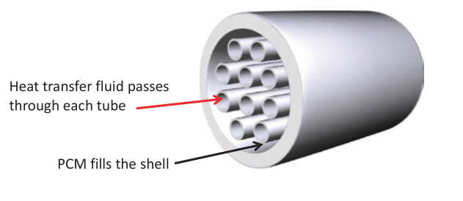

Figure 10. PCM on the shell side of a shell and tube heat exchanger

Numerical Study

2.1. Part1:

2.1.1. 2D-Computational Domain
In present system, 2D geometry of the both heat sinks is considered having fin thickness of 2 mm and 3 mm with adiabatic walls and a heat flux is implemented at the bottom of the system. Coupled with the review study we also performed the numerical investigation using CFD software namely ANSYS V.16.The 2D computational domain was investigated for the software learning purpose. The dimensions the physical domain are mentioned in Table 3.1. The Thermophysical properties of used PCM (n-eicosane) and aluminum are listed in Table 3.2 [16].
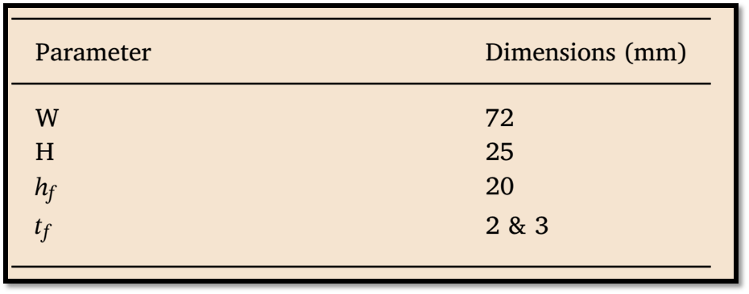
Table 3.1 Dimension of the 2-D physical domain

The heat sinks were made of aluminum with constant volume fraction of 9% which are acting as TCEs embedded with the PCM namely n-eicosane and with fin height of 20 mm.The physical domain were taken from experimental article and designed with respective above mentioned dimension. The physical domain is illustrated in Fig. 3.1.
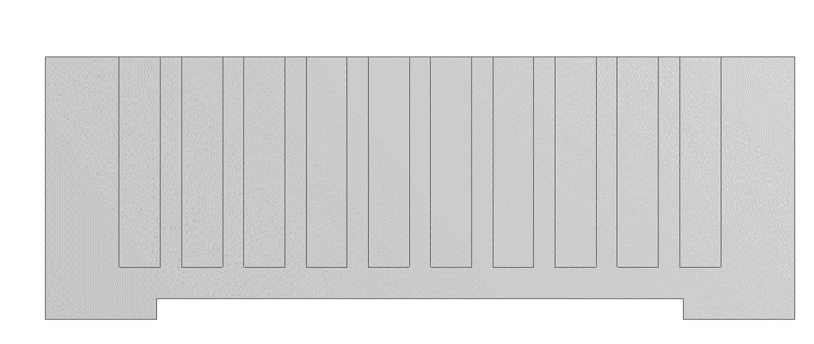

Figure 11. Computational domain for 2D geometry
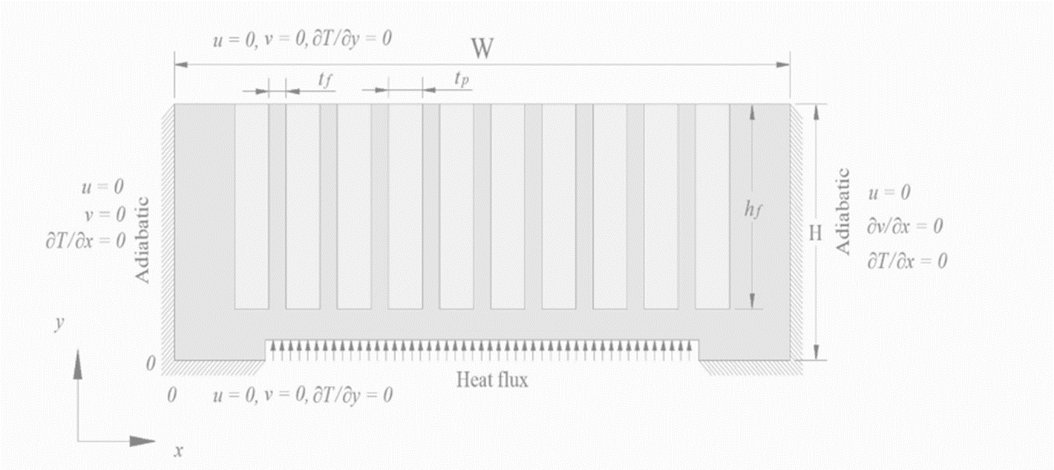
Figure 12. Applied boundary conditions

2.1.2. Grid independence test:

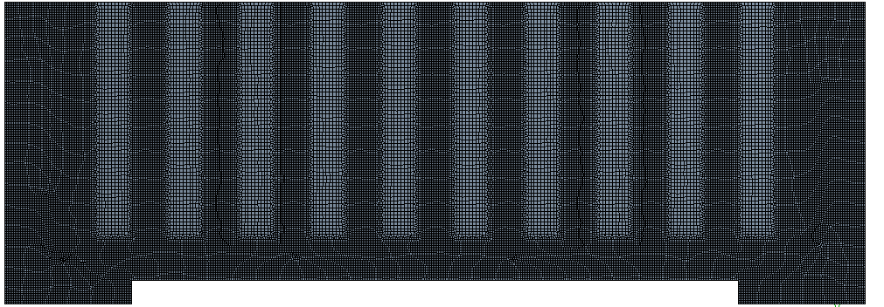
Figure 13. Structured grid shown for 2D computational domain

2.2. Contours:
2.2.1. Mass Fraction:
2.2. Contours:
2.2.1. Mass Fraction:
Fig 14a is demonstrating the mass fraction of PCM at 5min which is 0 at this point; it means that PCM hasn’t started melting yet. Whereas, Fig 14b shows melting after 15min. It is quite apparent that, at the bottom and sides of PCM cavities melting value is comparatively higher than at the center. The variation in solid-liquid interface can also be depicted from the Fig 14b as well. When the liquid fraction is 0, the PCM is fully in solid form and when it is 1 the PCM is fully melted. The region between 0 and 1 is known as the transition region where PCM exhibited both solid and liquid phases called mushy zone. The melting of PCM increases with the increase of time. With the increase of time, the melting region of PCM increases and therefore, a higher value of mass fraction is obtained at an identical time. In addition, the melting of PCM increases with the increase of time at an identical input heat flux, as expected. The rate of PCM melting lower at low input heat flux as compared to high heat flux as the time increases which is due to the rapid heat transfer into the PCM through fins, results in a higher rate of PCM melting.

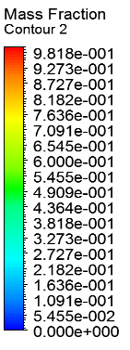
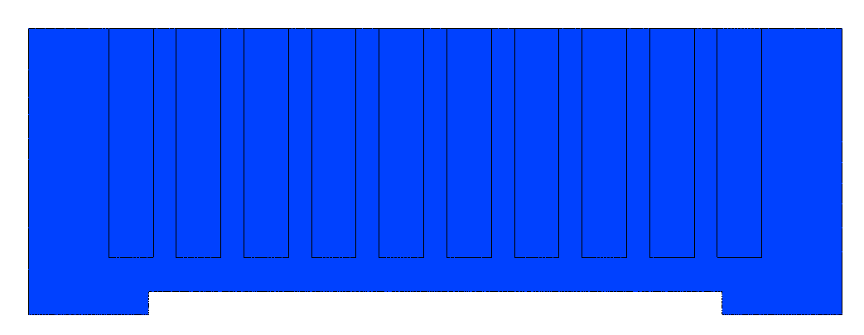 | 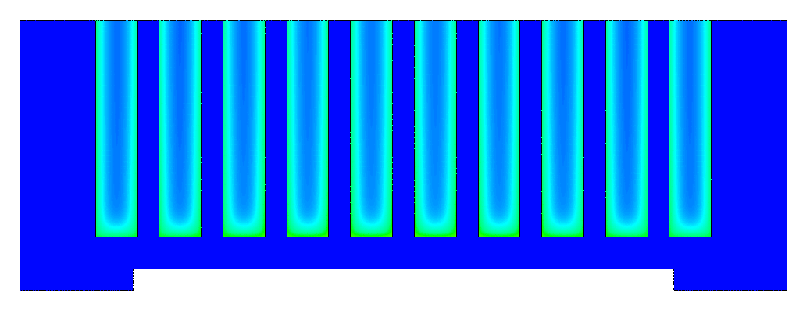
Fig14a: | Fig14b:
Figure 14. Mass fraction contours a) Time=5Min b) TIME=15min

Fig 15a is demonstrating the mass fraction of PCM at 25min which shows even higher melting values at the center. Whereas, Fig 15b shows melting after 35min. It is quite obvious that, n-eicosane has melted to a greater extent and has value of 1 at the sides which shows complete melting from solid state. It can be seen from Fig. 14b, that the PCM did not fully melt even after 15 min of heating. Contrarily, it is fully melted after 35 min. It is revealed that the higher the power level, higher the heat transfer rate results in higher the mass fraction rate or melting rate of the PCM based finned heat sink
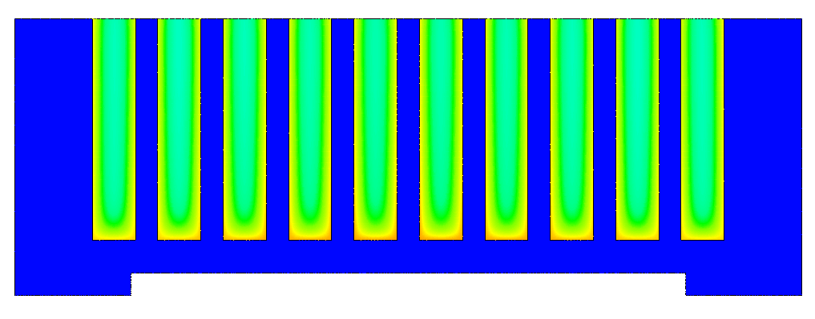 | 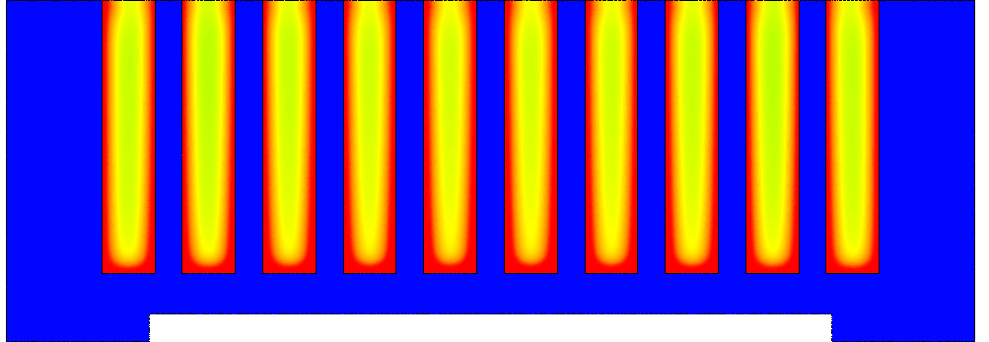
Fig15a | Fig15b
Figure 15. Mass fraction contours a) Time=25Min b) 35Min

2.2.2. Temperature:
The rate of heat transfer in a PCM filled finned heat sink can been from temperature contours shown in Fig. 16, which shows the distribution of temperature inside in the 2 mm and 3 mm fin thickness finned heat sink for different time steps at a power level of 5 W during melting. At a constant input power level, it can be seen clearly that the rate of temperature rise is higher in 2 mm fin thickness heat sink as compared 3 mm fin thickness heat sink in all times. Fig 16a demonstrates even higher value of temperature in the solid and PCM regions at 25min which is around 308.5K and 309.5K respectively. Furthermore, Fig 16b shows the temperature variation after 35min.For example, the temperature varies from 308.5 K to 309.5K for 2 mm fin thickness heat sink at 25 minute.
The higher temperature rise in 2 mm fin thickness heat sink is due the more number of fins compared to the 3 mm fin thickness heat sink. Furthermore, the penetration of heat in PCM region is more in case of 2 mm fin thickness heat sink causing a shorter melting time which can be seen in Fig. 16b especially at time 35 min.

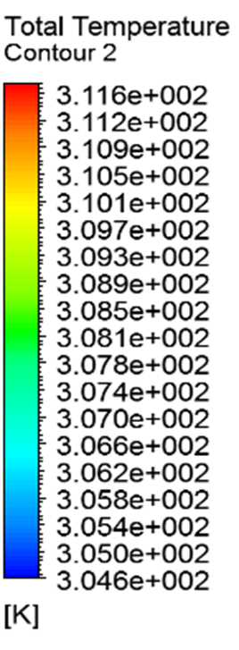
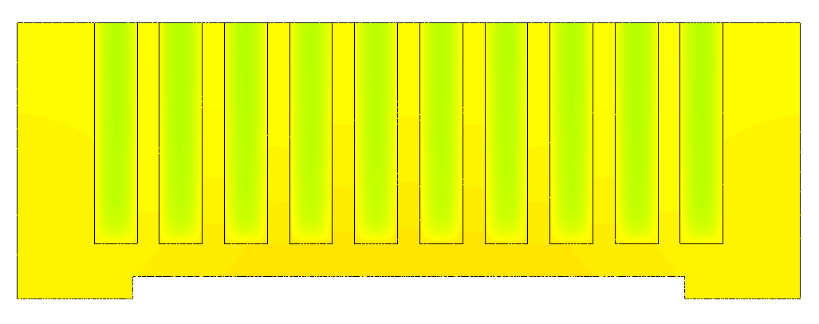 | 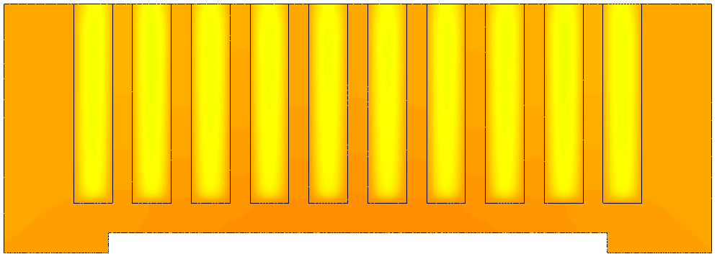
Figure16a | Figure16b
Figure 16. Temperature Contours a) 25 min b) 35 min

2.3 Part 2
Thermophysical Properties: The following table is presented to illustrate the Thermophysical properties of n-Eicosane PCM. This table is taken from the experimental study. 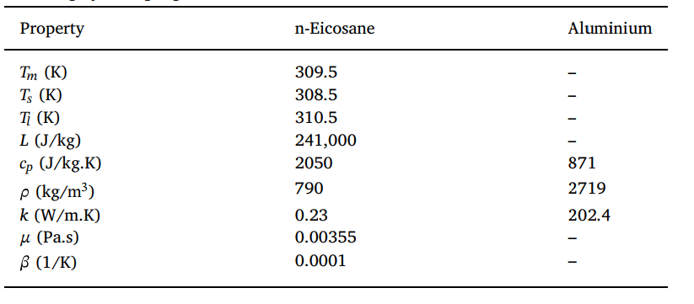

2.3.1 3D- Computational Domain:
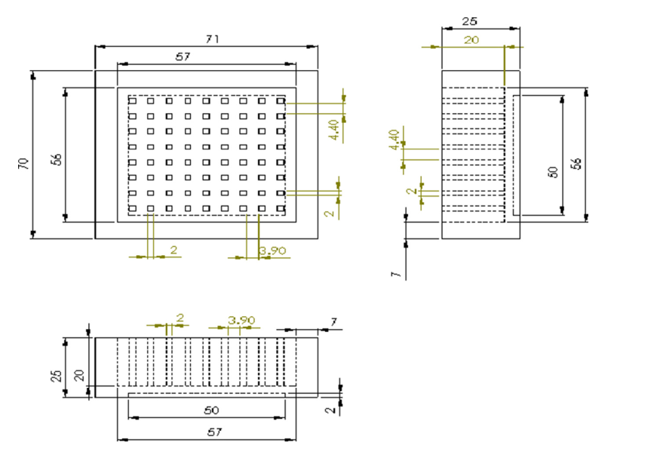
Figure 17a Dimensions of computational domain

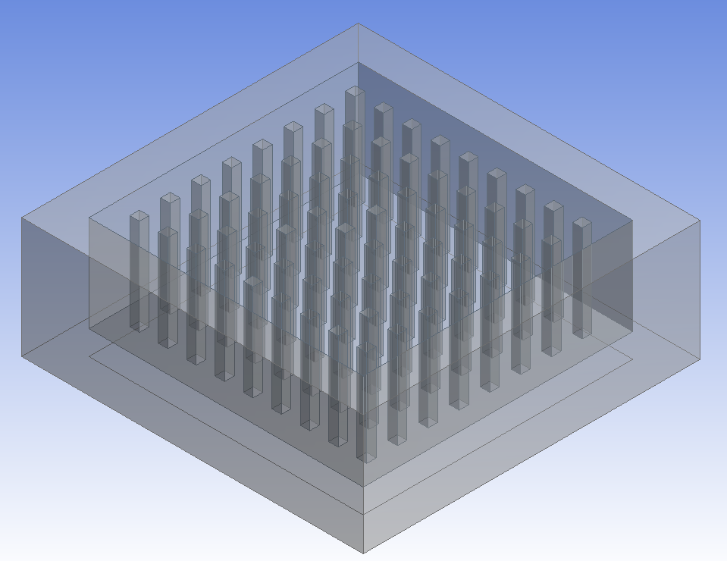
Figure 18b 3D-Computational domain shown in ANSYS WORKBENCH

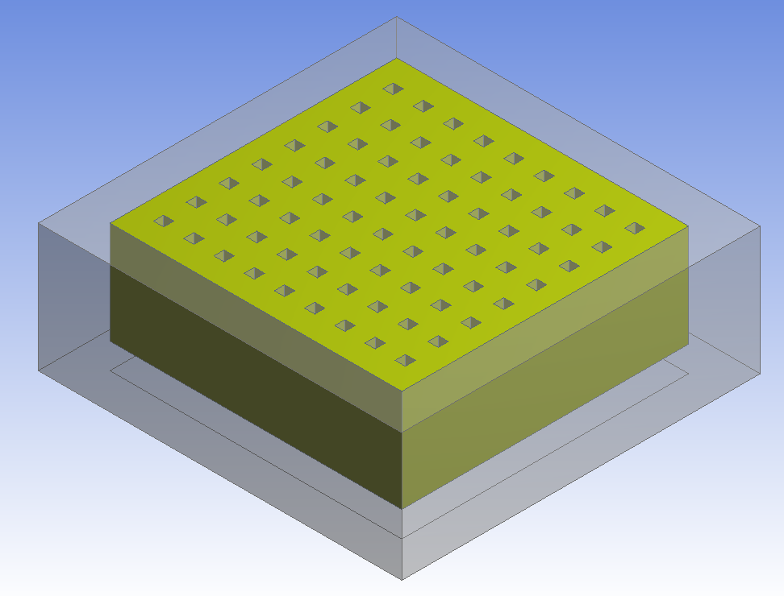 | 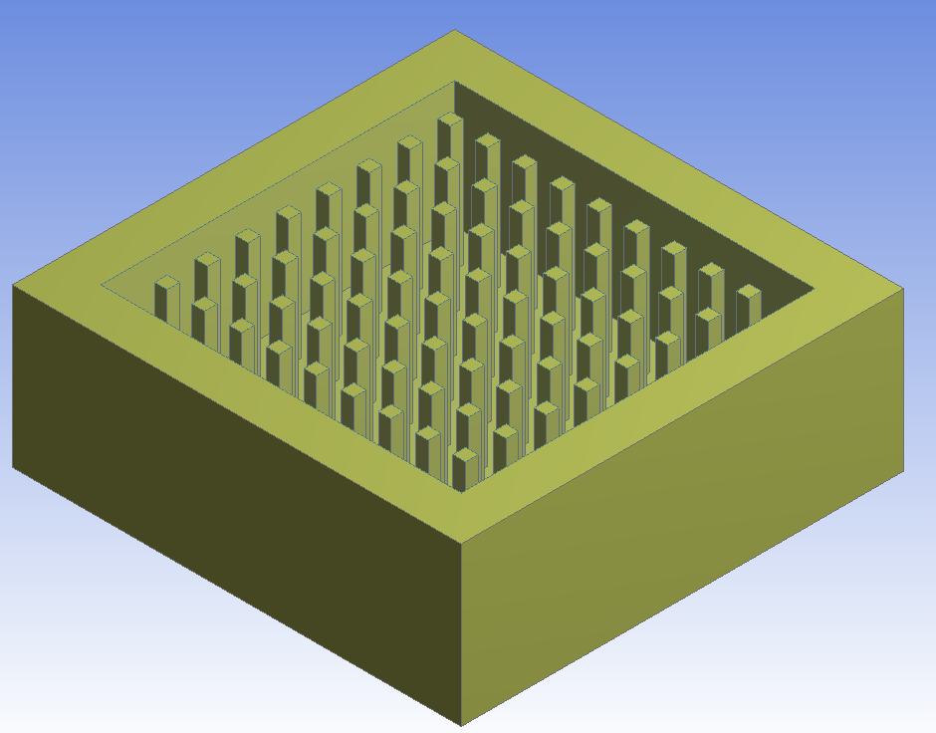
Figure 19c PCM (on the left) and Solid (on the right)

2.3.2 Grid independence test:
The structured mesh was designed in ANSYS for attaining higher accuracy in outcomes. The grid elements were varied from 0.5million to 4millions. 3.5million grid elements were selected for this study as they showed good validation against experimental investigation.
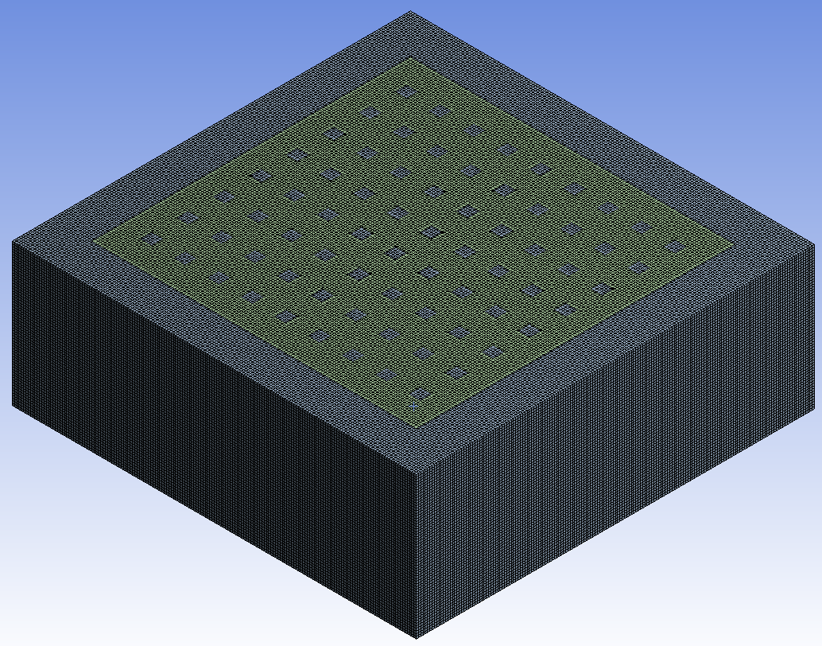
Figure 20. Mesh shown for 3D-Computational domain

2.3.3Validation study
The comparison between the current numerical study and experimental study [] is shown in the following table. It is quite clear that percentage decreases with time between both studies and hence shows the adequate accuracy of this study.
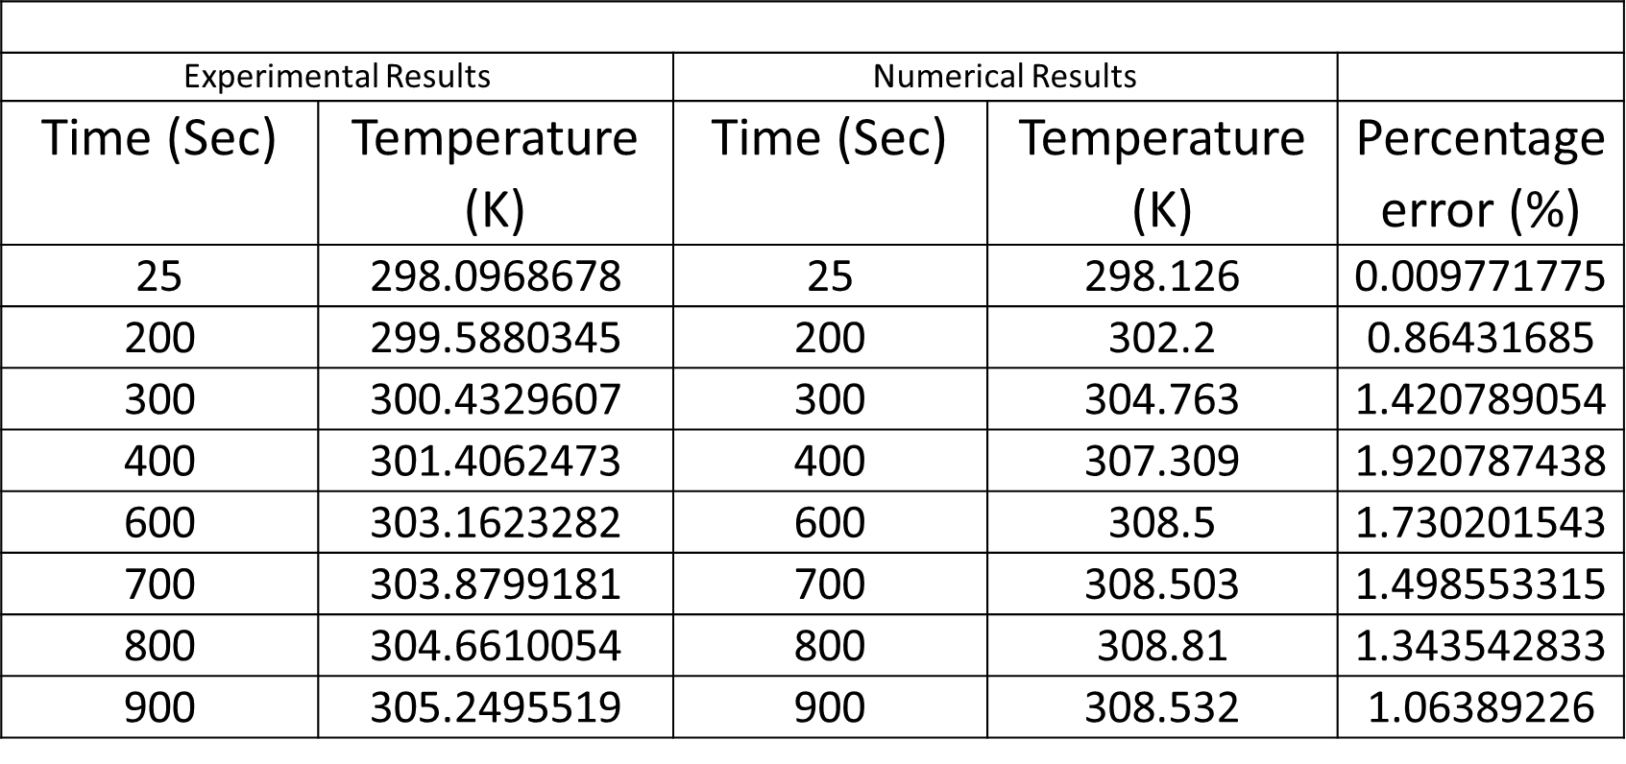

2.4. Contours

2.4.1. Temperature:
Figure21 is presented to show the variation of temperature in solid and fins regions. The temperature in solid region is higher at the bottom and slightly decreases in the upward direction as shown in Fig21a. Due to the inclusion of PCM, temperature is relatively low for the fins as depicted in Figure21b.
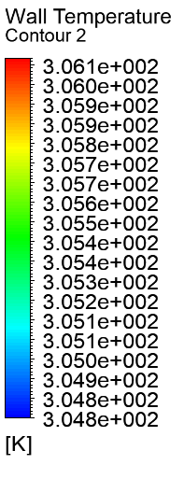
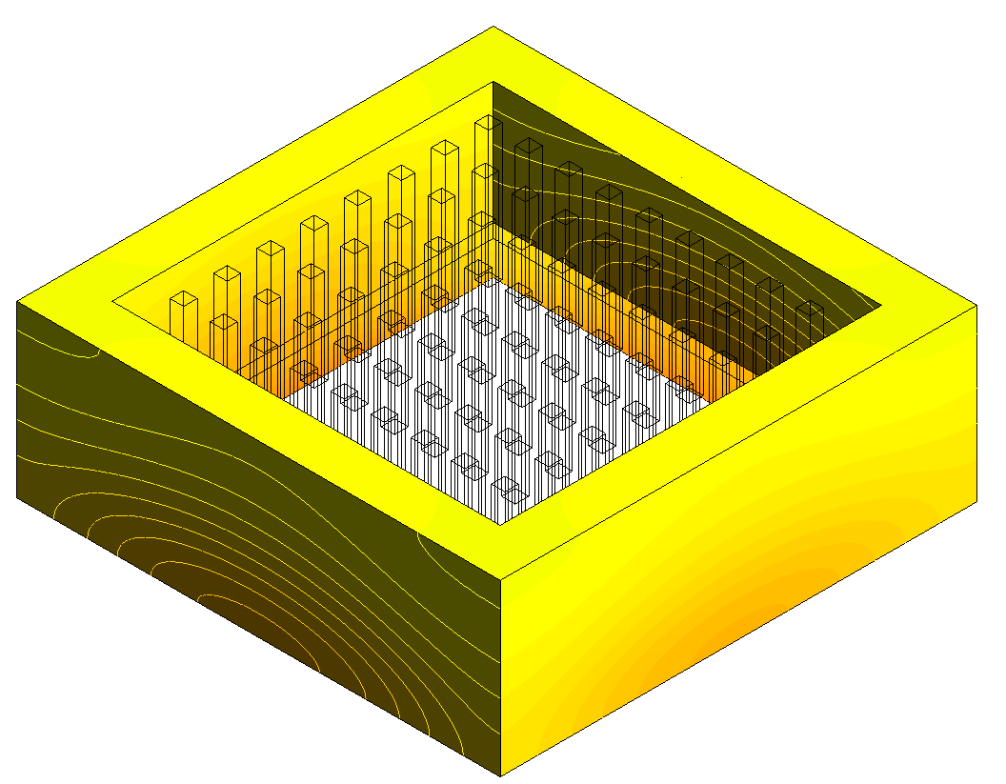 | 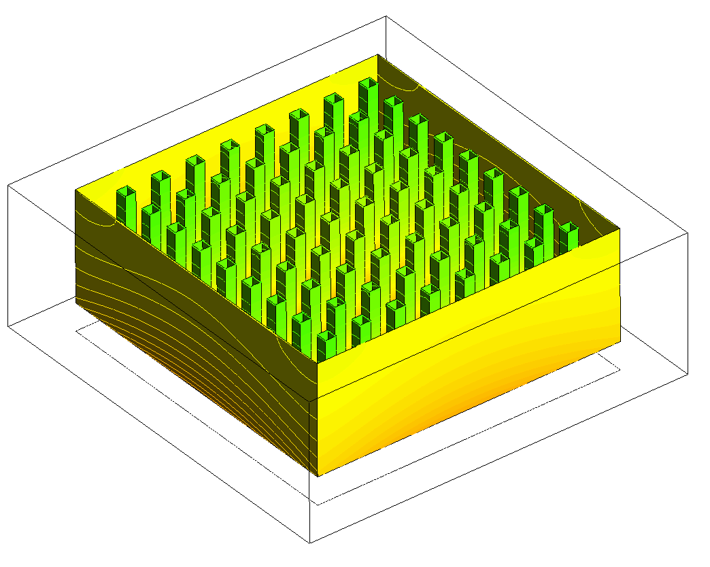
Figure 21a | Figure 21b
Figure 21. Temperature variation in the solid and fins regions at 5min

Figure 22 is demonstrating the temperature variation at 10min. It is quite clear that as the time increases, with the increment in mass fraction, temperature in solid PCM region increases too.
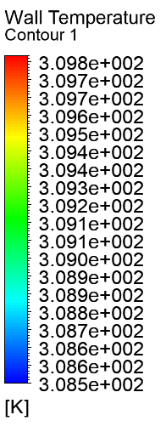
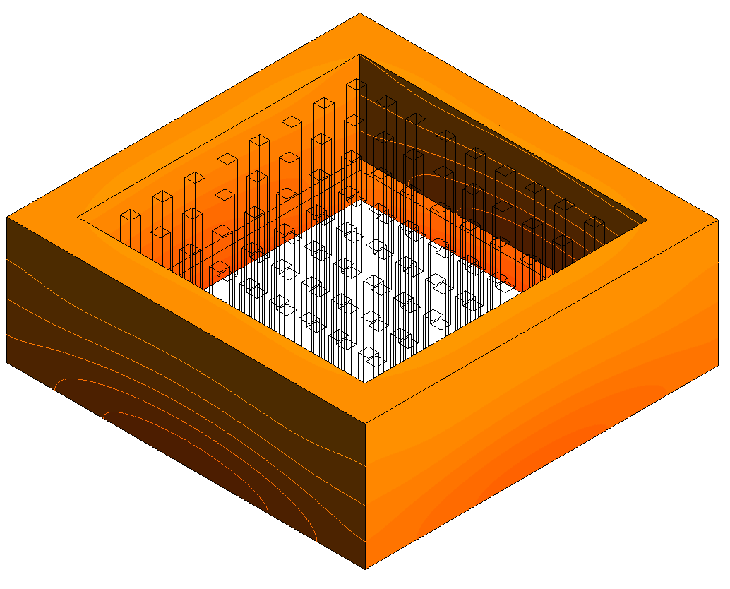 | 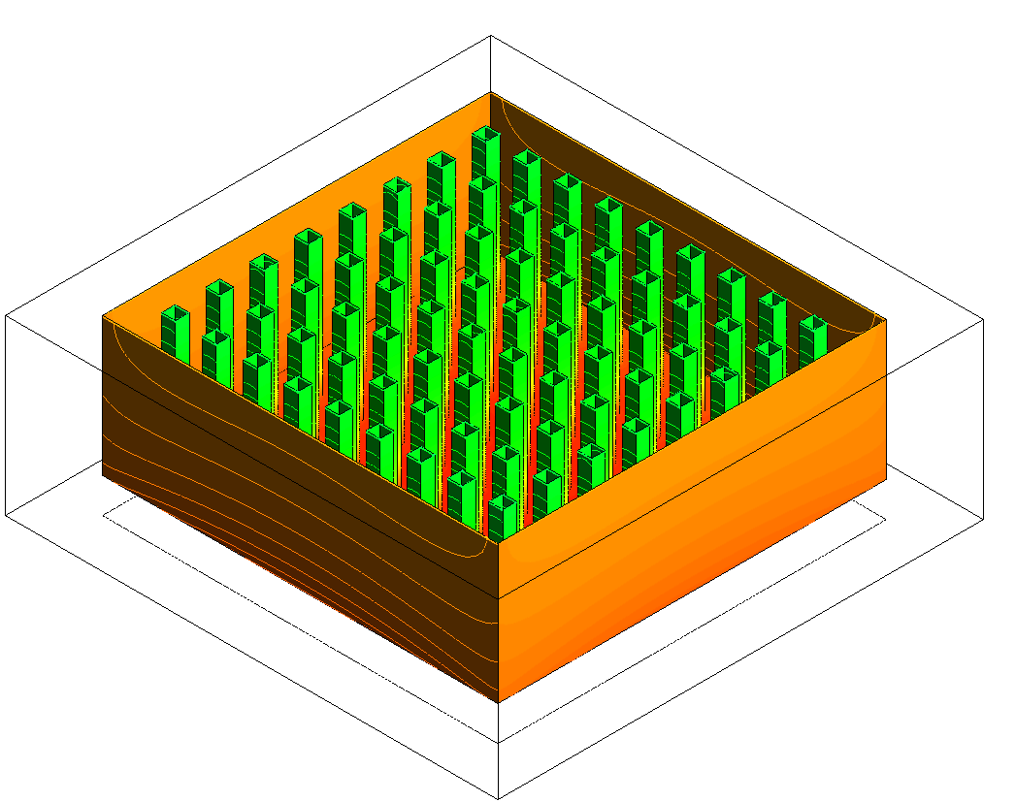
Figure 22a | Figure 22b
Figure 22. Temperature variation in the solid and fins regions at 10min.

Figure 23 is demonstrating the temperature variation at 15min which shows higher values in both regions except Fins. Since, PCM has imparted significant role in decreasing the surrounding temperature even after higher time period.

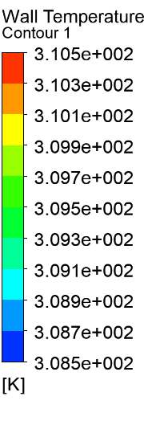
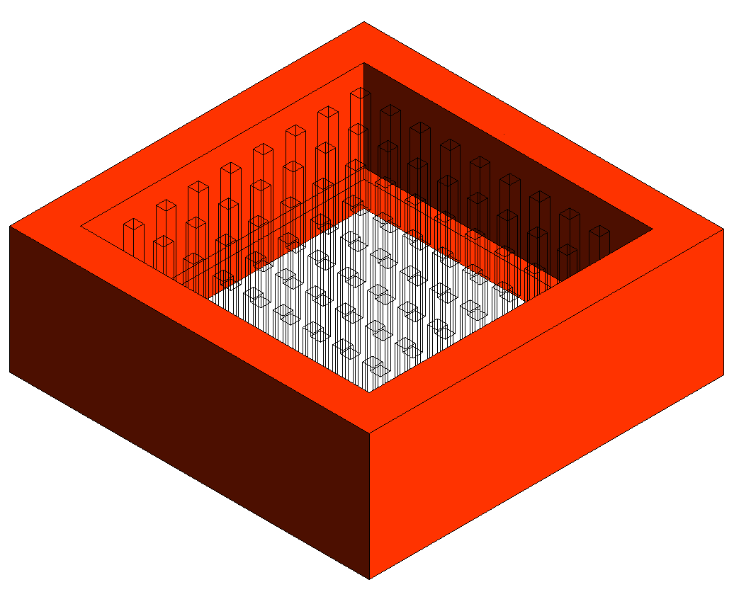 | 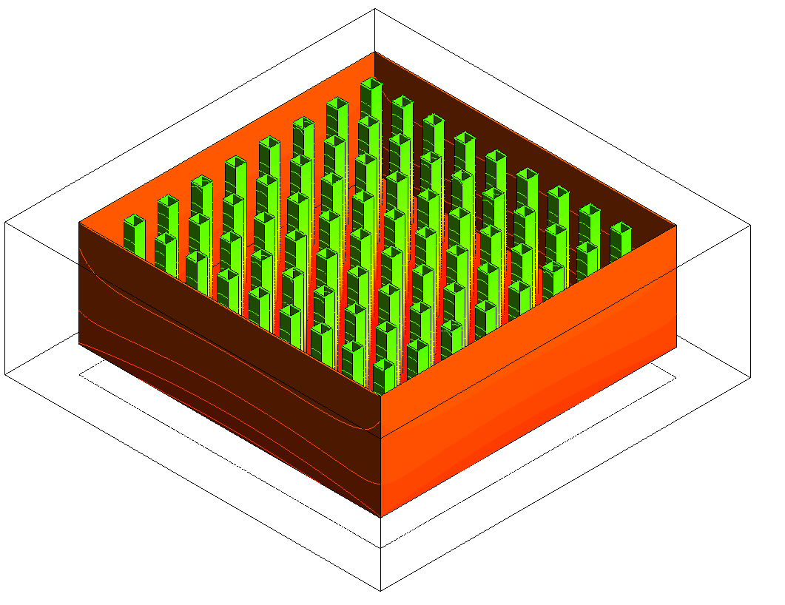
Figure 23a | Figure 23b
Figure 23. Temperature variation in the solid and fins regions at 15min.

2.4.2. Mass fraction:
Figure 24 is presented to demonstrate the mass fraction variation at three different time periods; 5, 10.5 and 15min. It is quite obvious that, as shown in 2D-CFD investigation, mass fraction increases with time which indicates the melting of PCM and hence cooling of heat sink.

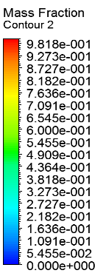
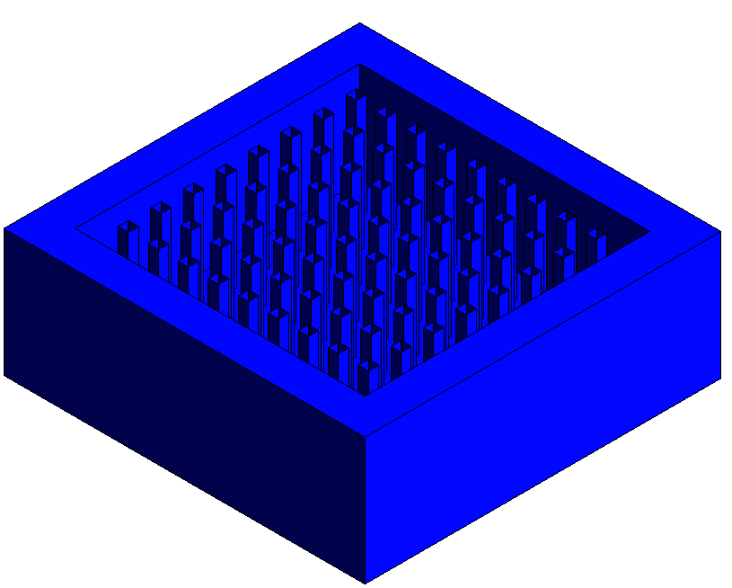  Time=5min | 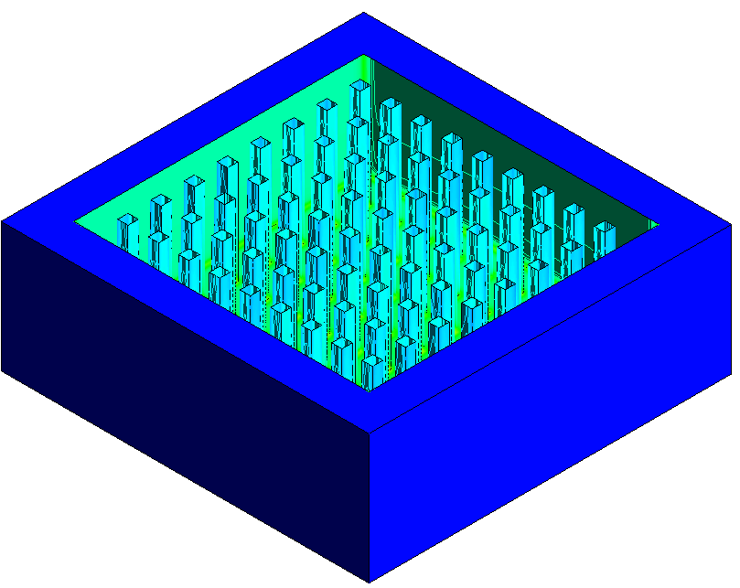  Time=10.5min
Figure24a | Figure24b
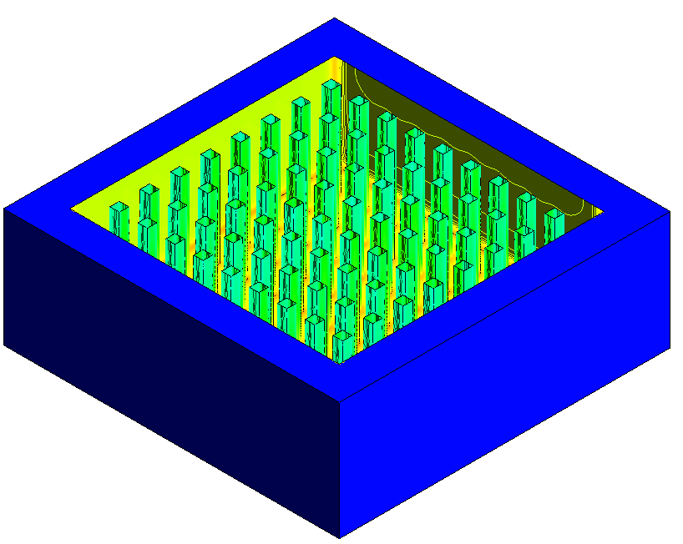
Time=15min
Figure24c
Figure 24. Mass fraction in 3D-computational domain at different time intervals

Conclusions:
- The current study was divided into two different parts; In part 1 review study was performed while part 2 dealt with the CFD investigation.
- PCMs are divided into three different categories; organic, inorganic and Eutectics.
- PCMs are used in various industrial sectors, to name a few they are incorporated in solar power plants, vehicles, Spacecraft thermal systems, electronics etc.
- The implementation of phase change materials in electronics tends to increase its cooling performance through melting-solidification cycle.
- Numerous authors have performed experimental and numerical studies and reported significant influence of PCMs on heat transfer performance of engineering devices.
- The 2D/3D- CFD investigations provided important insights into the implementation of commercial software ANSYS while understanding the use of solidification and melting model.
- Validation study demonstrated trivial discrepancy between the experimental and current (numerical) investigations.
- The numerical investigations showed significant enhancement in the heat sink performance through the use of organic PCM (n-eicosane) and rectangular fins.

Recommendation for researchers:
- The next task will be to create holes in rectangular fins and fill them with PCM to attain higher cooling performance.
- Moreover, fins with different cross sectional can be tested such as oval shaped fins haven’t been implemented before.

References
1. Javani, N., et al., Heat transfer and thermal management with PCMs in a Li-ion battery cell for electric vehicles. International Journal of Heat and Mass Transfer, 2014. 72: p. 690-703.
2. O’Connor, W.E., et al., Thermal property prediction and measurement of organic phase change materials in the liquid phase near the melting point. Applied energy, 2014. 132: p. 496-506.
3. Grodzka, P., Study of phase-change materials for a thermal control system. Huntsville, Ala: Lockheed Missiles & Space Company, 1970.
4. Warzoha, R.J., R.M. Weigand, and A.S. Fleischer, Temperature-dependent thermal properties of a paraffin phase change material embedded with herringbone style graphite nanofibers. Applied Energy, 2015. 137: p. 716-725.
5. Warzoha, R.J. and A.S. Fleischer, Improved heat recovery from paraffin-based phase change materials due to the presence of percolating graphene networks. International Journal of Heat and Mass Transfer, 2014. 79: p. 314-323.
6. Sharma, S.D. and K. Sagara, Latent heat storage materials and systems: a review. International Journal of Green Energy, 2005. 2(1): p. 1-56.
7. Zalba, B., et al., Review on thermal energy storage with phase change: materials, heat transfer analysis and applications. Applied thermal engineering, 2003. 23(3): p. 251-283.
8. Denholm, P. and M. Mehos, Enabling greater penetration of solar power via the use of CSP with thermal energy storage. Solar Energy: Application, Economics, and Public Perception, 2014. 99.
9. Feldhoff, J.F., et al., Comparative system analysis of direct steam generation and synthetic oil parabolic trough power plants with integrated thermal storage. Solar Energy, 2012. 86(1): p. 520-530.
10. Rathod, M.K. and J. Banerjee, Thermal stability of phase change materials used in latent heat energy storage systems: A review. Renewable and sustainable energy reviews, 2013. 18: p. 246-258.
11. Peng, Q., et al., High‐temperature thermal stability of molten salt materials. International Journal of Energy Research, 2008. 32(12): p. 1164-1174.
12. Kimura, H. and J. Kai, Phase change stability of CaCl2· 6H2O. Solar Energy, 1984. 33(6): p. 557-563.
13. Ge, H., et al., Low melting point liquid metal as a new class of phase change material: An emerging frontier in energy area. Renewable and Sustainable Energy Reviews, 2013. 21: p. 331-346.
14.Khare, S., et al., Selection of materials for high temperature latent heat energy storage. Solar energy materials and solar cells, 2012. 107: p. 20-27.
15. Kenisarin, M.M., High-temperature phase change materials for thermal energy storage. Renewable and sustainable energy reviews, 2010. 14(3): p. 955-970.
16. Tyagi, V.V. and D. Buddhi, PCM thermal storage in buildings: a state of art. Renewable and sustainable energy reviews, 2007. 11(6): p. 1146-1166.

