ISLAMIC UNIVERSITY OF TECHNOLOGY
Undergraduate Project


IUT Buy and Sell

Authors
Hamse Hassan Adnan 160040013
ZabihullahAmiri 160040016
Ashraf Ali 160040005

Supervisor:
Mohammad Ridwan Kabir
Lecturer
Department of Computer Science and Engineering (CSE).
A project submitted to the Department of CSE in fulfilment of the requirements
For the Degree of Higher Diploma in CSE.
Academic Year: 2018-2019

November, 2019

Declaration of Authorship
We hereby declare that the work which is being presented in the project entitled “IUT BUY AND SELL WEBSITE” in fulfillment of the requirements for the award of the degree of Higher Diploma submitted in the Department of Computer Science & Engineering, Islamic University of Technology is an authentic record of our own work carried out during the period from August, 2019 to November, 2019 under the supervision and guidance of “Mohamed Ridwan Karim”, Lecturer, Islamic University of Technology.
The matter embodied in this project work has not been submitted for the award of any other degree.
Authors:
Head of department:

_________________ ____________________
Hamse Hassan Adnan Prof. Dr. Md. MahbubAlam
ID: 160040013
_________________ Supervisor:

ID: 160040005____________________
Hamse Hassan Adnan Mohammad RidwanKabir
ID: 160040013 Lecturer
Zabihullah Amiri
_________________
Ashraf Ali

ID: 160040016

Acknowledgements
In completing this project, we have been fortunate to have help, support and encouragement from many people. We would like to acknowledge them for their cooperation.
First, we would like to thank Sir Mohammad Ridwan Kabir our project supervisor, for guiding us through each and every step of the process with knowledge and support. Thank you for your advice, guidance and assistance. We would also like to thank Prof. Dr. Md. Mahbub Alam, Head of Computer Science and Engineering department of Islamic University of Technology who always shows immense patience and understanding throughout the submission of thesis for whole department. Finally, we would like to dedicate this project to our Teachers and our parents, for their love, encouragement and help throughout the whole life.

With Regards,
Hamse Hassan
Zabihullah Amiri
Ashraf Ali

Contents
IUT BUY AND SELL 1
chapter 2 6
Introduction 6
2.1 Purpose: 6
2.2 objectives: 6
chapter 3 7
System Requirement Specifications 7
3.1 Scope: 7
3.2 Objectives 7
3.3 Product Prospective:- 8
3.4 2.Product Functions: 8
3.5 Assumptions and Dependencies: 8
3.6 Specific Requirements: 9
3.7 Hardware requirements: 9
chapter 4 : 10
Implemented Technologies 10
4.1 XAMPP: 10
4.2 Apache: 11
4.3 MYSQL: 11
4.4 PHP: 11
4.5 The Sublime Text3Editor: 12
4.6 HTML AND CSS: 12
4.7 JavaScript Framework (jQuery): 13
chapter 5 Project Description 14
5.1 Features Description: 14
5.2 Registration : 14
5.3 login in : 14
5.4 Forgot Password: 14
Home 15
5.5 Add Item: 15
Delete item 15
5.6 Data Flow Diagram: 16
5.7 ER Diagram 17
5.8 Use case diagram: 18
5.9 Class Diagram: 19
5.10 Data Tables: 20
chapter 6 User Manual 22
6.1 Registration of new Account: 23
6.2 Home Page: 23
6.3 User page: 25
6.4 Admin page: 26
6.5 Add item; 27
6.6 Chat sending: 28
6.7 Receiving massage: 29
6.8 Conclusion: 30
6.9 References: 30

Introduction

Shopping is one of the essential parts of our daily lifeWe're using different types of shops to buy differentkind of things every day.The IUT BUY AND SELL Is a system allows all operations of the shopping. Generally, it includesBuy items, sell item and exchange item.
IUT BUY AND SELL is the process whereby student or staff can directly buy goods from a seller in real-time, without an intermediary service, over the Internet. It is a form of electronic commerce. This project is an attempt to provide the advantages of online shopping to Users of a real shop. It helps buying the products in the shop anywhere through internet by using device. Thus, the customers will get the service of online shopping and home delivery from their website.Also, the student or the staff can sell the items that they don’t need, in website to make some money from the items that they selling.
In this website Iutian can buy or sell the product instead of going outside market and buy the product

Purpose:

The main characteristics of our developed system is that it is web based, fully responsive and
flexible. It can be accessed from any computer no matter where you are.
Its purpose is to make a web-basedecommerce for users to buy and sell the goods in the website
If the student wants to buy item he can chat to seller and reduce price if they agree;Similarly, if the student want to sell, he/she can sell the item that he wants to sell and make small money from the website

objectives:

The objective of the project is to make website shopping system to purchase items in a shop.
This website will help the student or staff to buy and sell the product that he/she need.
Also, it helps the student to buy the product that he wants instead of going to the market
Student or staff can sell the product that he don’t need and can make small money

System Requirement Specifications

Scope:

The real of World Wide Web have spread across millions of household, so
naturally, Internet has become by far the best platform for real estate marketing today.
Now a days when everything is online, how is it possible that real estate left web application
behind? There are lots of real estate companies who advertise their property online so idea
behind developing this application is that their property can also sell, or buy or even rent
property using this. These applications are not widely popular but in future, they have large
scope of growth.
This website is an online real estatemanagement through in which individual agents or buyer can maintain their products documentkeeping and managing
Products registration and also access its information and manage all the adding, updating,
deleting the ads and some of its tasks. The Admin user can inform their seller for regarding
to products and update the information regarding goods and cancellation of goods or
changing buyer choice.
The system is very useful for the IUT or other users that can post and edit the
information of their products and their personal info and admin can monitor records of all of
them. The system is also useful which also keeps track of Account details of buyers and
Investors.

Objectives
• The system should have a login. A login box should appear when the system is
invoked.
• The Admin should have all the type of authority.
• The Admin should maintain products. Admin identify products type as it is residential
• The Admin user can inform their agents for regarding to products and update the
information regarding products and delete of item or changing buyer
choice.
• The system is very useful for the IUT or other users that can post and
edit their products and their personal info and admin can monitor record
of all them. Overall description:

Product Prospective:-

Admin’s interface: Admin is a person who will handle the entire website. For that person
has to give the user name and password to enter the admin page. After entering right
password admin person can enter the admin home area. Here user buy different products &
sell them to the system. Buyer user goods &sellers verify each-other & make reliable
communication to each other.
User’s interface: User can visit the home page of real estate in which first the
introduction of our site mentionsfirst. The registered user can login from the login
module. Here guest can register free account to sell and buy property &buyer verify each other
& make reliable communication to each other.

2.Product Functions:

•Our system must save time and money: Accurate upfront software requirements
definition helps ensure your team works on the business problems that matter most.
•Reduce rework: Early validation and agreement by stakeholder’s means development and
quality teams spend less time on rework.
•Improve requirement accuracy: Industry-unique collaborative storyboarding improves
accuracy by promoting effective communication.

Assumptions and Dependencies:
Assumptions:
• The code should be free with compilation errors/syntax errors.
• The product must have an interface which is simple enough to understand.
Dependencies:

• All necessary hardware and software are available for implementing and use of the
tool.
• The proposed system would be designed, developed and implemented based on the
software requirements specifications document. End users should have basic
knowledge of computer and we also assure that the users will be given software
training documentation and reference material.
• The system is not required to save generated reports.

Specific Requirements:

Software requirements:
- Xampp-win32-1.7.7-VC9-installer
- Mozilla Firefox
- WinRAR (wrar361)

Hardware requirements:

- Minimum 350MB Hard Disk space for installation
- 4GB HD space required for a typical live system with 1000-2000 events
- Recommended minimum CPU - Pentium 4, 3.2GHz
- Recommended 1GB RAM for a Central Server with 3 Nodes
- Network card

:

Implemented Technologies

We have used several technologies for sake of better implementation of the system, some of them are described below one by one.

XAMPP:

XAMPP is an open source free software developed by Apache friends. XAMPP software package contains Apache distributions for Apache server, MariaDB, PHP, and Perl. And it is basically a local host or a local server. This local server works on your own desktop or laptop computer. You can just install this software on your laptop or desktop and test the clients or your website before uploading it to the remote web server or computer. This XAMPP server software gives you suitable environment for testing MYSQL, PHP, Apache and Perl projects on the local computer.
The full form of XAMPP is X stands for Cross-platform, (A) Apache server, (M) MariaDB, (P) PHP and (P) Perl. The Cross-platform usually means that it can run on any computer with any operating system.
Next MariaDB is the most famous database server and it is developed by MYSQL team. PHP usually provides a space for web development. PHP is a server-side scripting language. And the last Perl is a programming language and is used to develop a web application.

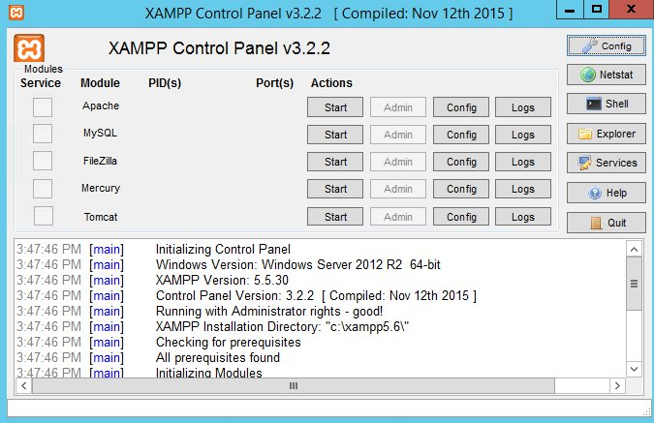
Figure 1

The XAMPP installation process is very simple and fast. Once XAMPP is installed on your local computer it acts as a local server or local host. You can test the websites before uploading it to the remote web server. This XAMPP server software gives you suitable environment for testing MYSQL, PHP, Apache and Perl applications on a local computer.

What are the Main Tools of XAMPP and its definition?
XAMPP contains tools such as Apache, MYSQL, PHP, and Perl. We will see these tools.


Figure 2

Apache:
Apache server is an open source free software which is initially developed by a group of software developers and now it is maintained by Apache software foundation. Apache HTTP is a remote server (computer) if someone request files, images or documents using their browser they will serve those files to clients using HTTP servers. Mainly hosting companies use this application to create a VPS server and shared hosting for their clients.

MYSQL:

MYSQL is an open source software. It is actually a relational database management system (RDBMS). This SQL stands for Structured Query Language. It is the most popular and best RDBMS used for developing a variety of web-based software applications. With the help of MYSQL, it is possible to organize the information, manage, retrieve and update the data whenever you wish to do.

PHP:

The full form of PHP is Hypertext Preprocessor. It is a server-side scripting language that helps you to create dynamic websites. This language is mainly used to build web-based software applications. It is an open source software and works fine with MYSQL. What actually happens is, the PHP code will be executed on the server and at the browser side its HTML code will be displayed.

The Sublime Text3Editor:

Sublime Text is a cross platform source code editor written in C++ and python. It originally
supports plenty of programming and markup languages, and its functionality can be increased
via users with plugins.
Sublime Text 3 has two main features that are symbol pane management and symbol indexing.
Through pane management users are to move between panes by hotkeys and symbol indexing
10 enable Sublime Text to scan files and build an index to make easy the features Go to Symbol and
Go to Definition in project.
It is downloaded from www.sublimetext.com/3 site. A list of some features of Sublime Text are as following,
- It is python based plug-in API
- It is cross platform (Linux, Linux, OS X)
- Compatible with numerous language framers form Text Mate
- Project specific preferences
- And others.

HTML AND CSS:

HTML stands for Hypertext Markup Language and CSS stands for Cascading Style Sheets are
the crucial technologies for creating web pages. HTML supplies the structure of the page, and
CSS the layout, for diversity of devices. Together with scripting and graphics, HTML and CSS
are the fundamental of building Web Applications and Web pages.

HTML provides designers and developers the following facilities:
To design forms for directing transactions with remote services, for use in making
- reservation, searching for information, ordering products, and others.

- Retrieving online information through hypertext links.

- To include video and sound clips, spread sheets, and other applications straight in their documents.

- Designer can publish online documents with text, headings, tables, photos and others.

CSS describes the Web pages presentation, involving layout, colors, and fonts. It enables the
designer to adjust the presentation to various types of devices, like a small screen, large
screens, or printers.
CSS is separate from HTML, and their separation makes it easy to preserve and maintain sites,
share style sheets across pages, and accommodate pages to various environments.

Frameworks:

JavaScript Framework (jQuery):

jQuery is JavaScript library intended to make simple the client-side scripting of HTML. It is the
most popular JavaScript framework, which is free and open-source software licensed under the
MIT License.
Several of the largest companies, including:
• Google
• IBM
• Microsoft

Project Description

Features Description:

The system should be designed in such a way that only authorized people should be allowed to access some particular modules. The records should be modified by only administrators and no one else. The user should always be in control of the application and not the vice versa. The user interface should be consistent so that the user can handle the application with ease and speed. The application should be visually, conceptually clear.

Registration :

Whenever the new user wants to login to the system, at first she/he has to register themselves in the system. The criteria for registration process is easy, the user needs to fill these four fields which are (Name, Email address, Password, Confirm Password).

login in :
Sign in is a window through which a user can login to the system, in login portion we have two fields to be filled in (Email Address and Password). When the user correctly enters his/her email address and password to the system, system will check the given information by comparing them with the information in the database.
If the given information match, user will be successfully logged in otherwise there will error message popped out.

Forgot Password:

This window will appeared when user press forgot password. If a user forgot his/her password, they can easily reset their password by writing email address. Our system will send a random code to the email address, after receiving the code, the user need to enter the code in to system.
The system will check whether the given code is correct or not, if it is correct, another will pop out for new password.

Home:

Home page is the main page of our system, when a user log in to the system, the page which will be appeared first is HOME page. Home page is containing items picture and price, discretion,one thing more that the home page will host are the courses that already have been made by the teacher. Clicking on the course will lead the user to new page.

Add Item:

The user can add item by but the picture of the items that he wants to add and price and the description of item. Admin can see the items that the user add also admin can add his own product.

Deleteitem:

The admin can remove user and item from the website. User can delete the items that he post into the website
Admin can see all items that user add and admin can also delete that items .also he can delete the user from the database/

Data Flow Diagram:
A data flow diagram (DFD) maps out the flow of information for any process or system. It uses defined symbols like rectangles, circles and arrows, plus short text labels, to show data inputs, outputs, storage points and the routes between each destination.
In our system, when first the teacher wants to enter the system, the data given in the fields will be checked with database, if the given data and stored data matched the user will be logged in to the system successfully.
Next operation is Add new Courses, Where the user will enter the information of a course and store them in the database.
Also user can add new classes, take attendance, generate report etc.…

ER Diagram

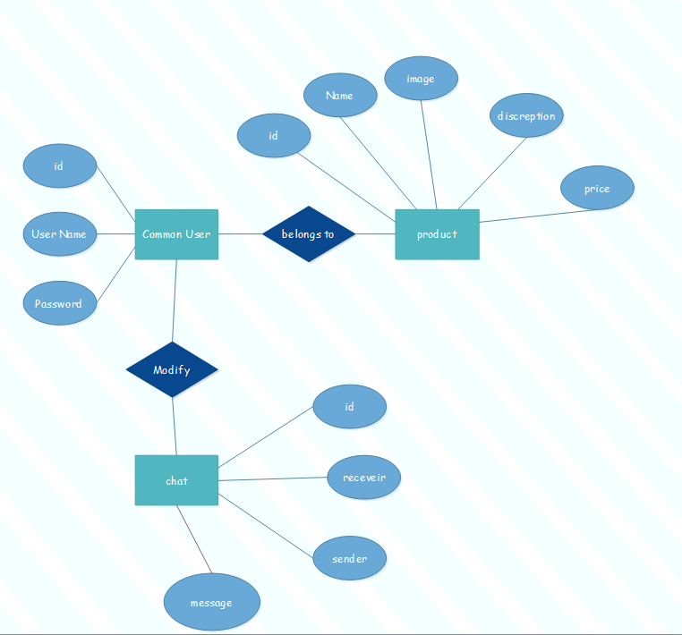

Use case diagram:

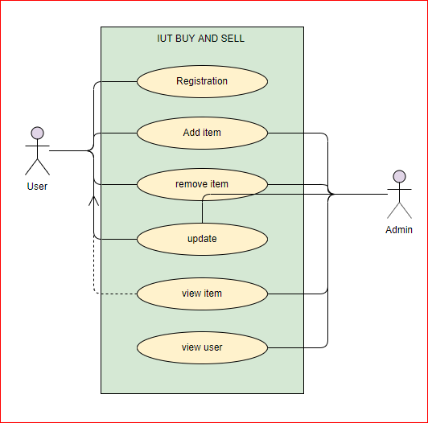

Class Diagram:

In software engineering, a class diagram in the Unified Modeling Language (UML) is a type of static structure diagram that describes the structure of a system by showing the system's classes, their attributes, operations (or methods), and the relationships among objects.
In case of our system, we have two basic data tables which are user, and courses and also there are two other tables User info, and CID…
The User class is containing three attributes and two methods, and Student class is containing four attributes and three methods.

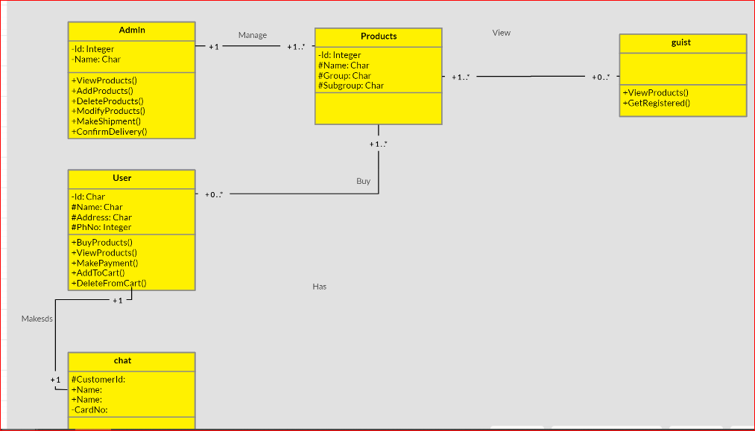
Figure 3

Data Tables:

Database is using for storing the information of the users and students. Database is so vital part of the system. In our system we used MYSQL database.
In our database basically there are four main tables, 1) USER, 2) admin., Chat, Product and Order.

CREATE TABLE `users` (
`idusers` int(11) NOT NULL,
`username` varchar(45) DEFAULT NULL,
`password` varchar(45) DEFAULT NULL,
`firstname` varchar(45) DEFAULT NULL,
`lastname` varchar(45) DEFAULT NULL,
`regdate` varchar(45) DEFAULT NULL,
`userdetails` text,
`userType` varchar(45) DEFAULT NULL,
`contact` varchar(45) NOT NULL,
`banned` int(11) NOT NULL
) ENGINE=InnoDB DEFAULT CHARSET=latin1;

CREATE TABLE `products` (
`idproducts` int(11) NOT NULL,
`productName` varchar(45) DEFAULT NULL,
`description` text,
`photo` text,
`price` int(11) DEFAULT NULL,
`details` text,
`uploadDate` varchar(45) DEFAULT NULL,
`productCategory` varchar(25) NOT NULL,
`uploadedBy` int(11) NOT NULL,
`condition` varchar(15) NOT NULL
) ENGINE=InnoDB DEFAULT CHARSET=latin1;

CREATE TABLE `orders` (
`idorders` int(11) NOT NULL,
`customerId` varchar(45) DEFAULT NULL,
`orderDate` varchar(45) DEFAULT NULL,
`details` text,
`products` text,
`totalPrice` int(11) NOT NULL,
`customer` text NOT NULL,
`orderStatus` int(11) NOT NULL,
`uploadedBy` int(11) NOT NULL
) ENGINE=InnoDB DEFAULT CHARSET=latin1;

CREATE TABLE `chats` (
`chatid` int(11) NOT NULL,
`chatthread` varchar(10) COLLATE utf8mb4_unicode_ci NOT NULL,
`sender` varchar(15) COLLATE utf8mb4_unicode_ci NOT NULL,
`receiver` varchar(15) COLLATE utf8mb4_unicode_ci NOT NULL,
`product` varchar(25) COLLATE utf8mb4_unicode_ci NOT NULL,
`message` text COLLATE utf8mb4_unicode_ci NOT NULL,
`senttime` varchar(15) COLLATE utf8mb4_unicode_ci NOT NULL,
`seentime` varchar(15) COLLATE utf8mb4_unicode_ci NOT NULL,
`seen` varchar(15) COLLATE utf8mb4_unicode_ci NOT NULL
) ENGINE=InnoDB DEFAULT CHARSET=utf8mb4 COLLATE=utf8mb4_unicode_ci;

User Manual

IUT BUY AND SELL is consist of multiple features, First of all our system is more helpful for staffs, student are included.
So the main user of the system is Admin, who will be able to sign up for the system, Sign in, Add new items, Add User, Delete and students, We will discuss each of them separately.

Registration of new Account:

Whenever the new user wants to login to the system, at first she/he has to register themselves in the system. The criteria for registration process is easy, the user needs to fill these four fields which are (Name, Email address, Password, Confirm Password).

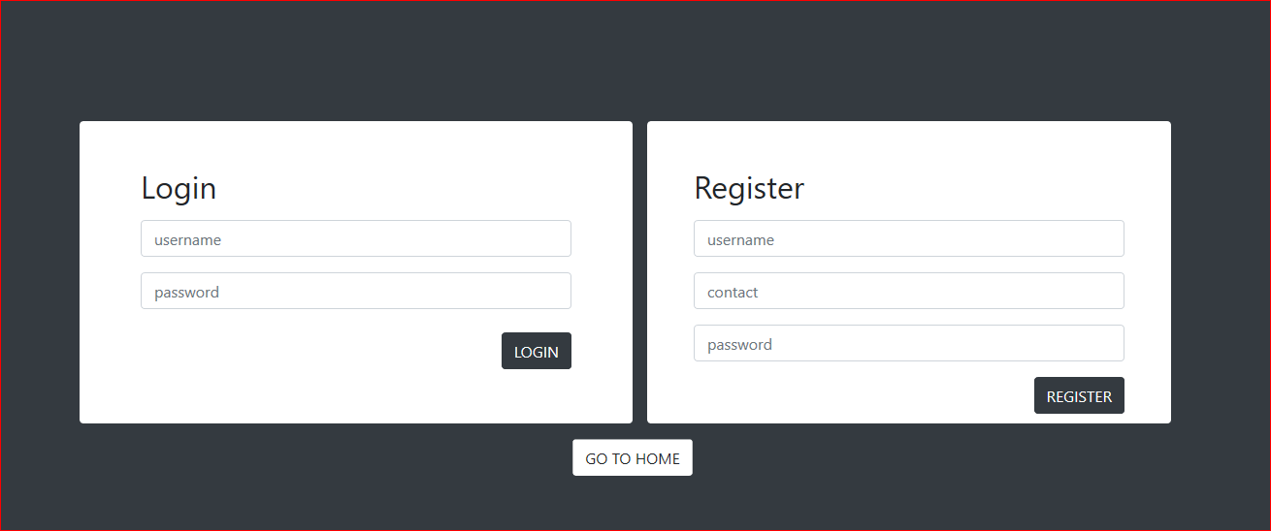
Figure 4

Home Page:
Home page is the main page of our system, when a user log in to the system, the page which will be appeared first is HOME page. Home page is containing latest items and price of the items

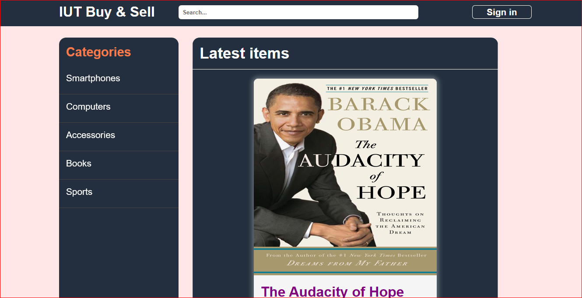
Figure 5

User page:
In the user page user can see the items that he/she post into the website and also he can see the latest items the user post.

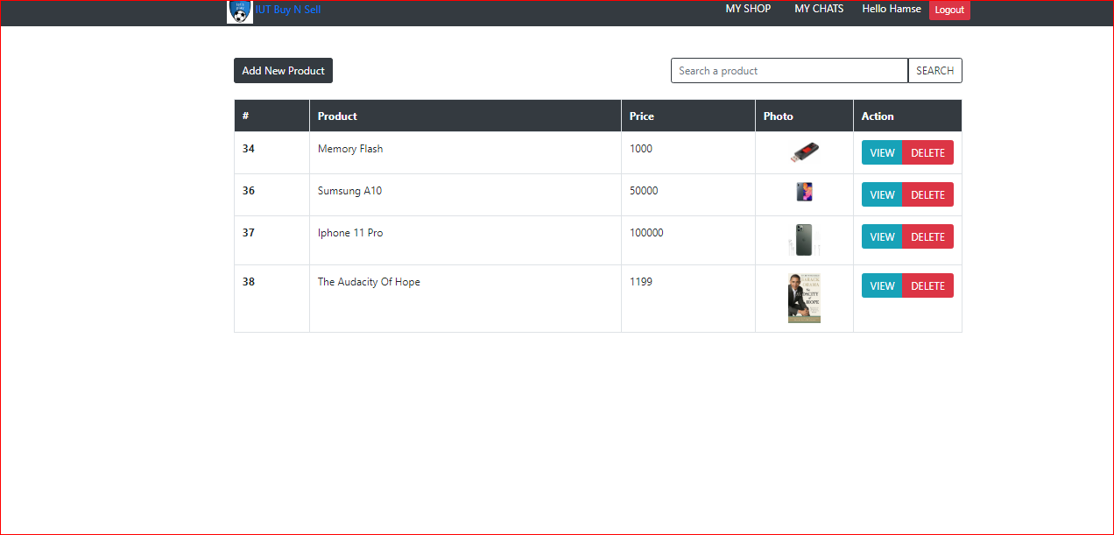
Figure 6

Admin page:
Admin can see all users and all items that users post ,admin can also delete the users and the items that user post .
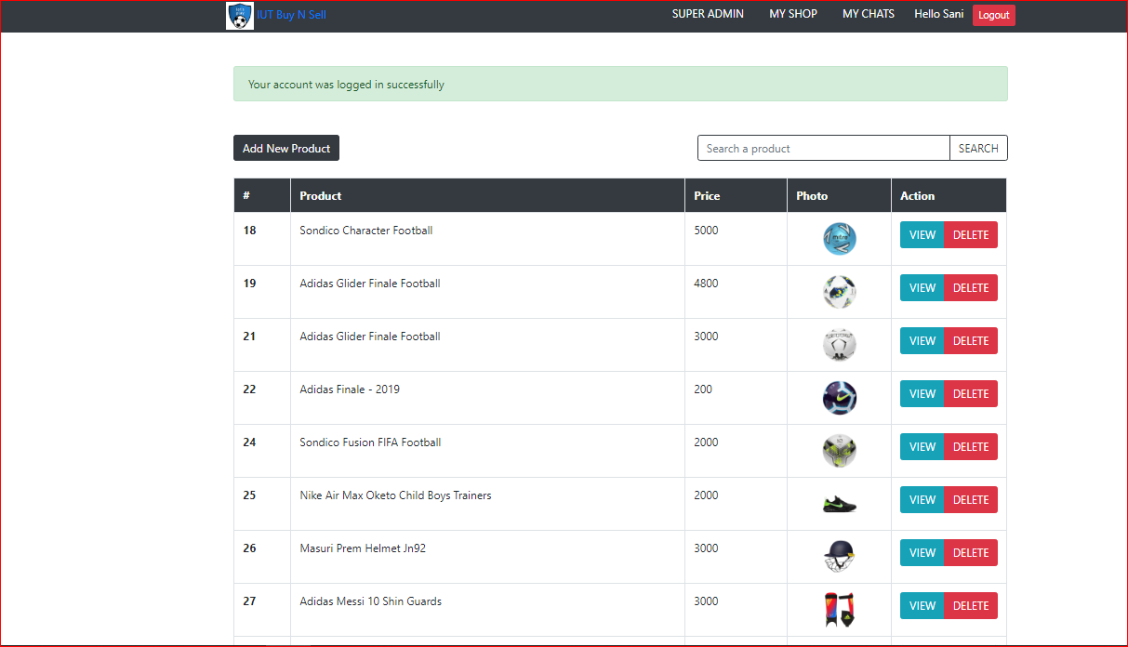
Figure 7

Add item;
When we add item, you are going to provide four picture of the items that you want sell also you provide description and price of the product.

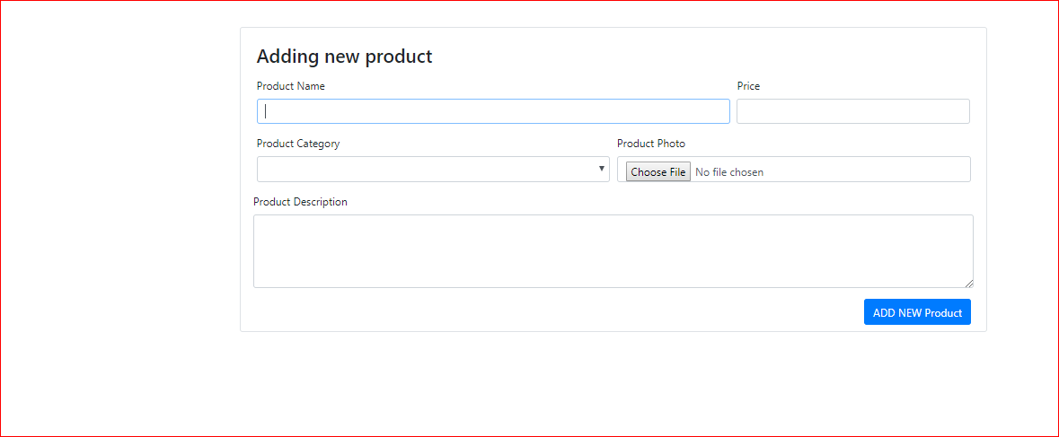
Figure 8

Chat sending:
When you want to buy product, you can send massage to the seller to reduce the price of the if he agrees you can reduce the price:

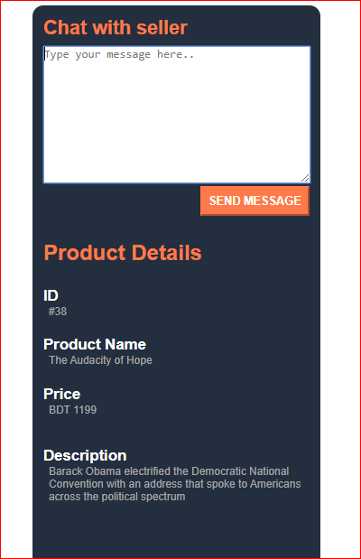
Figure 9

Receiving massage:
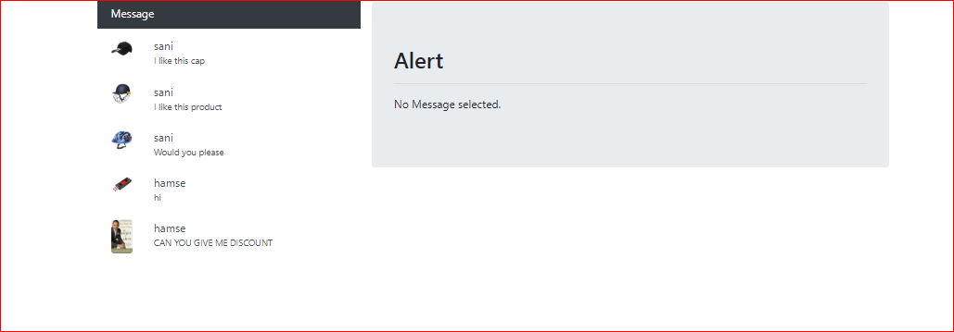
Figure 10

Conclusion:

In this work, the project is developed using PHP server-sidescripting language and CSS, HTML,JavaScript for designing which is fully meet the system’sgoals.
The internet has become a major resource in modern business, thus electronic shopping has gained significance not only from the entrepreneur’s but also from the customer’s point of view.
For entrepreneur the electronic shopping generates new business opportunities and for the customers, it makes comparative shopping possible.
As per a survey, most consumers of online stores are impulsive and usually make a decision to stayon a site within the few seconds. “website design is like a shop interior if the shop looks poor like hundreds of other shops the customer is most likely to skip to the other sites”
Hence, we have designed the project to provide the user with easy navigation,
In this project the user is provided with an e-commerce web site that can be used to buy and sell goods online

References:
W3school
YouTube

