Islamic University of Technology

Thesis Topic:

Control of Linear systems using Fuzzy and evolutionary
Algorithms.

A thesis Presented to
The Academic Faculty
By
Shahadat Hossain (112473)
Mohammad AL Imran (112474)
Syed Hassan Shovo (112463)
Muhammad Shahjalal (112403)

Department of Electrical & Electronic Engineering
Islamic University of Technology
Gazipur, Bangladesh.

Approved By

Prof. Dr. Md. Shahid Ullah
Head of Department
Department of Electrical and Electronic Engineering
Islamic University of Technology

Supervised By

Raquib Ridwan
Assistant Professor
Department of Electrical & Electronic Engineering
Islamic University of Technology
Declaration of Authorship

Shahadat Hossain
Student id.:112473

Syed Hassan Shovo
Student id:112463

Mohammad AL Imran
Student Id:112474

Muhammad Shahjalal
Student Id:112403

Acknowledgements

First and foremost, we offer gratitude to the Almighty Allah(SWT) for giving us the capability to do this work with good health.

We are grateful to our research supervisor Raquib Ridwan, for the support and guidance throughout our research. He created a research environment for which we were able to explore many ideas without constraint. We have gained a wealth of knowledge and experience in science and engineering through his direction that is beyond value to our future endeavor. For these things we give many thanks to him.

We would like to thank all the faculty members of the department of EEE, IUT for their inspiration and help.

At last but not the least, we are thankful to our family, friends and well-wishers for their support and inspiration. Without them it would never have been possible for us to make it this far.

Index
- DC motor 06-09
  - Introduction 06
  - Control of DC motor 06-07
  - Governing equation of DC motor 08-09
  - Parameters of DC motor 09
2. PID Controller 10-13
2.1 Introduction 10
2.2. loop-tuning 10-11
2.3 Stability 11
2.4 Various tuning methods 11-12
2.5 Limitations of PID controller 12
  - Simulink model of PID controller in the system` 13

3. Fuzzy Logic 14-16
3.1 Introduction 14-15
3.2 What is fuzzy logic 15
3.3 Objectives of fuzzy logic 15
3.4 Main components of fuzzy logic 16
- Genetic Algorithm 18-26
4.1 Introduction 18
4.2 What is genetic algorithm 18
4.3 Genetic Algorithm overview 19
4.4 Search space 19-20
4.5 Implementation details 20-21
4.6 Effects of genetic operators 21
4.7 How the algorithm works 21-22
4.8 Crossover 22-23
4.9 Selection 24-26
4.10 Mutation 26
5. Overview of thesis work 27-29
6. References 30-32
Chapter-1

DC MOTOR

1.1 Introduction
A DC motor is any of a class of electrical machines that converts direct current electrical power into mechanical power. The most common types rely on the forces produced by magnetic fields. Nearly all types of DC motors have some internal mechanism, either electromechanical or electronic, to periodically change the direction of current flow in part of the motor. Most types produce rotary motion; a linear motor directly produces force and motion in a straight line.

DC motors were the first type widely used, since they could be powered from existing direct-current lighting power distribution systems. A DC motor's speed can be controlled over a wide range, using either a variable supply voltage or by changing the strength of current in its field windings. Small DC motors are used in tools, toys, and appliances. The universal motor can operate on direct current but is a lightweight motor used for portable power tools and appliances. Larger DC motors are used in propulsion of electric vehicles, elevator and hoists, or in drives for steel rolling mills. The advent of power electronics has made replacement of DC motors with AC motors possible in many applications.

1.2 Control of the DC motor

In armature control of separately excited DC motors, the voltage applied to the armature of the motor is adjusted without changing the voltage applied to the field. Figure shows a separately excited DC motor equivalent model.

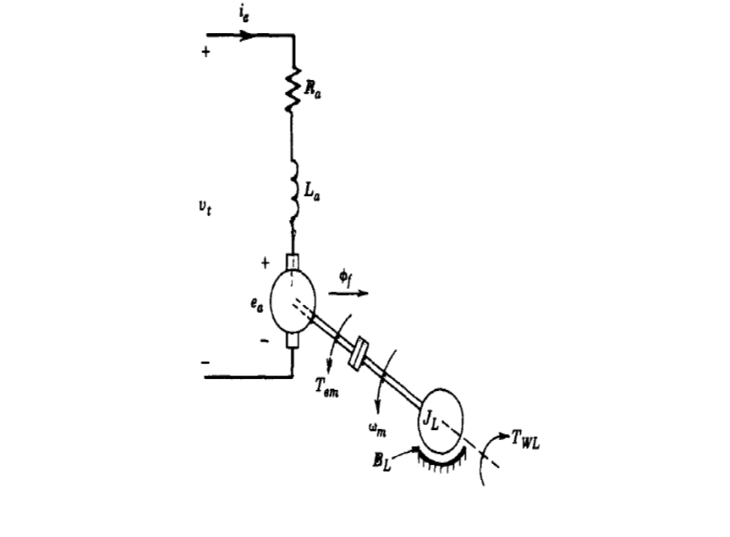

Figure: General Model of a separately excited DC motor

Here,
Ia is armature current (In Ampere)
Ra is armature resistance (in Ohm)
La is armature inductance (in Henry)
Tm is mechanical torque developed (In Nm)
Jm is moment of inertia (In Kg/m2)
Bm is friction co-efficient of motor (In Nm/ (rad/sec))
W is angular velocity (In rad/sec)
Vt is armature voltage (In Volt)
Eb is back emf of the motor (In Volt)

1.3 Governing Equation of the DC Motor
The equantions govering a DC motor are shown below:
As there are two parts of our proposed DC model, one is electrical , another one is mechanical part. Equations are separated as follows:

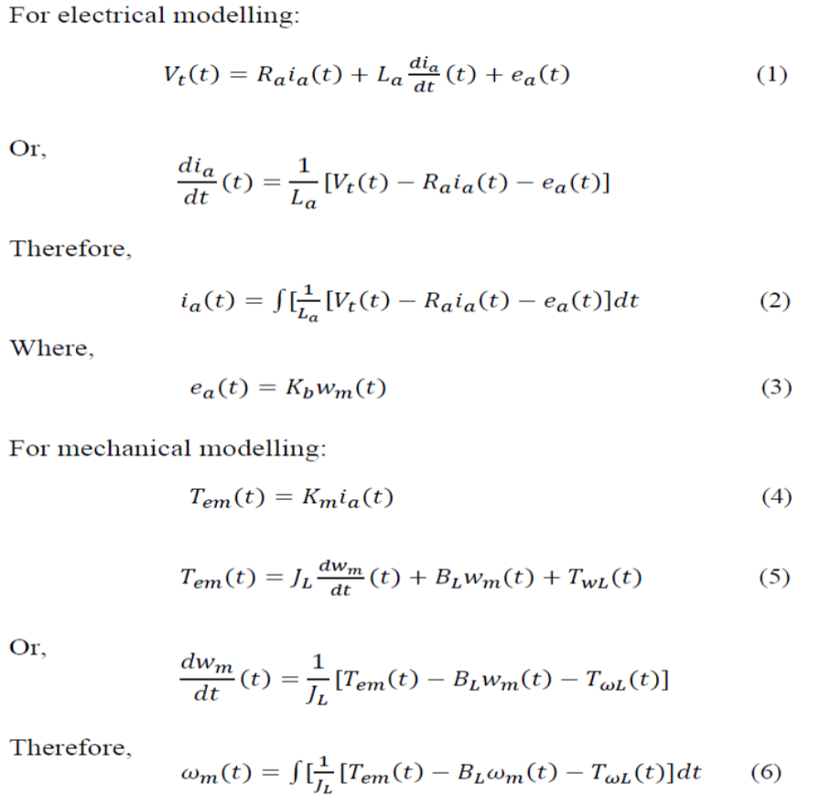

Therefore, a Simulink model is designed with the assistance of the governing equation of the separately excited DC motor:
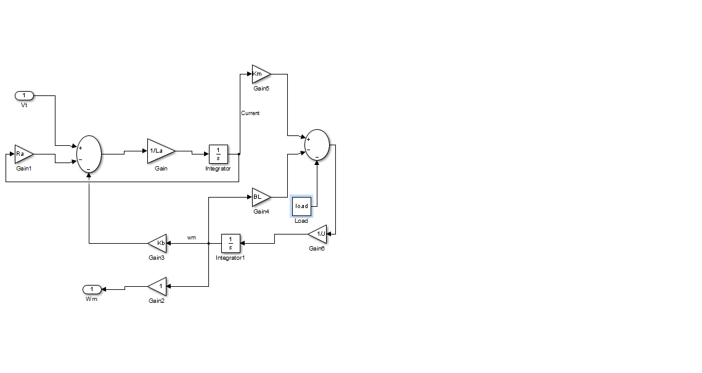Figure: Simulink Model of the DC Motor
1.4 Parameters of the DC Motor
The parameters of the DC motor used for the simulations in this paper are as follows:

Armature resistance (in Ohm) = 0.5 Ω
Armature inductance (La) = 0.02H
armature voltage (Vt) = 200 V
Mechanical Inertia(JL) = 0.1 kg. m2
moment of inertia (In Kg/m2)
friction co-efficient(BL) = 0.008N-m/ (rad/sec)
back emf constant (Kb) = 1.25 V/(rad/sec)
Rated speed = 3000 rpm
Motor torque constant (Km) = 1 N-m/A
Chapter 2

PID Controller

2.1 Introduction

A proportional-integral-derivative controller (PID controller) is a control loop feedback mechanism (controller) commonly used in industrial control systems. A PID controller continuously calculates an "error value" as the difference between a measured process variable and a desired set point. The controller attempts to minimize the error over time by adjustment of a control variable, such as the position of a control valve, a damper, or the power supplied to a heating element, to a new value determined by a weighted sum:
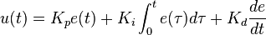
Where Kp, K_{i}, and K_{d}, all non-negative, denote the coefficients for the proportional, integral, and derivative terms, respectively (sometimes denoted P, I, and D). In this model, P accounts for present values of the error (e.g. if the error is large and positive, the control output will also be large and positive), I accounts for past values of the error (e.g. if the output is not sufficient to reduce the size of the error, error will accumulate over time, causing the controller to apply stronger output), and D accounts for predicted future values of the error, based on its current rate of change.

2.2 Loop tuning

Tuning a control loop is the adjustment of its control parameters (proportional band/gain, integral gain/reset, derivative gain/rate) to the optimum values for the desired control response. Stability (no unbounded oscillation) is a basic requirement, but beyond that, different systems have different behavior, different applications have different requirements, and requirements may conflict with one another.

PID tuning is a difficult problem, even though there are only three parameters and in principle is simple to describe, because it must satisfy complex criteria within the limitations of PID control. There are accordingly various methods for loop tuning, and more sophisticated techniques are the subject of patents; this section describes some traditional manual methods for loop tuning.

Designing and tuning a PID controller appears to be conceptually intuitive, but can be hard in practice, if multiple (and often conflicting) objectives such as short transient and high stability are to be achieved. PID controllers often provide acceptable control using default tunings, but performance can generally be improved by careful tuning, and performance may be unacceptable with poor tuning. Usually, initial designs need to be adjusted repeatedly through computer simulations until the closed-loop system performs or compromises as desired.

2.3 Stability
If the PID controller parameters (the gains of the proportional, integral and derivative terms) are chosen incorrectly, the controlled process input can be unstable, i.e., its output diverges, with or without oscillation, and is limited only by saturation or mechanical breakage. Instability is caused by excess gain, particularly in the presence of significant lag.
Generally, stabilization of response is required and the process must not oscillate for any combination of process conditions and set points, though sometimes marginal stability (bounded oscillation) is acceptable or desired.

2.4 Various Tuning Method

a) Manual tuning:
If the system must remain online, one tuning method is to first set k_{i} and k_{d} values to zero. Increase the k_{p} until the output of the loop oscillates, then the k_{p} should be set to approximately half of that value for a "quarter amplitude decay" type response. Then increase ki until any offset is corrected in sufficient time for the process. However, too much k_{i} will cause instability. Finally, increase k_{d}, if required, until the loop is acceptably quick to reach its reference after a load disturbance. However, too much k_{d} will cause excessive response and overshoot. A fast PID loop tuning usually overshoots slightly to reach the set point more quickly; however, some systems cannot accept overshoot, in which case an over-damped closed-loop system is required, which will require a k_{p} setting significantly less than half that of the k_{p} setting that was causing oscillation.

b) Ziegler–Nichols method:
Another heuristic tuning method is formally known as the Ziegler–Nichols method, introduced by John G. Ziegler and Nathaniel B. Nichols in the 1940s. As in the method above, the k_{i} and k_{d} gains are first set to zero. The proportional gain is increased until it reaches the ultimate gain, k_{u}, at which the output of the loop starts to oscillate. K_{u} and the oscillation period T_{u} are used to set the gains as shown:

Control Type | k_{p} | k_{i} | k_{d}
P | .50k_{u} | - | -
PI | .45k_{u} | 1.2kp/Tu | -
PID | .60k_{u} | 2k_{p} /Tu | kpTu/8

2.5 Limitations of PID controller
While PID controllers are applicable to many control problems, and often perform satisfactorily without any improvements or only coarse tuning, they can perform poorly in some applications, and do not in general provide optimal control. The fundamental difficulty with PID control is that it is a feedback system, with constant parameters, and no direct knowledge of the process, and thus overall performance is reactive and a compromise. While PID control is the best controller in an observer without a model of the process, better performance can be obtained by overtly modeling the actor of the process without resorting to an observer.
PID controllers, when used alone, can give poor performance when the PID loop gains must be reduced so that the control system does not overshoot, oscillate or hunt about the control set point value. They also have difficulties in the presence of non-linarites, may trade-off regulation versus response time, do not react to changing process behavior (say, the process changes after it has warmed up), and have lag in responding to large disturbances.
The most significant improvement is to incorporate feed-forward control with knowledge about the system, and using the PID only to control error. Alternatively, PIDs can be modified in more minor ways, such as by changing the parameters (either gain scheduling in different use cases or adaptively modifying them based on performance), improving measurement (higher sampling rate, precision, and accuracy, and low-pass filtering if necessary), or cascading multiple PID controllers.

2.6 Simulink Model of PID Controller on our System

Primarily only PID Controller is used for controlling our system. The layout of our whole system is shown below:
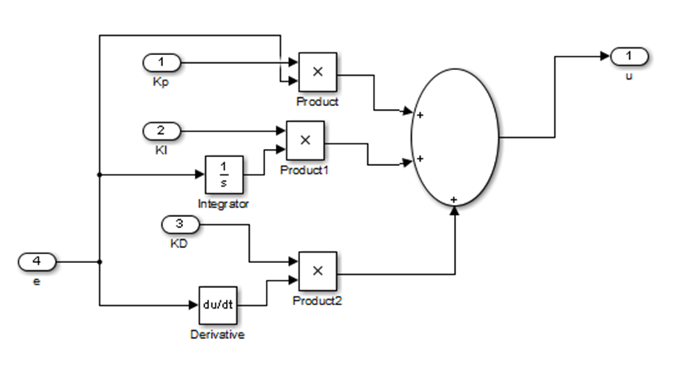
Figure: Simulink Model of PID Controller

Chapter 3

FUZZY LOGIC

3.1 Introduction
In the literature sources, we can find different kinds of justification for fuzzy systems theory. Human knowledge nowadays becomes increasingly important – we gain it from experiencing the world within which we live and use our ability to reason to create order in the mass of information (i.e., to formulate human knowledge in a systematic manner). Since we are all
limited in our ability to perceive the world and to profound reasoning, we find ourselves everywhere confronted by uncertainty which is a result of lack of information (lexical impression, incompleteness), in particular, inaccuracy of measurements. The other limitation factor in our desire for precision is a natural language used for describing/sharing knowledge, communication, etc. We understand core meanings of word and are able to communicate accurately to an acceptable degree, but generally we cannot precisely agree among ourselves on the single word or terms of common sense meaning. In short, natural languages are vague.
Our perception of the real world is pervaded by concepts which do not have sharply defined boundaries – for example, many, tall, much larger than, young, etc. are true only to some degree and they are false to some degree as well. These concepts (facts) can be called fuzzy or gray (vague) concepts – a human brain works with them, while computers may not do it (they reason with strings of 0s and 1s). Natural languages, which are much higher in level than programming languages, are fuzzy whereas programming languages are not. The door to the development of fuzzy computers was opened in 1985 by the design of the first logic chip by Masaki Togai and Hiroyuki Watanabe at Bell Telephone Laboratories. In the years to come fuzzy computers will employ both fuzzy hardware and fuzzy software, and they will be much closer in structure to the human brain than the present-day computers are.
The entire real world is complex; it is found that the complexity arises from uncertainty in the form of ambiguity. According to Dr. Lotfi Zadeh, Principle of Compatability, the complexity, and the imprecision are correlated and adds, the closer one looks at a real world problem, the fuzzier becomes its solution (Zadeh 1973). The Fuzzy Logic tool was introduced in 1965, also by Lotfi Zadeh, and is a mathematical tool for dealing with uncertainty. It offers to a soft computing partnership the important concept of computing with words’. It provides a technique to deal with imprecision and information granularity. The fuzzy theory provides a mechanism for representing linguistic constructs such as “many,” “low,” “medium,” “often,” “few.” In general, the fuzzy logic provides an inference structure that enables appropriate human reasoning capabilities.
On the contrary, the traditional binary set theory describes crisp events, events that either do or do not occur. It uses probability theory to explain if an event will occur, measuring the chance with which a given event is expected to occur. The theory of fuzzy logic is based upon the notion of relative graded membership and so are the functions of mentation and cognitive processes. The utility of fuzzy sets lies in their ability to model uncertain or ambiguous data,so often encountered in real life.
It is important to observe that there is an intimate connection between Fuzziness and Complexity. As the complexity of a task (problem), or of a system for performing that task, exceeds a certain threshold, the system must necessarily become fuzzy in nature. Zadeh, originally an engineer and systems scientist, was concerned with the rapid decline in information afforded by traditional mathematical models as the complexity of the target system increased. As he stressed, with the increasing of complexity our ability to make precise and yet significant statements about its behavior diminishes. Real world problems (situations) are too complex, and the complexity involves the degree of uncertainty – as uncertainty increases, so does the complexity of the problem. Traditional system modeling and analysis techniques are too precise for such problems (systems), and in order to make complexity less daunting we introduce appropriate simplifications, assumptions, etc. (i.e., degree of uncertainty or Fuzziness) to achieve a satisfactory compromise between the information we have and the amount of uncertainty we are willing to accept. In this aspect, fuzzy systems theory is similar to other engineering theories, because almost all of them characterize the real world in an approximate manner.

3.2 What is fuzzy logic
A Fuzzy Logic Controller (FLC) was proved analytically to be equivalent to a nonlinear PI controller when a nonlinear defuzzifiction method was used. The foundations of fuzzy logic
have become firmer and its impact within the basic sciences - and especially in mathematical and physical sciences - has become more visible. Fuzzy controllers have been proposed for physical systems which do not lend themselves too easy and accurate mathematical modelling and crisp variables, and therefore, cannot be tackled by traditional strict analytic control design techniques. Instead, control variables are represented by fuzzy variables which let the level of uncertainty of the variables to be modelled in a systematic way. In addition, the expert knowledge of a typical operator of such a process is embodied in a set of linguistic or rule-based engines which constitutes the core of a fuzzy controller.
Imprecise
Fuzzy
Logic
System
Data
Vague Decisions
Statements
Figure: A fuzzy logic system which accepts imprecise data and vague statements such as low, medium, high and provides decisions
3.3 Objectives of Fuzzy Logic
The objective is to implement FLC for controlling the speed of a dc motor. The goal of
designed FLC in this study is to minimize speed error. The bigger speed error the bigger controller input is expected .In addition, the change of speed of error plays important role to define controller input. Consequently FLC uses error (e) and change in error (ce) for linguistic variables which are generated from control rules. The output variable is the change in control variable of the motor drive. The output variable from FLC is given to the plant
i.e DC motor.

3.4 Main components of fuzzy logic
A fuzzy logic controller has four main components:

a) Fuzzification
b) Inference
c) Aggregation
d) Defuzzification

- Fuzzification:
Converting crisp facts into fuzzy sets described by linguistic expressions. Membership
functions can be flat on the top, piece-wise linear and triangle shaped, rectangular, or ramps with horizontal shoulders.
- Inference:
The fuzzy IF-THEN rule expresses a fuzzy implication relation between the fuzzy sets of the premise and the fuzzy sets of the conclusion. The following steps describe this process:
1. Matching of the facts with the rule premises (determination of the degree of firing DOF of the facts to the rule premises).
2. If the rule contains logic connections between several premises by fuzzy AND or fuzzy OR the evaluation is performed by t-norms or t-conorms (the result gives then the DOF of the facts to the complete premise).
3. Implication: The next step is the determination of the individual rule output. The DOF of a rule interacts with its consequent to provide the output of the rule. It will be a fuzzy subset over the output universe.
- Aggregation: This process aggregates the individual rule outputs to obtain the overall system output. It will be also a fuzzy subset over the output universe (a union operation yields a global fuzzy set of the output).
- Defuzzification:
To obtain crisp output (various defuzzification methods can be used, as, e.g., center
of gravity, bisector of area, and mean of maximum, to obtain a crisp numerical output value).

Chapter 4

Genetic Algorithm

4.1 Introduction
Genetic Algorithm were invented to mimic some to the processes observed in natural evolution. Many people, biologists included are astonished that life at the level of complexity that we observe could have evolved in relatively short time suggested by the fossil record. The idea with GA is to use this power of evolution to solve optimization problems. The father of the original Genetic Algorithm was Jon Holland who invented it in the early 1970’s.

4.2 What is Genetic Algorithm
Genetic Algorithm are adaptive heuristic search algorithm based on the evolutionary ideas of natural selection and genetics. As such they represent an intelligent exploitation of a random search used to solve optimization problems. Although randomized, Gas are by no means random, instead they exploit historical information to direct the search into the region of better performance within the search space. The basic techniques of the Gas are designed to simulate processes in natural systems necessary for evolution, especially those follow the principles first laid down by Charles Darwin of “survival of the fittest.” Since in nature, competition among individuals for scant resources results in the fittest individuals dominating over the weaker ones.
It is better than conventional AI in that it is more robust. Unlike older AI systems, they do not break easily even if the inputs changed slightly or in the presence of reasonable noise. Also, in searching a large state space, multi model state space, or n-dimensional surface a genetic algorithm may offer significant benefits over more typical search of optimization techniques. (linear programing, heuristic, depth-first, breath-first and praxis.)

4.3 Genetic Algorithm Overview
GAs simulate the survival of the fittest among individuals over consecutive generation for solving a problem. Each generation consists of a population of character strings that are analogous to the chromosome that we see in our DNA. Each individual represents a point in a search space and a possible solution. The individuals in the population are then made to go through a process of evolution.
GAs are based on an analogy with the genetic structure and behavior of chromosomes within a population of individuals using the following foundations:
- Individuals in a population compete for resources and mates.
- Those individuals most successful in each 'competition' will produce more offspring than those individuals that perform poorly.
- Genes from `good' individuals propagate throughout the population so that two good parents will sometimes produce offspring that are better than either parent.
- Thus each successive generation will become more suited to their environment.

4.4 Search Space
A population of individuals are is maintained within search space for a GA, each representing a possible solution to a given problem. Each individual is coded as a finite length vector of components, or variables, in terms of some alphabet, usually the binary alphabet {0,1}. To continue the genetic analogy these individuals are likened to chromosomes and the variables are analogous to genes. Thus a chromosome (solution) is composed of several genes (variables). A fitness score is assigned to each solution representing the abilities of an individual to `compete'. The individual with the optimal (or generally near optimal) fitness score is sought. The GA aims to use selective `breeding' of the solutions to produce `offspring' better than the parents by combining information from the chromosomes.
The GA maintains a population of n chromosomes (solutions) with associated fitness values. Parents are selected to mate, on the basis of their fitness, producing offspring via a reproductive plan. Consequently, highly fit solutions are given more opportunities to reproduce, so that offspring inherit characteristics from each parent. As parents mate and produce offspring, room must be made for the new arrivals since the population is kept at a static size. Individuals in the population die and are replaced by the new solutions, eventually creating a new generation once all mating opportunities in the old population have been exhausted. In this way it is hoped that over successive generations better solutions will thrive while the least fit solutions die out.
New generations of solutions are produced containing, on average, more good genes than a typical solution in a previous generation. Each successive generation will contain more good `partial solutions' than previous generations. Eventually, once the population has converged and is not producing offspring noticeably different from those in previous generations, the algorithm itself is said to have converged to a set of solutions to the problem at hand.

4.5 Implementation Details (Based on Natural Selection)
After an initial population is randomly generated, the algorithm evolves the through three operators:
- selection which equates to survival of the fittest;
- crossover which represents mating between individuals;
- mutation which introduces random modifications.

A. Selection Operator
- key idea: give preference to better individuals, allowing them to pass on their genes to the next generation.
- The goodness of each individual depends on its fitness.
- Fitness may be determined by an objective function or by a subjective judgement.
B. Crossover Operator
- Prime distinguished factor of GA from other optimization techniques
- Two individuals are chosen from the population using the selection operator
- A crossover site along the bit strings is randomly chosen
- The values of the two strings are exchanged up to this point
- If S1=000000 and s2=111111 and the crossover point is 2 then S1'=110000 and s2'=001111
- The two new offspring created from this mating are put into the next generation of the population
- By recombining portions of good individuals, this process is likely to create even better individual
C. Mutation Operator
- With some low probability, a portion of the new individuals will have some of their bits flipped.
- Its purpose is to maintain diversity within the population and inhibit premature convergence.
- Mutation alone induces a random walk through the search space
- Mutation and selection (without crossover) create a parallel, noise-tolerant, hill-climbing algorithms

4.6 Effects of Genetic Operators

- Using selection alone will tend to fill the population with copies of the best individual from the population
- Using selection and crossover operators will tend to cause the algorithms to converge on a good but sub-optimal solution
- Using mutation alone induces a random walk through the search space.
- Using selection and mutation creates a parallel, noise-tolerant, hill climbing algorithm

4.7 How the Algorithm work
- randomly initialize population(t)
- determine fitness of population(t)
- repeat
  - select parents from population(t)
  - perform crossover on parents creating population(t+1)
  - perform mutation of population(t+1)
  - determine fitness of population(t+1)
- until best individual is good enough
4.8 Cross over
4.8.1 What is crossover:
In genetic algorithms, crossover is a genetic operator used to vary the programming of initial values into another value. The crossover operator is a genetic operator that combines (mates) two chromosomes (parents) to produce a new chromosome (offspring). The idea behind crossover is that the new chromosome may be better than both of the parents if it takes the best characteristics from each of the parents. Crossover occurs during evolution according to a user definable crossover probability. For purpose of this work, only crossover operators that operate on two parents and have no self-adaptation properties will be considered.

4.8.2 Types of crossover:
  - Single point Crossover:
When performing crossover, both parental chromosomes are split at a randomly determined crossover point. Subsequently, a new child genotype is created by appending the first part of the first parent with the second part of the second parent [3, 4]. A single crossover point on both parents' organism strings is selected. All data beyond that point in either organism string is swapped between the two
parent organisms. Figure 1 shows the single point crossover (SPC) process.
  - Two-point Crossover:
Apart from SPC, many different crossover algorithms have been devised, often involving more than one cut point. It should be noted that adding further crossover points
reduces the performance of the GA. The problem with adding additional crossover points is that building blocks are more likely to be disrupted. However, an advantage of
having more crossover points is that the problem space may be searched more thoroughly. In two-point crossover (TPC), two crossover points are chosen and the contents between these points are exchanged between two mated parents [5, 6].

  - Intermediate Crossover:
Intermediate creates off springs by a weighted average of the parents. Intermediate crossover (IC) is controlled by a single parameter Ratio:
offspring = parent1+rand*Ratio*(parent2 - parent1)
If Ratio is in the range [0,1] then the off springs produced are within the hypercube defined by the parents’ locations at opposite vertices. Ratio can be a scalar or a vector of length number of variables. If Ratio is a scalar, then all of the off springs will lie on the line between the parents. If Ratio is a vector, then children can be any point within the hypercube [7].

  - Heuristic Crossover:
In heuristic crossover (HC), heuristic returns an offspring that lies on the line containing the two parents, a small distance away from the parent with the better fitness value
in the direction away from the parent with the worse fitness value. The default value of Ratio is 1.2. If parent1 and parent2 are the parents, and parent1 has the better fitness
value, the function returns the child [7],

offspring = parent2 + Ratio * (parent1 - parent2)
  - Arithmetic Crossover:
In arithmetic crossover (AC), arithmetic creates children that are the weighted arithmetic mean of two parents. Children are feasible with respect to linear constraints and bounds. Alpha is random value between [0,1]. If parent1 and parent2 are the parents, and parent1 has the better fitness value, the function returns the child [7],

offspring =alpha*parent1 + (1-alpha) *parent2

4.9 Selection Process
4.9.1 What is Selection Process:
Basic genetic algorithm (GA) is generally composed of two processes. The first process is selection of individuals for the production of the next generation and the second process is manipulation of the selected individuals to form the next generation by crossover and mutation techniques. The selection mechanism determines which individuals are chosen for mating (reproduction) and how many offspring each selected individual produces. The main principle of selection strategy is “the better is an individual; the higher is its chance of being parent.” Generally, crossover and mutation explore the search space, whereas selection reduces the search area within the population by discarding poor solutions. However, worst individuals should not be discarded and they have some chances to be selected because it may lead to useful genetic material. A good search technique must find a good trade-off between exploration and exploitation in order to find a global optimum [1]. Hence, it is important to find a balance between exploration (i.e. poor solutions must have chance to go to the next generation) and exploitation (i.e. good solutions go to the next generation more frequently than poor solutions) within the mechanism of the selection.

4.9.2 Types of Selection Process:
The different selection strategy used in the GA process will significantly affect the performance of the algorithm differently.

  - Tournament Selection:
Tournament selection is probably the most popular selection method in genetic algorithm due to its efficiency and simple implementation [8]. In tournament selection, n
individuals are selected randomly from the larger population, and the selected individuals compete against each other. The individual with the highest fitness wins and will be included as one of the next generation population. The number of individuals competing in each tournament is referred to as tournament size, commonly set to 2 (also called binary tournament). Tournament selection also gives a chance to all individuals to be selected and thus it preserves
diversity, although keeping diversity may degrade the convergence speed.

  - Proportional Roulette Wheel Selection:
In proportional roulette wheel, individuals are selected with a probability that is directly proportional to their fitness values i.e. an individual’s selection corresponds to a portion
of a roulette wheel. The probabilities of selecting a parent can be seen as spinning a roulette wheel with the size of the segment for each parent being proportional to its fitness.
Obviously, those with the largest fitness (i.e. largest segment sizes) have more probability of being chosen. The fittest individual occupies the largest segment, whereas the least fit
have correspondingly smaller segment within the roulette wheel. The circumference of the roulette wheel is the sum of all fitness values of the individuals.

The basic advantage of proportional roulette wheel selection is that it discards none of the individuals in the population and gives a chance to all of them to be selected. Therefore, diversity in the population is preserved. However, proportional roulette wheel selection has few major deficiencies. Outstanding individuals will introduce a bias in the beginning of the search that may cause a premature convergence and a loss of diversity. For example, if an initial population contains one or two very fit but not the best individuals and the rest of the population are not
good, then these fit individuals will quickly dominate the whole population and prevent the population from exploring other potentially better individuals. Such a strong domination causes a very high loss of genetic diversity which is definitely not advantageous for the optimization
process. On the other hand, if individuals in a population have very similar fitness values, it will be very difficult for the population to move towards a better one since selection probabilities for fit and unfit individuals are very similar.

  - Rank Based Roulette Wheel Selection:
Rank-based roulette wheel selection is the selection strategy where the probability of a chromosome being selected is based on its fitness rank relative to the entire population. Rank-based selection schemes first sort individuals in the population according to their fitness and
then computes selection probabilities according to their ranks rather than fitness values. Hence rank-based selection can maintain a constant pressure in the evolutionary search where it introduces a uniform scaling across the population and is not influenced by super-individuals or the spreading of fitness values at all as in proportional selection. Rank based selection uses a function to map the indices of individuals in the sorted list to their selection probabilities.
Although this mapping function can be linear (linear ranking) or non-linear (non-linear ranking), the idea of rank based selection remains unchanged. The performance of the selection scheme depends greatly on this mapping function.
Rank-based selection schemes can avoid premature convergence and eliminate the need to scale fitness values, but can be computationally expensive because of the need to
sort populations. Once selection probabilities have been assigned, sampling method using roulette wheel is required to populate the mating pool. Rank-based selection scheme
helps prevent premature convergence due to “super” individuals, since the best individual is always assigned the same selection probability, regardless of its objective value. However, this method can lead to slower convergence, because the best chromosomes do not differ so much from other ones.
4.10 Mutation
Mutation is a genetic operator used to maintain genetic diversity from one generation of a population of genetic algorithm chromosomes to the next. It is analogous to biological mutation. Mutation alters one or more gene values in a chromosome from its initial state. In mutation, the solution may change entirely from the previous solution. Hence GA can come to better solution by using mutation. Mutation occurs during evolution according to a user-definable mutation probability. This probability should be set low. If it is set too high, the search will turn into a primitive random search.
The classic example of a mutation operator involves a probability that an arbitrary bit in a genetic sequence will be changed from its original state. A common method of implementing the mutation operator involves generating a random variable for each bit in a sequence. This random variable tells whether or not a particular bit will be modified. This mutation procedure, based on the biological point mutation, is called single point mutation. Other types are inversion and floating point mutation. When the gene encoding is restrictive as in permutation problems, mutations are swaps, inversions, and scrambles.
The purpose of mutation in GAs is preserving and introducing diversity. Mutation should allow the algorithm to avoid local minima by preventing the population of chromosomes from becoming too similar to each other, thus slowing or even stopping evolution. This reasoning also explains the fact that most GA systems avoid only taking the fittest of the population in generating the next but rather a random (or semi-random) selection with a weighting toward those that are fitter.
Overview of Thesis Work

The whole system of the thesis based on following Simulink model:

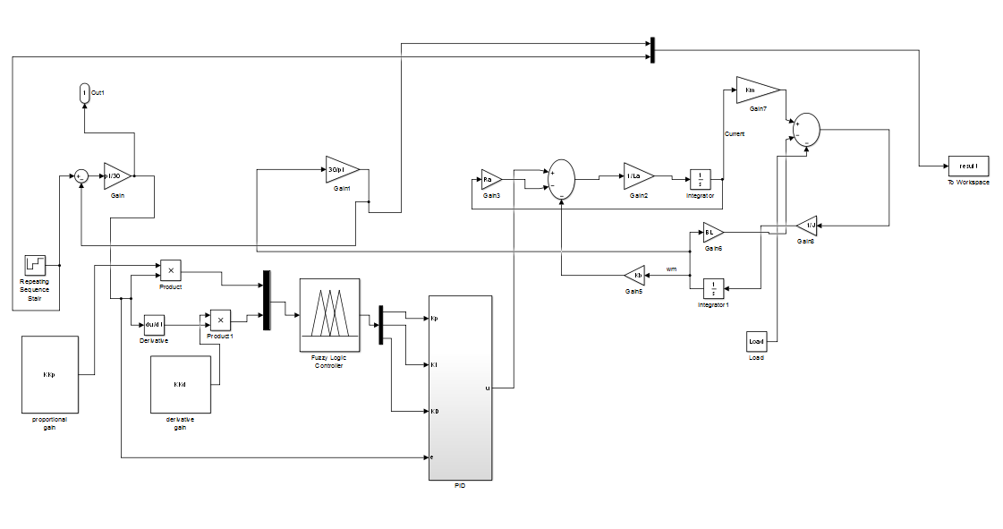

Figure: Simulink Model of the whole system

In this system, there are fuzzy & PID controller to control linear system like DC motor. But only using this two, the result is not satisfactory. That’s why genetic algorithm is used. Here, two values of proportional gain and derivative gain are selected by the operators of genetic algorithm. This process continued until this values meet the efficiency criteria.

At first, only using Fuzzy & PID, the result we get are given below:
For load 0,
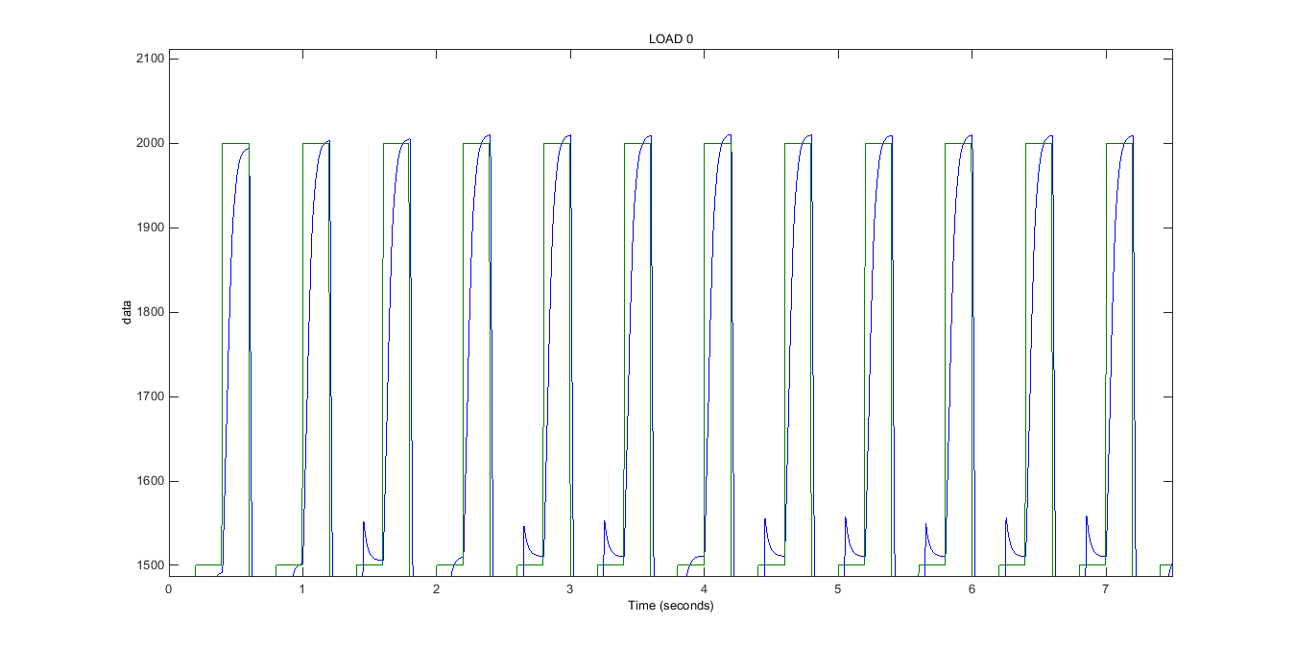
For load 1,
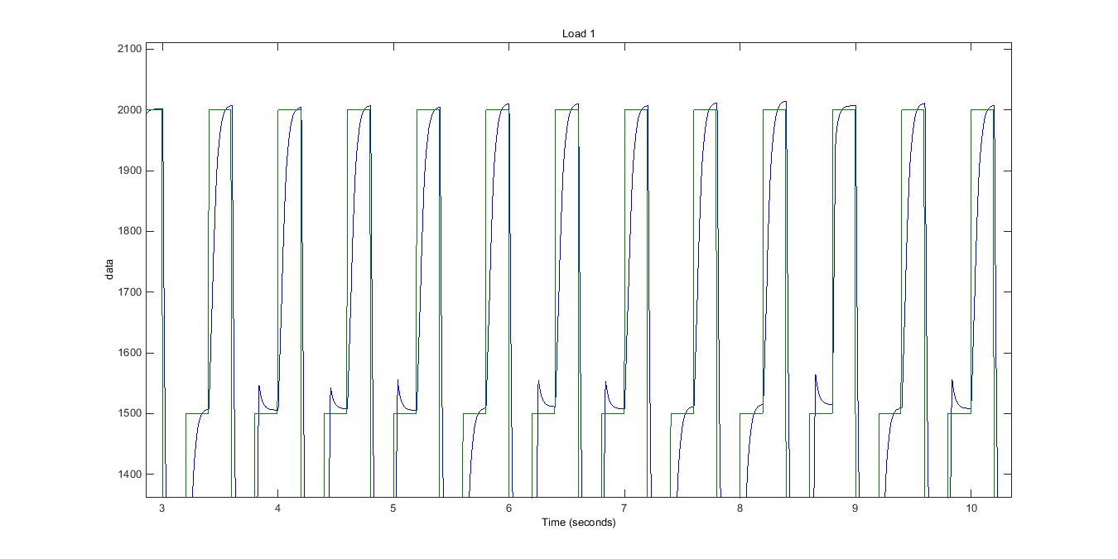
For load 2,
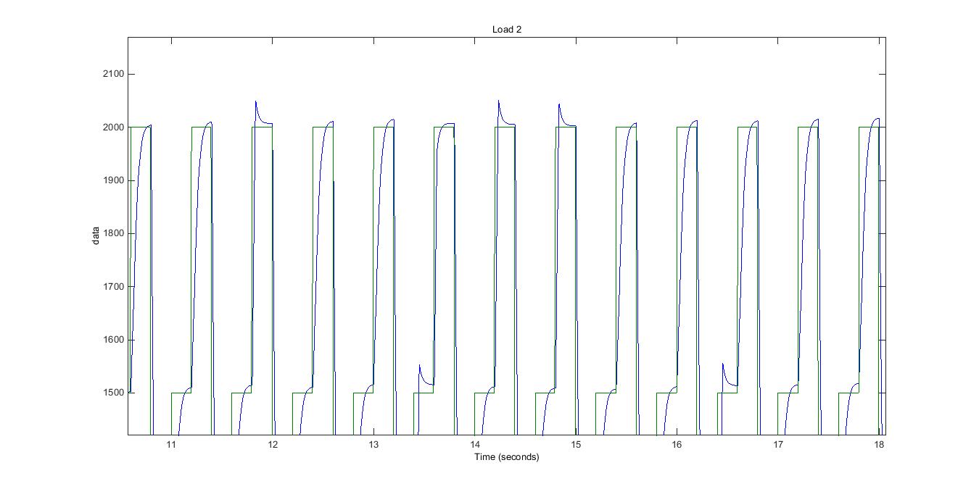

This graphs shows that only using fuzzy logic with PID, the input-output curve of the DC motor is facing some problems like overshooting, less efficiency and so on.
These problems are mostly been solved by using genetic algorithm with fuzzy & PID which are shown below:

For load 0,
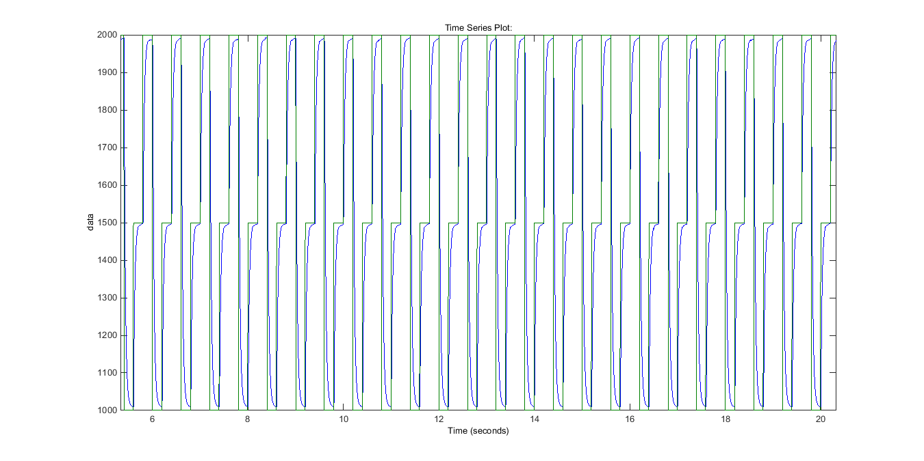
For load 1,
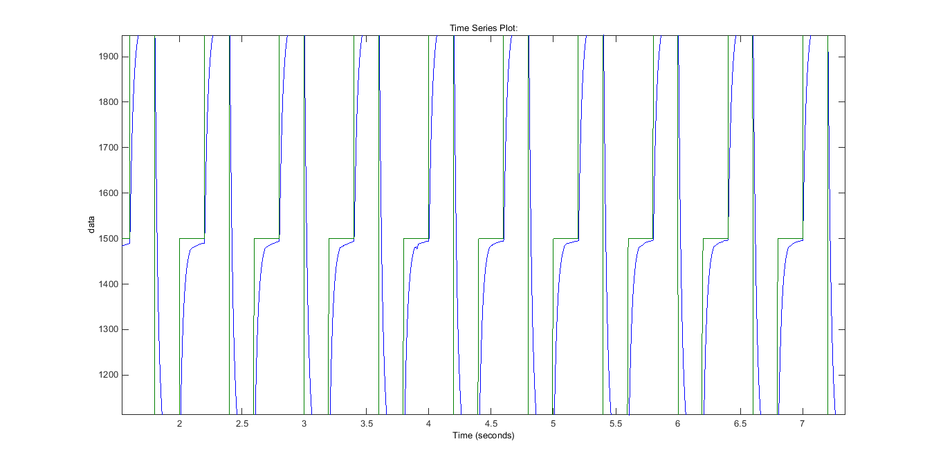
For load 2,
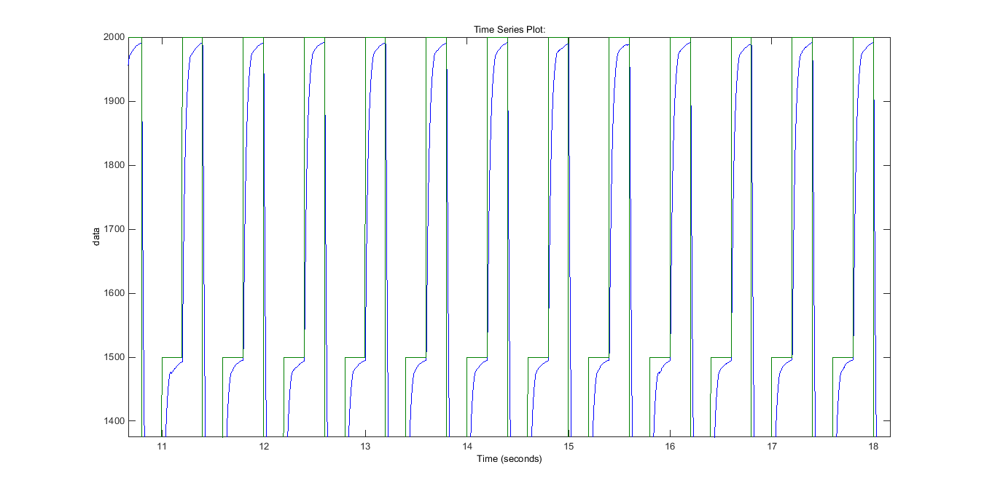
References
[1].Paul I-HaiLin,Santai Hwang and John Chou, "COMPARISON ON FUZZY LOGIC AND PID CONTROLS FOR A DC MOTOR POSITION CONTROLLER" Indiana-Purdo University Fort Wayne.
[2]. J.Tang and R.Chassaing, “PID Controller Using theTMS320C31 DSK for Real-Time DC Motor Control” Proceedings of the 1999 Texas Instruments DSPS Fest, Houston, Texas, August 1999
[3].Y.P. Yang, C.H. Cheung, S.W. Wu, J .P Wang "OPTIMAL DESIGN AND CONTROL OF AXIAL-FLUX BRUSHLESS DC WHEEL MOTOR FOR ELECTRICAL VEHICLES” Proceedings of the 10th Mediterranean Conference on Control and Automation - MED2002 Lisbon, Portugal, July 9-12, 2002.
[4]Hyun Cheol Cho, Kwon Soon Lee and Sami M. Fadali REAL-“TIME ADAPTIVE SPEED CONTROL OF DC MOTORS WITH BOUNDED PERIODIC RANDOM DISTURBANCE” ICIC International °c 2009 ISSN 1349-4198.
[5].M.Fallahi, Member, IAENG, S.Azadi, Member, IAENG. “Adaptive Control of a DC Motor Using Neural Network Sliding Mode Control” Proceedings of the International Multi Conference of Engineers and Computer Scientists 2009 Vol II IMECS 2009, March 18 - 20, 2009, Hong Kong [6]Jang J. S. R. Adaptive network based fuzzy inference systems. IEEE Transactions on systems man and cybernetics 1993, p 665-685.
[7]Boumediene ALLAOUA*, Abdellah LAOUFI, Brahim GASBAOUI, and Abdessalam ABDERRAHMANI ''Neuro-Fuzzy DC Motor Speed Control Using Particle Swarm Optimization'' Issue 15, July-December 2009
[8]. M.Fallahi, Member, IAENG, S.Azadi, Member, IAENG.“Robust Control of DC Motor Using Fuzzy Sliding Mode Control with PID Compensator” Proceedings of the International Multi Conference of Engineers and Computer Scientists 2009 Vol II IMECS 2009, March 18 - 20, 2009, Hong Kong J.Tang and R.Chassaing
[9] J. Jantzen, "Tutorial on Fuzzy Logic", Technical University of Denmark: Department of Automation, Technical report number 98-E 868, 19 Aug 1998, URL:http://www.iau.dtu.dk/
[10] J. Jantzen, "Design of Fuzzy Controllers", Technical University of Denmark: Department of Automation, Technical report number 98-E 864, 19 Aug 1998, URL:http://www.iau.dtu.dk/
[11] C. C. Lee, "Fuzzy Logic in Control Systems: Fuzzy Logic Controller-Part I", IEEE Transactions on Systems, Man, and Cybernetics, Vol. 20, No. 2, pp. 404-418, 1990.
[12] C. C. Lee, "Fuzzy Logic in Control Systems: Fuzzy Logic Controller-Part II", IEEE Transactions on Systems, Man, and Cybernetics, Vol. 20, No. 2, pp. 419-435, 1990.
[13] R. Isermann, "On Fuzzy Logic Applications for Automatic Control, Supervision, and Fault Diagnosis", IEEE Transactions on Systems, Man, and Cybernetics Part A: Systems and Humans, Vol. SMC-28, No. 2, pp. 221-235, 1998.
[14] R. R. Yager and D. P. Filev, "Essentials of Fuzzy Modeling and Control", John Wiley & Sons, 1994.
[15] T. E. Marlin, "Process Control: Designing Process and Control Systems for Dynamic Performance", McGraw-Hill,1995.
[16]D. E. Goldberg. Genetic Algorithms in Search, Optimization & Machine Learning, Addison-Wesley,1989.
[17] J. Magalhães-Mendes, Project scheduling under multiple resources constraints using a genetic algorithm, WSEAS TRANSACTIONS on BUSINESS and ECONOMICS, Issue 11, Volume 5, November 2008, pp. 487-496.
[18] I. Essafi, Y. Mati and S.D. Pérès, A genetic local search algorithm for minimizing total weighted
tardiness in the job-shop scheduling problem, Computers & Operations Research, Vol. 35, Issue 8, 2008, pp. 2599-2616.
[19] J.F. Gonçalves, J.M. Mendes, and M.C.G. Resende. A hybrid genetic algorithm for the job shop scheduling problem. European Journal of Operational Research, Vol. 167, 2005, pp. 77-95.
[20] J.J.M. Mendes, J.F. Gonçalves and M.G.C. Resende, A random key based genetic algorithm for the resource constrained project scheduling problem. Comput. Oper. Res. 36, 1, 2009, pp. 92-109.
[21] D. Y. Sha and C. Hsu, A hybrid particle swarm optimization for job shop scheduling problem.
Computers & Industrial Engineering, 51, 4, 2006, pp. 791-808.
[22] F. Pezzela and E. Merelli, A tabu search method guided by shifting bottleneck for the job shop scheduling problem, European Journal of Operational Research, Vol. 120, 2000, pp. 297-310.
[23] C. Rego and R. Duarte, A filter-and-fan approach to the job shop scheduling problem, European Journal of Operational Research, Vol. 194, 2009, pp. 650–662.
[24] E. Nowicki and C. Smutnicki, A Fast Taboo Search Algorithm for the Job-Shop Problem, Management Science, Vol. 42, No. 6, 1996, pp. 797-813.
[25]J. Adams, E. Balas and Z. Zawack, The shifting bottleneck procedure for job shop scheduling,
Management Science, Vol. 34, 1988, pp. 391-401.
[26] C. Y. Zhang, P. Li. and Z. Guan, A very fast TS/SA algorithm for the job shop scheduling problem, Computers & Operations Research, Vol. 35, 2008, pp. 282-294.
[27]H.R. Lourenço, Local optimization and the job-shop scheduling problem, European Journal of Operational Research, Vol. 83, 1995, pp. 347-364.
[28]Wikipedia, Google and many more internet resources.

